**Case Project: Implementing and Managing Microsoft 365 Environment for a Mid-Sized Organization**

**Objective**: To provide hands-on experience in implementing, configuring, and managing a Microsoft 365 environment for a fictional mid-sized organization named "TechSolutions Inc."

**Scenario**: TechSolutions Inc. is a mid-sized IT services company with 300 employees. The company is transitioning to Microsoft 365 to improve collaboration, security, and productivity. As part of the IT team, you are responsible for setting up and managing the Microsoft 365 environment. This case project will cover various aspects of Microsoft 365, including user and group management, security and compliance, and service configuration.

**Tasks**:

**Task 1: Setting Up and Configuring User Accounts**  
  
**Part A:**

1. **Bulk Import Users**:
   * Use the Microsoft 365 admin center to bulk import 10 users from a CSV file.  
       
     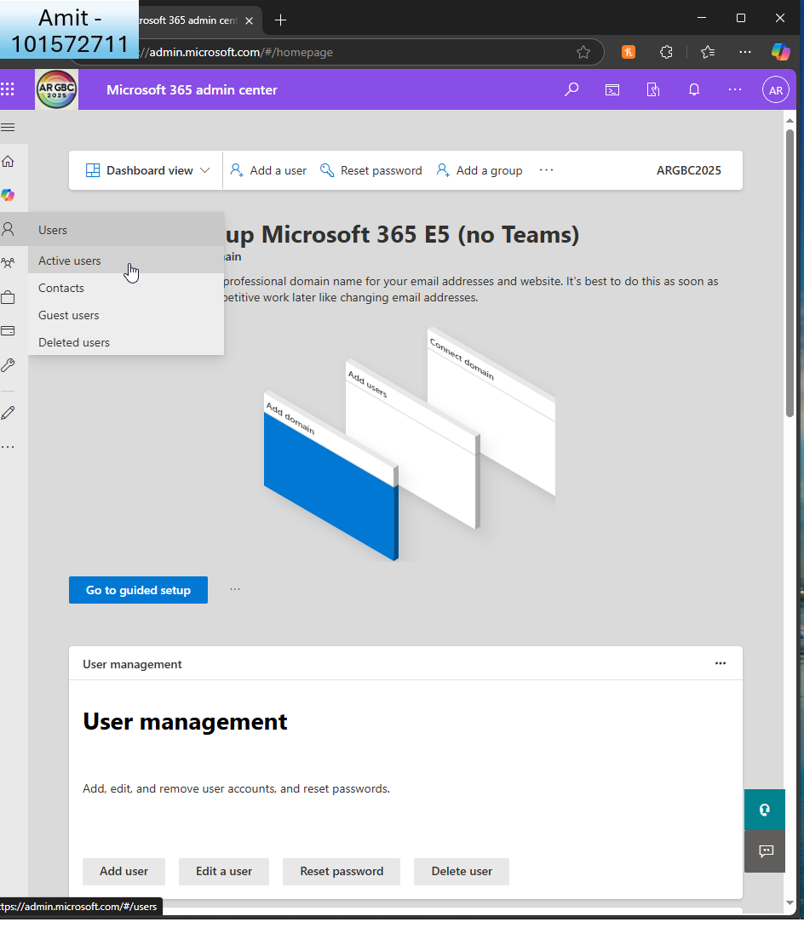  
     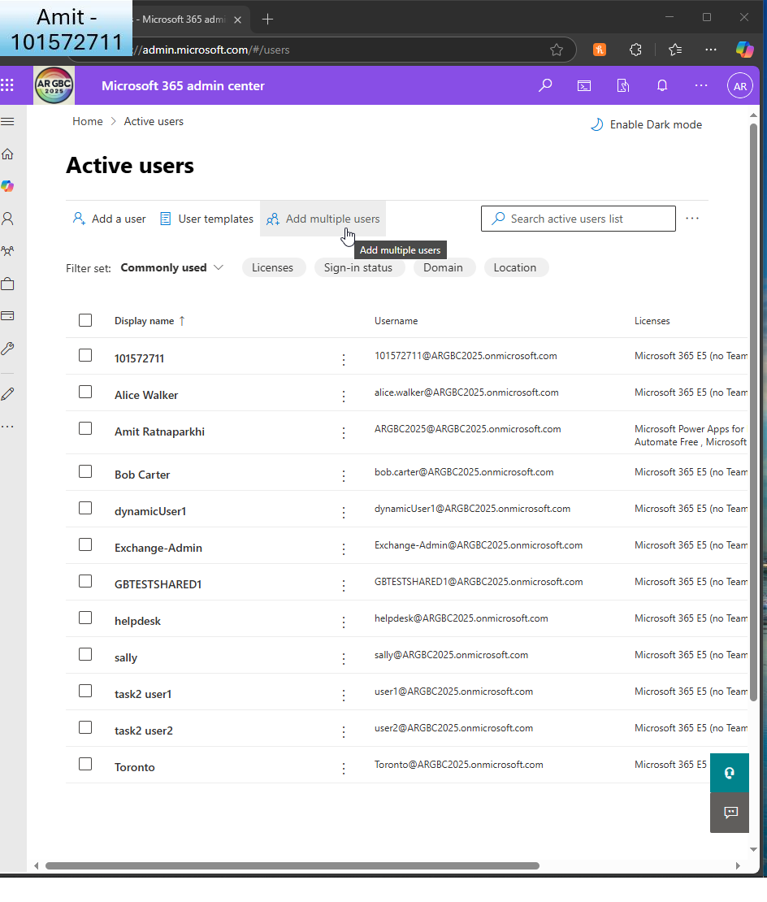  
       
     I then add multiple users  
       
     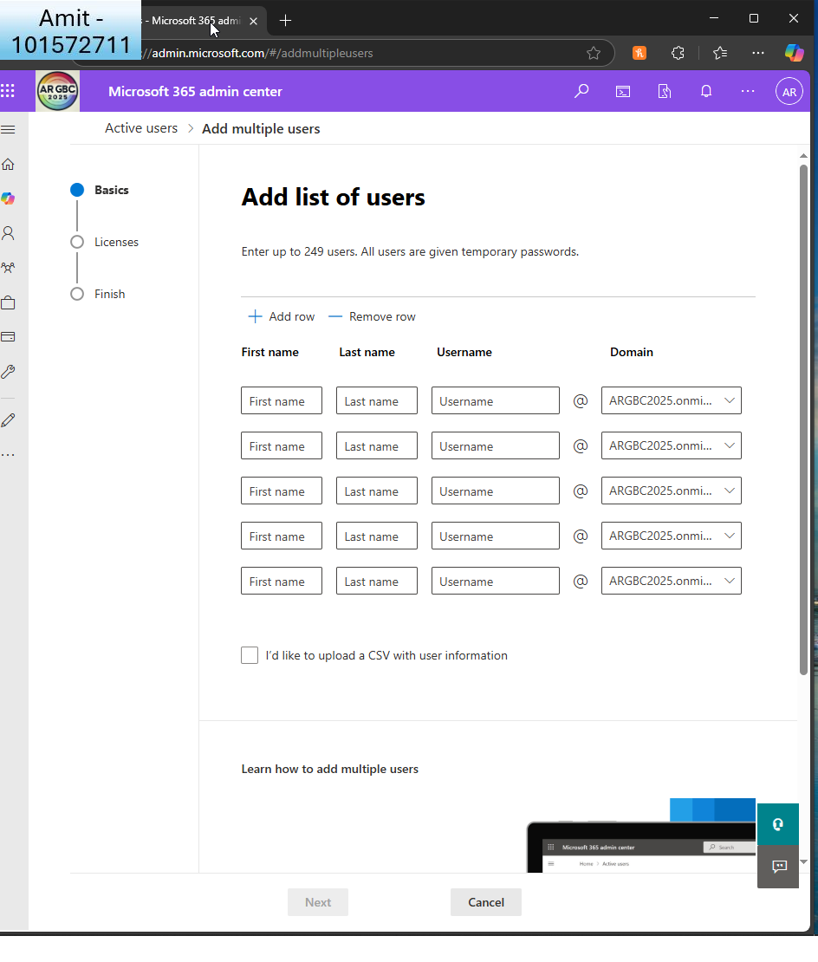

I choose to upload a CSV  
  
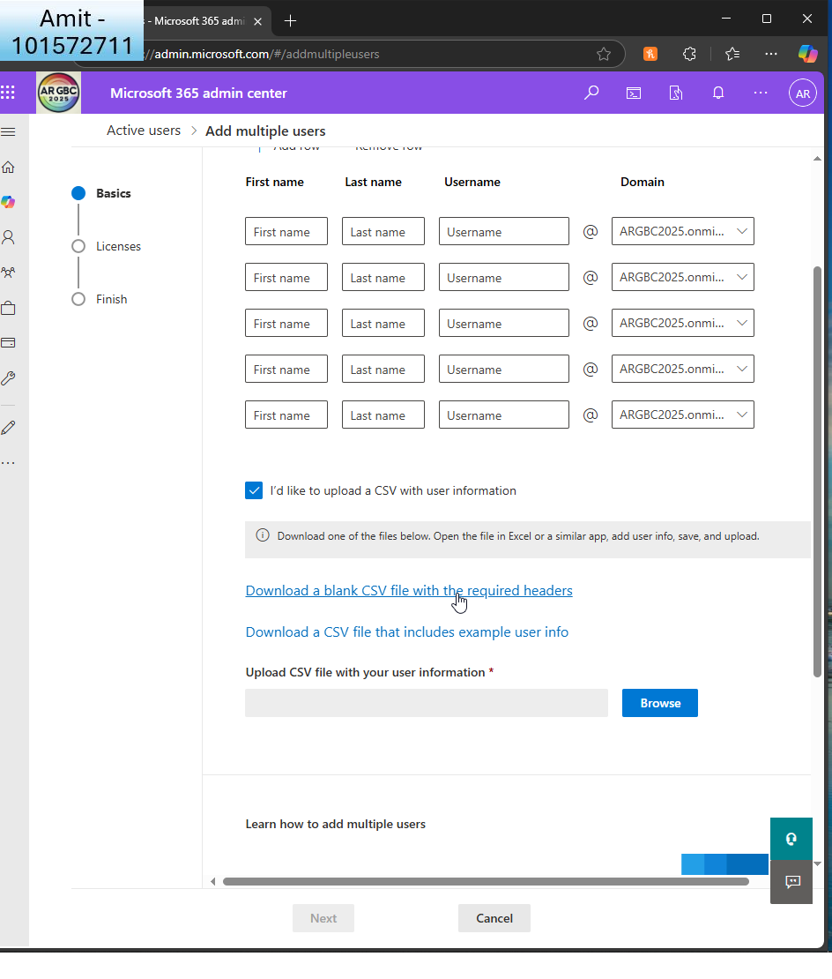  
I download a blank CSV template  
  
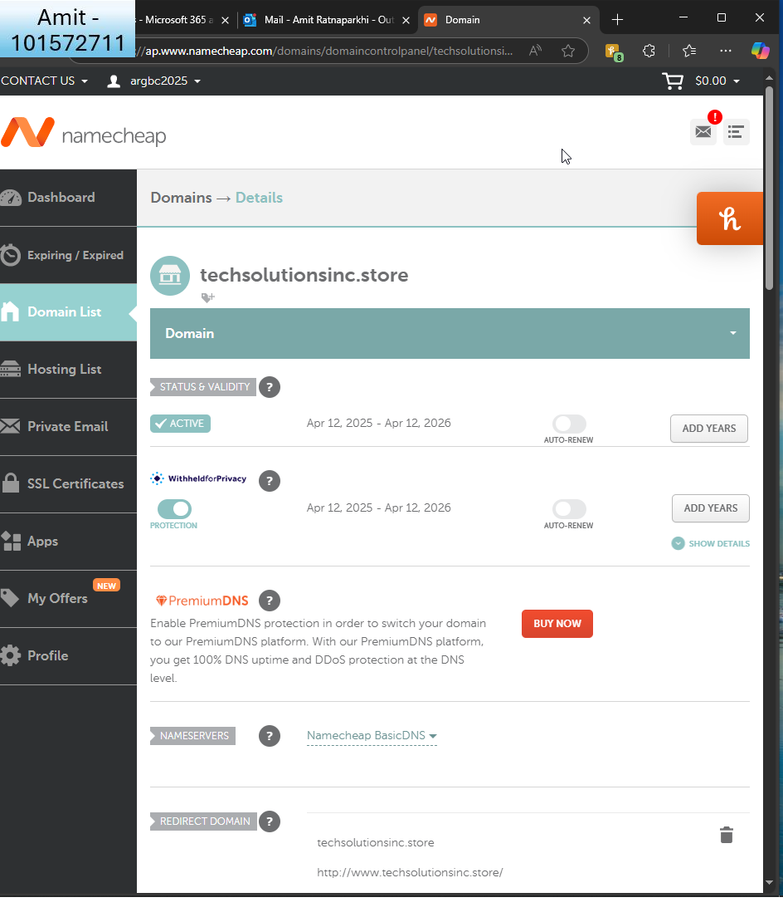  
  
I wanted to reflect Techsolutions as a name, so I bought a domain called techsolutions.store from namecheap

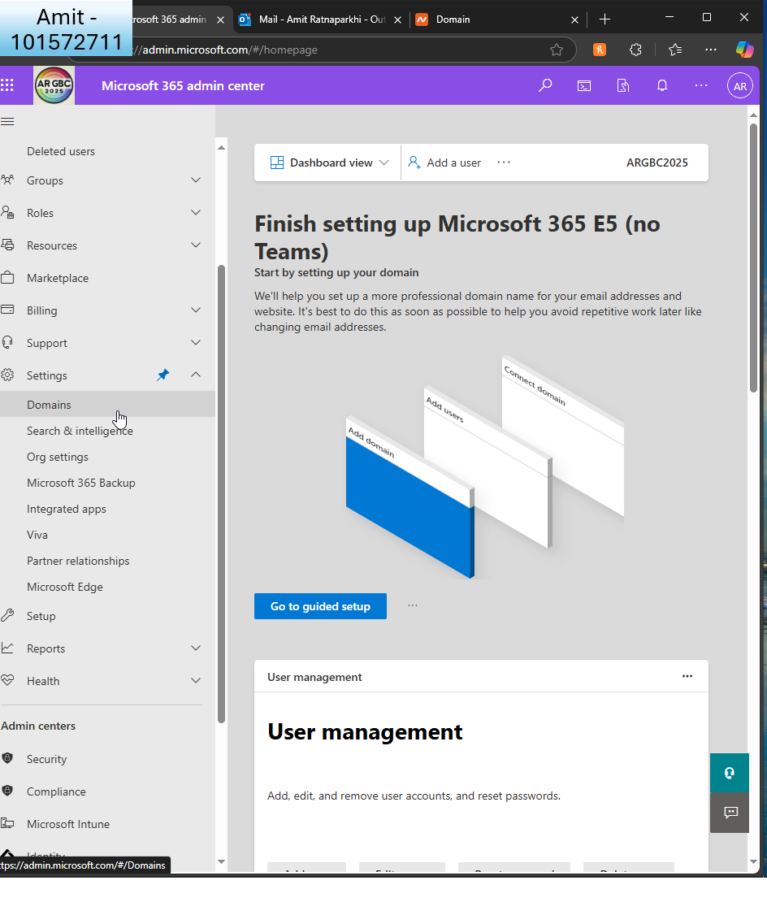I connect the domain to MS365

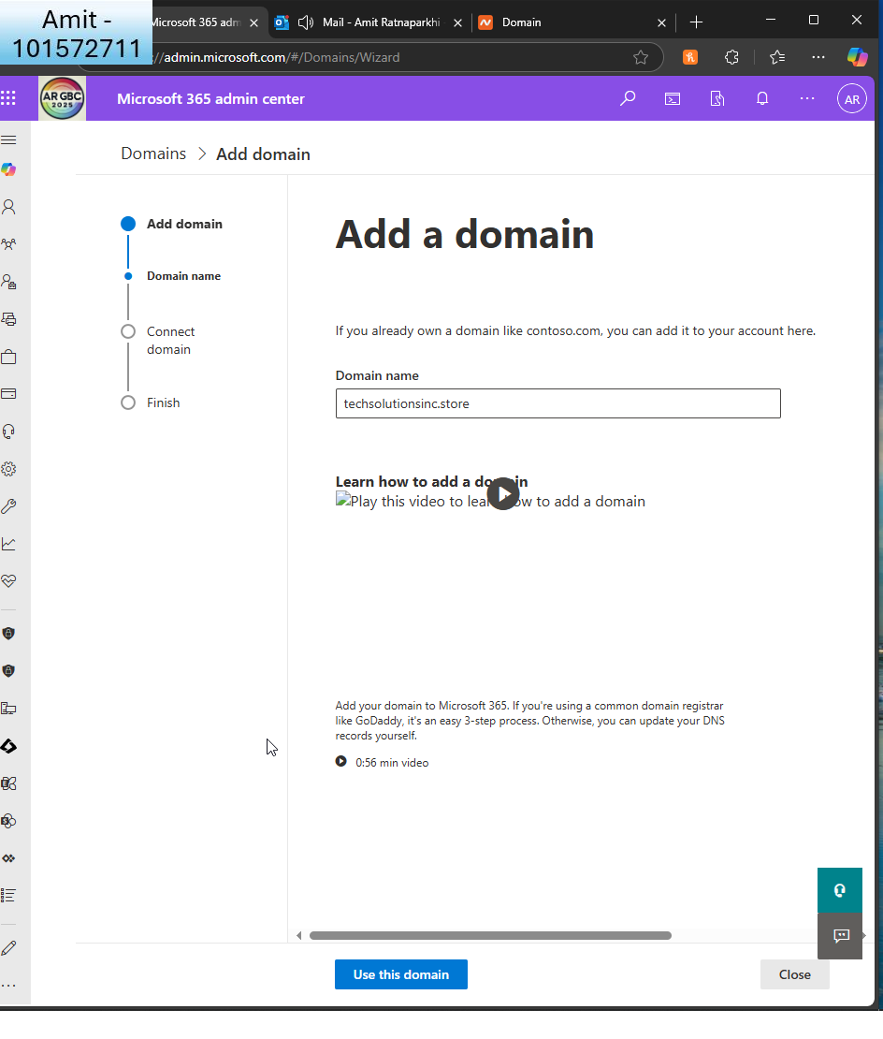

I add the domain  
  
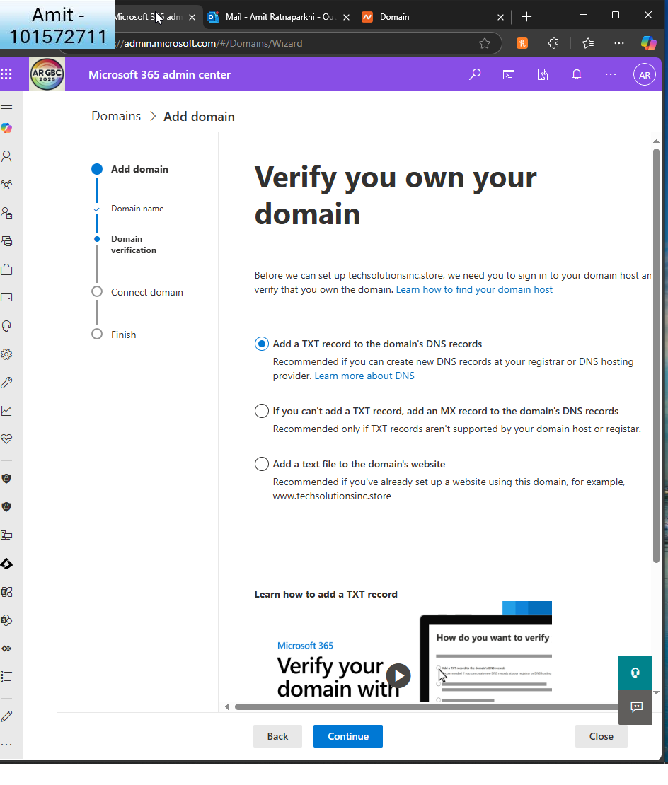  
I add the TXT  
  
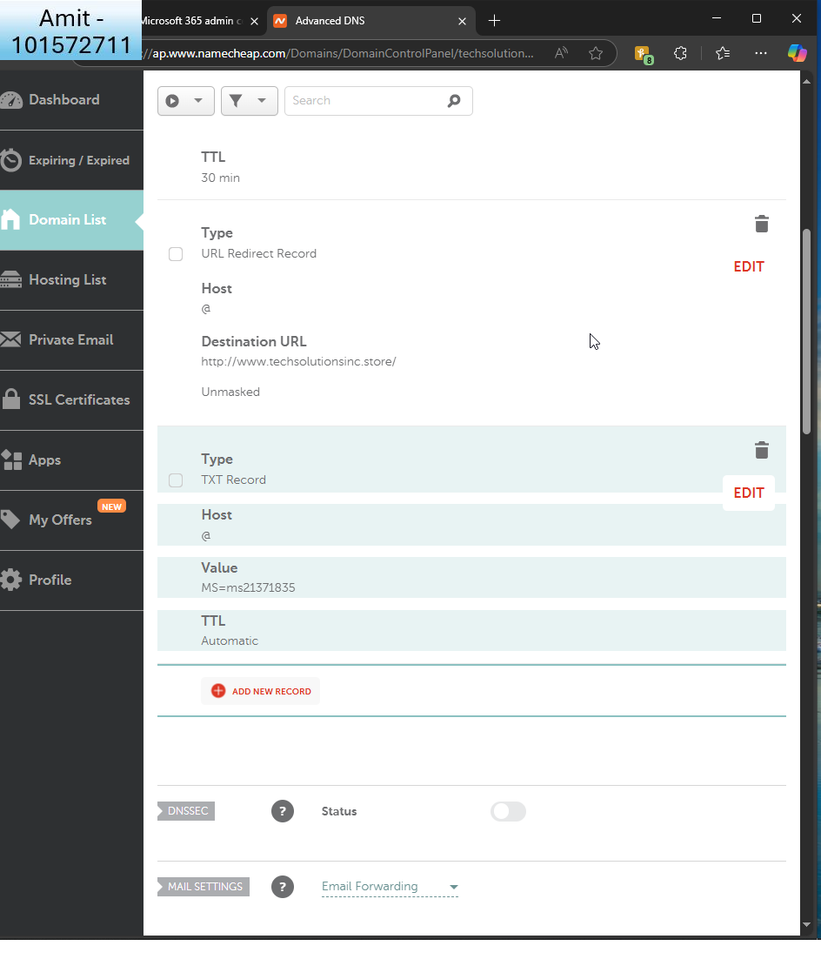

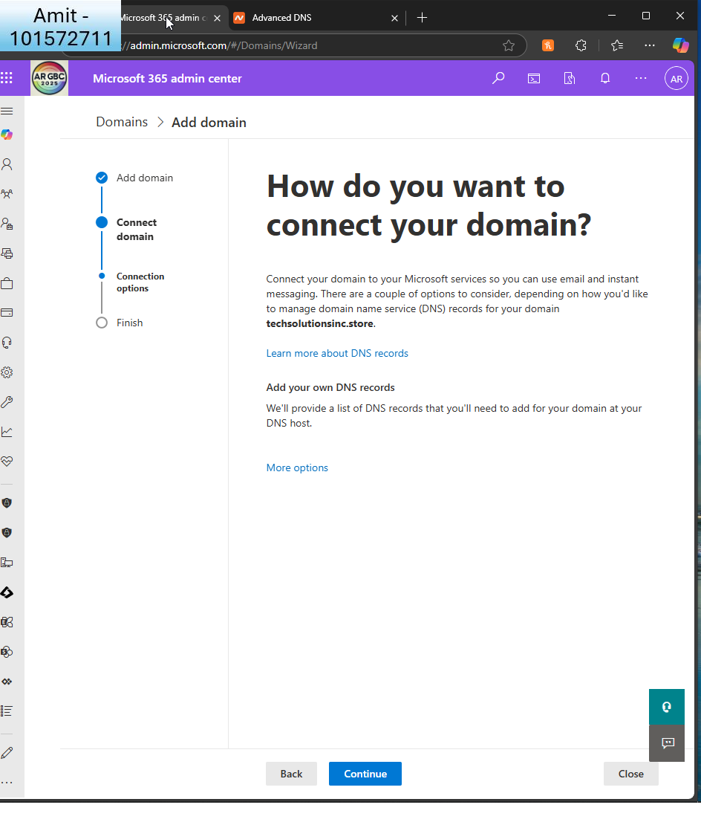I go back to admin centre to connect the domain  
  
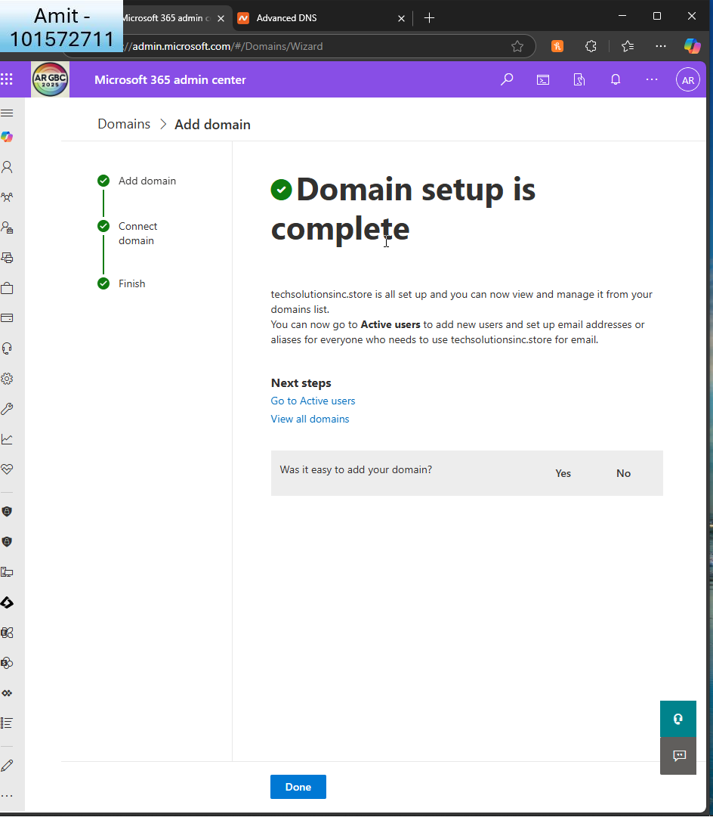  
I also made sure the MX and TXT records are correct  
  
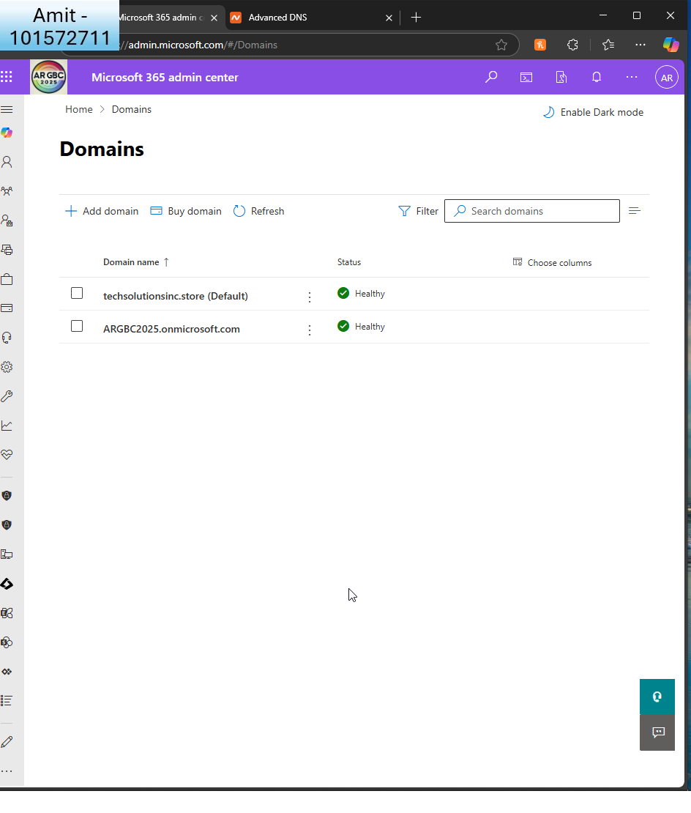  
I can see my domain now and it’s default  
  
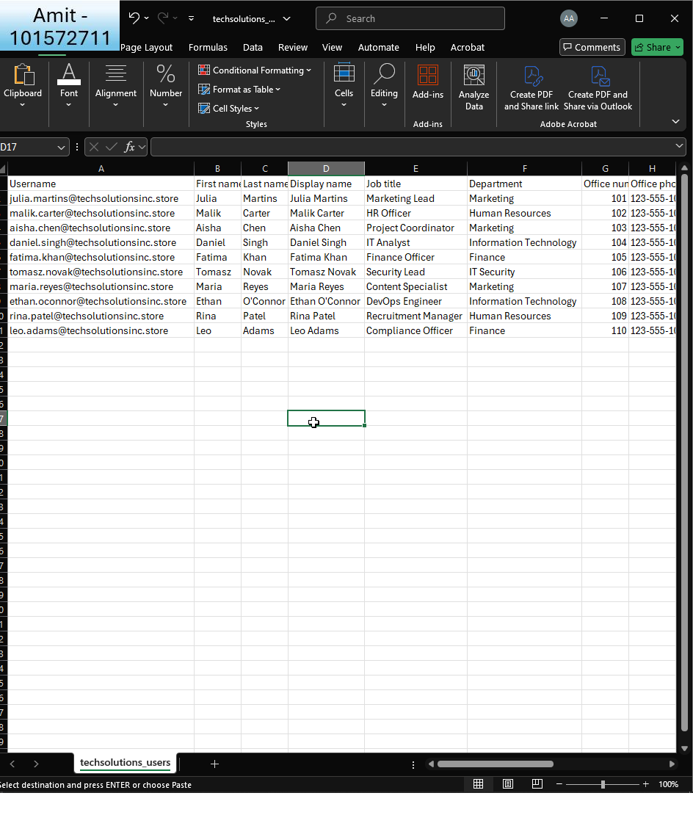I used chatGPT to fill the CSV file with information  
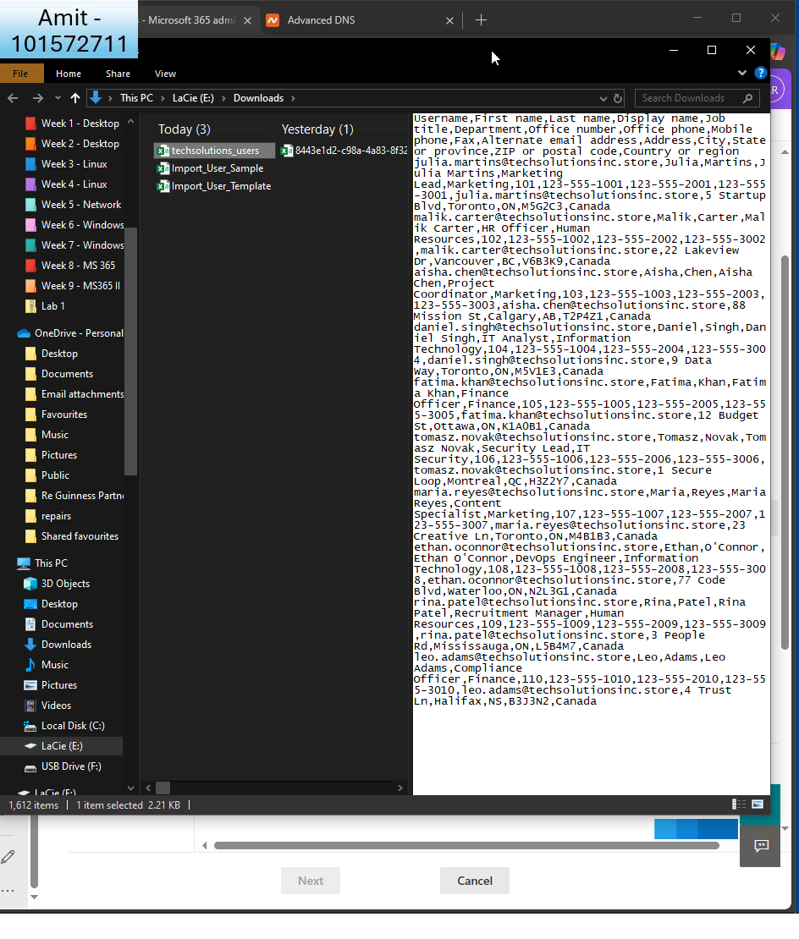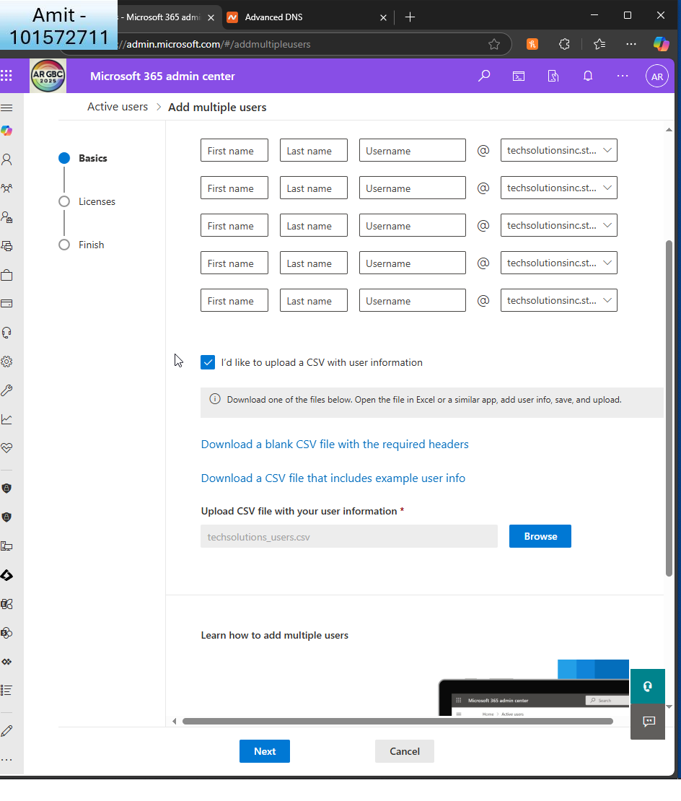  
I upload the file

* + Assign appropriate licenses (Microsoft 365 E3 or E5) to the imported users.  
      
    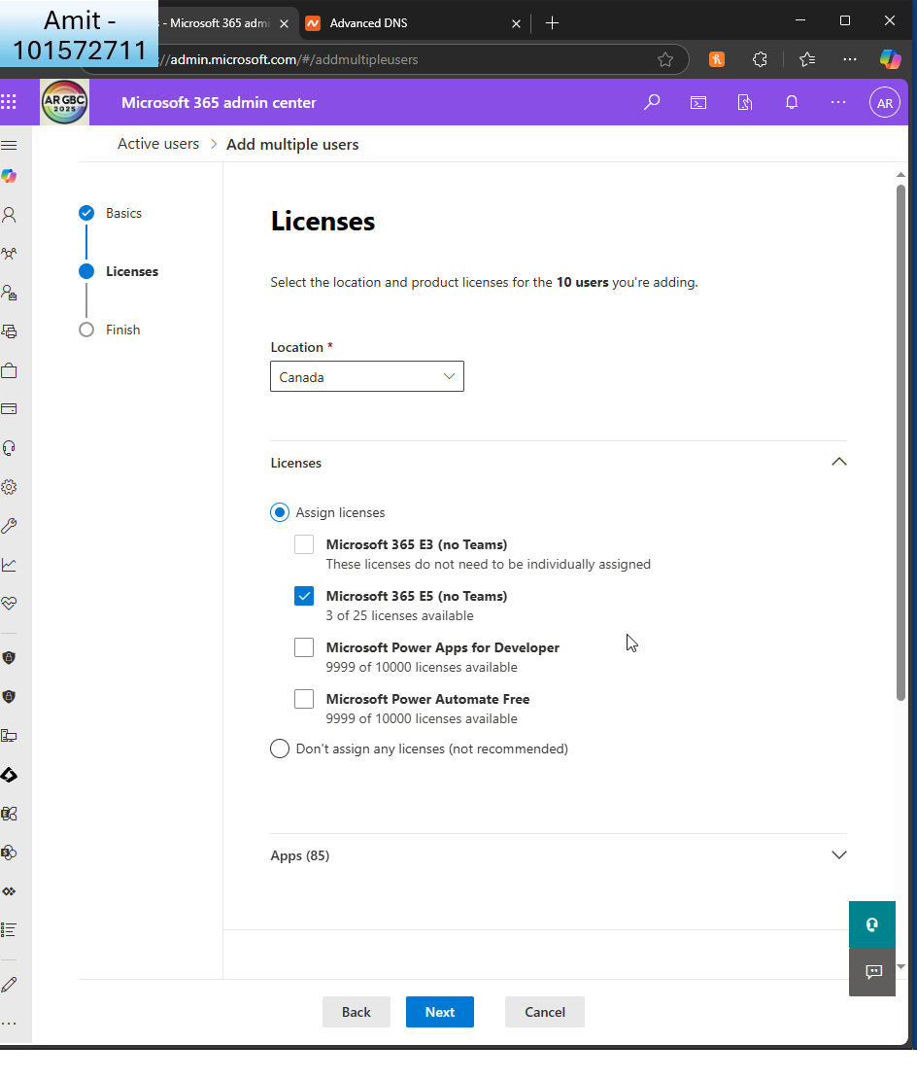  
    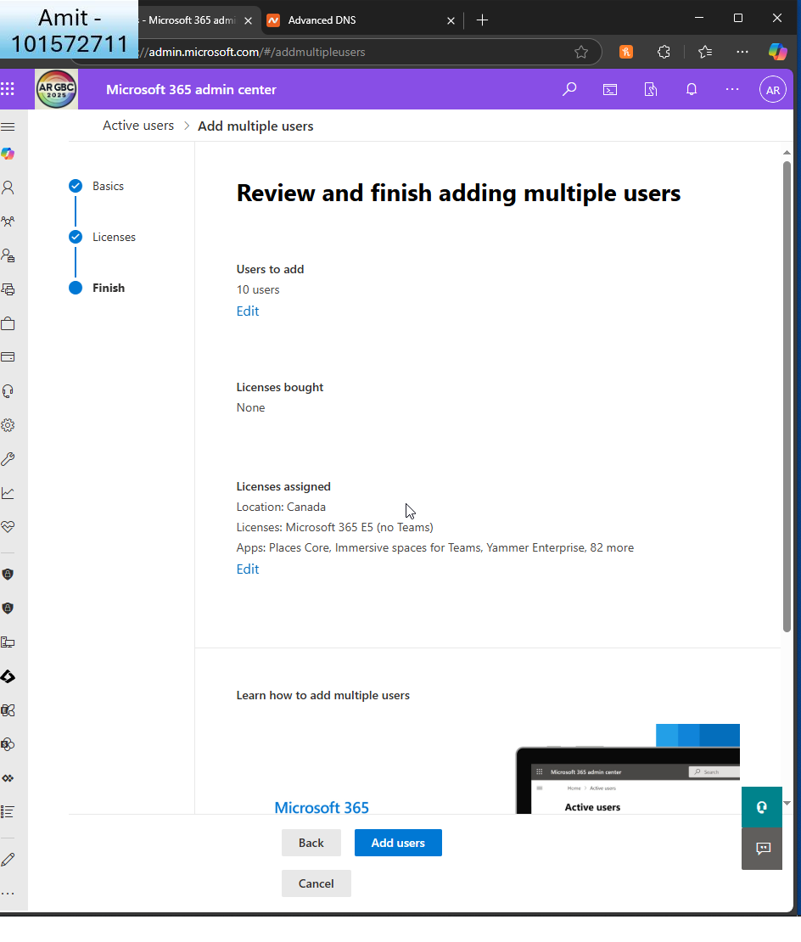

I review and finish adding multiple users  
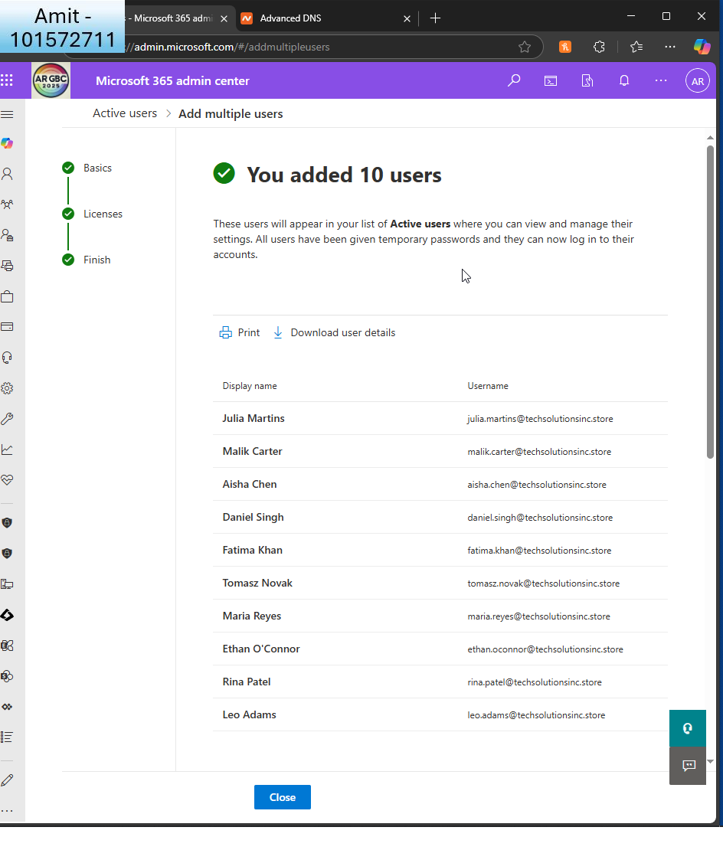

1. **Configure User Profiles**:
   * Ensure each user has a profile picture, contact information, and job title set.  
       
     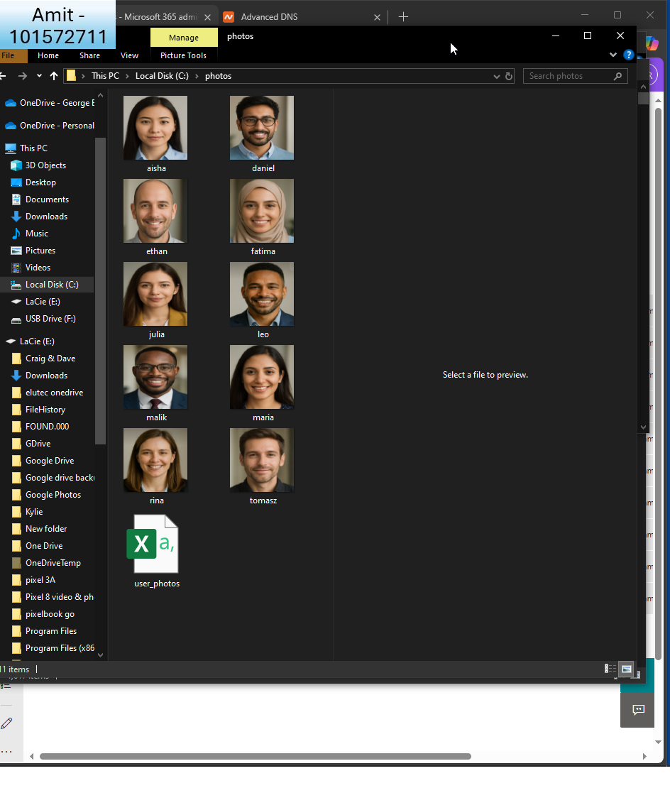  
       
     I used chatgpt to create 10 photos and ensure they are all square, all PNG and all same pixels so MS365 can import them via powershell  
       
       
       
     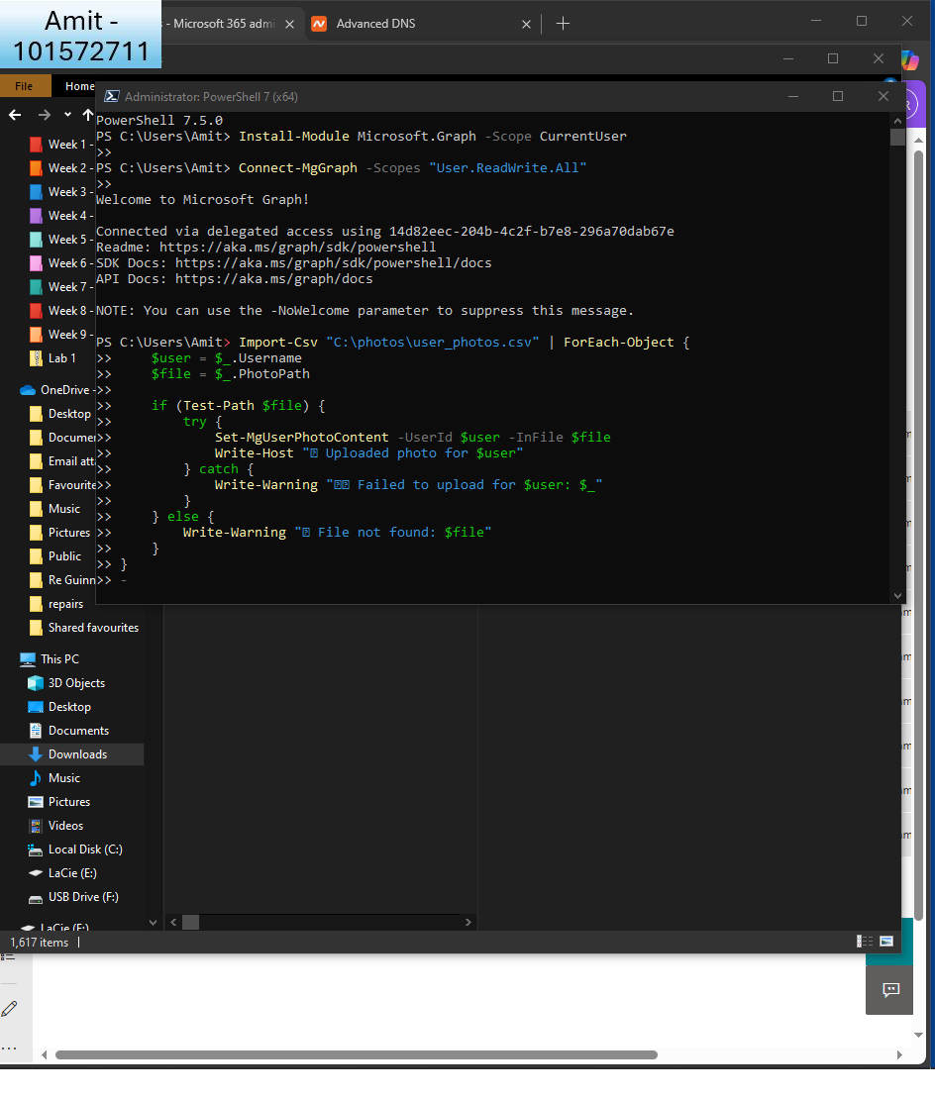  
     I use this script to set the photo in the profile  
       
     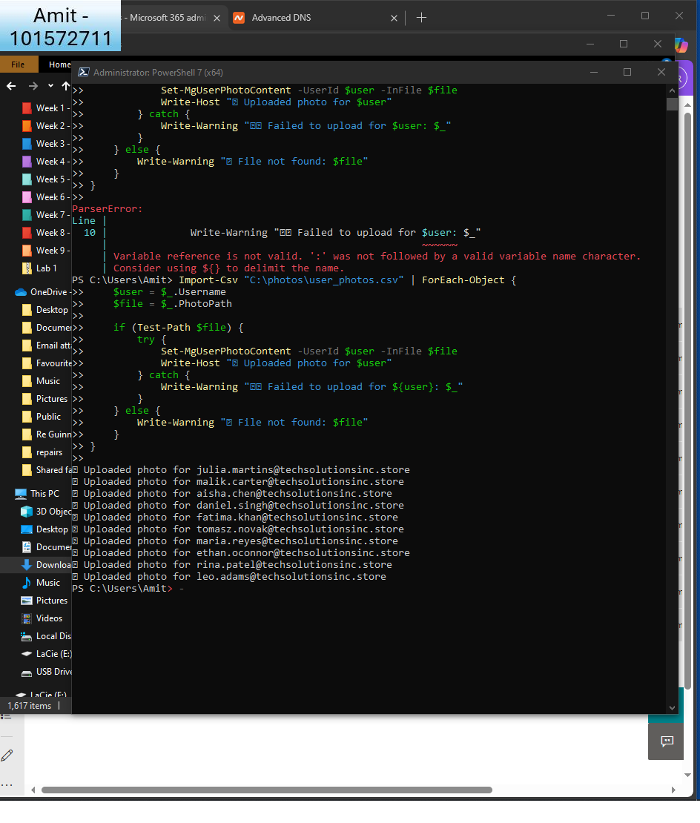  
       
     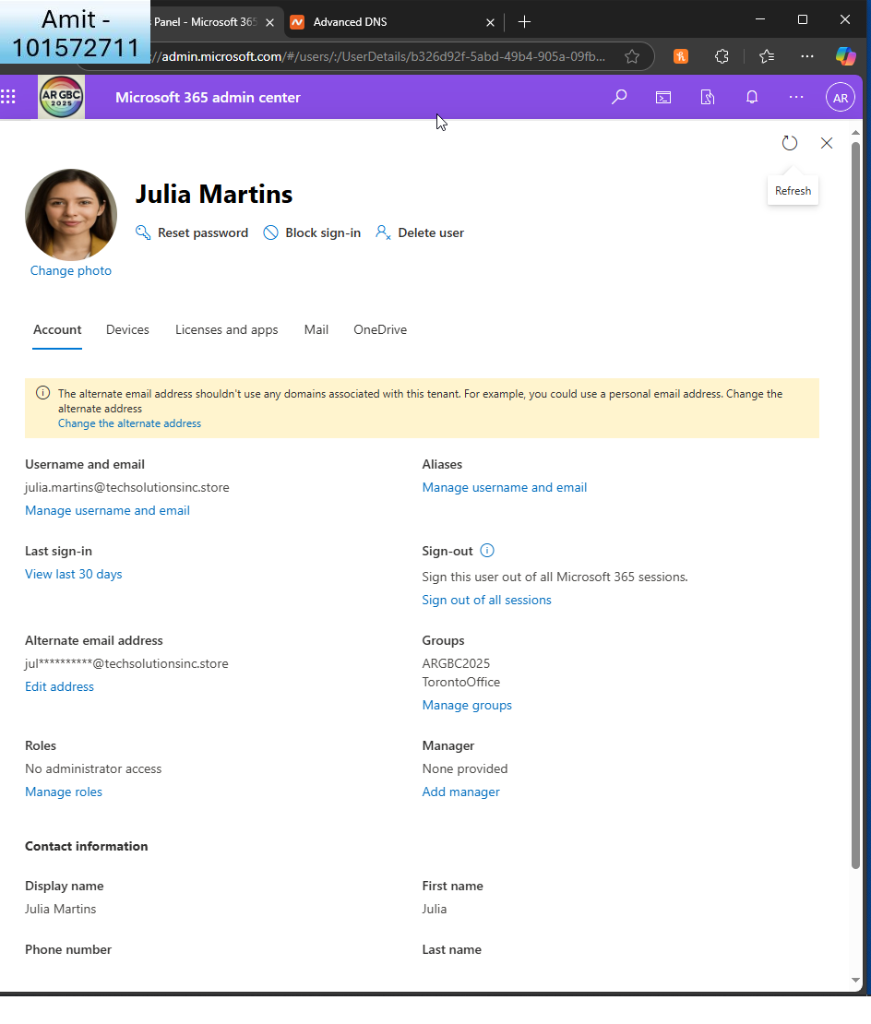  
       
     Here’s the confirmation
   * Configure user settings to include organization-specific information.  
     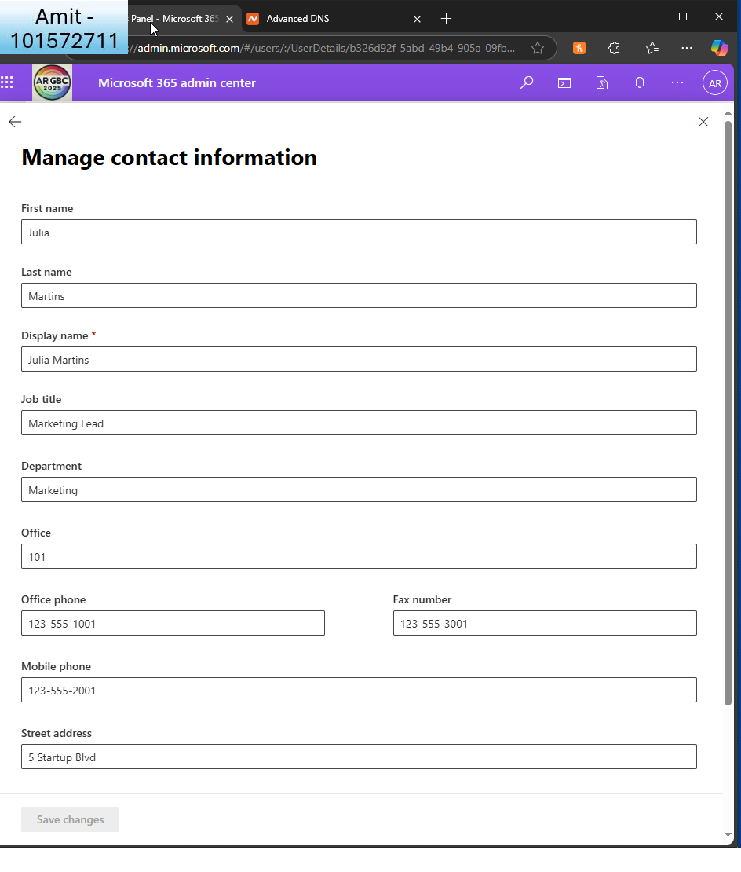  
       
     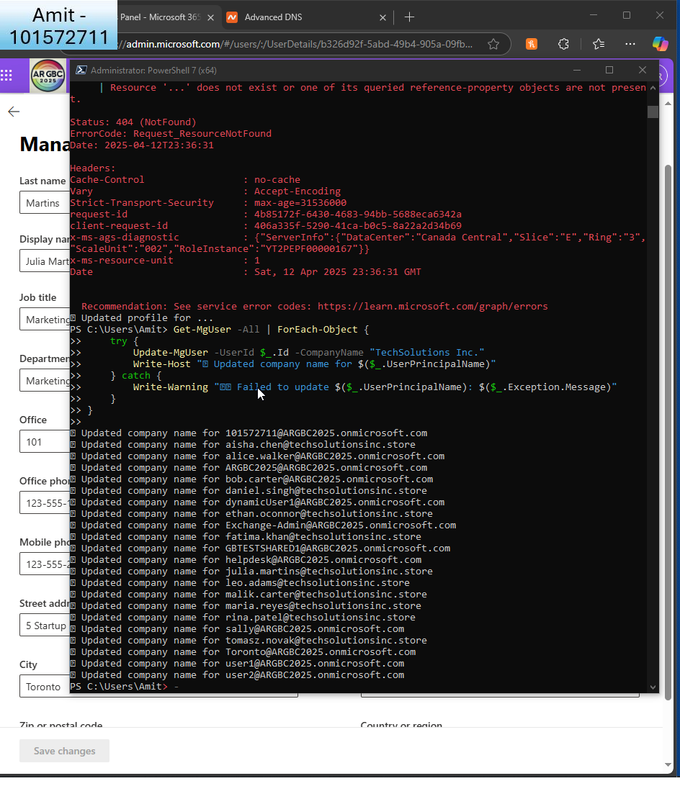  
       
     I also used powershell to update the company name
2. **Create Office 365 Groups**:
   * Create three Office 365 groups for different departments: IT, HR, and Marketing.  
       
     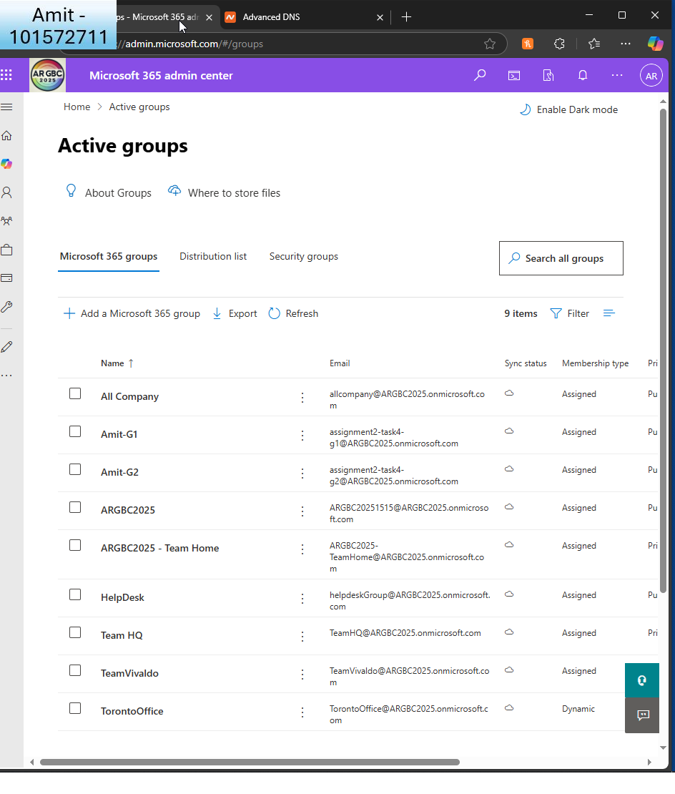  
       
     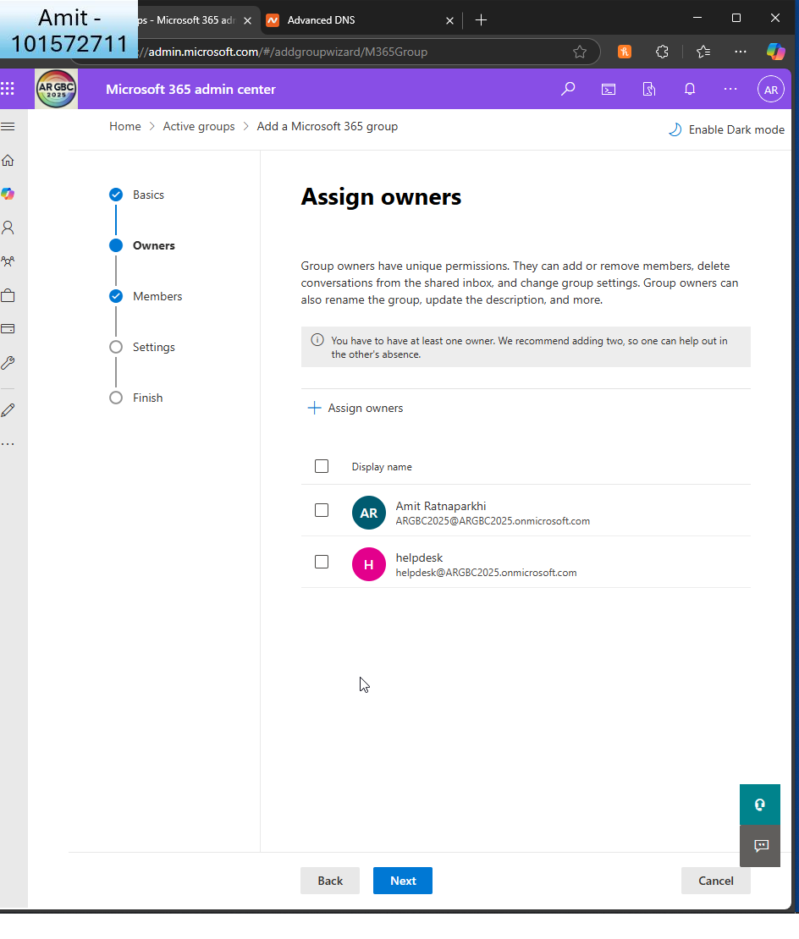  
       
     I add 2 owners per group (GA and helpdesk)
   * Add users to their respective groups.  
       
     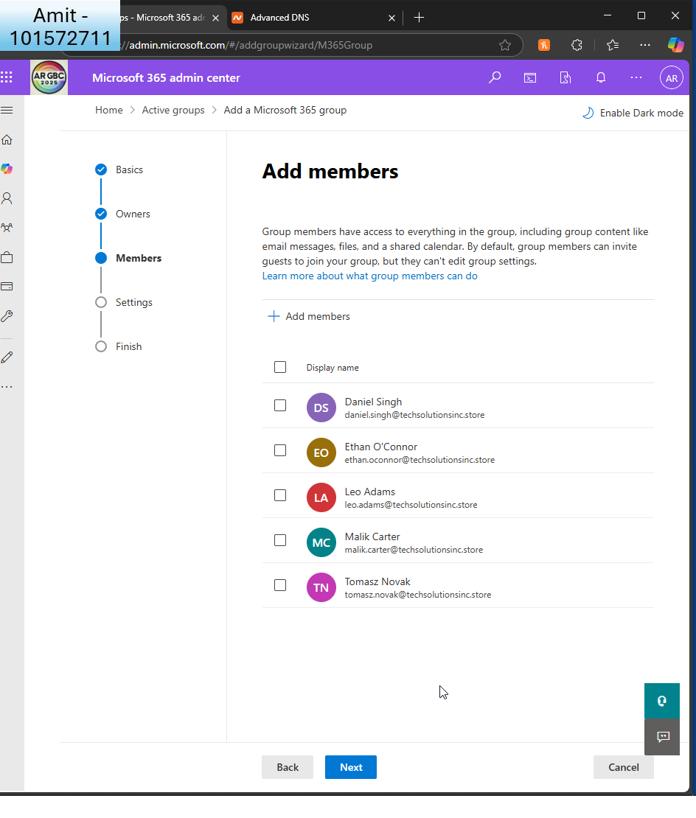  
     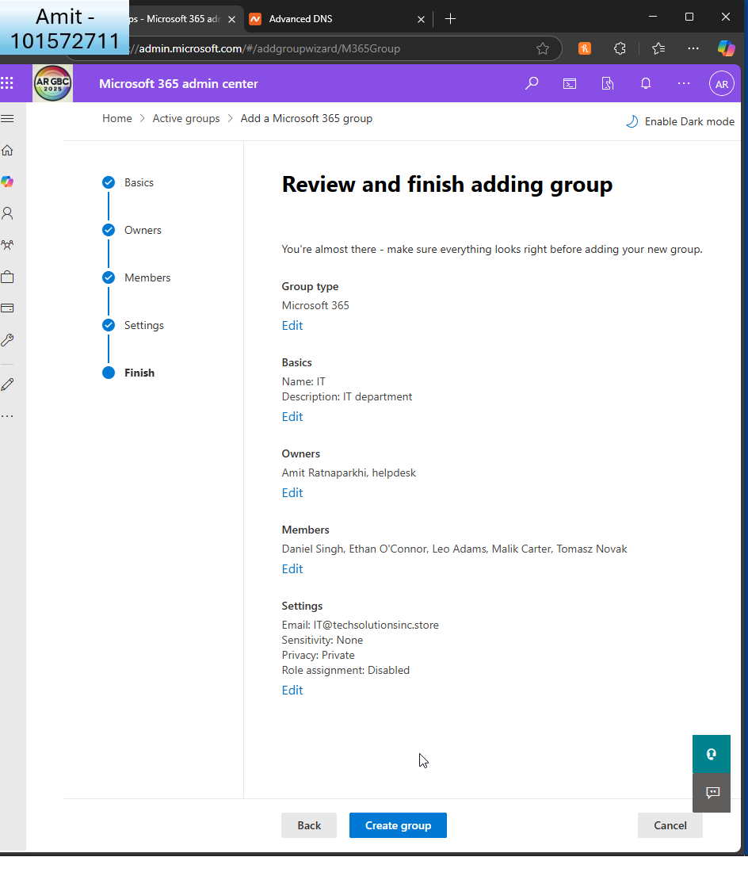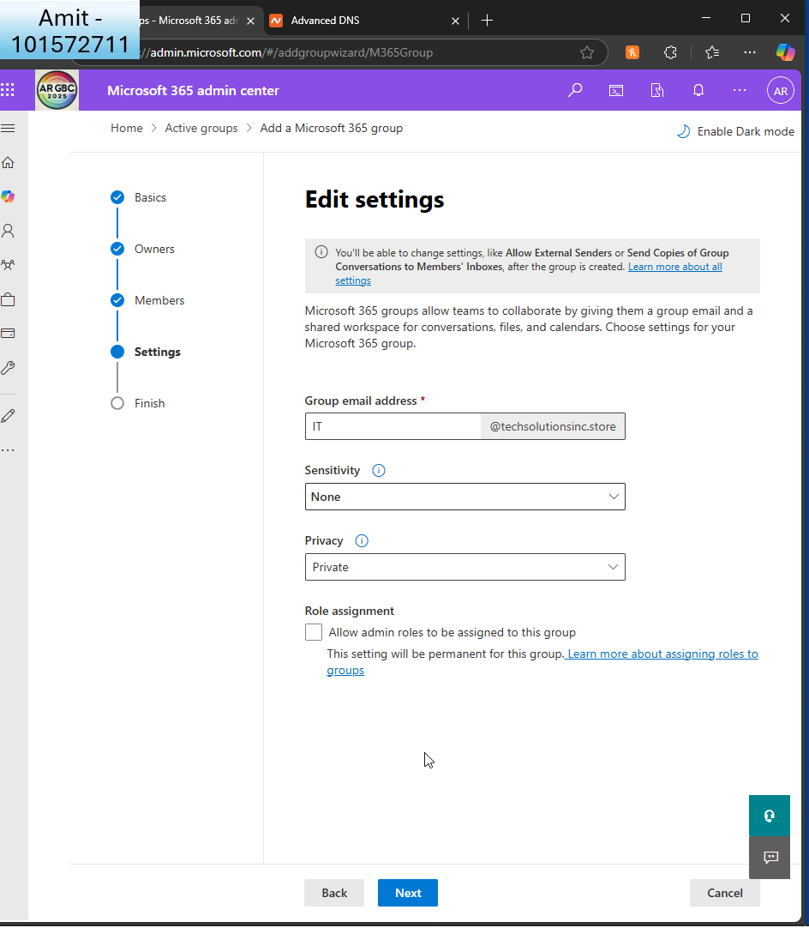

This is the IT department  
  
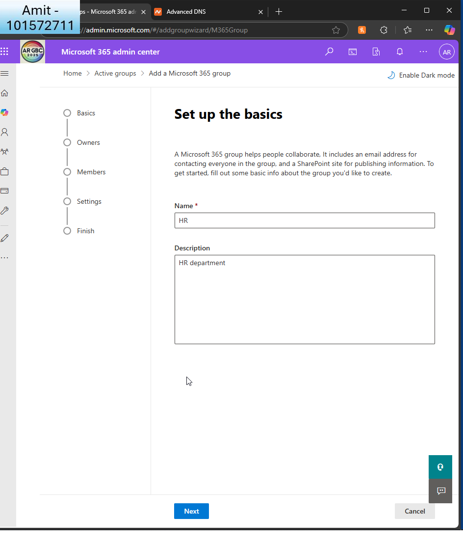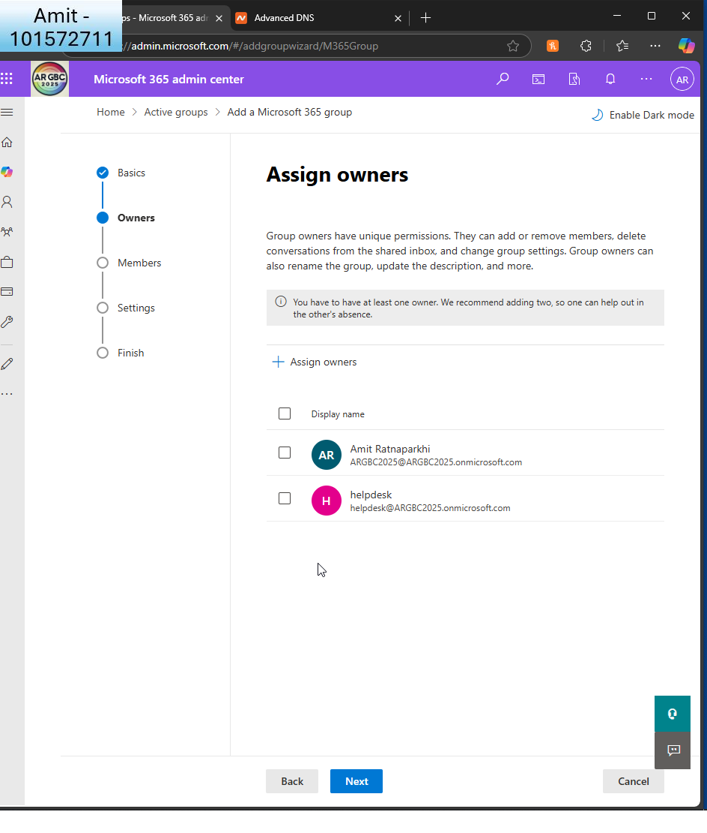  
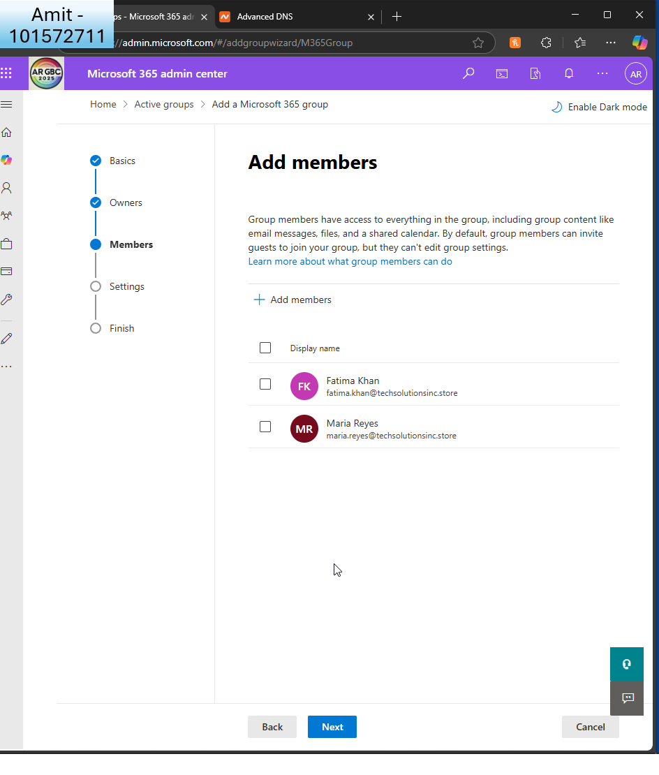

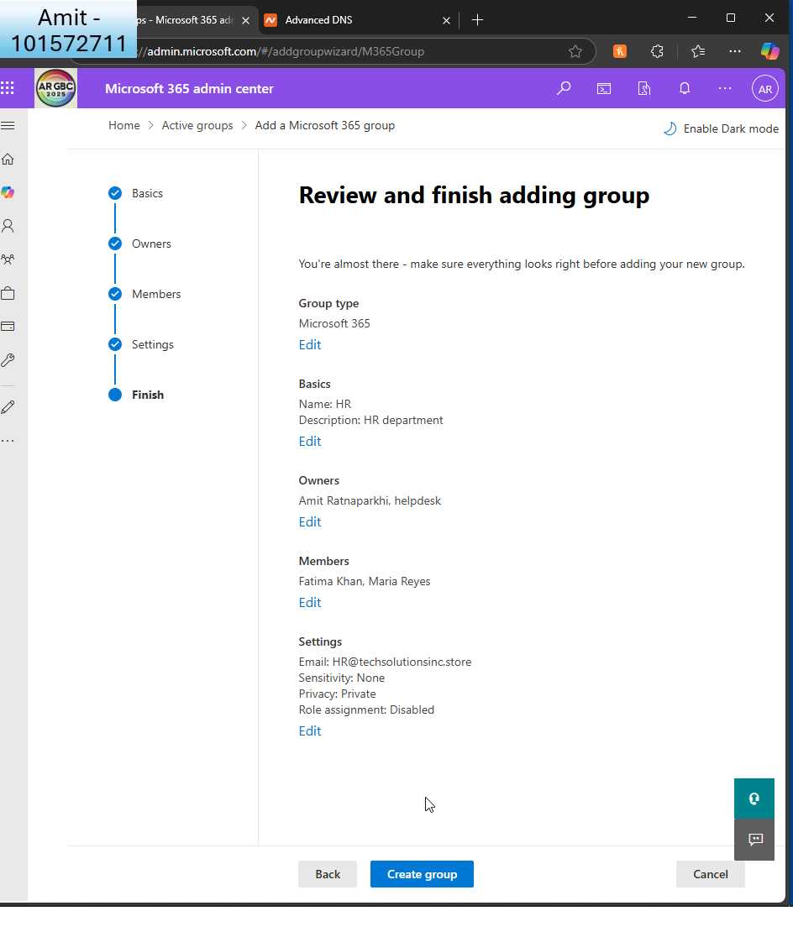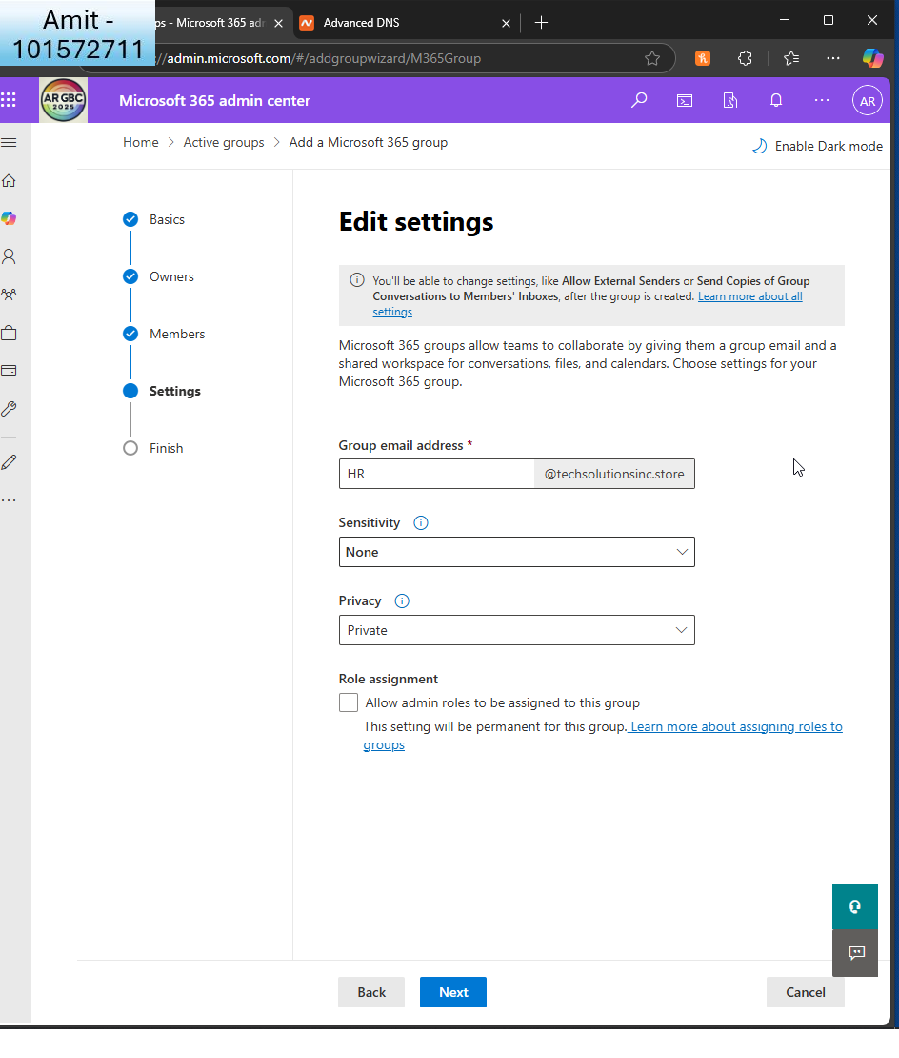

This is the HR department  
  
  
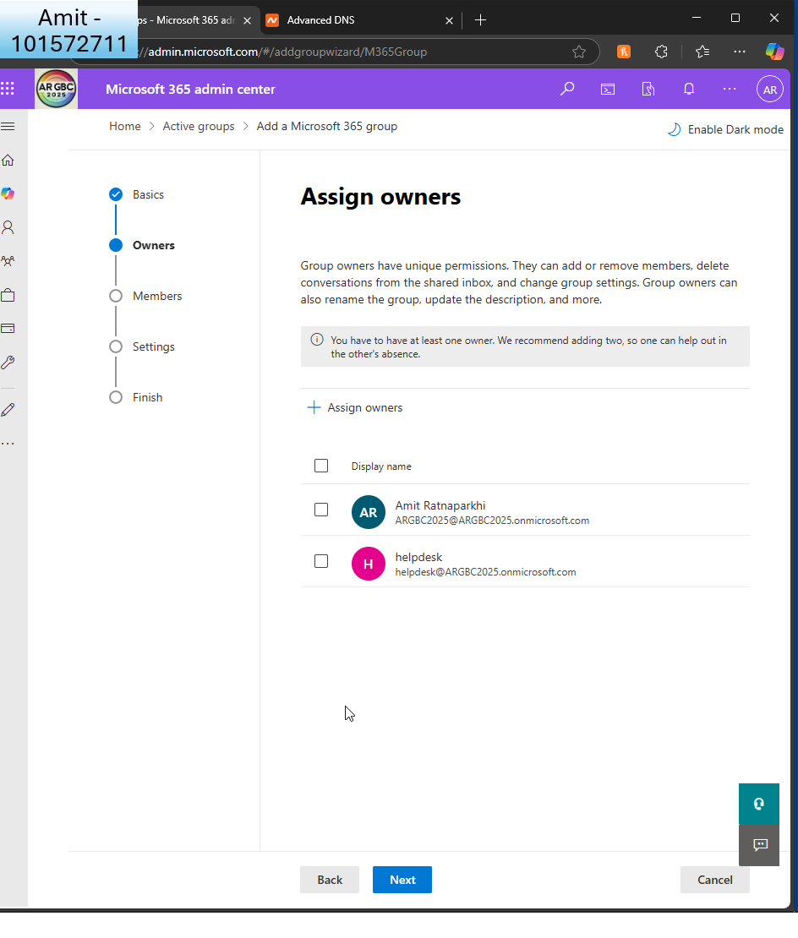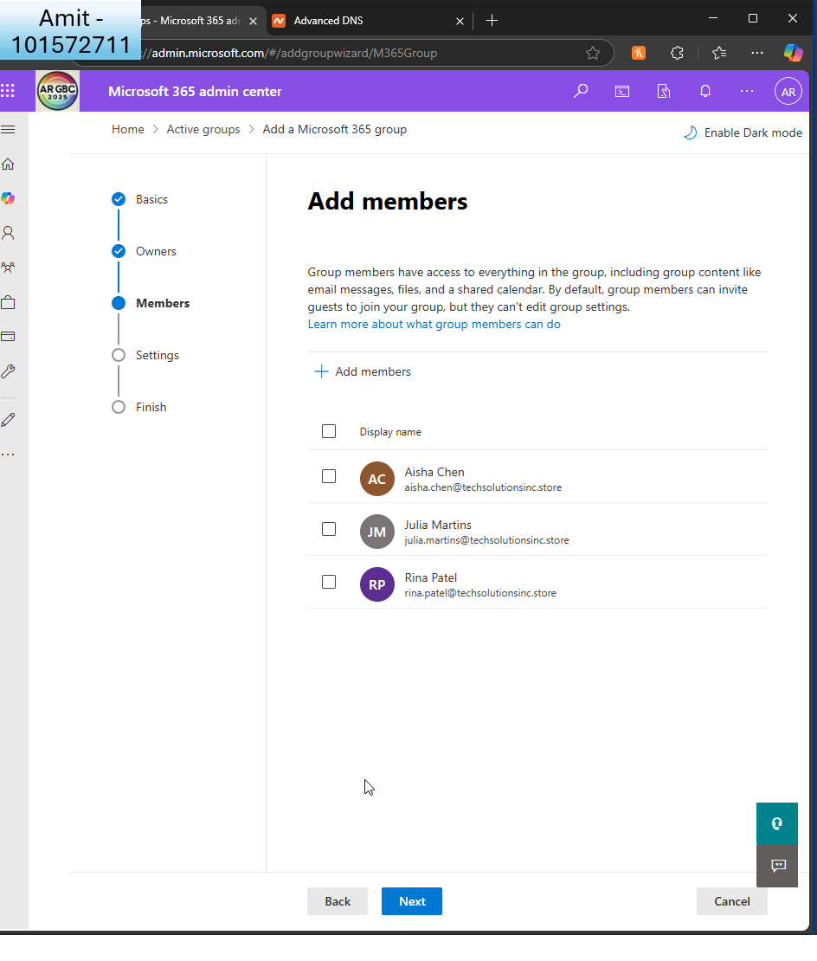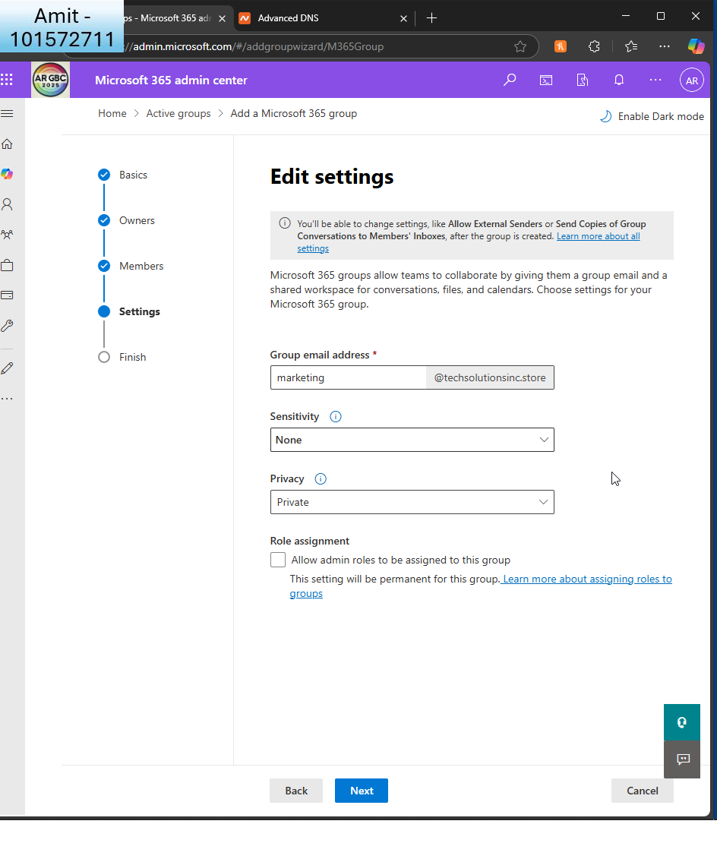  
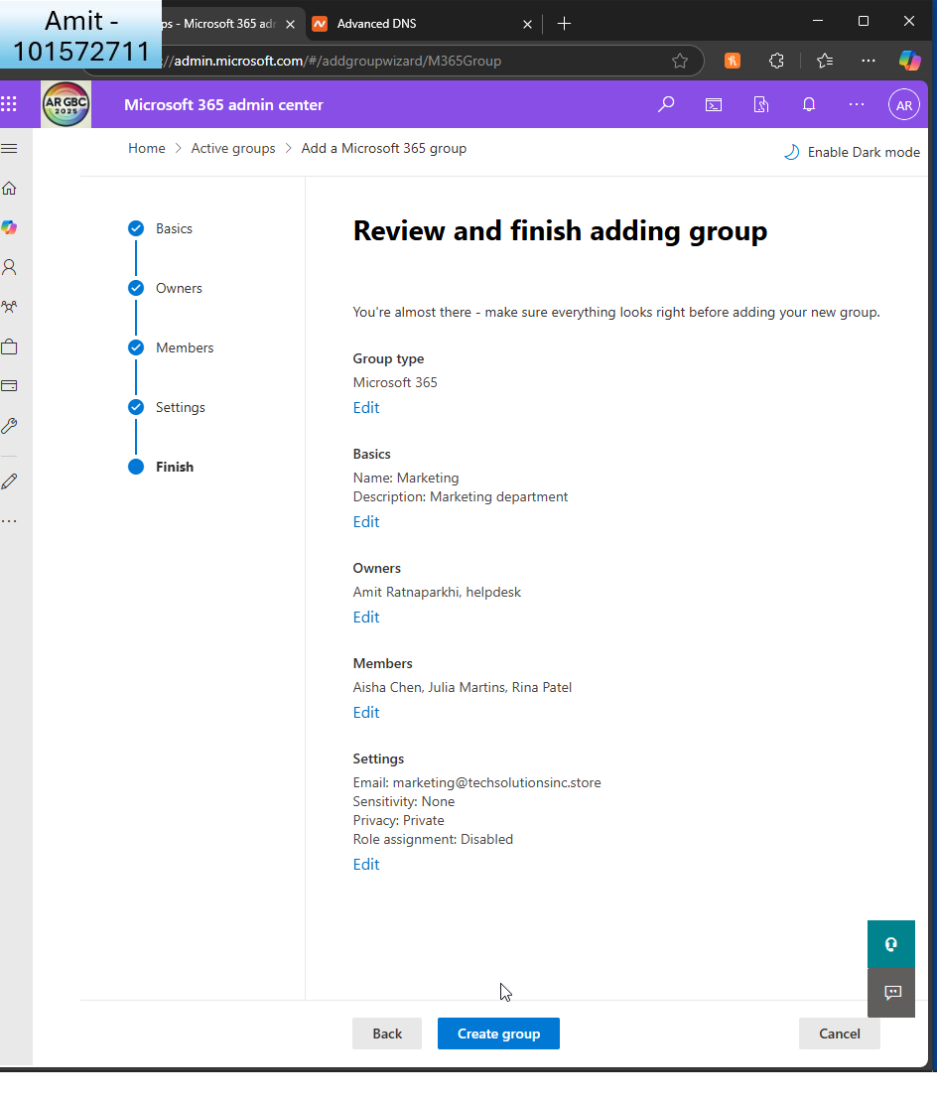  
This is the marketing department  
  
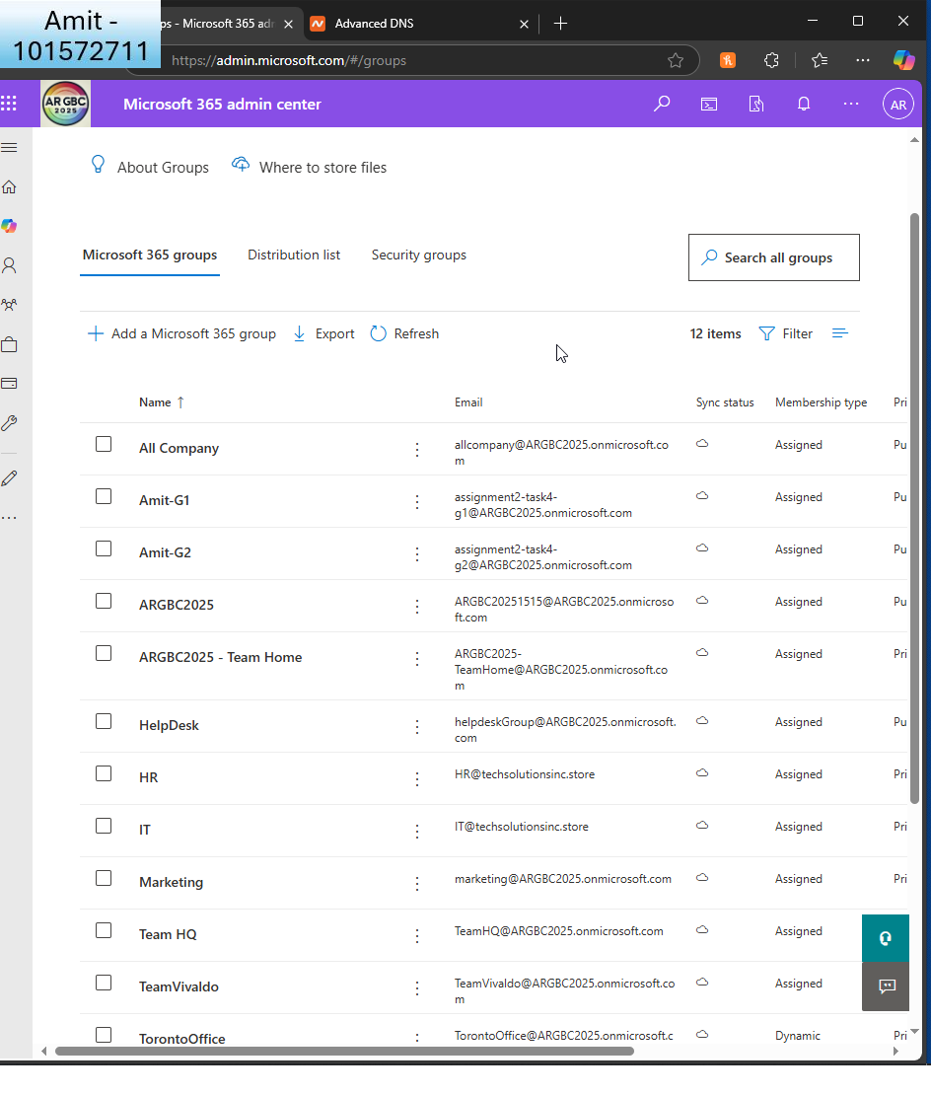  
Confirmation of groups creation

1. **Configure User Permissions**:
   * Assign specific permissions to the HR group to access sensitive HR documents in SharePoint.  
     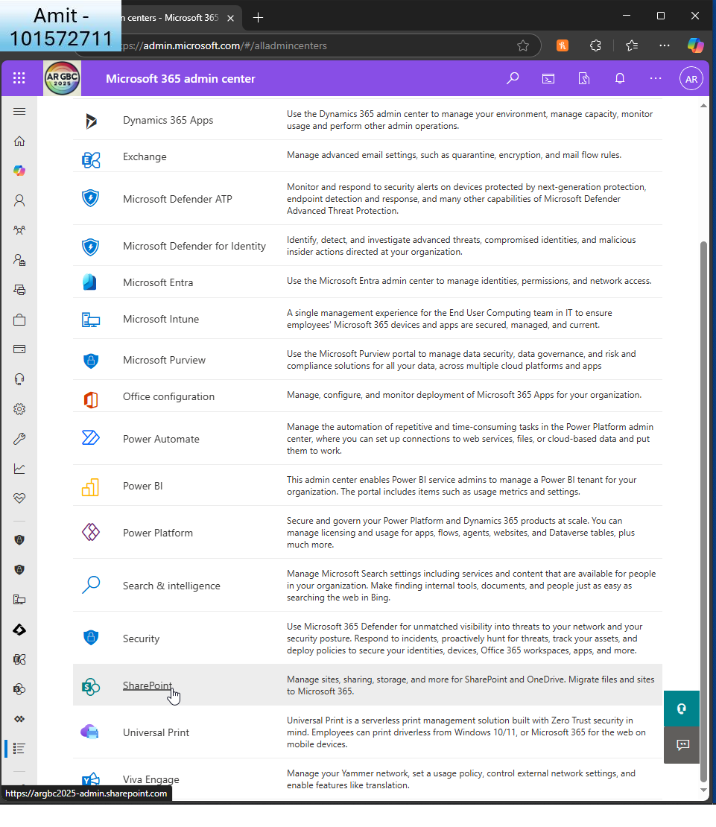

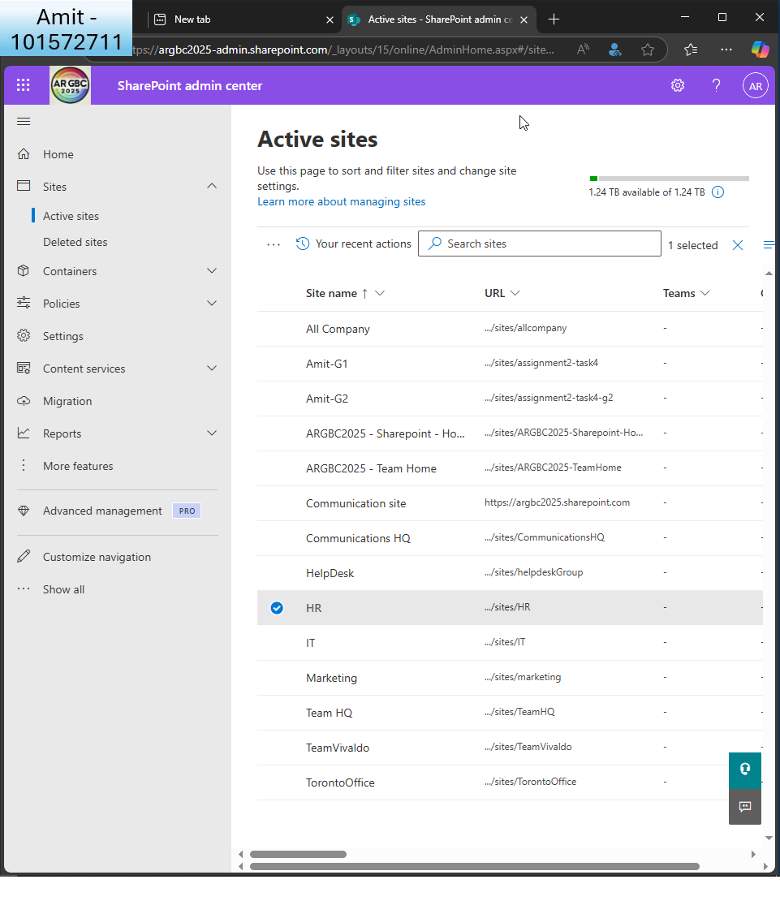  
I choose the HR sharepoint site  
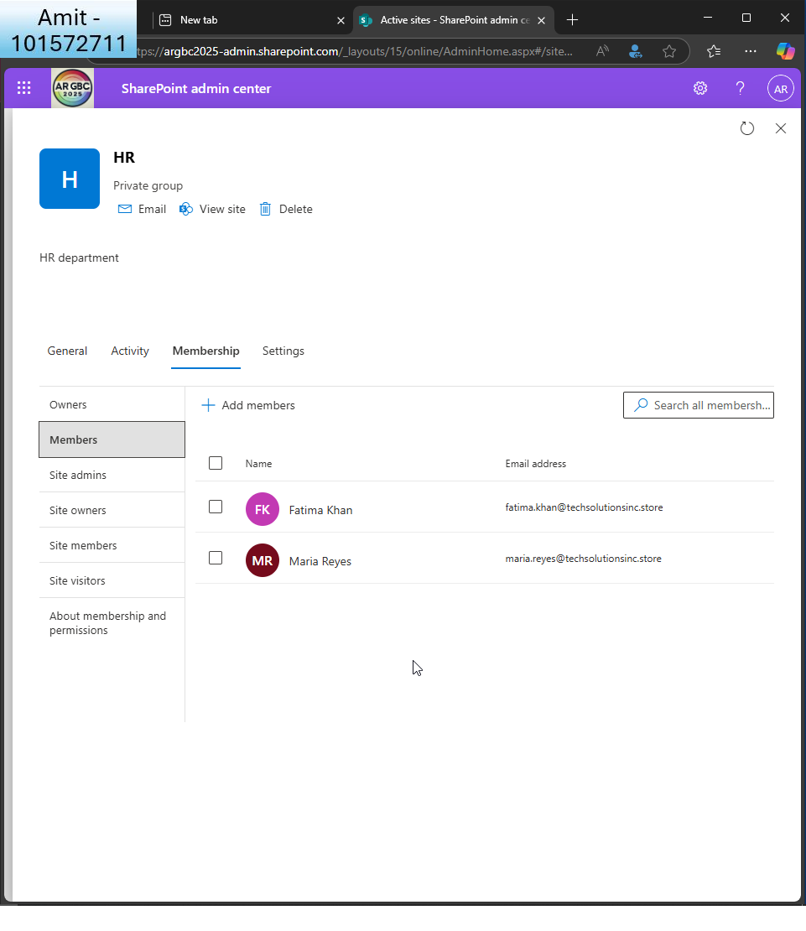  
  
I see the members of the group  
  
  
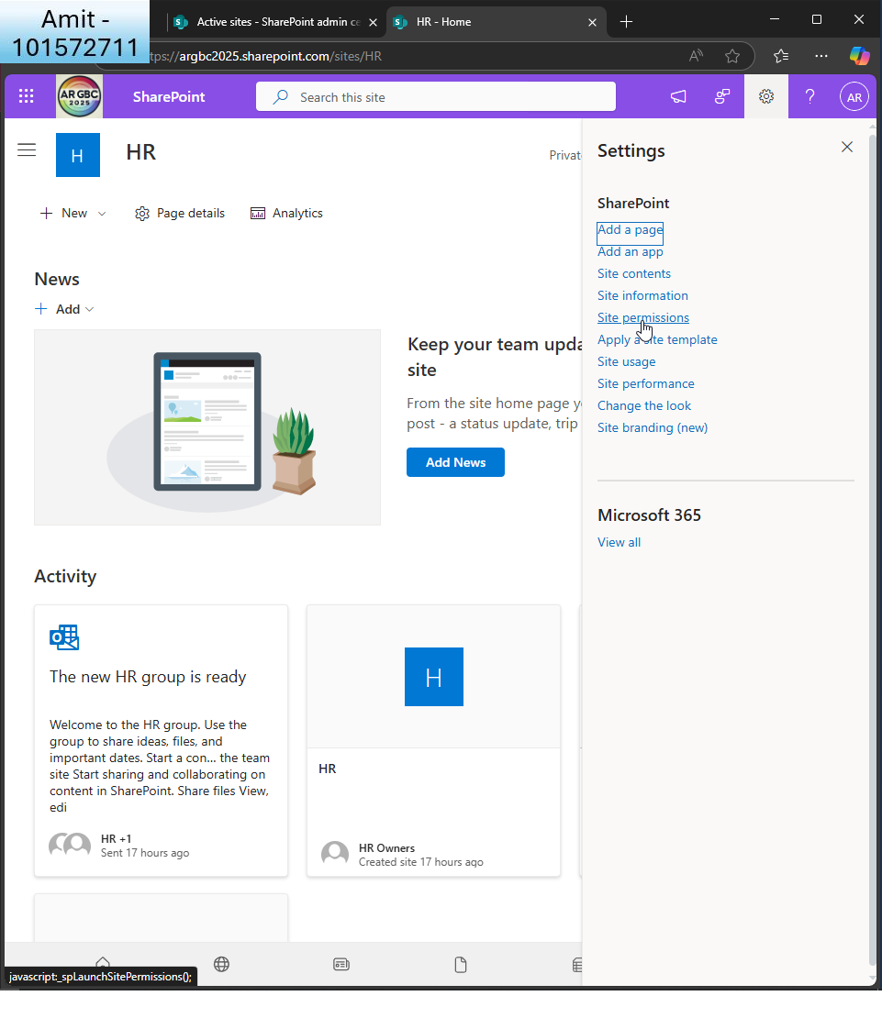  
I change site permissions  
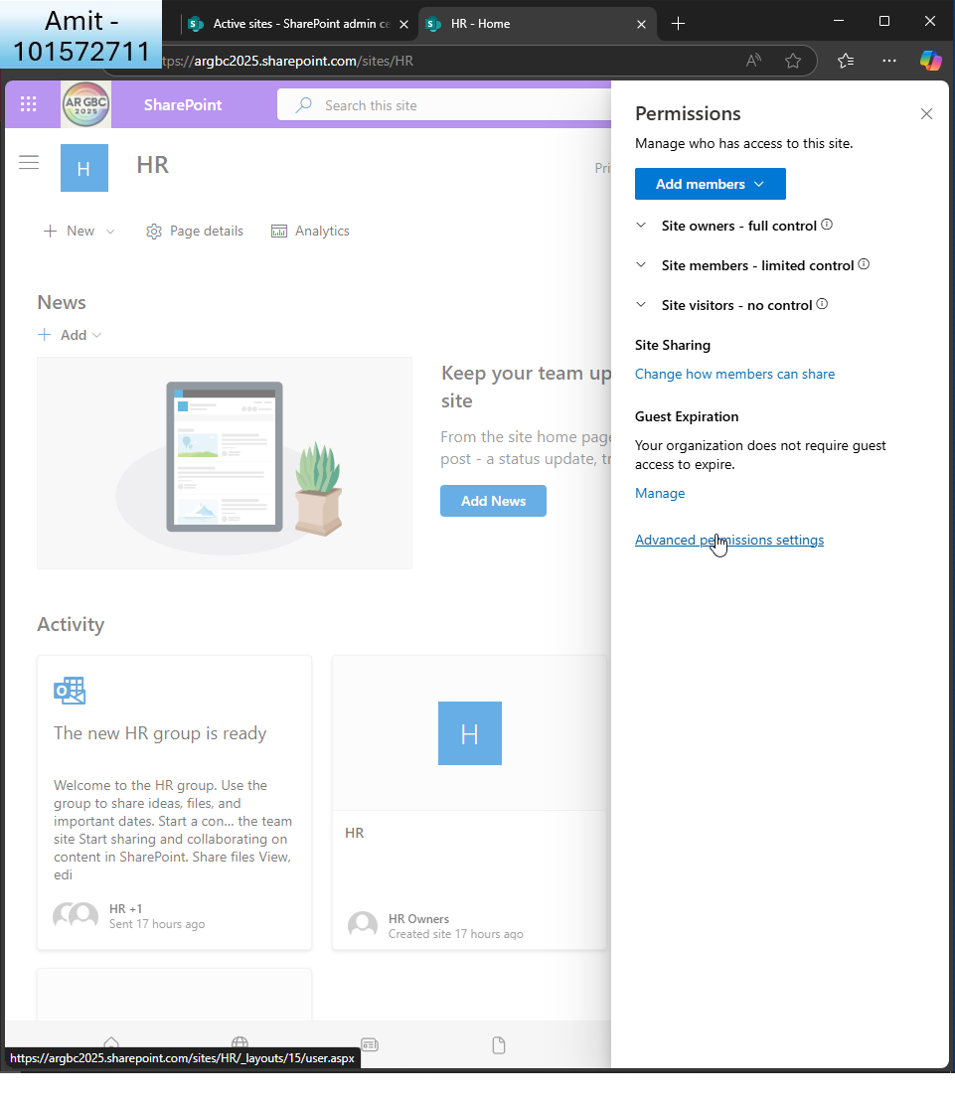  
I click ’advanced permissions settings’  
  
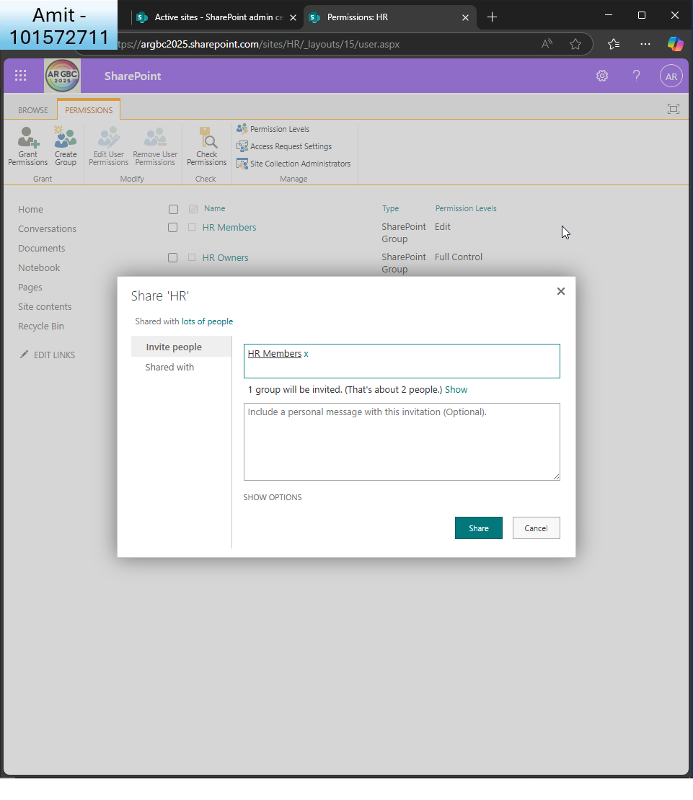  
I choose HR group   
  
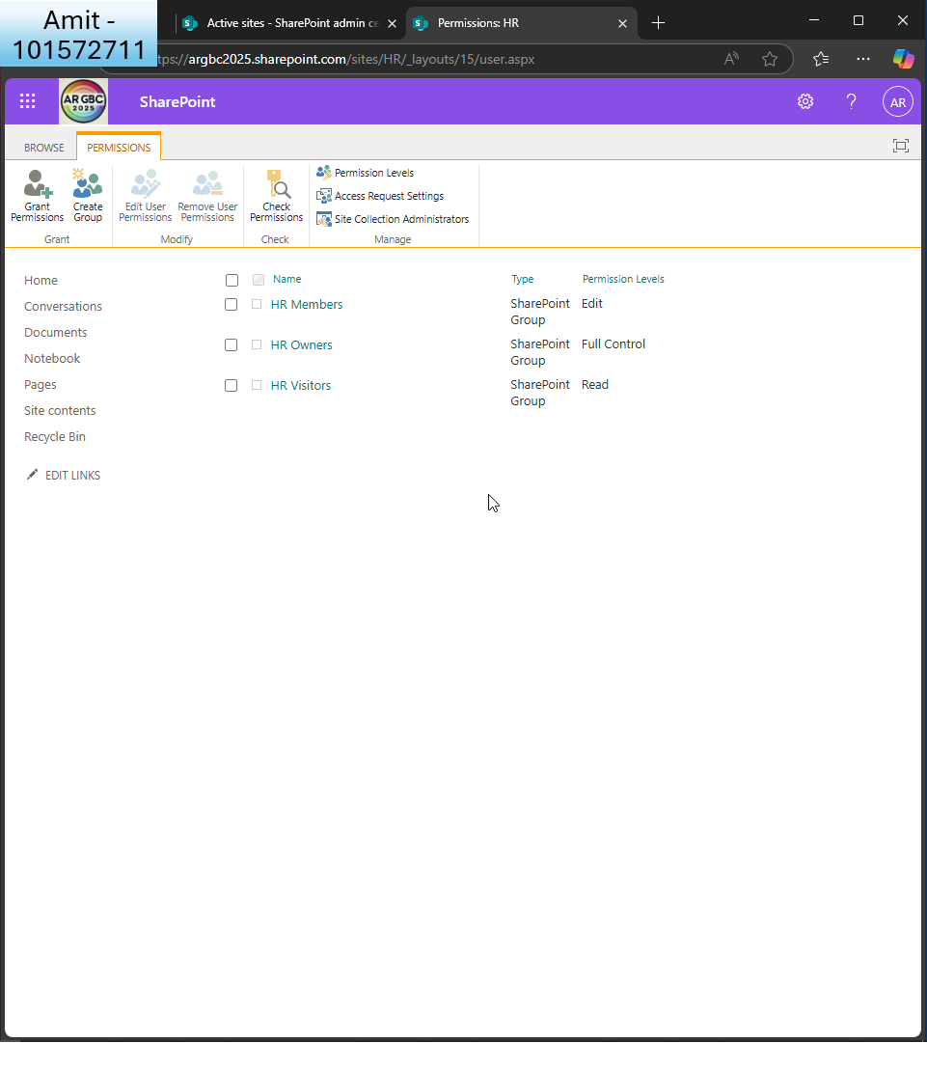  
I can see the different levels of permissions

* + Ensure the Marketing group has permission to create and manage Microsoft Teams.

Part B:

What a task! I found it a little complicated at first but once it was done, it was nice to have that feeling of accomplishment!   
  
Task 1 gave me hands-on experience with creating a Microsoft 365 environment for practical and realistic purposes. As a first step, I actually went ahead and registered a live domain techsolutionsinc.store with Namecheap and paired it with Microsoft 365. Setting up DNS records like MX, TXT, and CNAME records was an exercise, to be sure, but one that highlighted how domain control is critical to both email and identity functionality within a cloud configuration.

It was not too difficult to mass-import users (I learnt using Powershell), but configuring their profiles was a tad hard! I learnt how to personalise user fields like job titles, offices, and Departments, and I even mass-added profile pictures to all users. I wanted to give it a realistic feel so I used ChatGPT to create their photos! It entailed learning to script, debugging file paths, and manipulating authentication scopes with Microsoft Graph. It was rewarding to have an entire directory of staff at the end.

Enablement of Microsoft 365 for HR, Marketing, and IT helped to cement how role-based access and collaboration work across the Microsoft platform. Provision of controlled access to SharePoint to the HR team gave me direct experience with how permissions can be scoped finely for confidential data.

Overall, I found Microsoft 365 to be powerful but at times frustrating to navigate through the process. Certain settings were difficult to locate, occasionally the UI was not great! (particularly between new vs. legacy admin portals), and group/team relationships were not as clear as required. I wish that Microsoft would make group-level permissions more intuitive, particularly moving between Teams, SharePoint, and Entra. It feels like there’s a lack of consistency.   
  
In total, I was able to learn how to provision a professional Microsoft 365 estate from scratch, and the exercise did help me increase my confidence with regards to working with live tenants.

**Task 2: Implementing Security Measures**

1. **Set Up and Configure Microsoft Defender for Office 365**:  
     
   Part A:
   * Access the MS Defender and navigate to Secure Score.  
       
     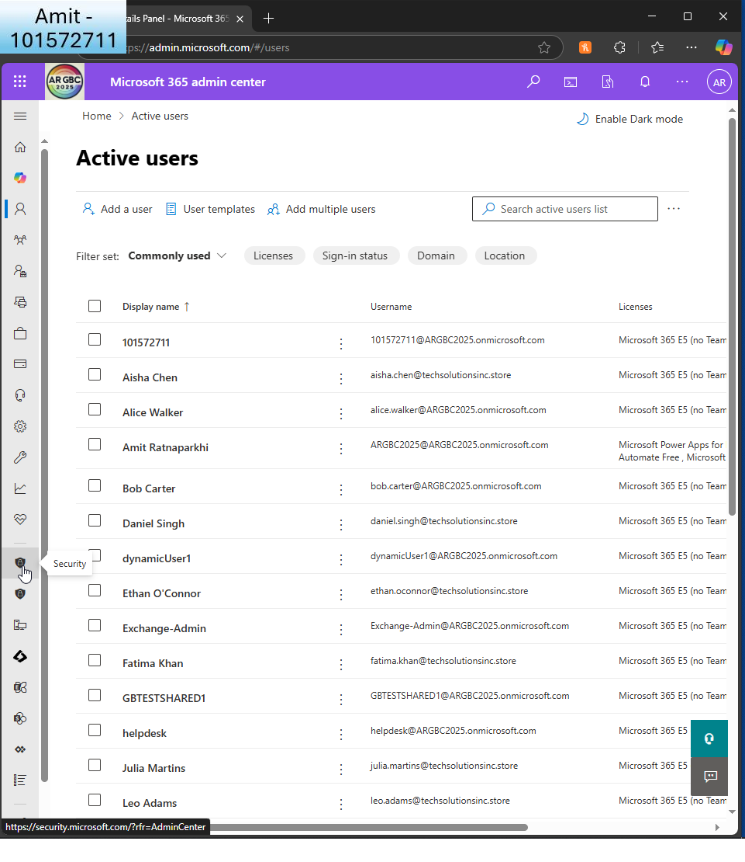  
       
     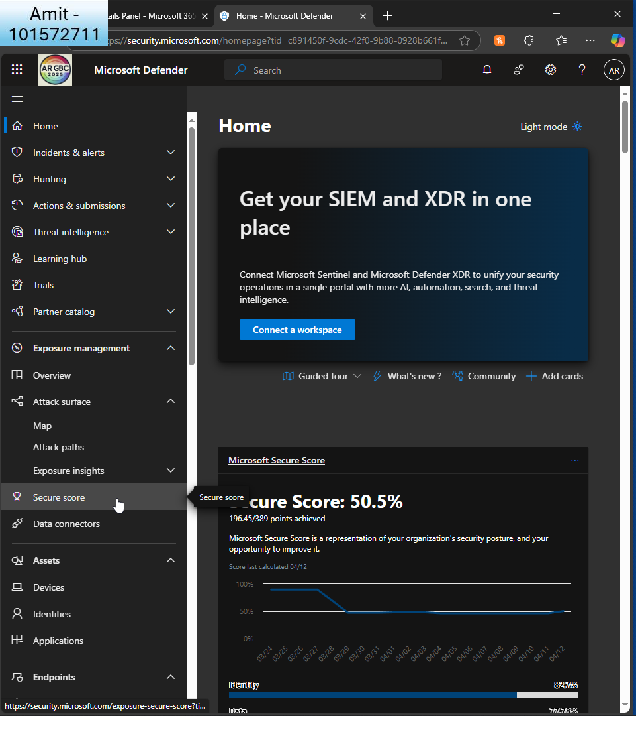  
       
     Here I can see my score of 50.5%  
       
     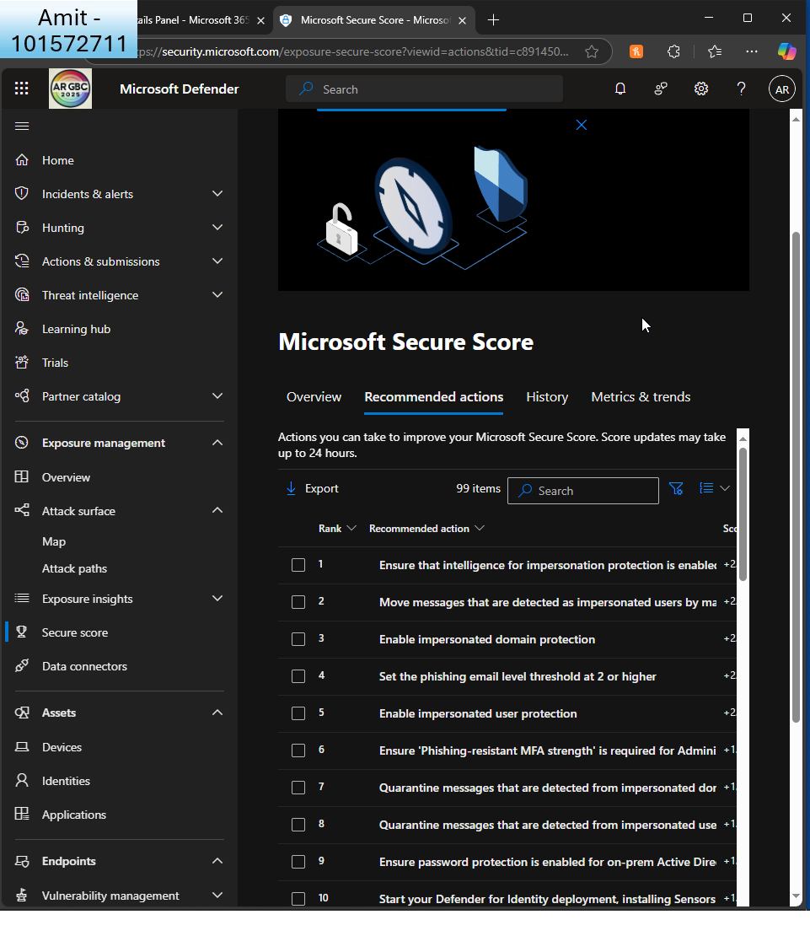  
       
     Here I see a list of recommendations
   * Ensure that Safe Links and Safe Attachments have been enabled for all users.  
       
     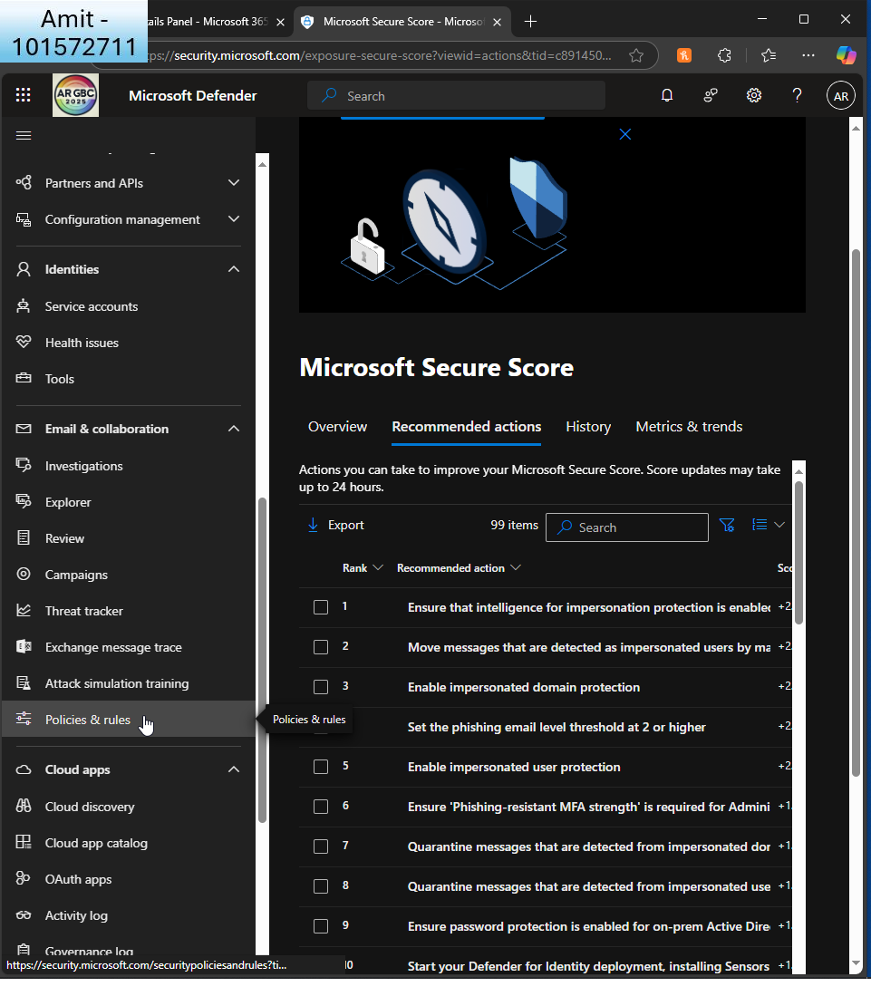  
     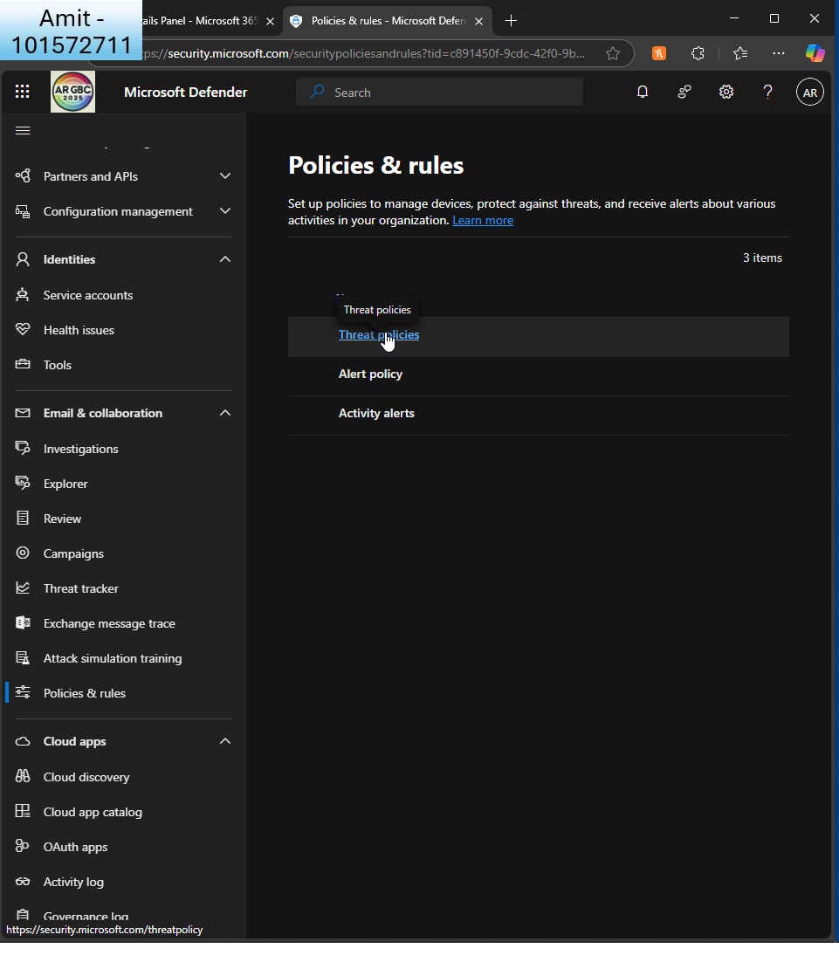  
       
     I check the current threat policies  
       
     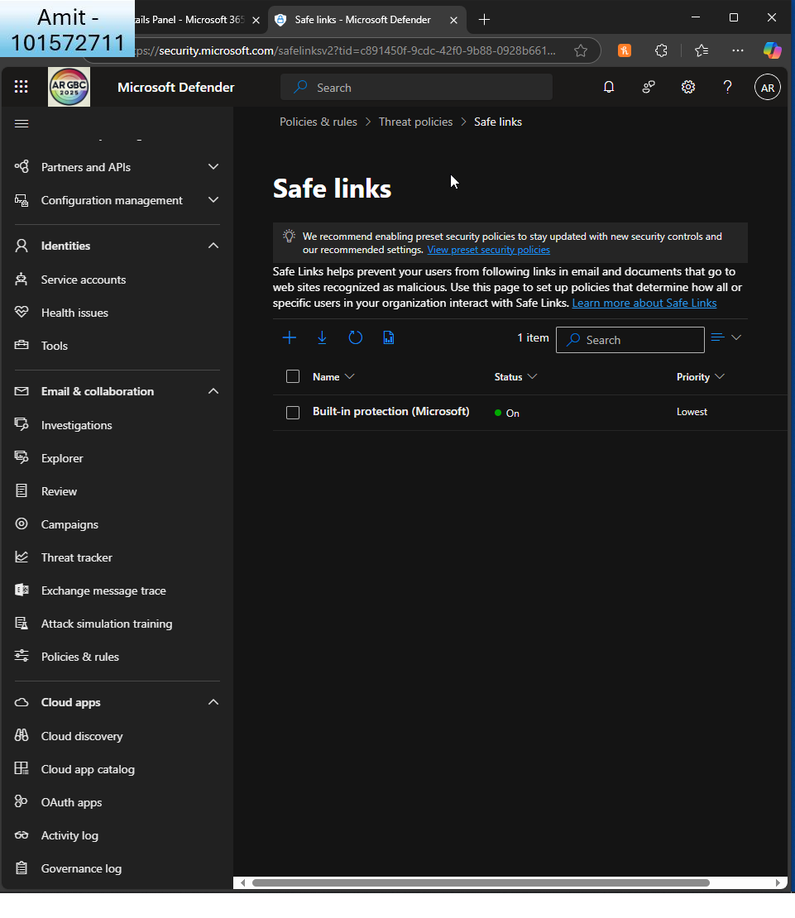  
       
     I can see safe links is already enabled  
       
     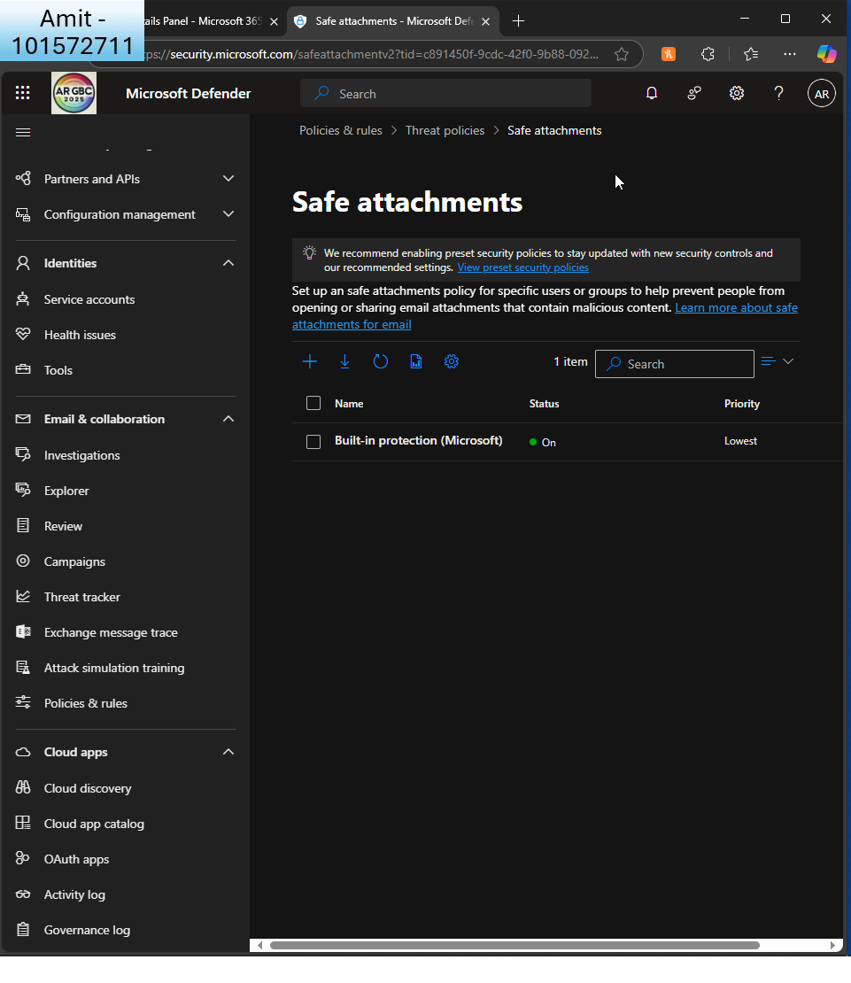

As is safe attachments

* + Navigate to Policies and rules, then configure at least one policy to protect against phishing, malware, or spam.  
      
    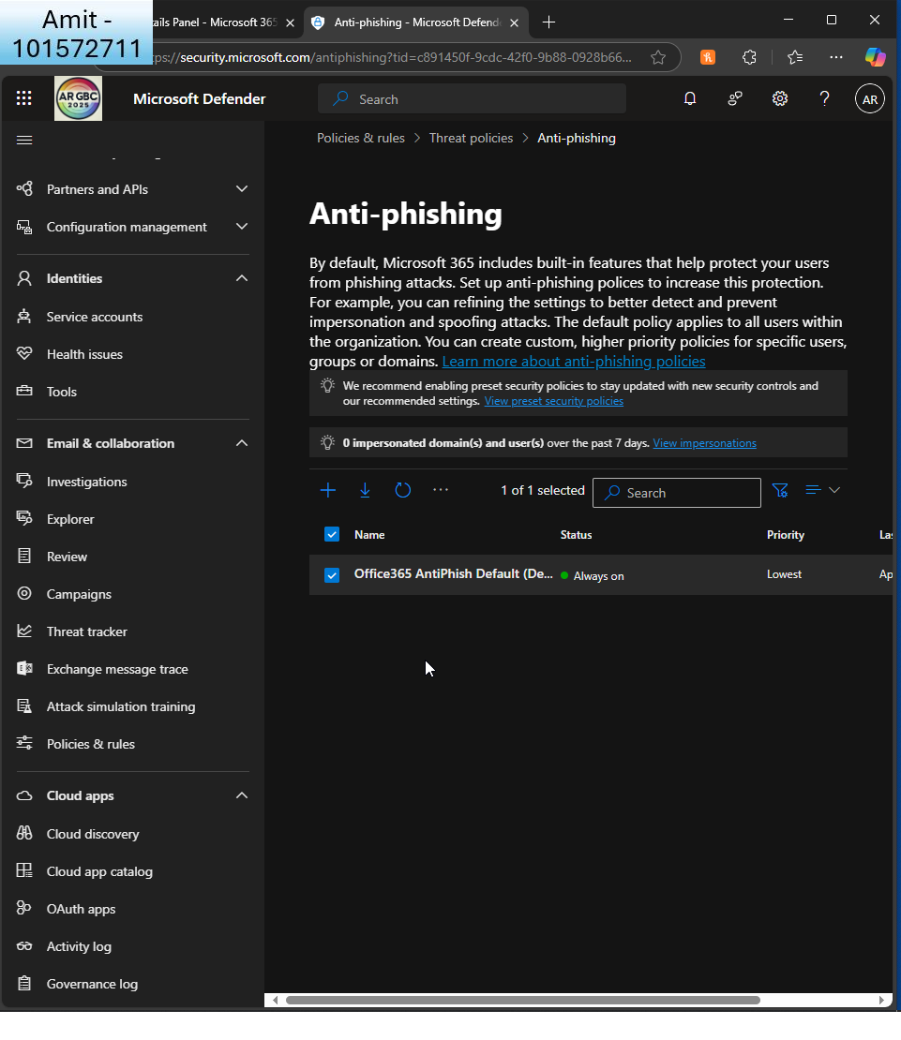

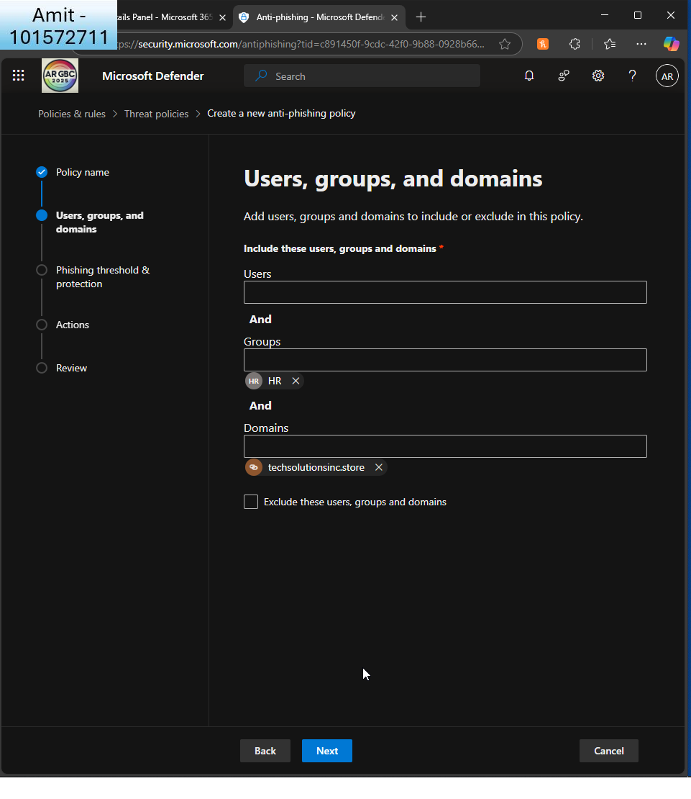  
I create a new anti-phishing policy to apply to my HR group on techsolutions domain  
  
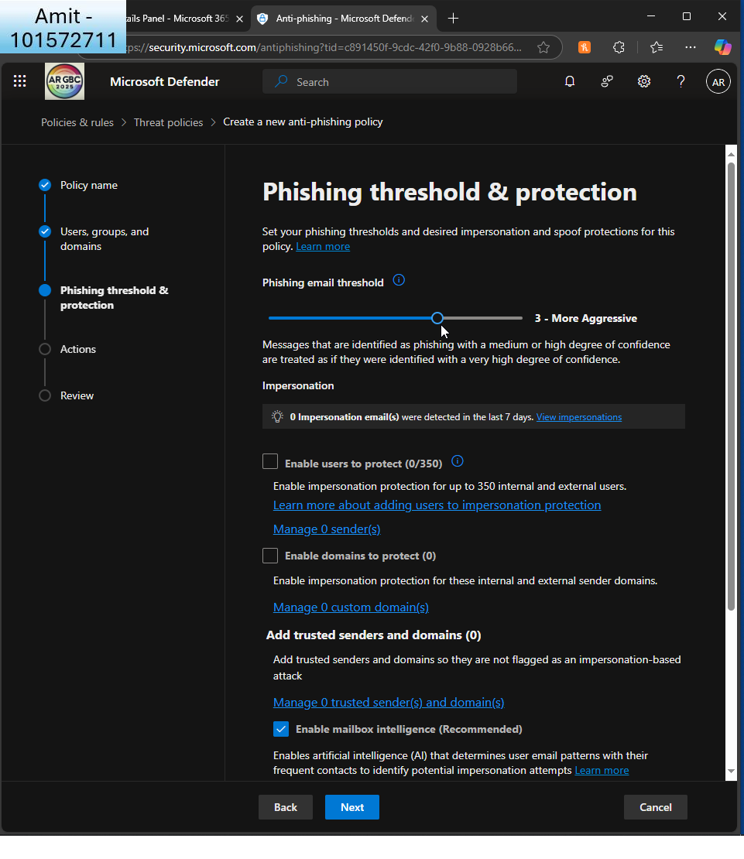  
I choose a more aggressive threshold  
  
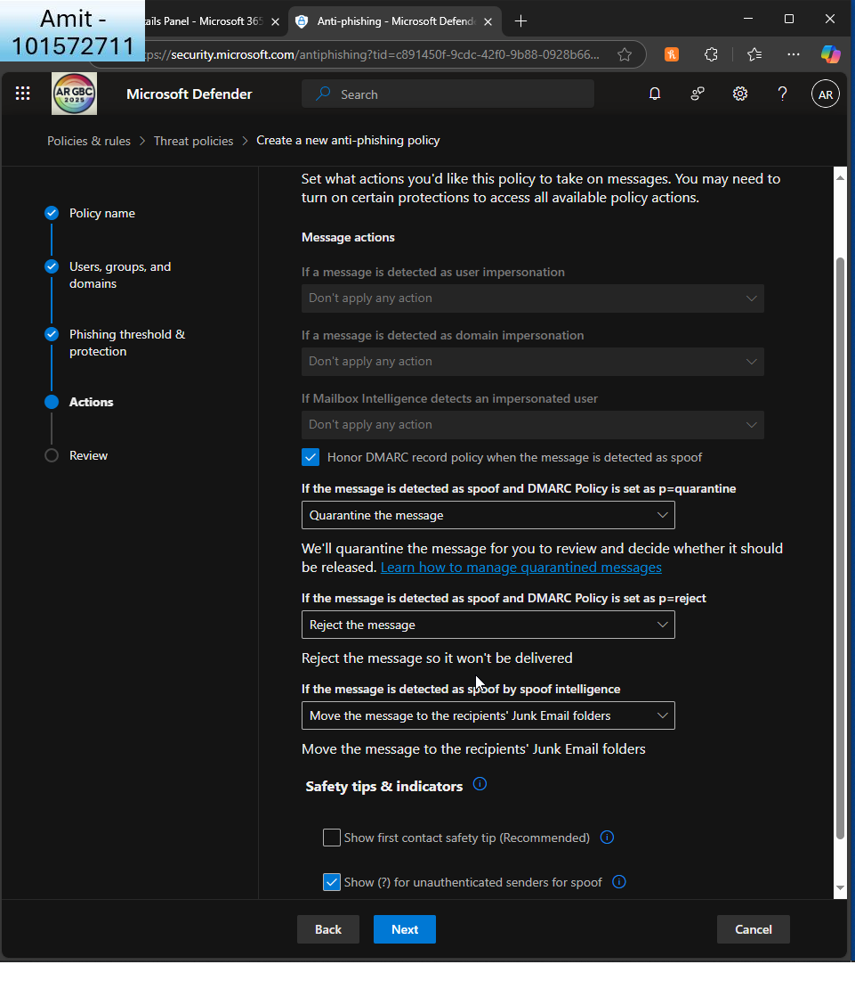I keep default settings  
  
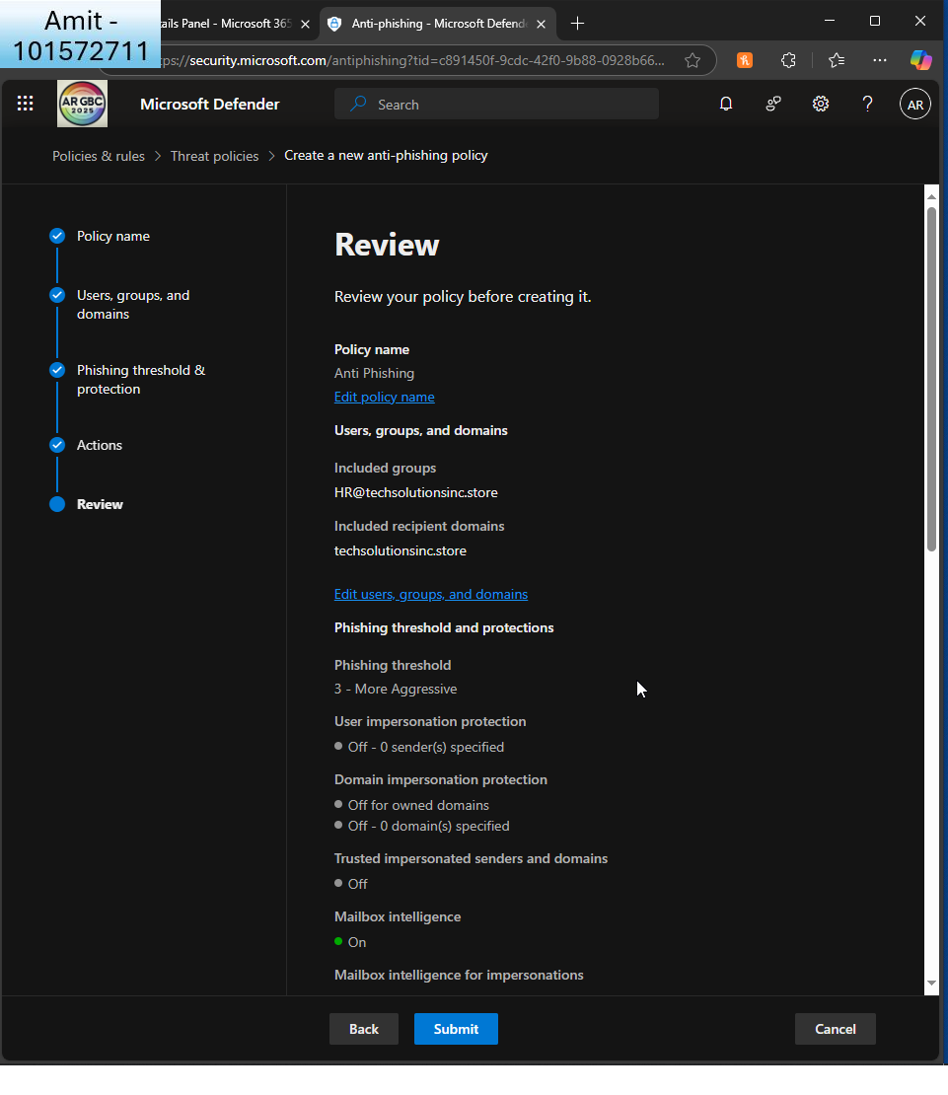  
I review the policy

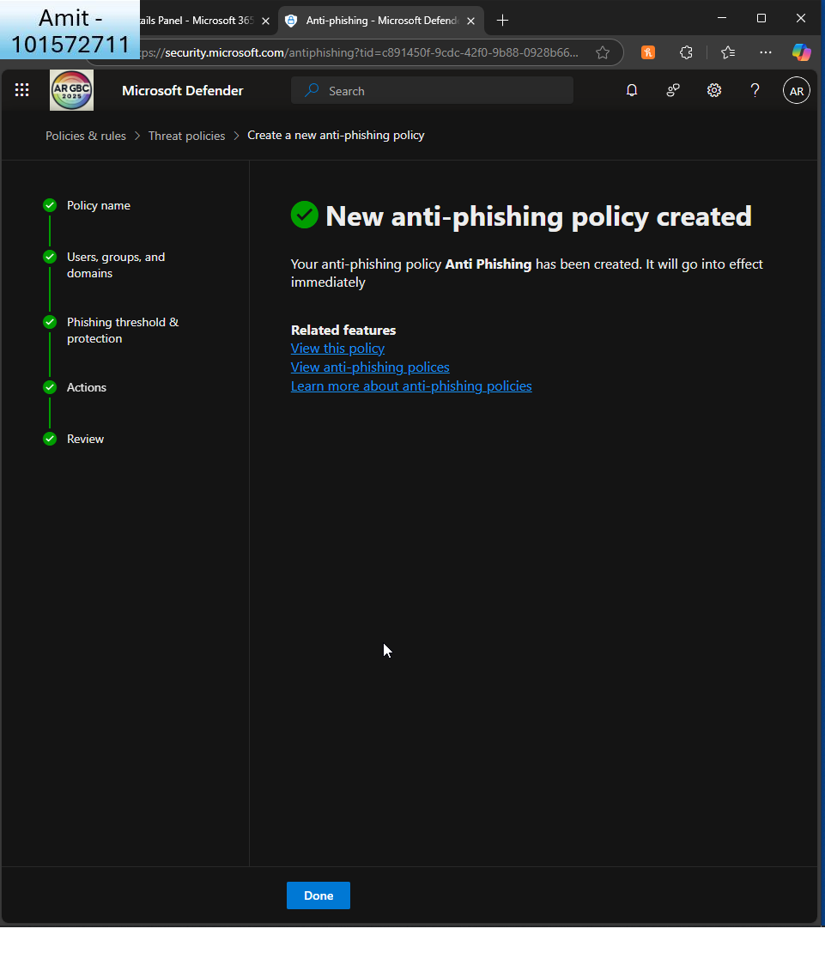I see the confirmation

1. **Set Up Data Encryption**:  
     
   Part A:
   * Configure Microsoft 365 Message Encryption.
   * Ensure that emails from inside the organization are automatically encrypted. (Hints: Navigate to Exchange admin center, and then Rules)  
       
       
     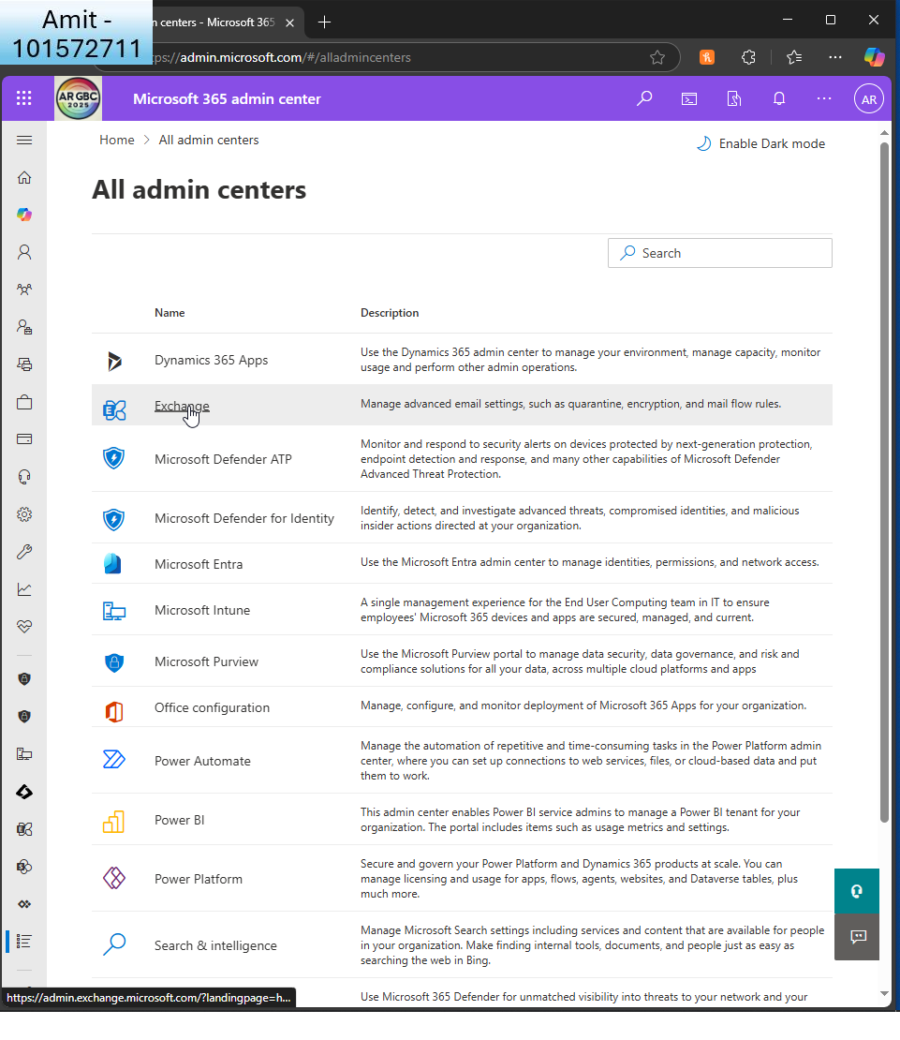  
     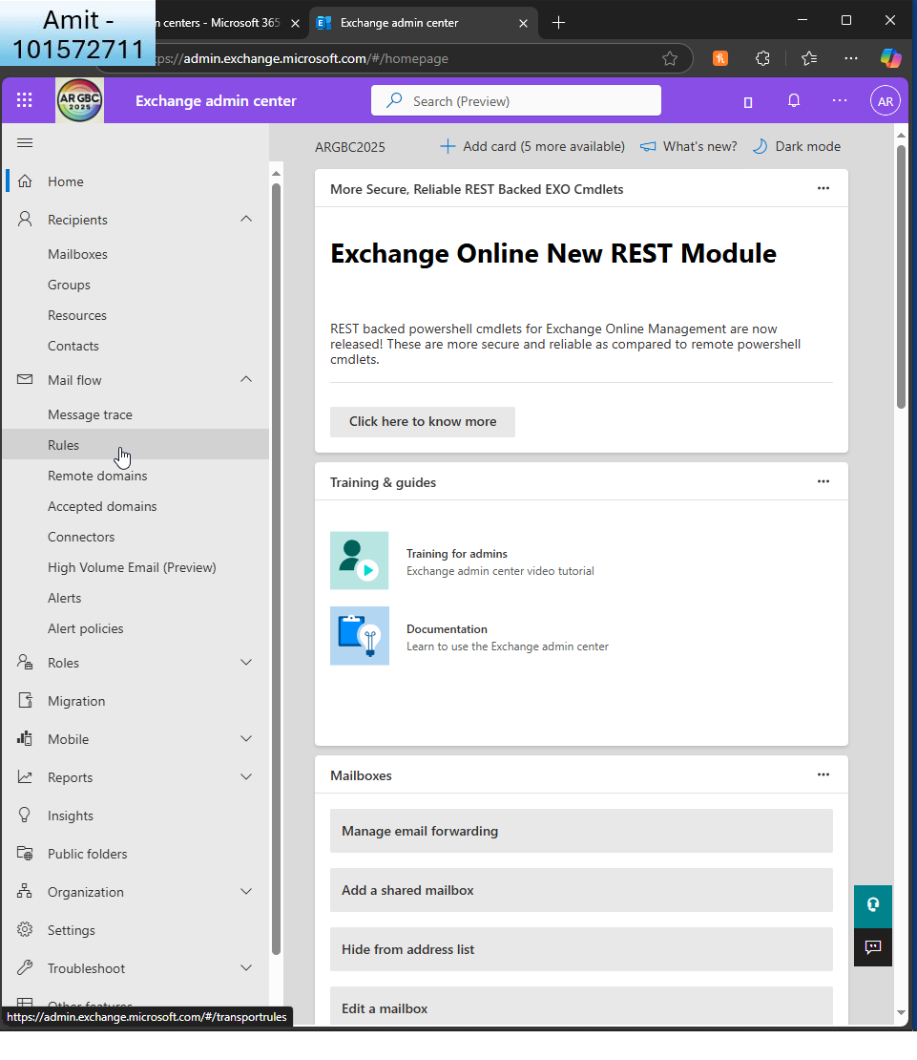  
       
     I click ’rules’ in Exchange admin centre  
       
     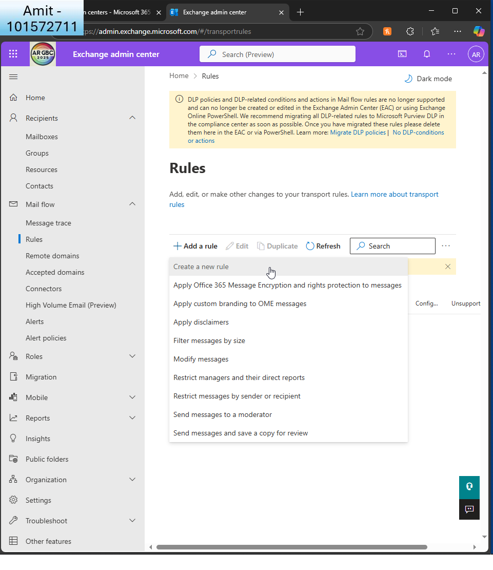  
       
     I create a new rule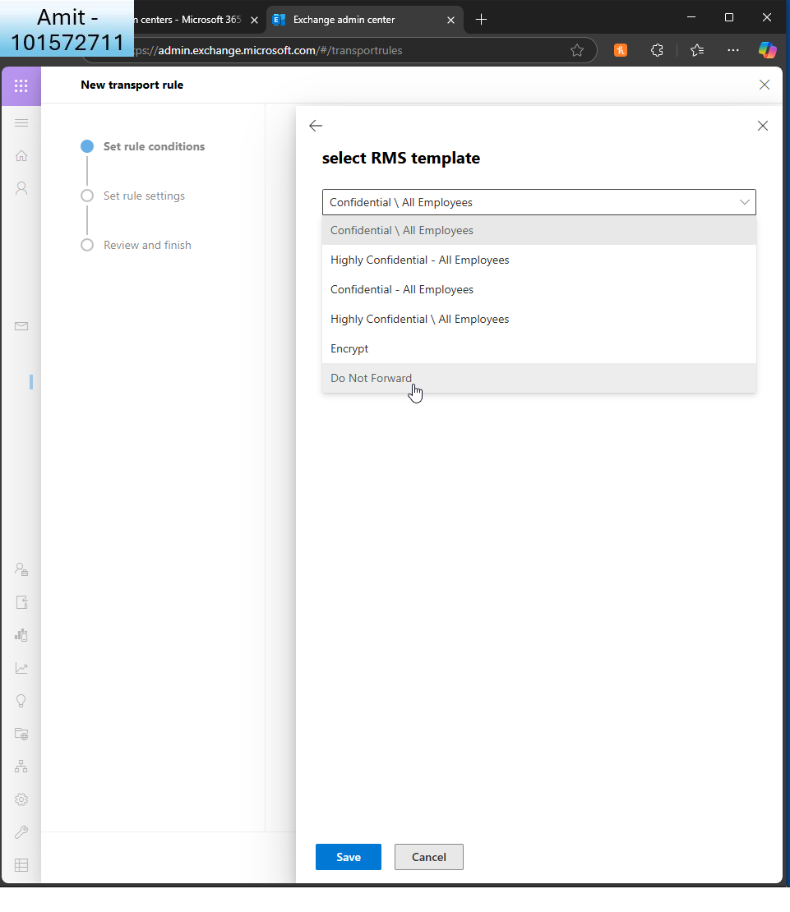  
     I set it so it doesn’t forward (then changed it to ’encrypt’ as per assignment rules - below)  
       
       
       
       
     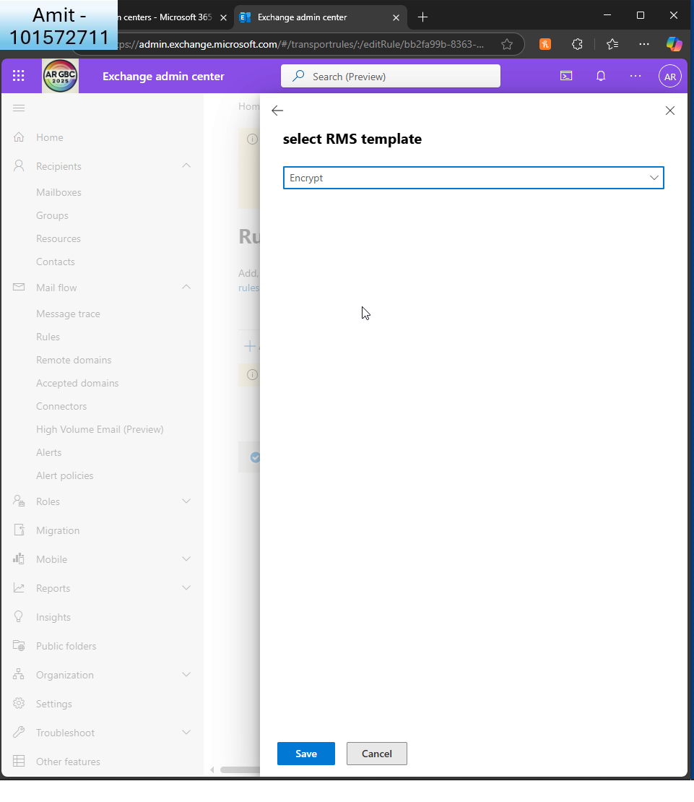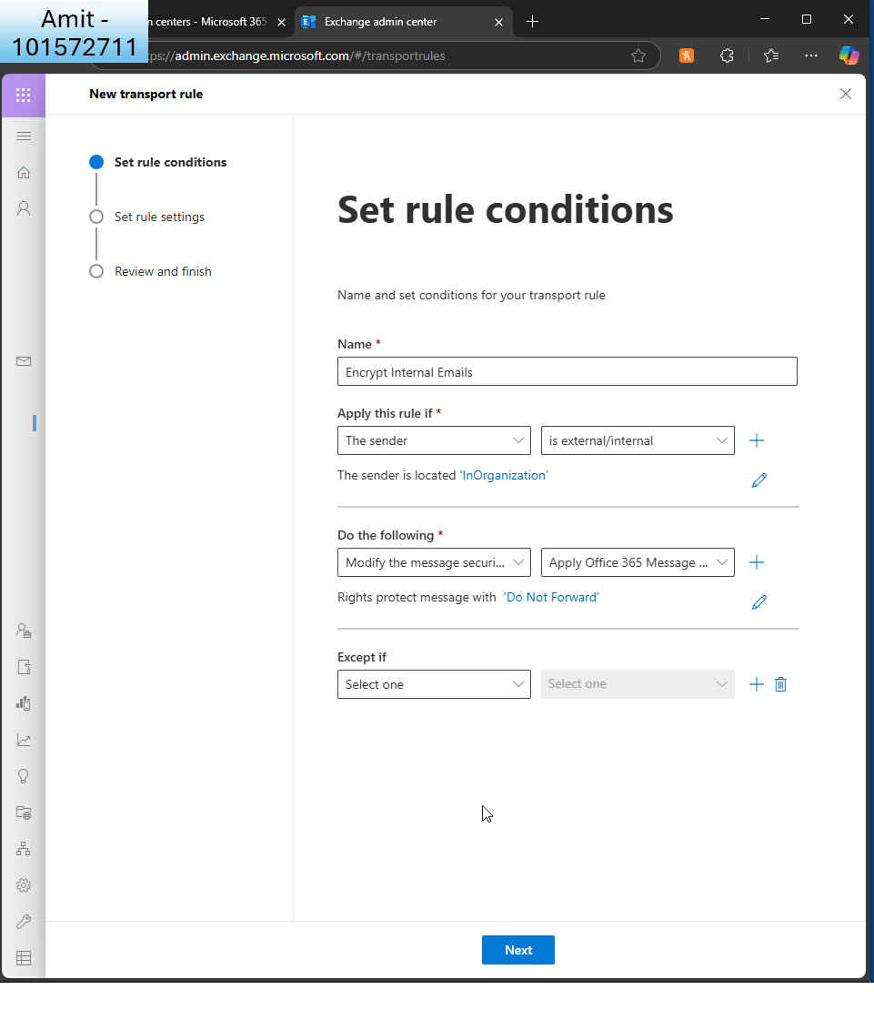  
       
     I set the conditions so if the sender is inside the organisation  
       
     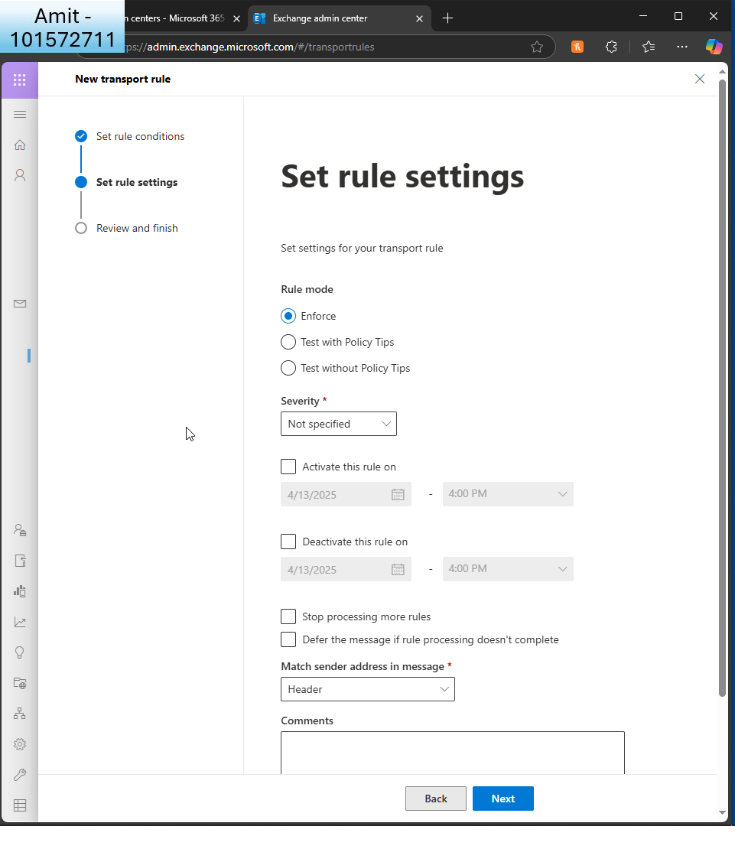  
       
     I enforce the policy  
       
     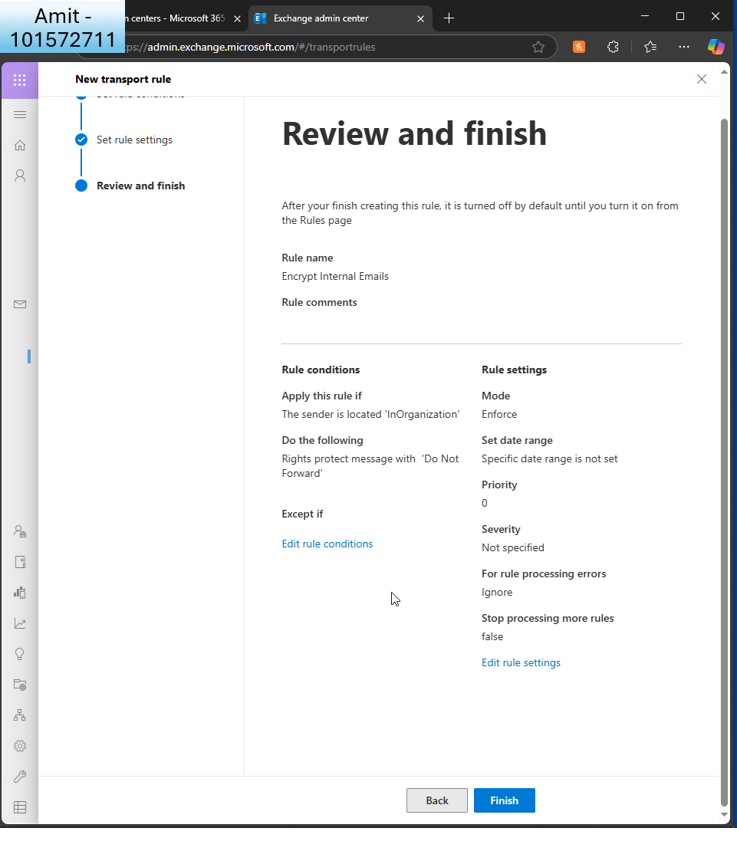  
       
     I review and finish  
       
     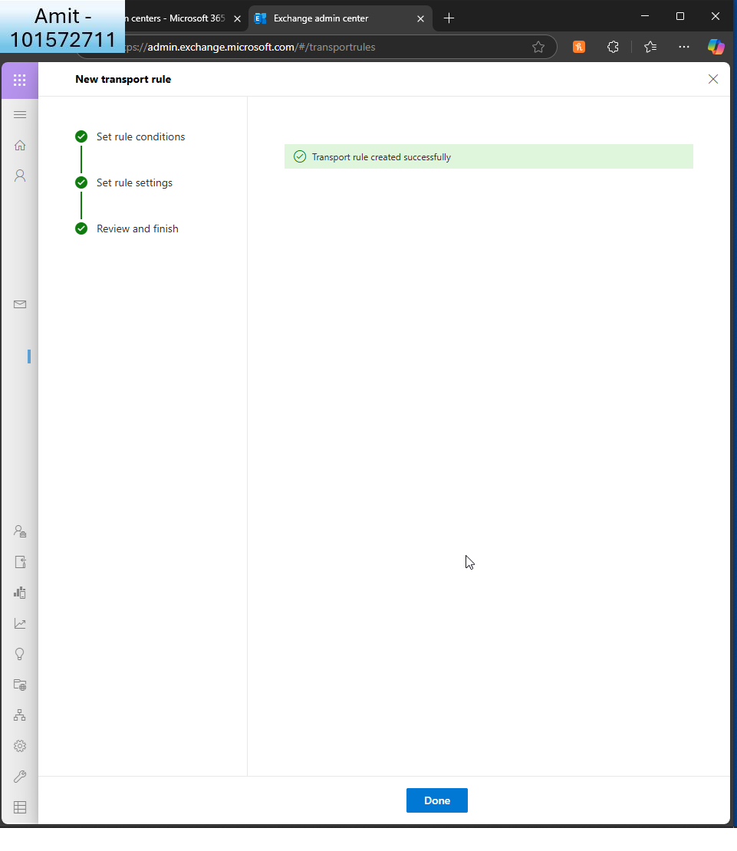  
       
     I see the confirmation  
       
     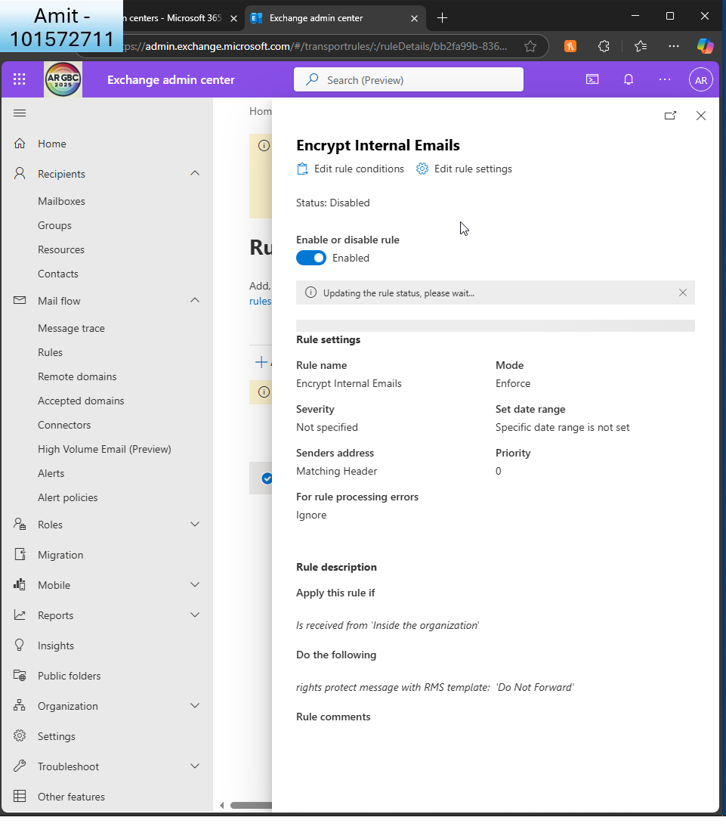  
       
     I enable the rule  
       
       
     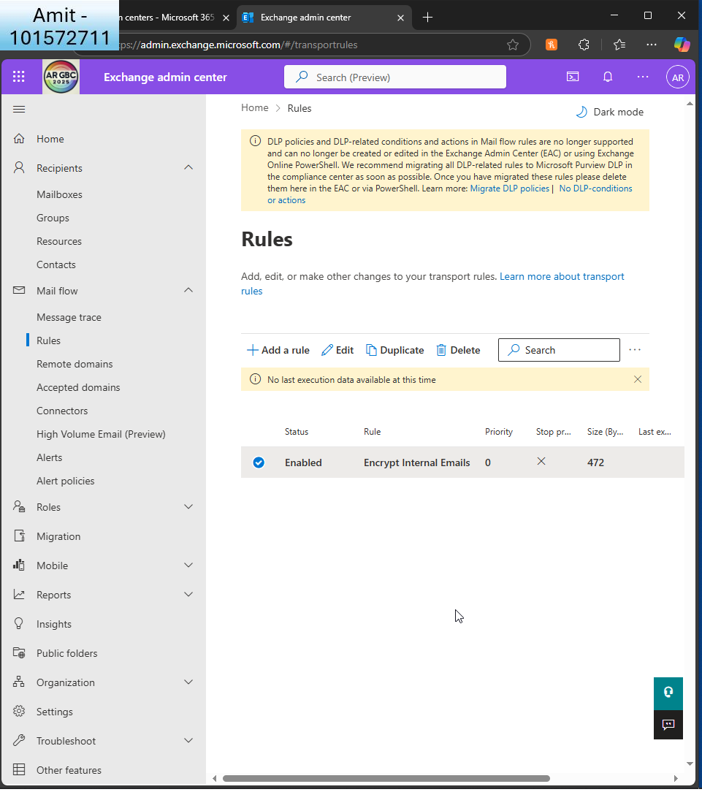  
       
     I see the confirmation it’s enabled.  
       
     Part B:

Task 2 involved enabling security features, and it was so cool to see how secure Microsoft 365 is! I started with Microsoft Defender and proceeded to enable Safe Links and Safe Attachments for all. I realised that a single malicious link or attachment could put the entire company at risk! This proves how important this part is.

Microsoft 365 Message Encryption was a nice first step. I created a rule to encrypt automatically all messages that went to others within the company, ensuring private messages remain secure without requiring users to do anything. It was nice to realise that changing rules a few times could provide good security for an entire company.  
  
I liked the explanation that MS365 gives when it comes to creating policies in terms of how aggressive the policy needs to be. It’s on a sliding scale, which is nice and user friendly.

There were a few issues with the exercise. The user interface is difficult to comprehend since the same settings are used for other admin user interfaces as well. It can be improved to make it easier for administrators to understand. I also noticed that when you create a rule, you have to manually enable it, it’s not enabled by default.  
  
Nevertheless, through this exercise, I got to see how large corporations make and maintain security rules. I got to see how critical it is to safeguard communication and how wonderful it is to realise that one administrator could do this. The power!

**Task 3: Configuring and Managing Collaboration Tools**

1. **Set Up SharePoint Online**:

Create an online SharePoint site for each department (IT, HR, Marketing).  
  
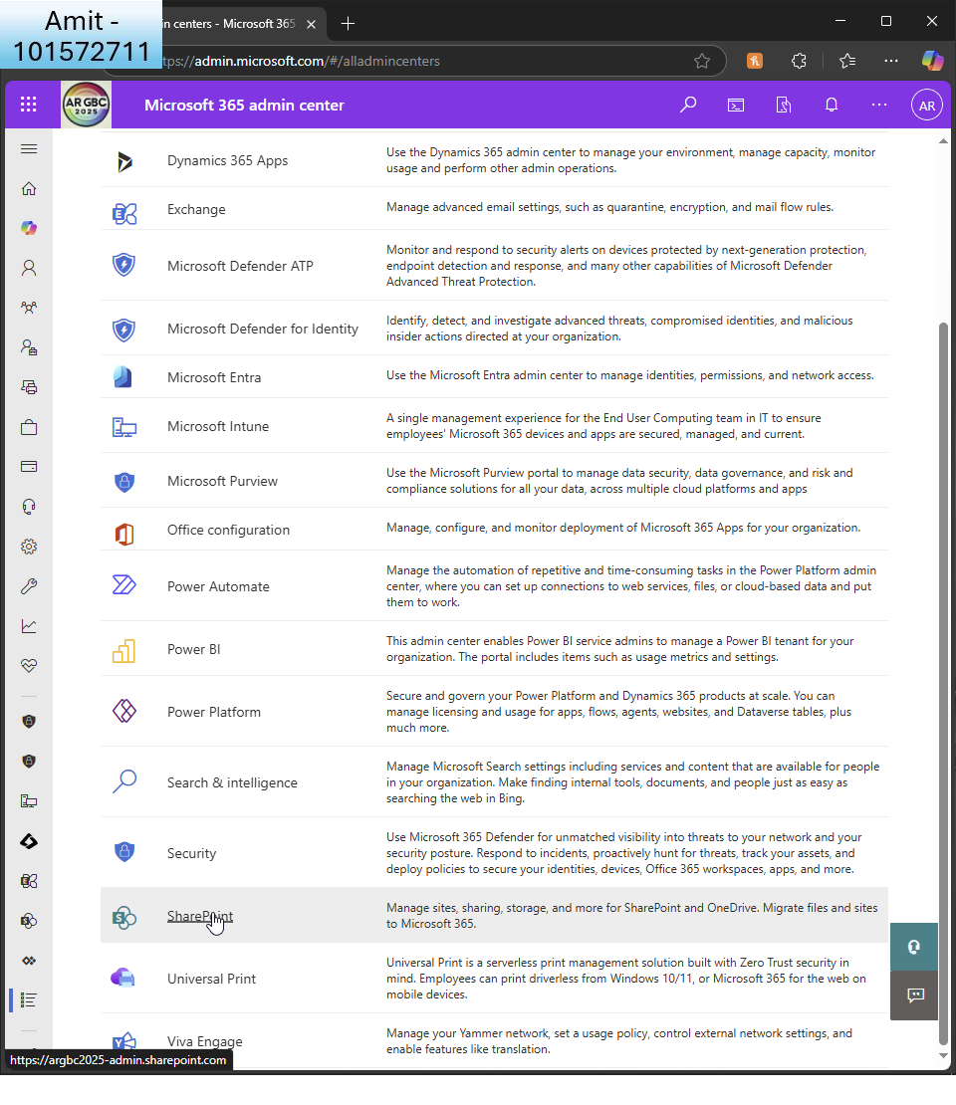  
  
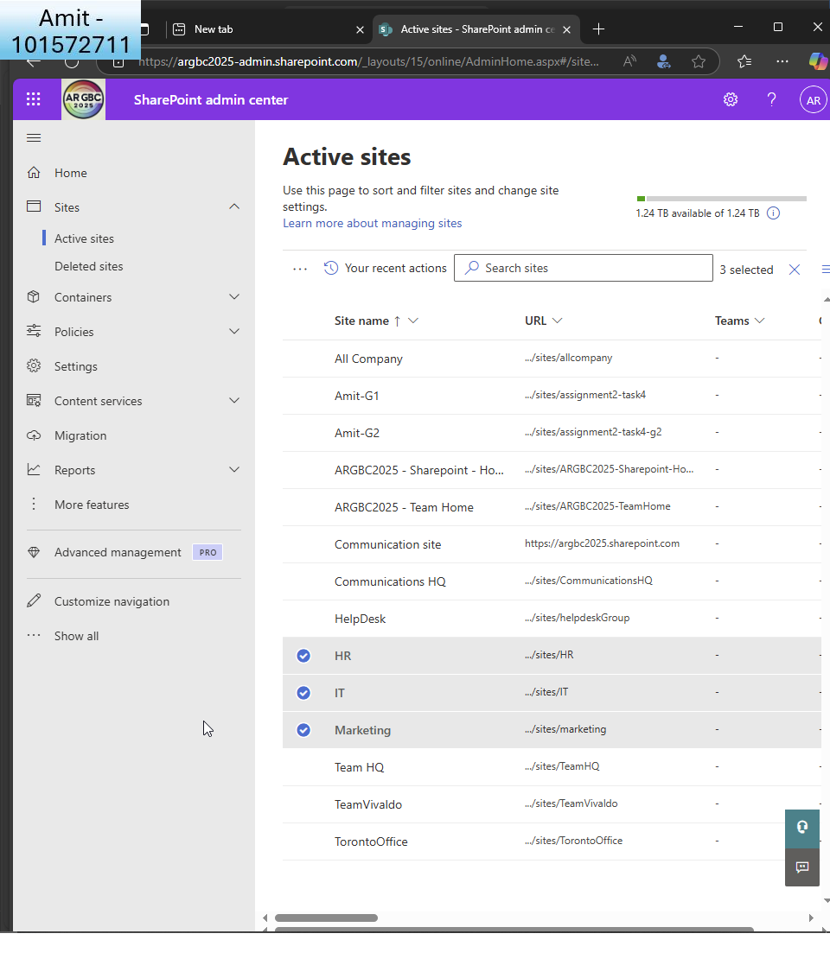  
  
I create 3 sites in sharepoint to reflect the 3 different departments (HR, IT, Marketing)  
  
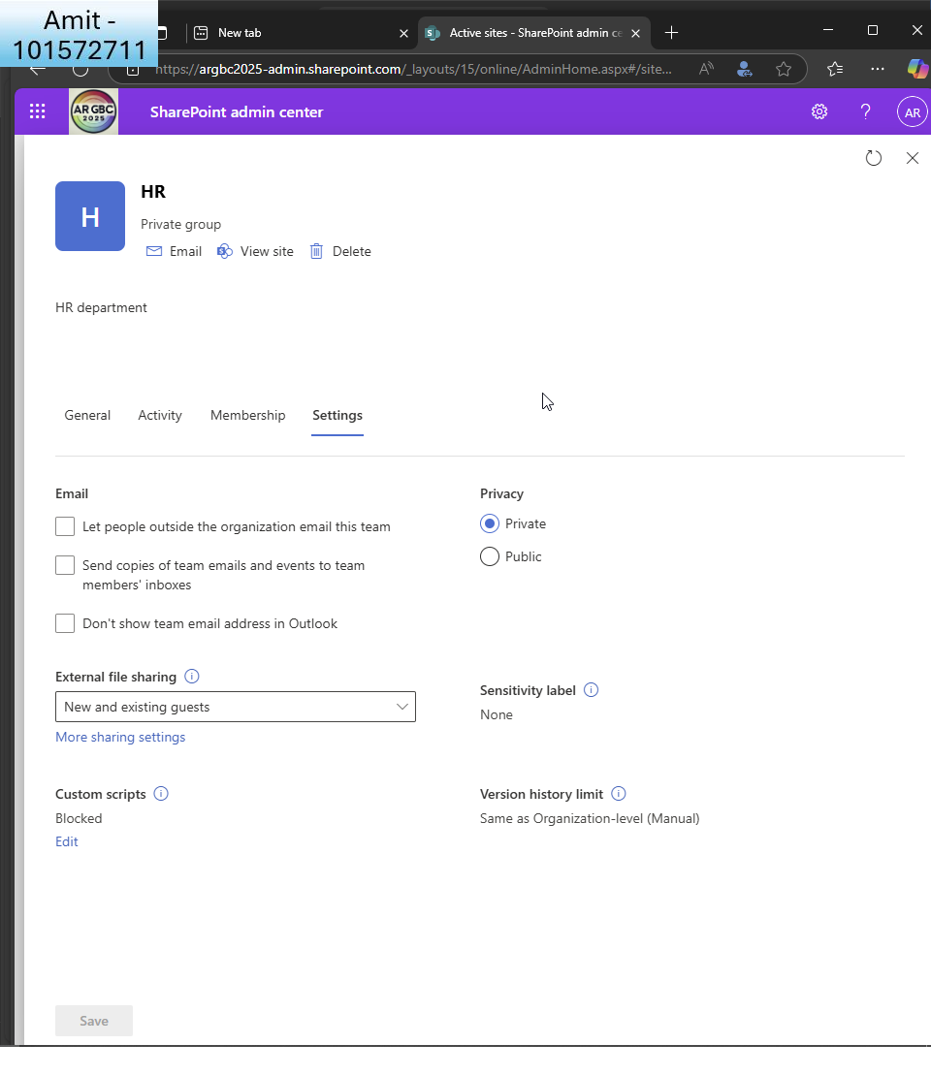  
  
HR site

* + Configure document libraries and permissions for each site.  
      
    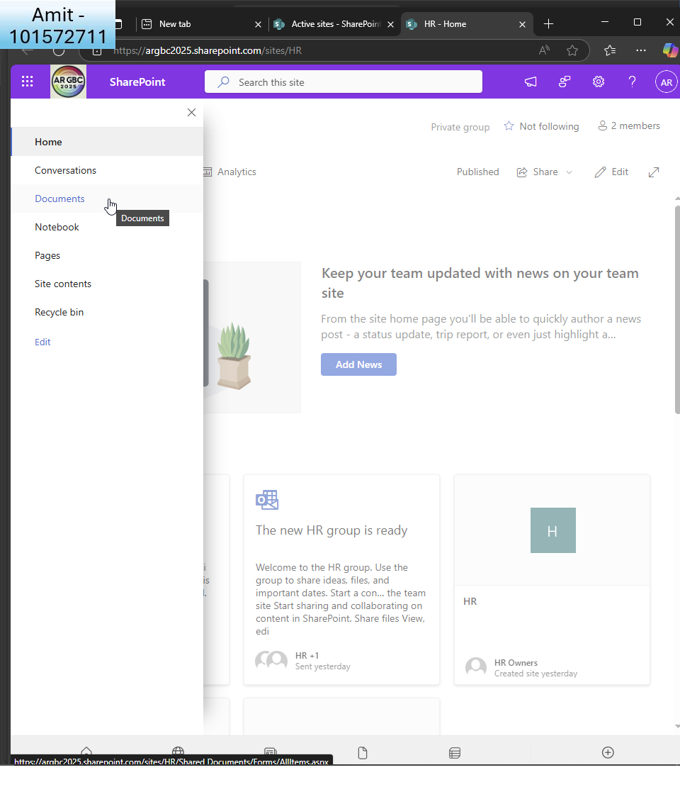  
      
    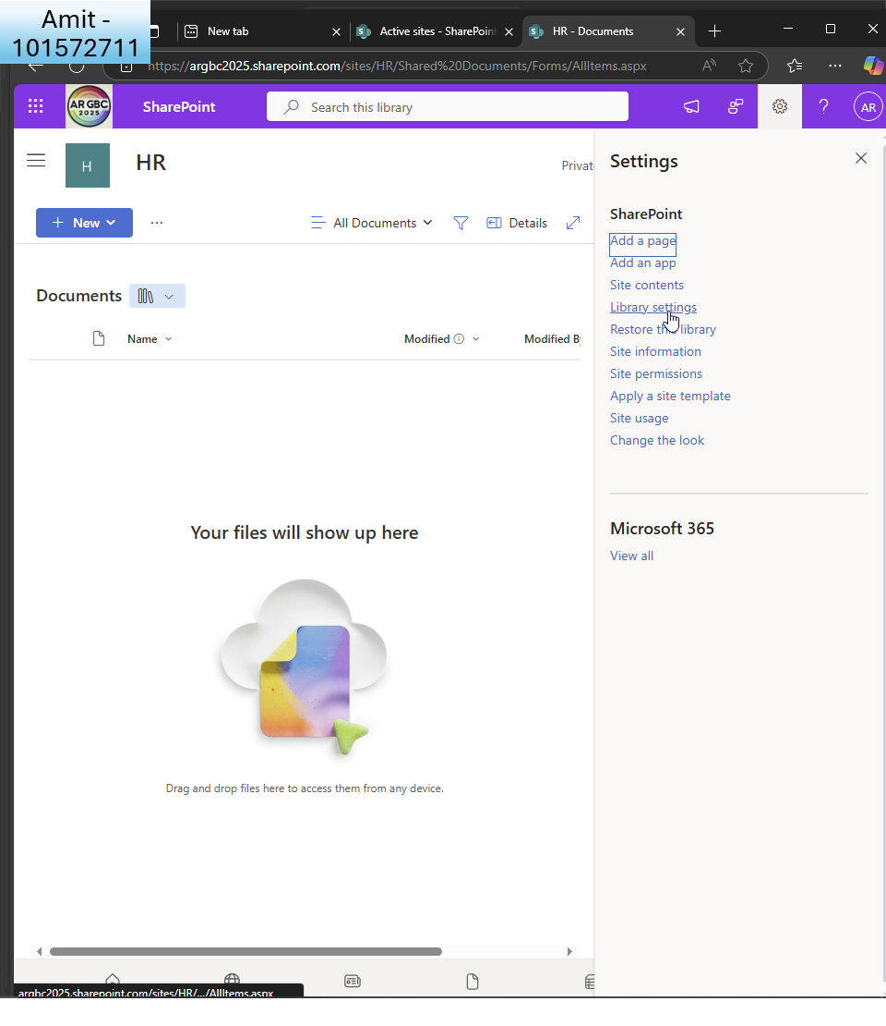  
      
    I click library settings within documents of the sharepoint site  
      
    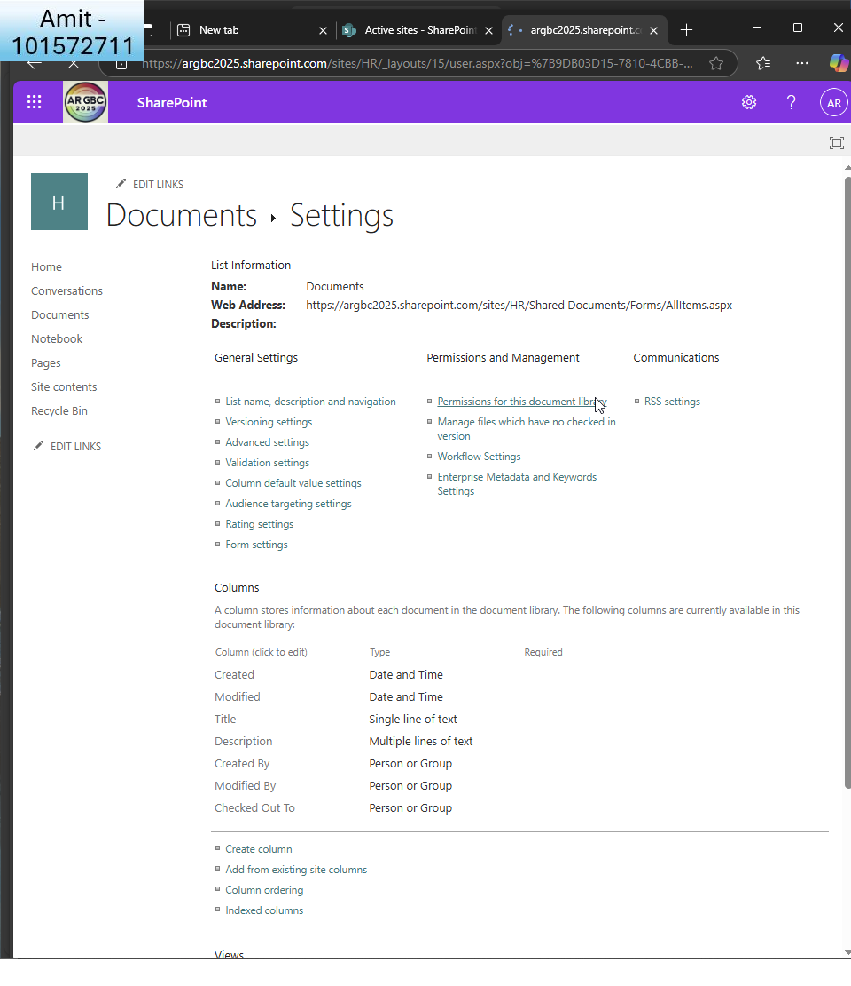  
      
    I click the permissions to edit them  
      
    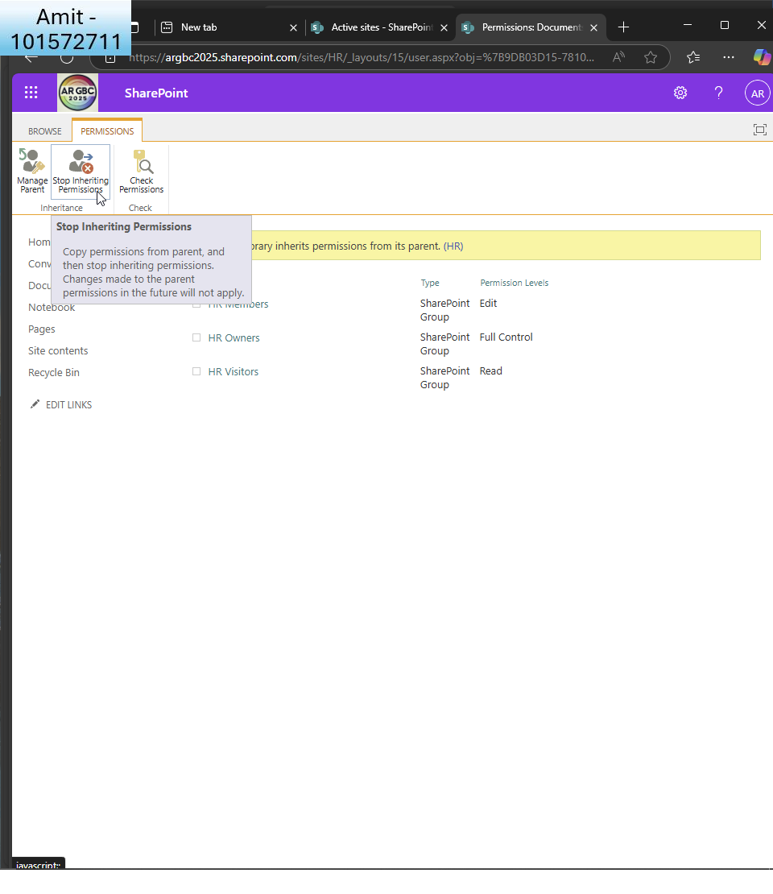  
      
    I click to step inheriting permissions  
      
      
    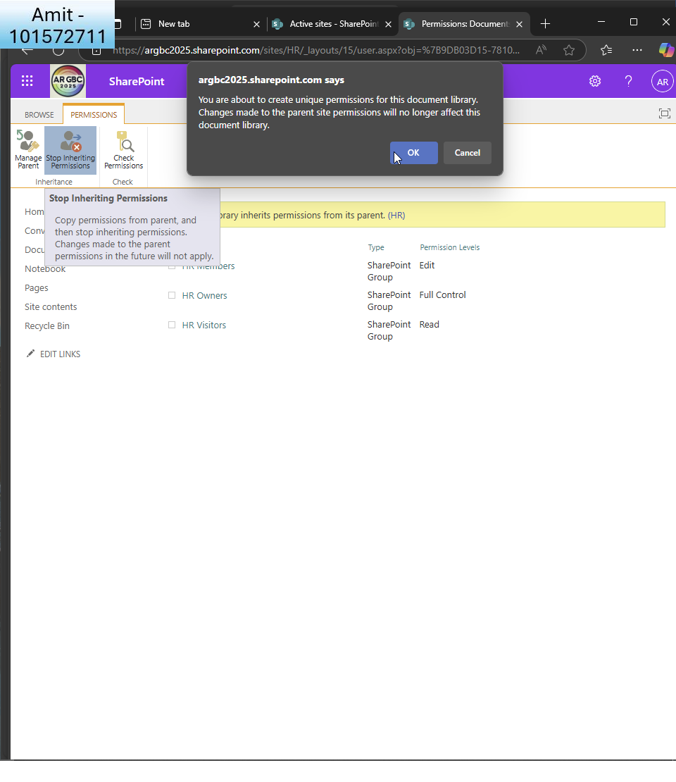  
      
    It gives me a warning via a popup  
      
    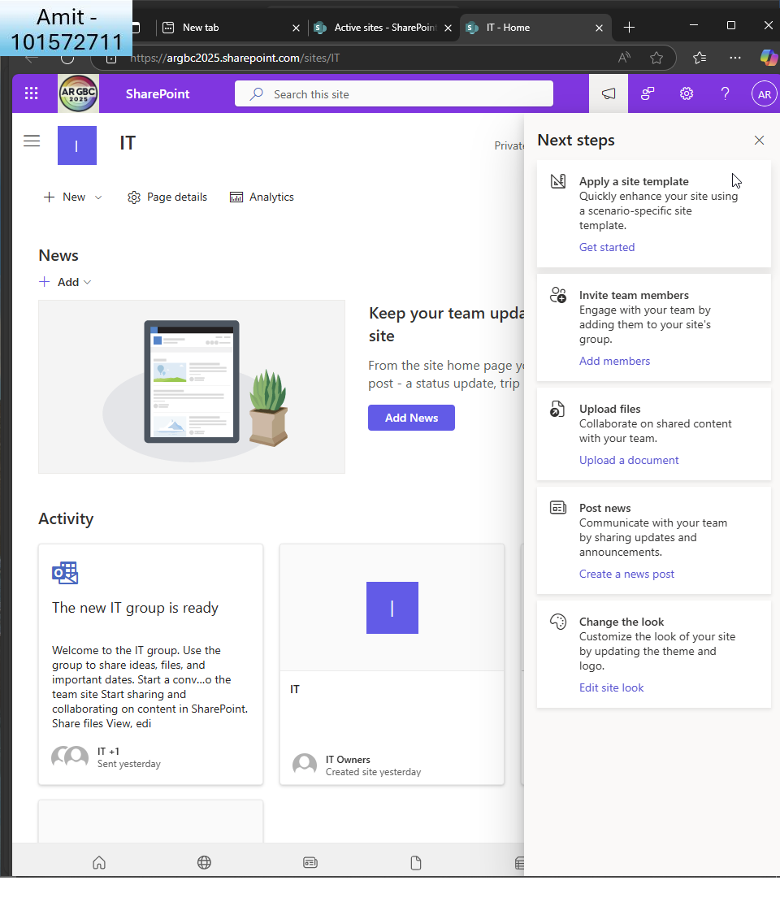  
      
    I do the same for IT department.  
      
    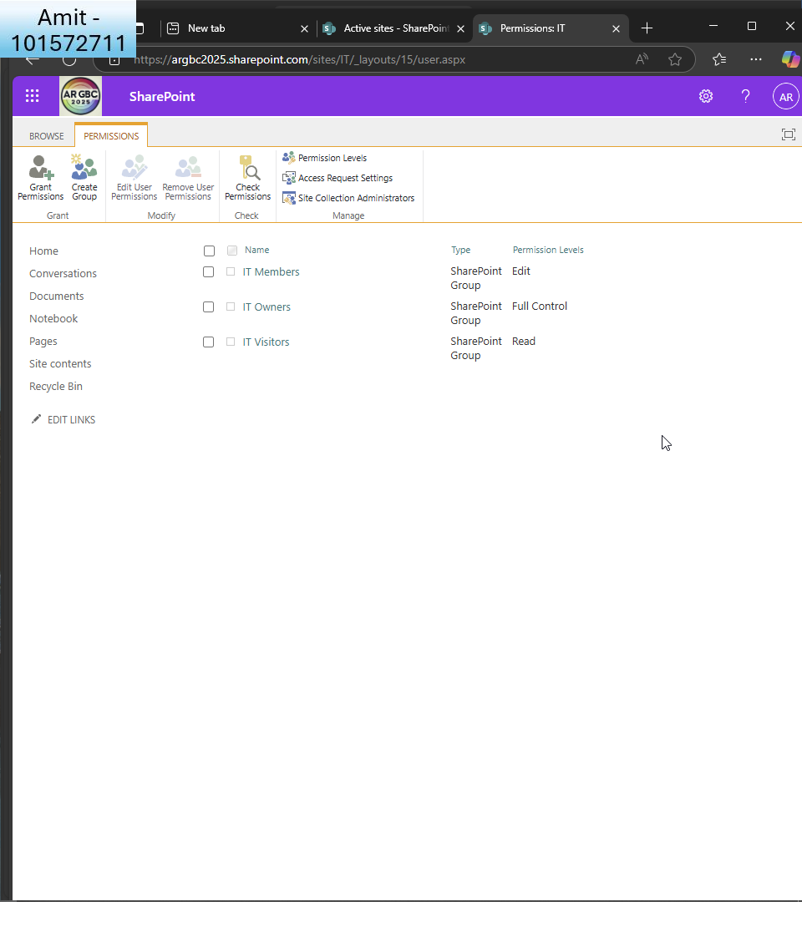  
      
    I see the permissions  
      
    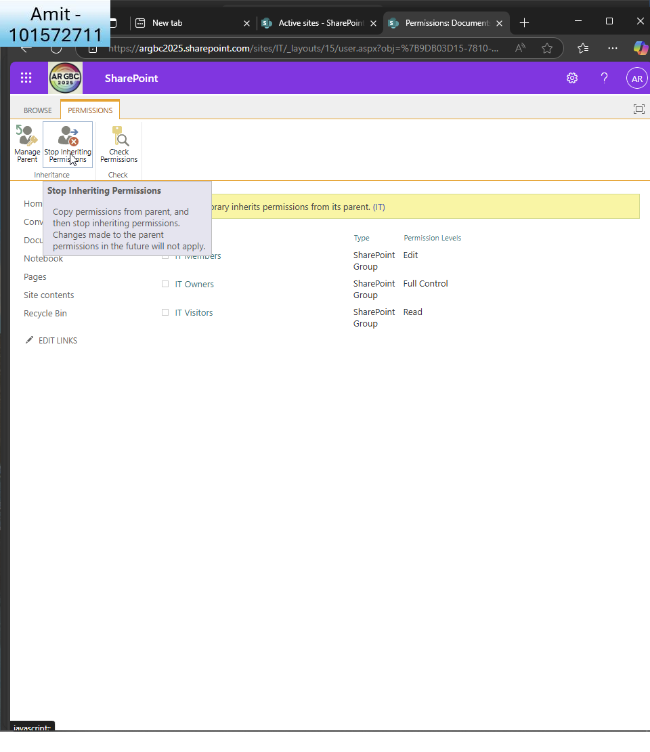  
      
    I click to stop inheriting permissions  
      
    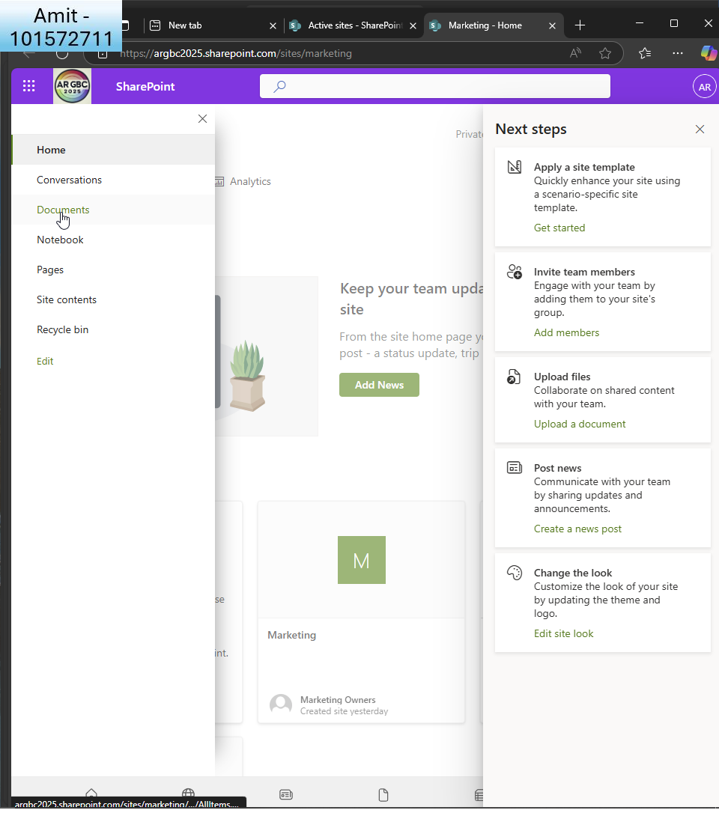  
      
    I do the same for the marketing site  
    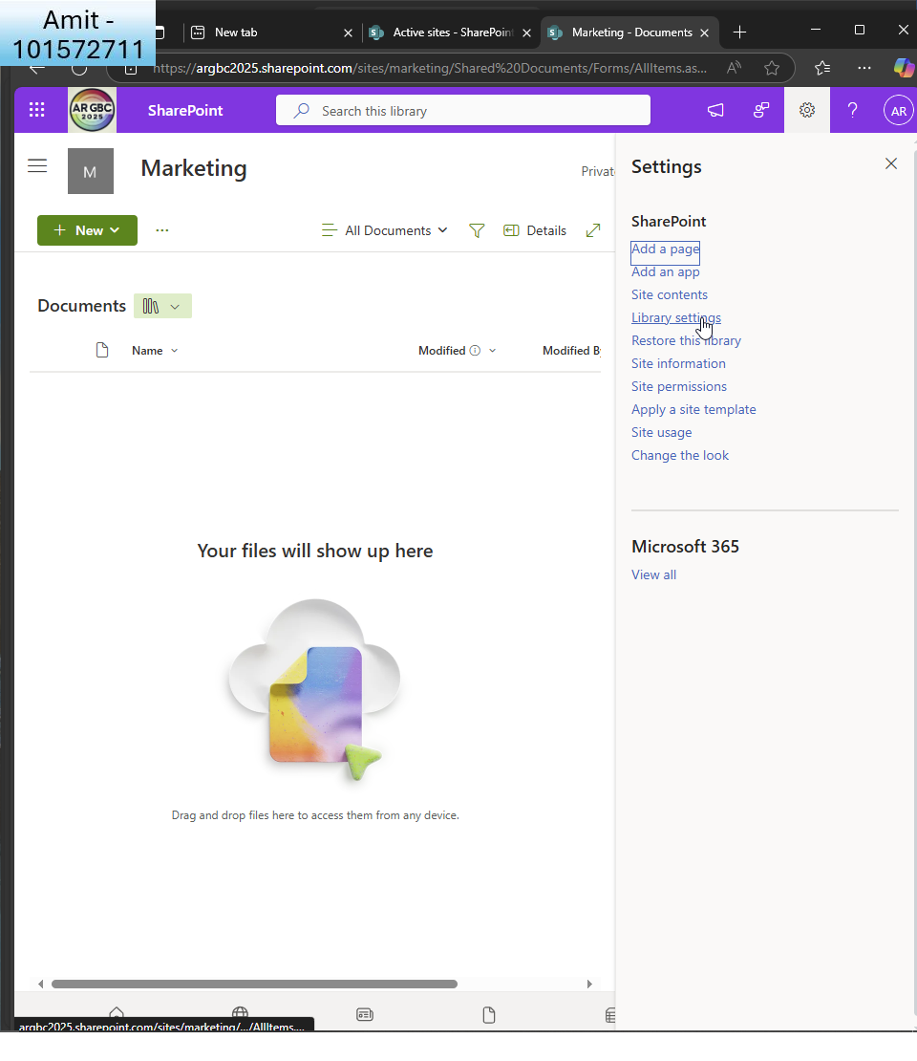  
      
    I click the library settings  
      
    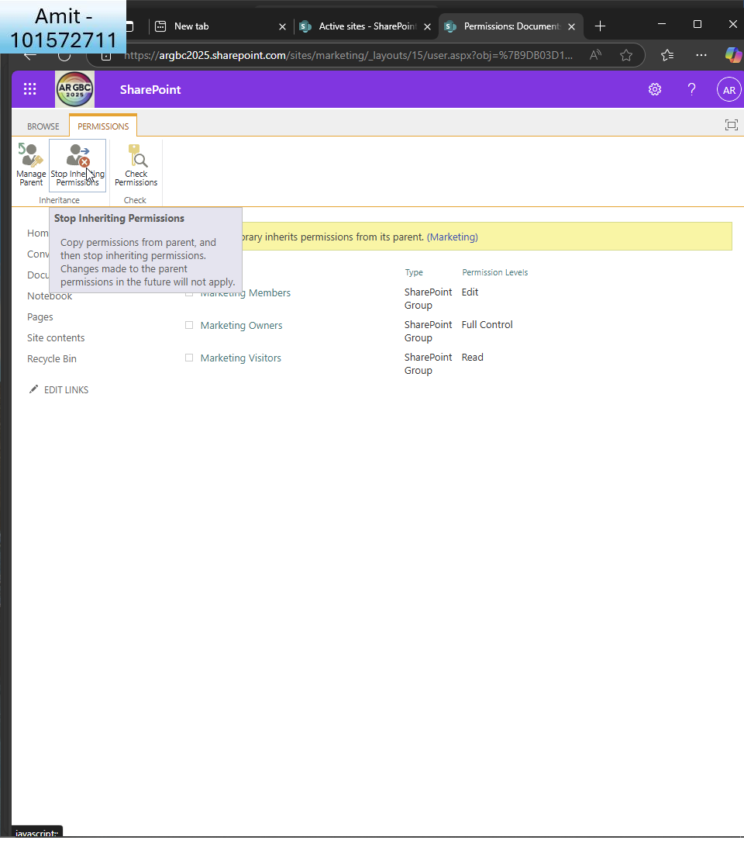  
      
    I stop inheriting permissions once more  
      
    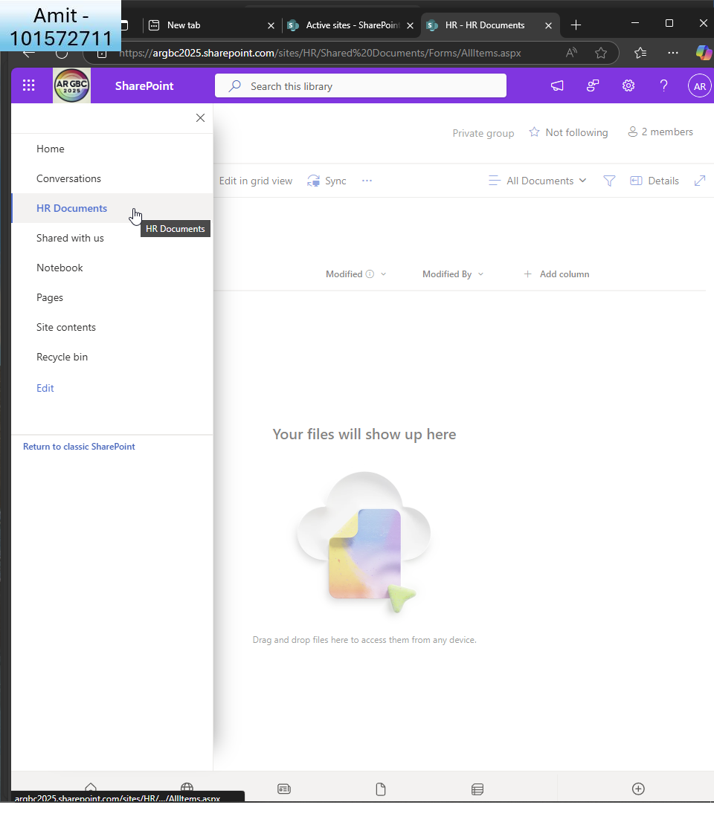  
      
    I also rename the documents to ’HR documents’ for organisation
  + Enable versioning and content approval for the HR document library.  
    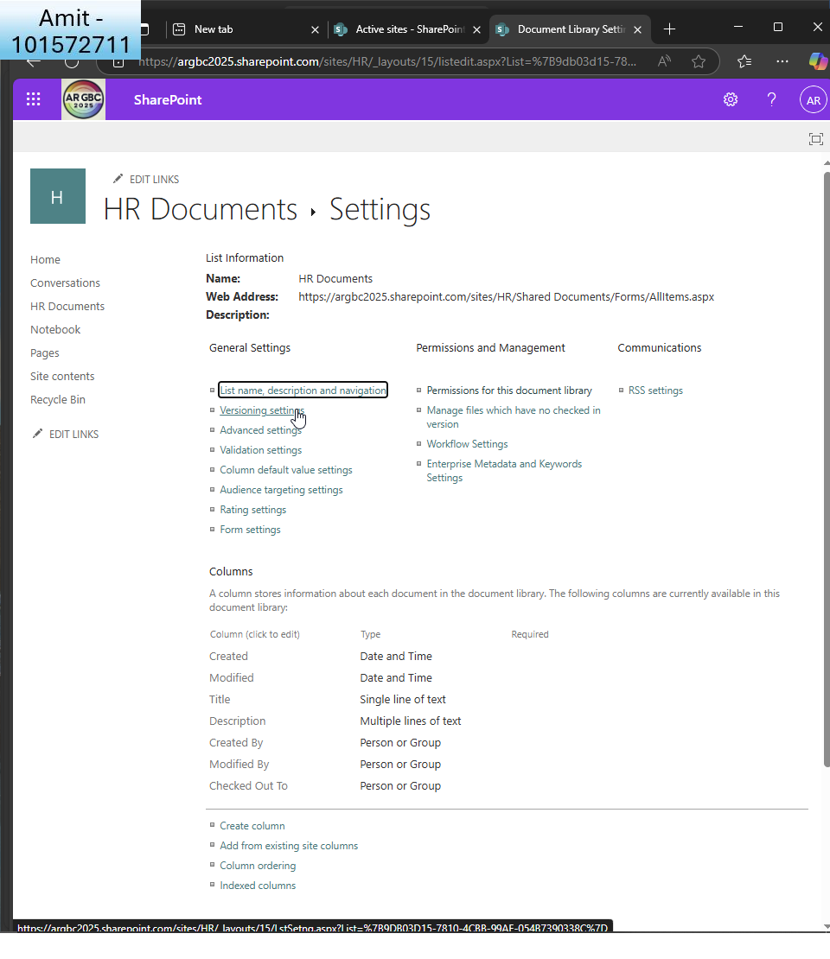  
      
    whilst in the document settings I click versioning settings  
      
    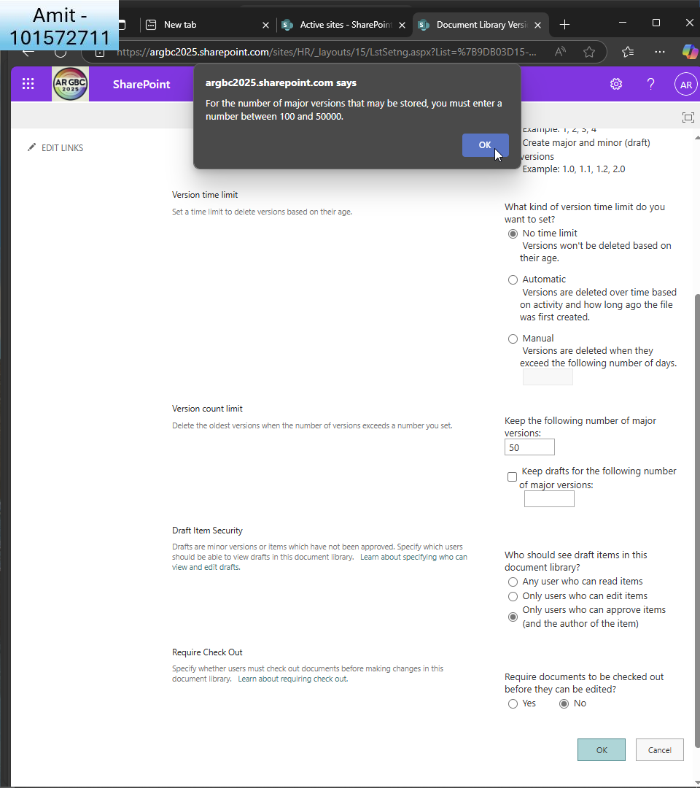  
      
    I change some options. For example, create major and minor drafts, number of major versions to 50 (later changed to 100 since MS only accept 100 as a minimum) and check only users who can approve items, and author can see draft items.  
      
    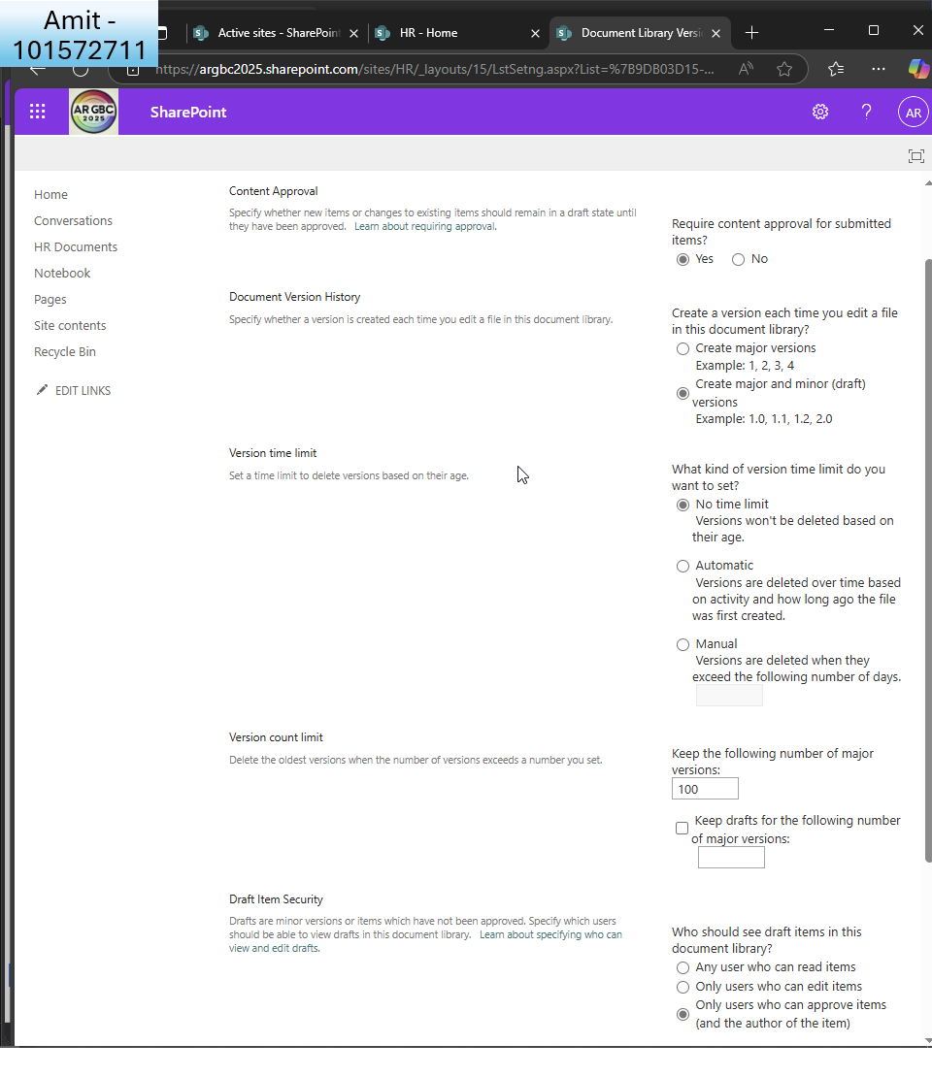

1. **Implement OneDrive for Business**:
   * Configure OneDrive settings to restrict external sharing.  
       
     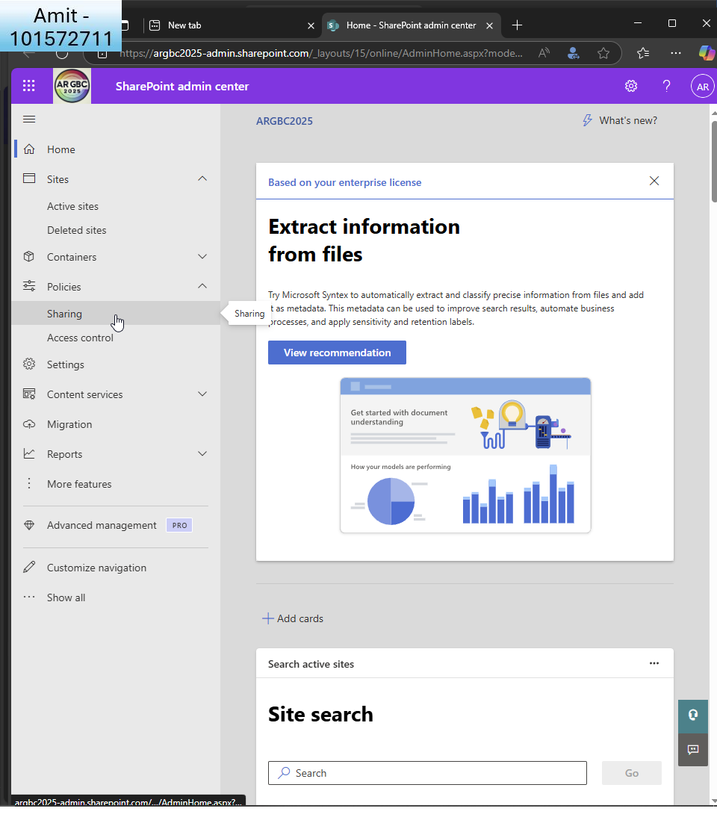  
       
     I go to the sharepoint admin centre  
       
     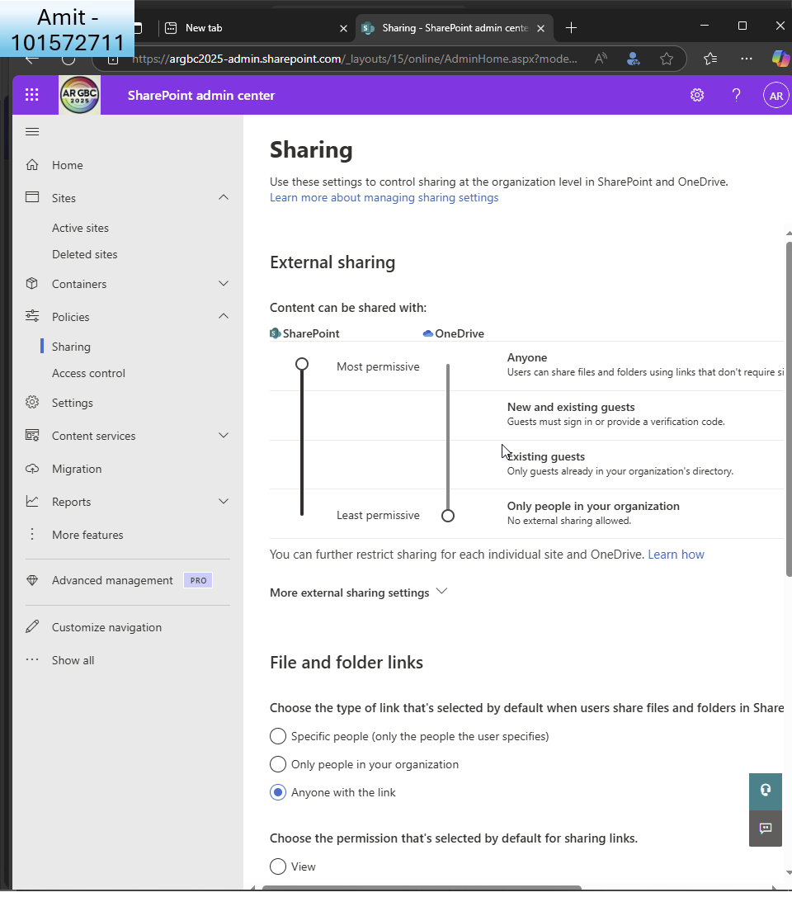  
       
     I click ’sharing’ under ’policies’ and slide the scale down for onedrive so only people within my organisation can share with each other
   * Enable file retention policies to ensure data is retained for at least five years.  
       
     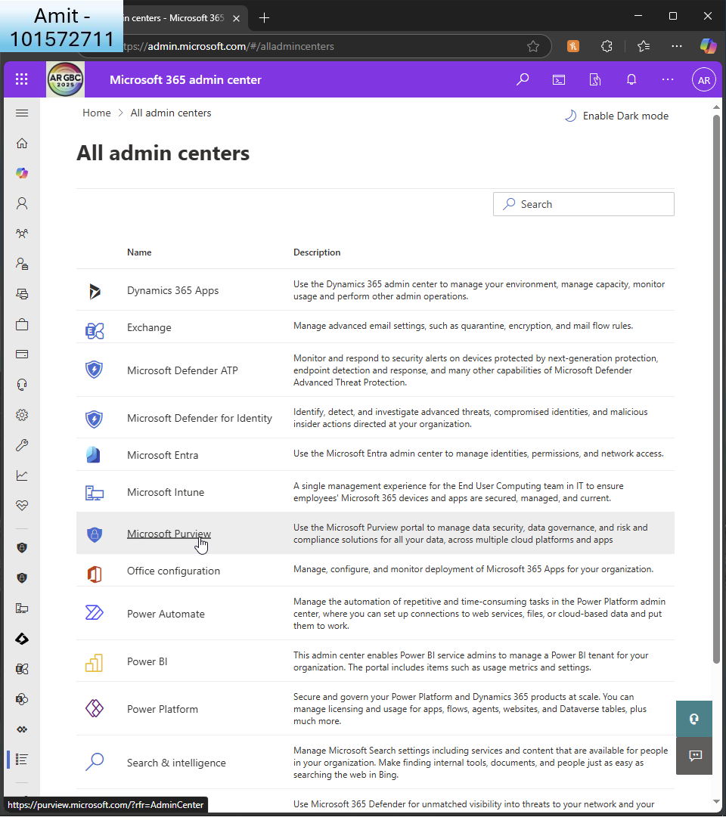  
       
     I go to MS purview  
     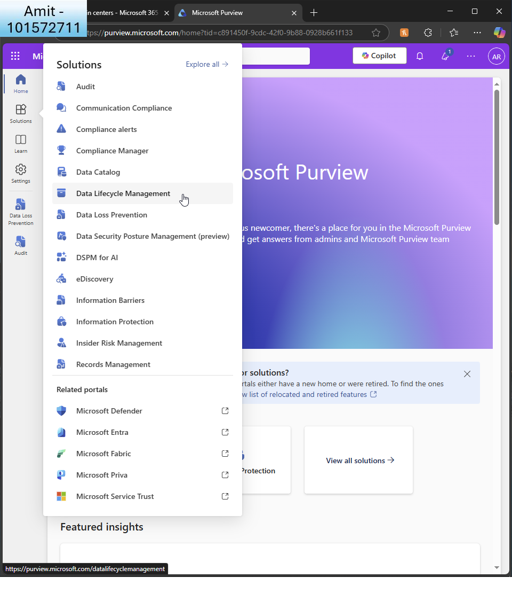  
       
     I click to create a DLP policy  
       
     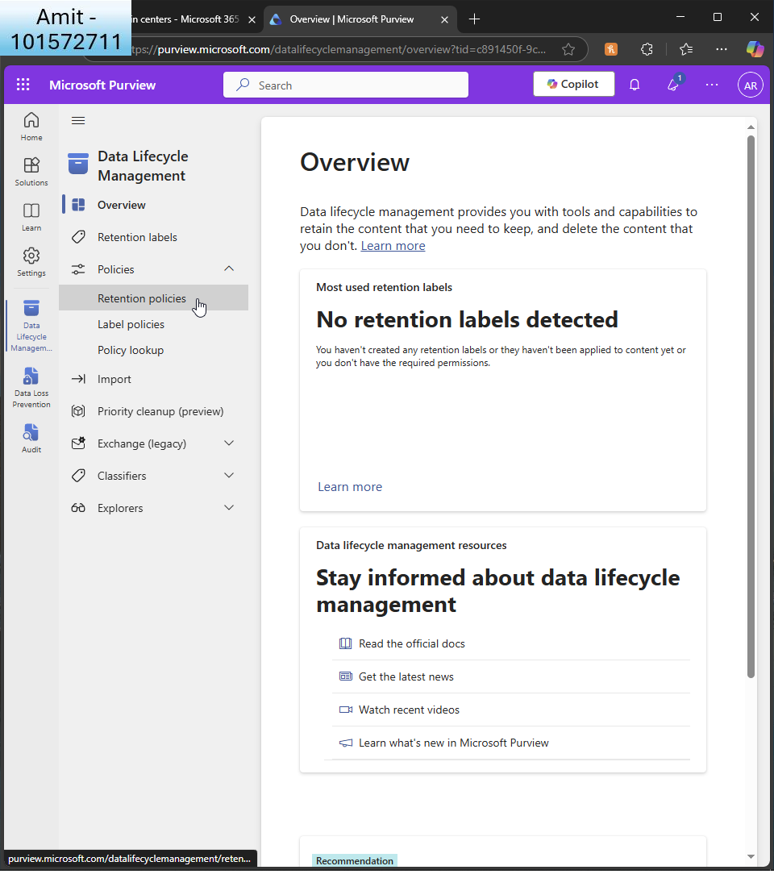  
       
     I click ’retention policies’  
       
     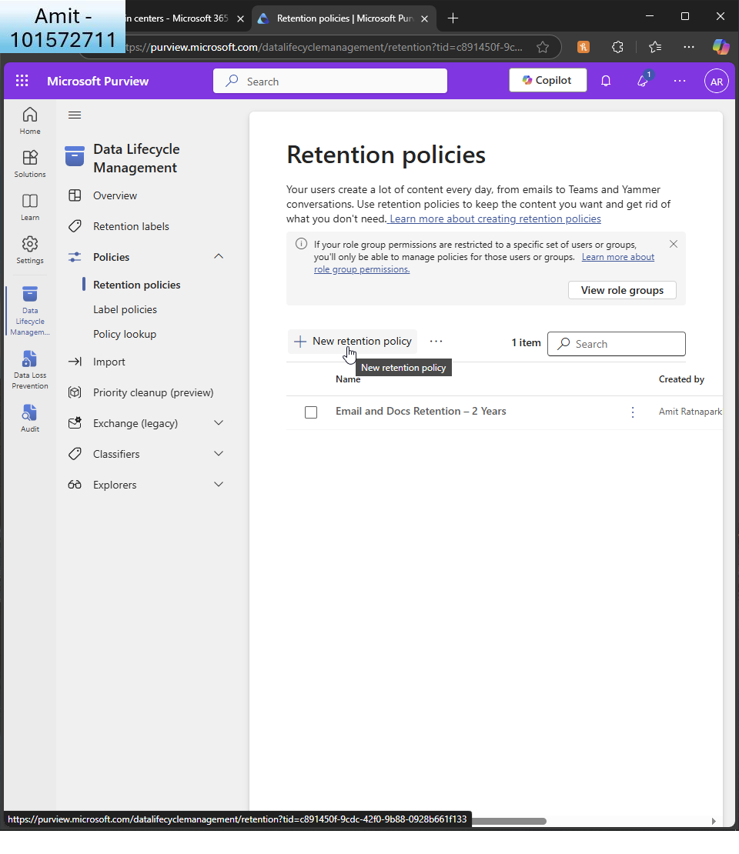

And create a new retention policy  
  
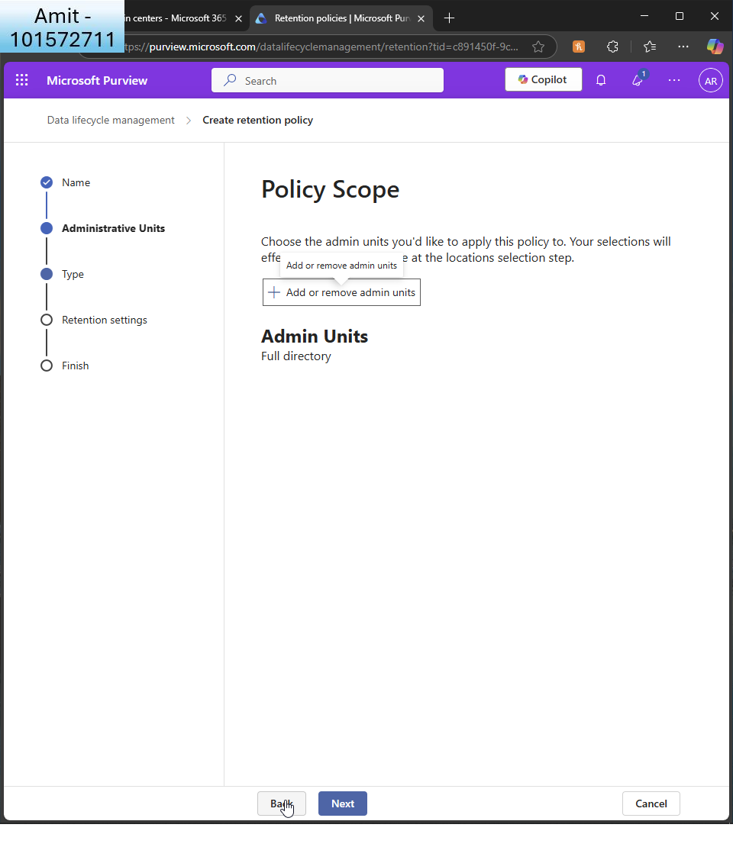  
I leave it for all admin units  
  
  
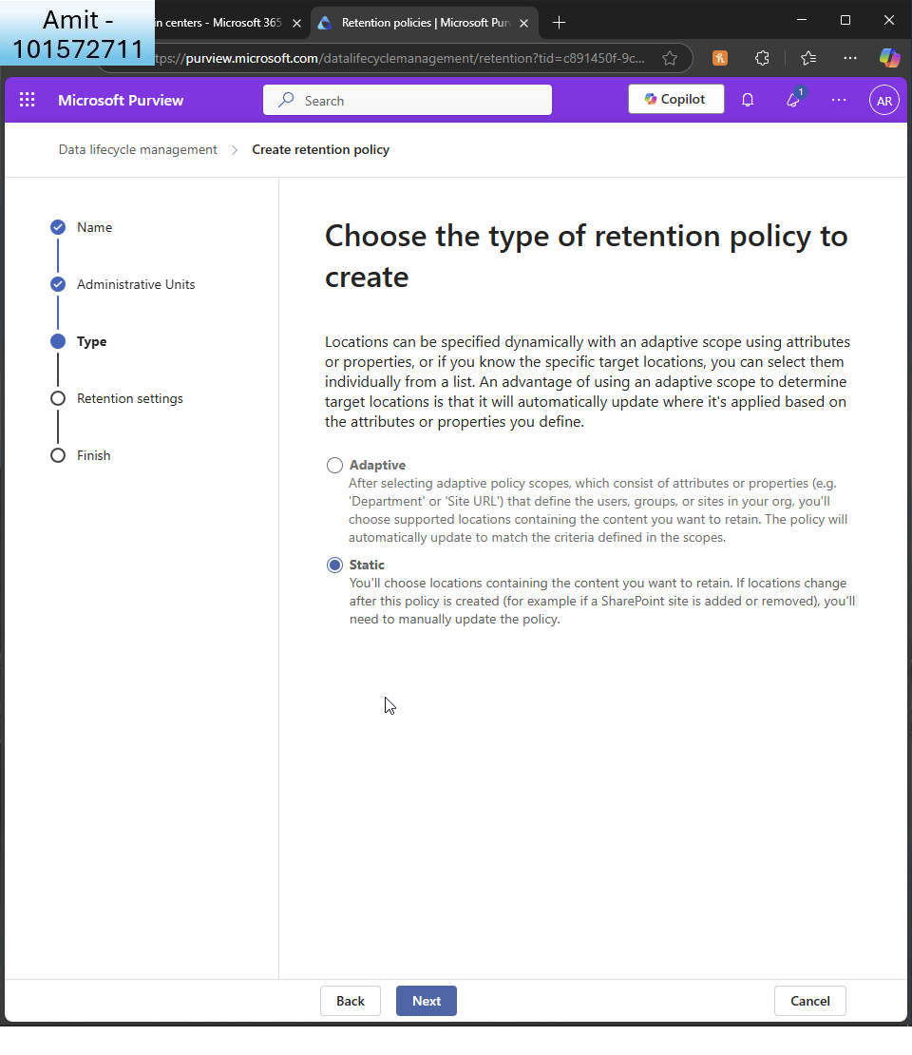  
I choose ’static’  
  
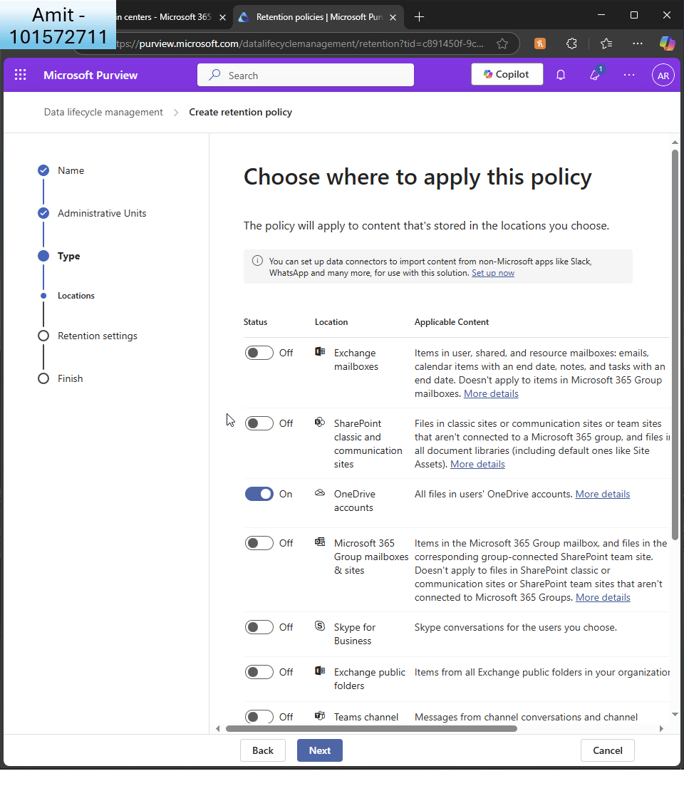  
I apply it only to onedrive accounts  
  
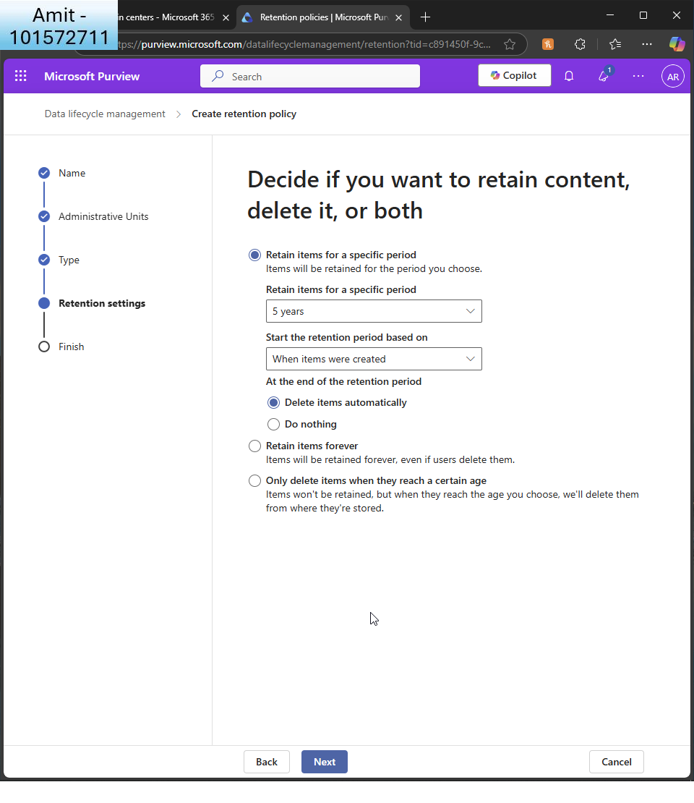I choose to retain for 5 years and delete items automatically  
  
  
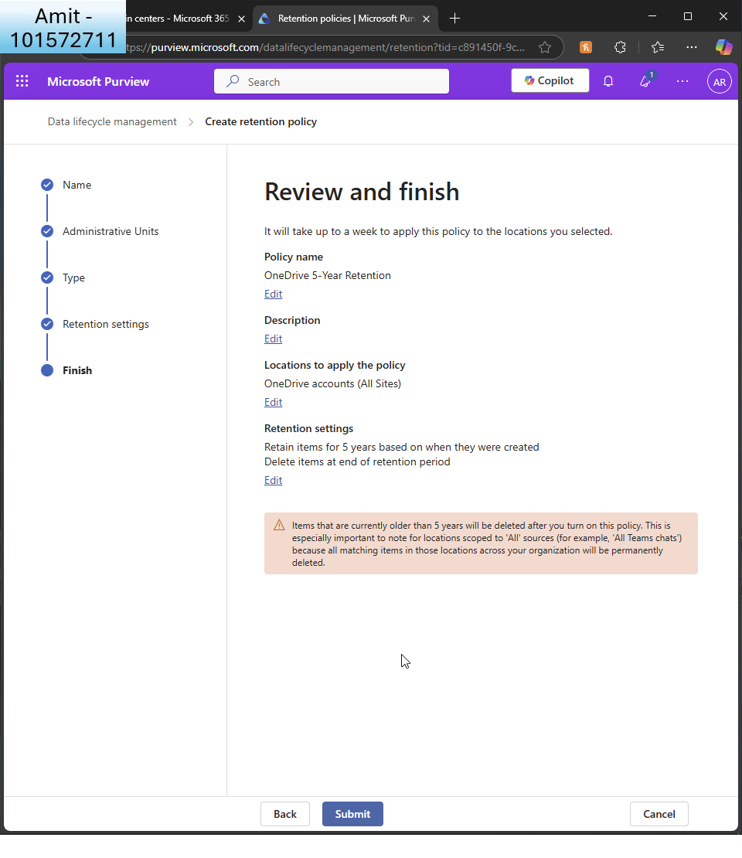  
I review and finish  
  
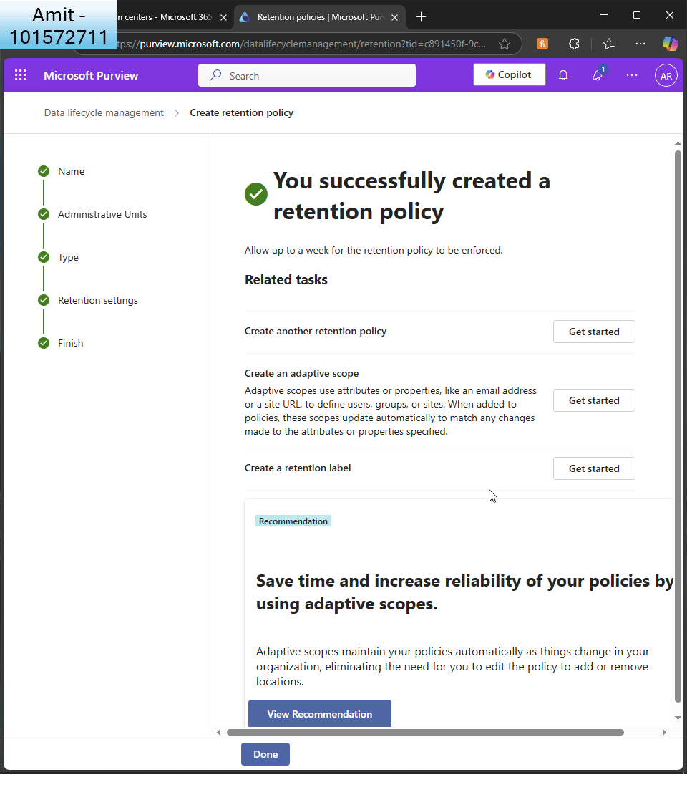

It confirms it has been created

* + Set up a policy to automatically move old files to the Recycle Bin after a year.  
      
    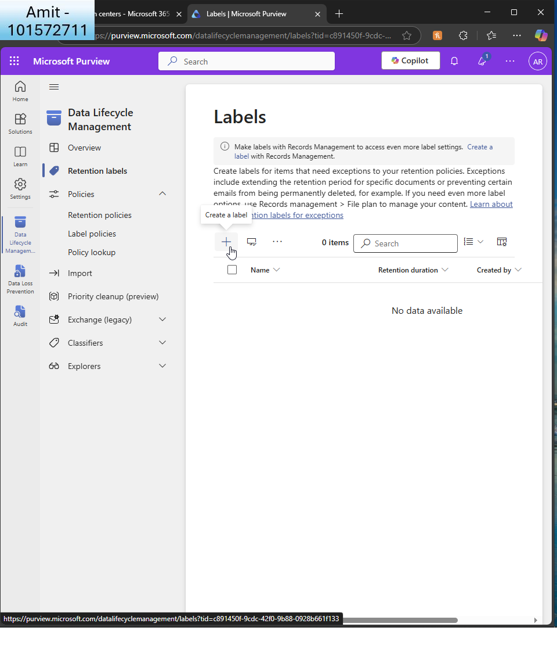  
      
    Still within DLP, I choose ’retention labels’  
      
    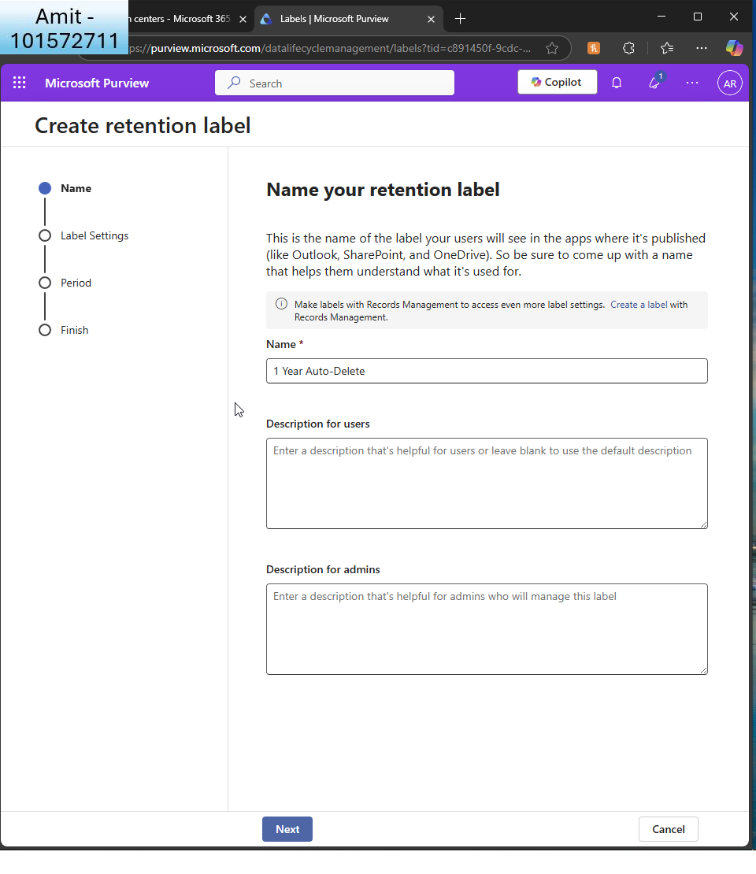  
      
    I name the retention label  
      
    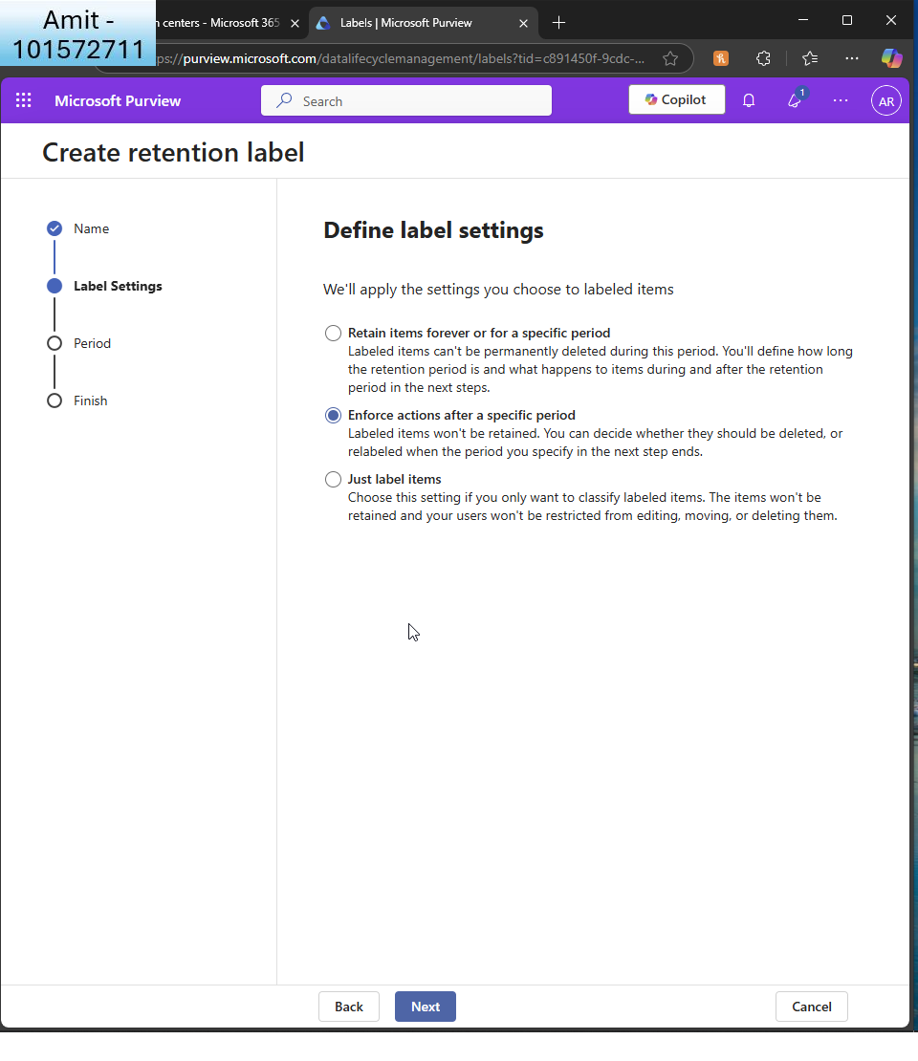  
      
    I enforce action after specific period i.e. 1 year  
      
    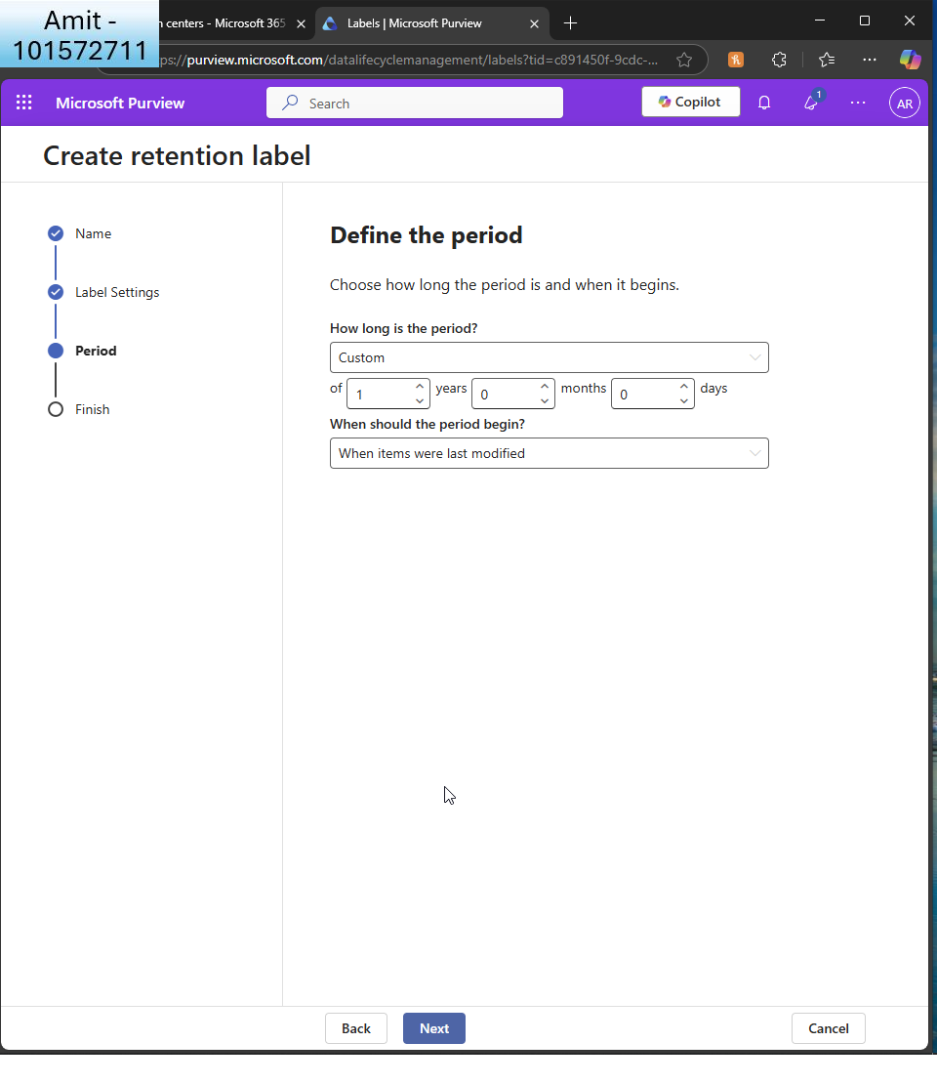  
      
    Here I specify 1 year retention from when the item was last modified.  
    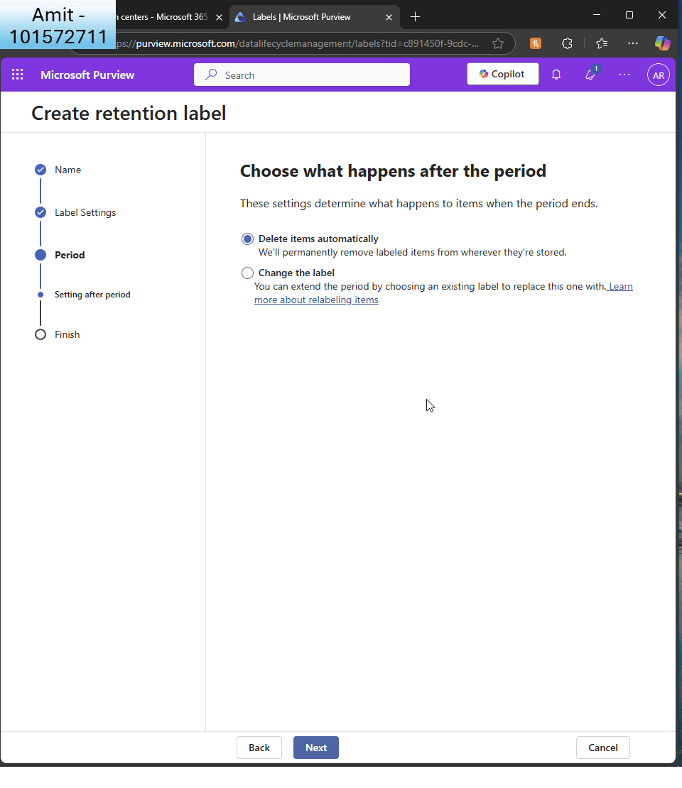  
      
    Here I choose the action to delete the items automatically  
      
    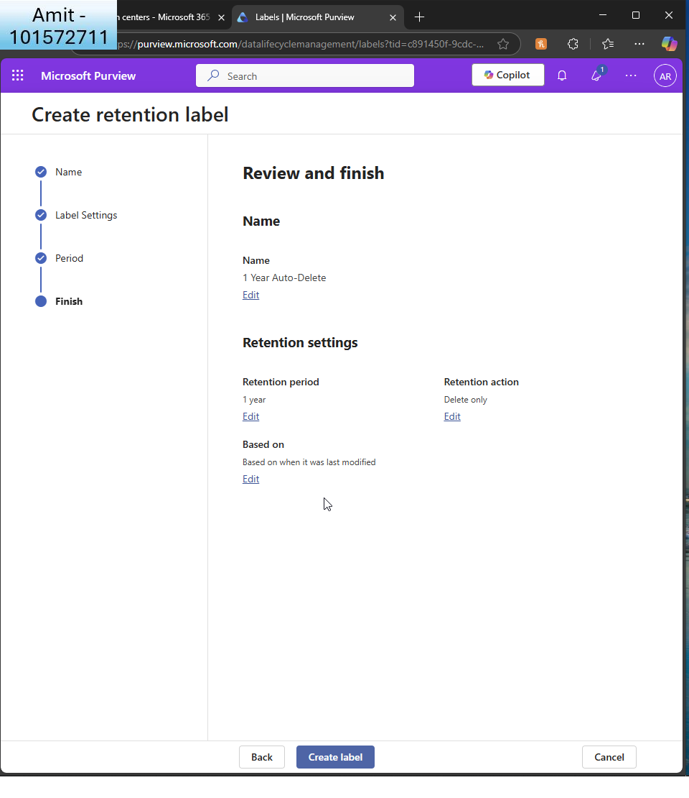  
      
    I review and finish  
      
    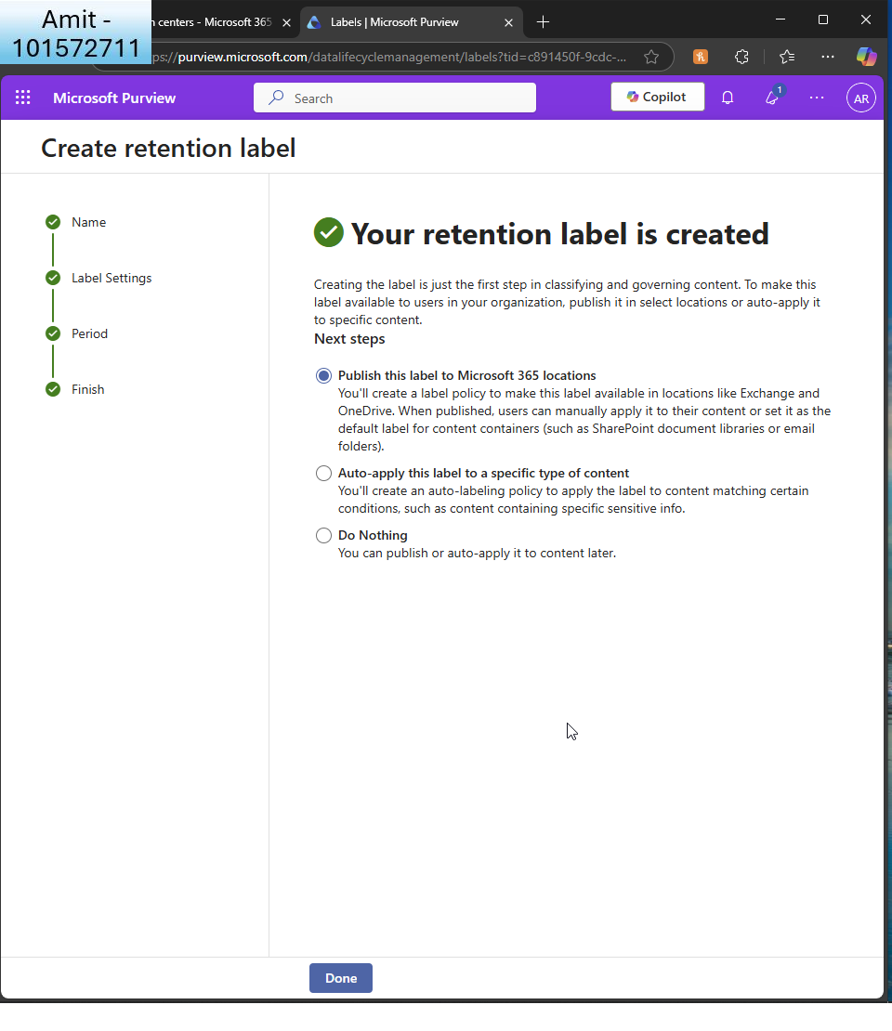  
      
    I see the confirmation  
      
    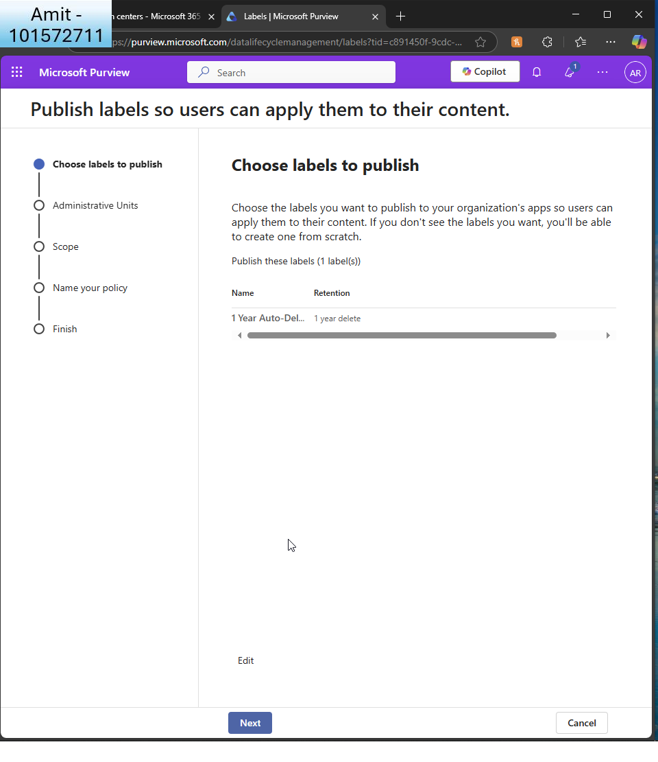  
      
    I now publish the label  
      
    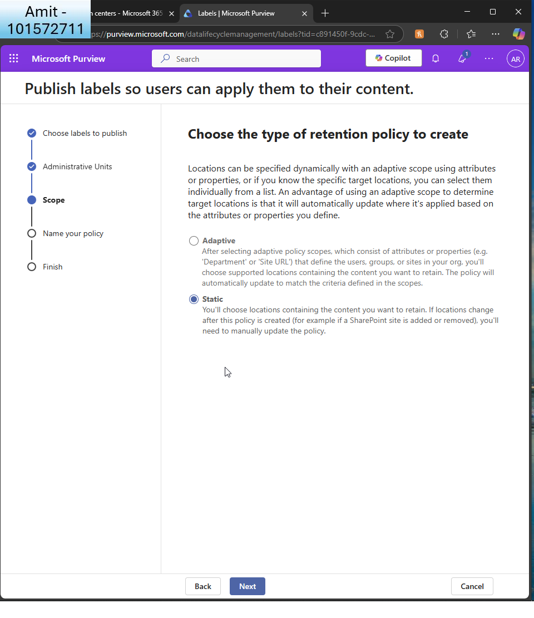  
      
    I choose ’static’  
      
    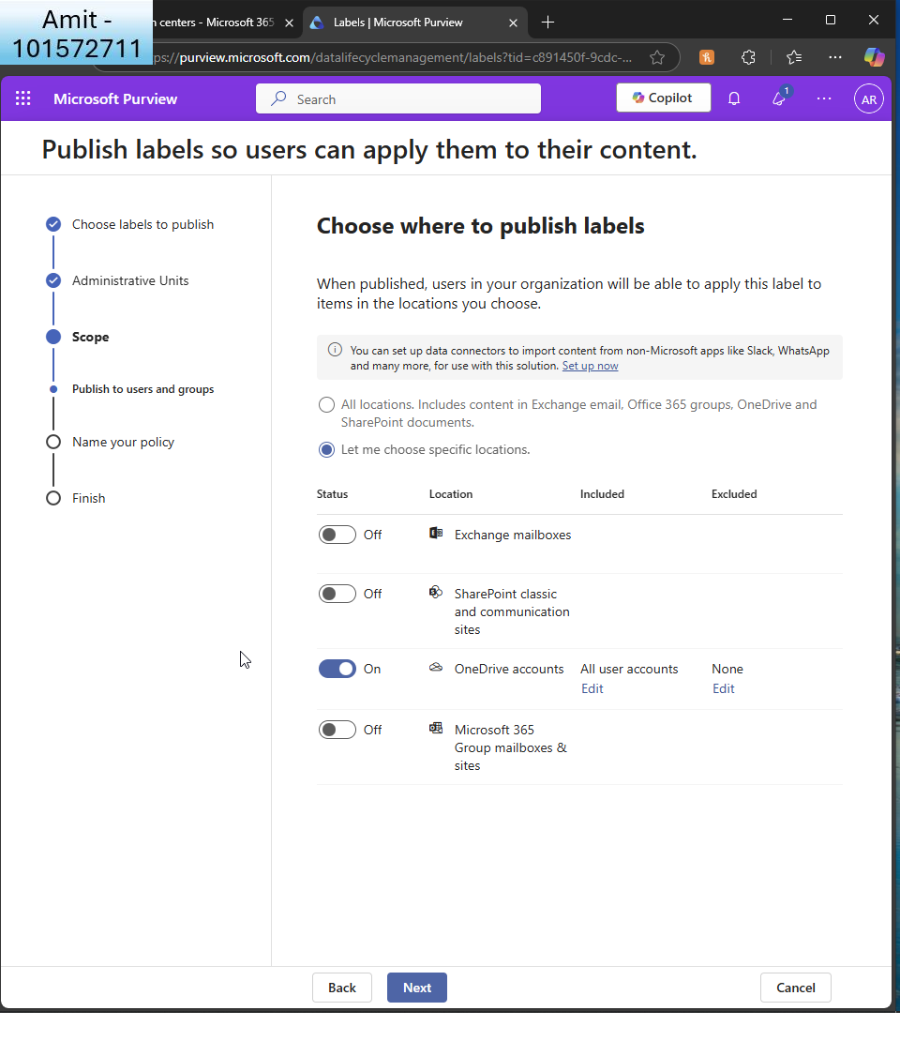

And specify only onedrive accounts  
  
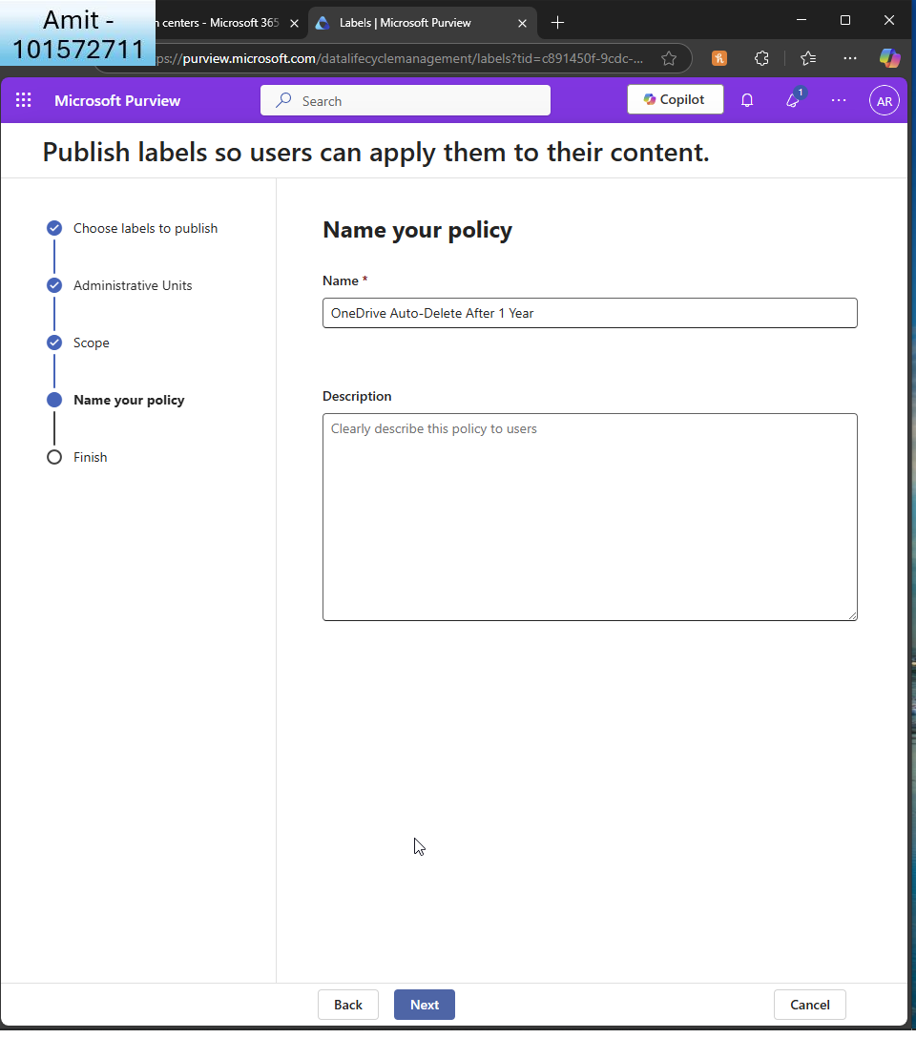  
I name the policy  
  
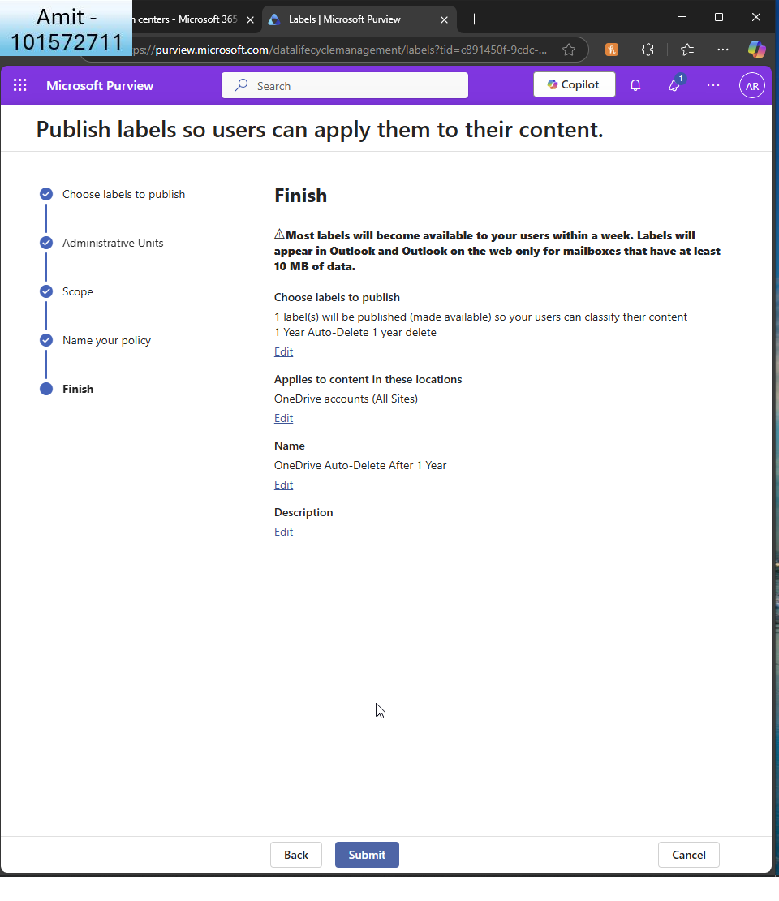  
I finish creating the policy  
  
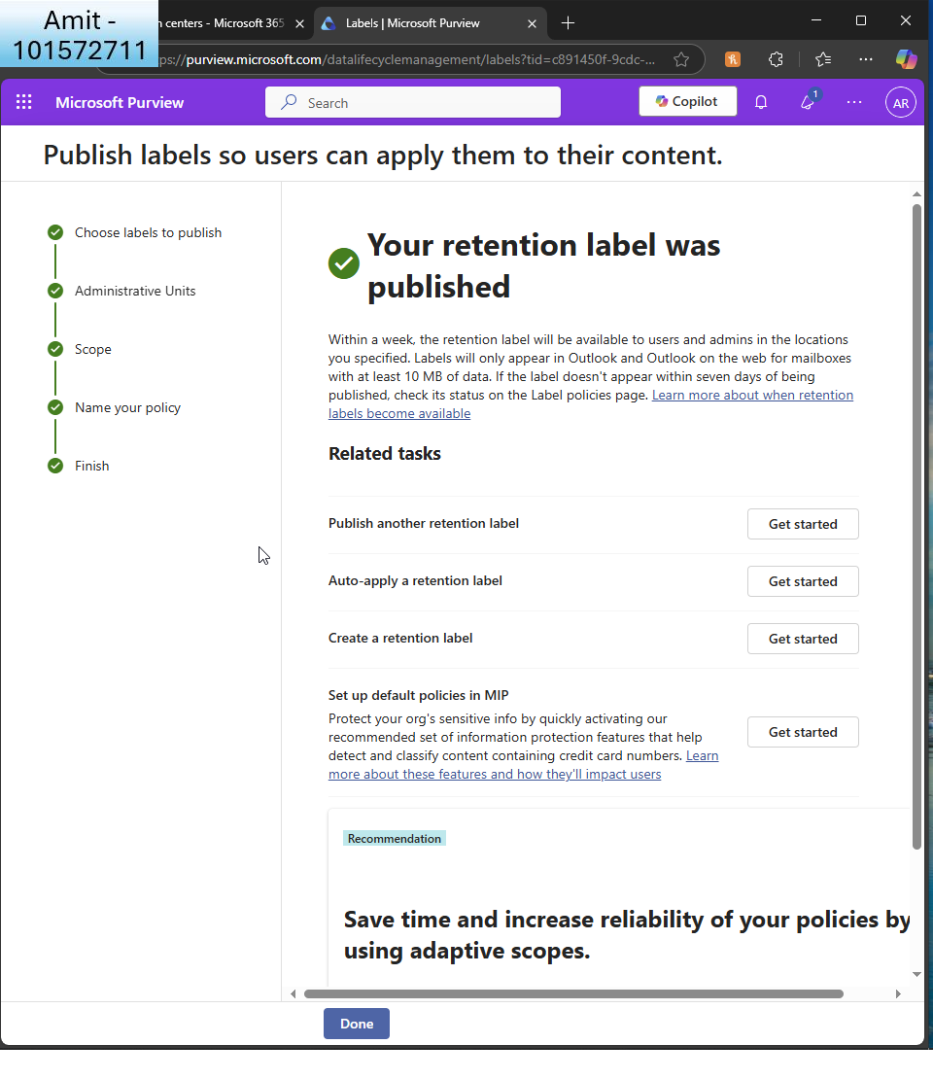I see the confirmation

1. **Set Up Viva Engage for Enterprise Social Networking**:
   * Configure Viva to allow only internal communications.  
       
     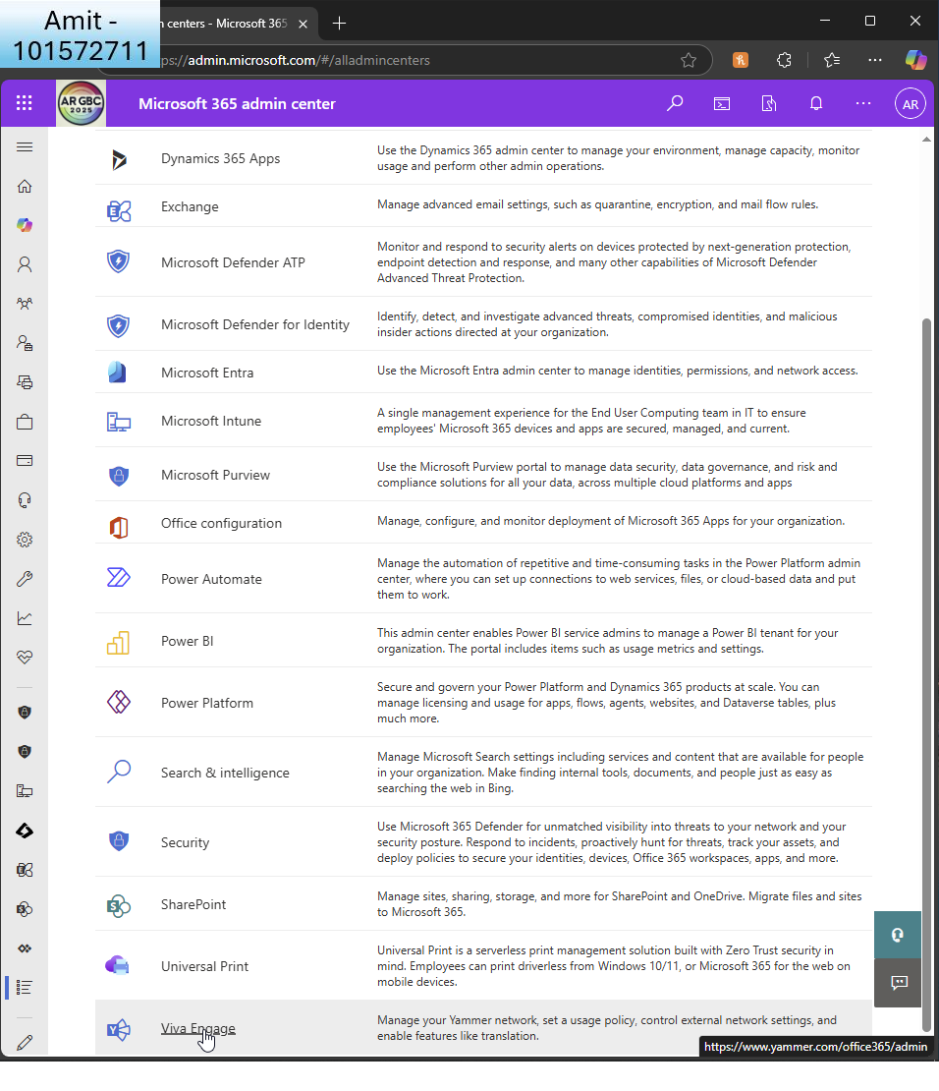  
       
     I choose ’Viva Engage’ from all admin centres  
       
     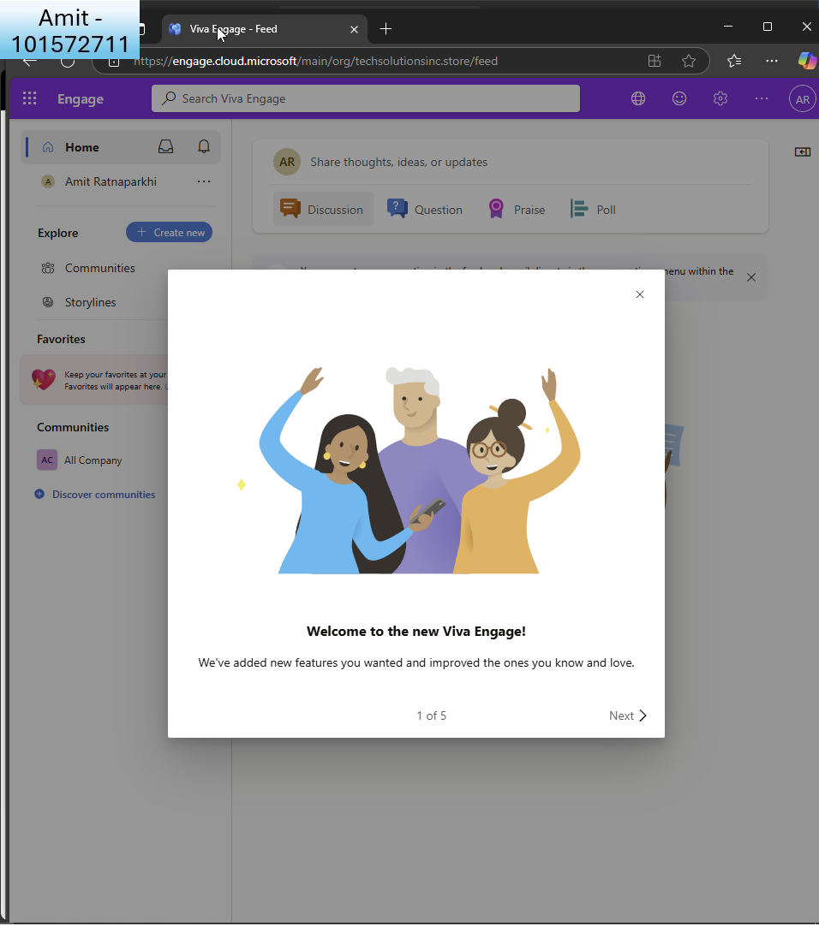  
     I see the welcome screen for the new viva engage  
       
     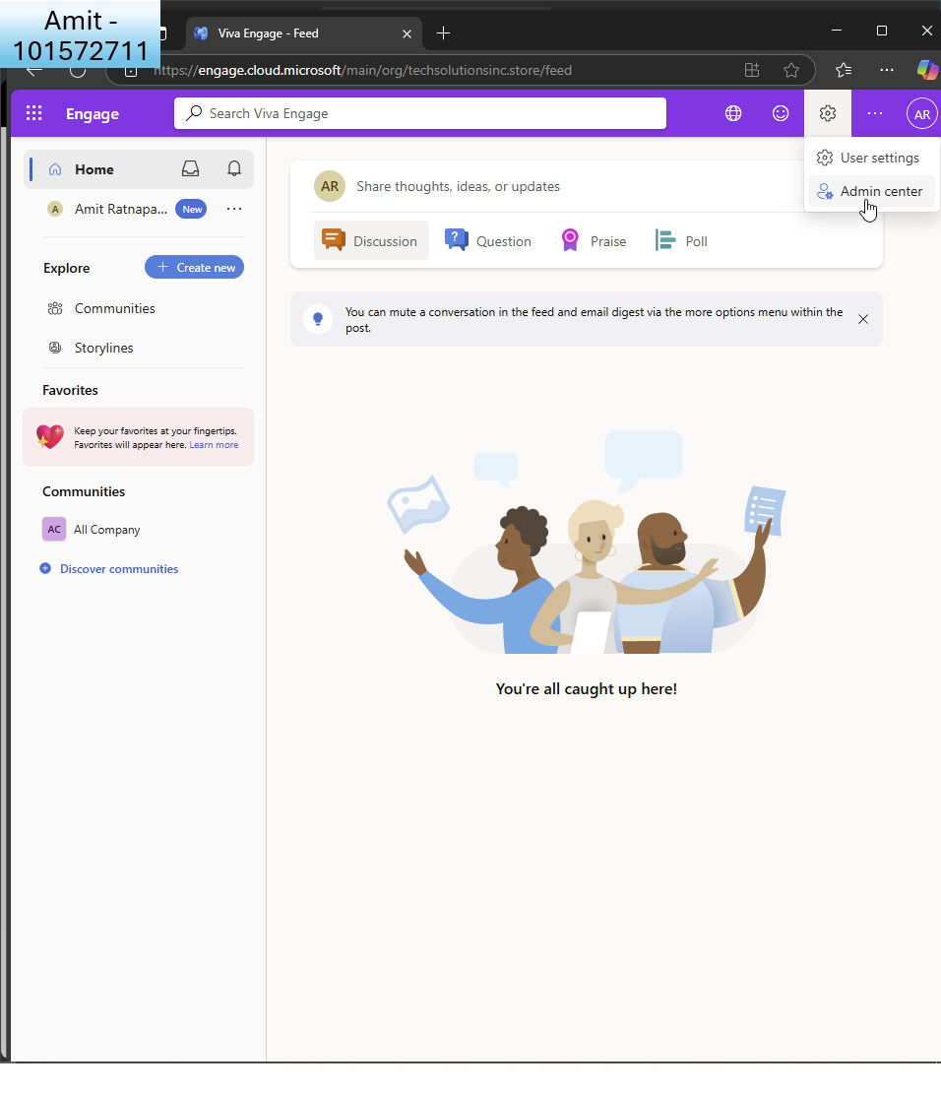  
     I click ’admin cerntre’  
       
     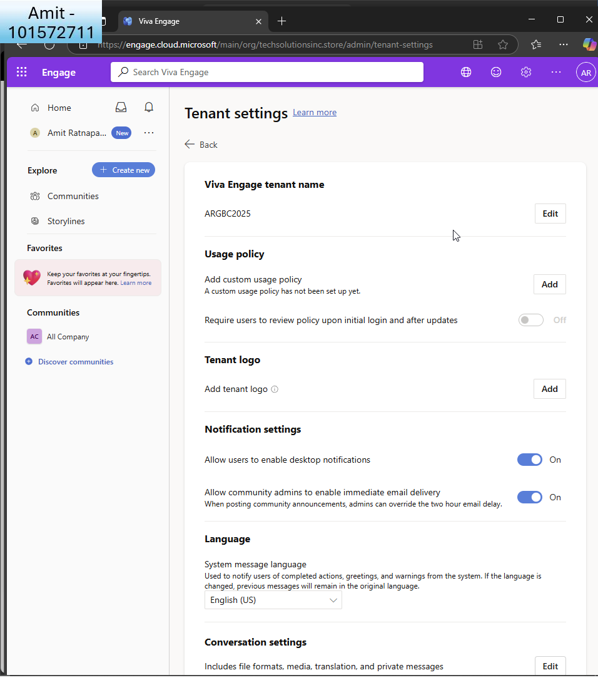  
       
     I see the tenant settings  
     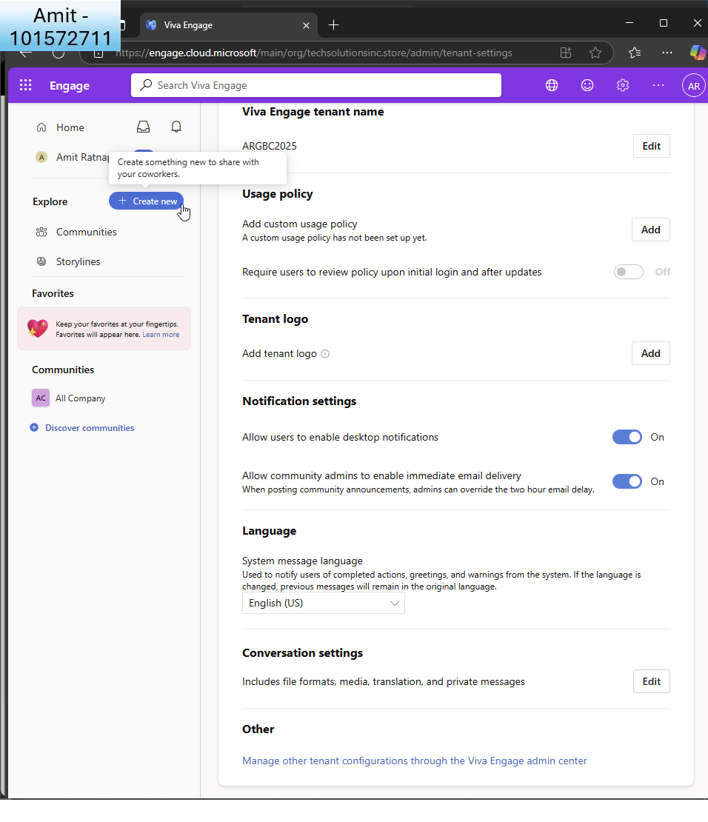  
       
     I click ’other tenant configurations’ at the bottom  
       
     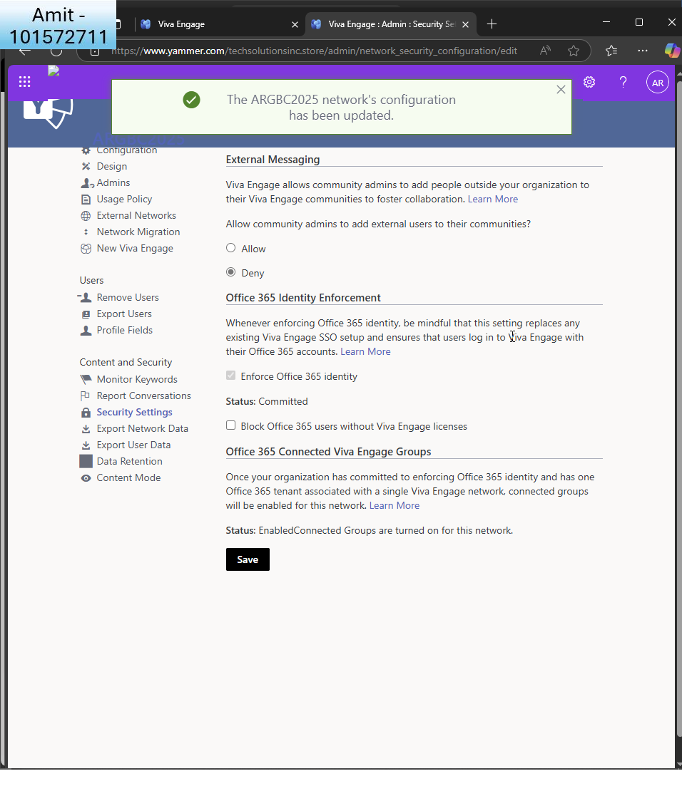

I choose to ‘deny’ the ability for community admins to add external users

* + Set up groups for company-wide announcements and department-specific discussions.  
    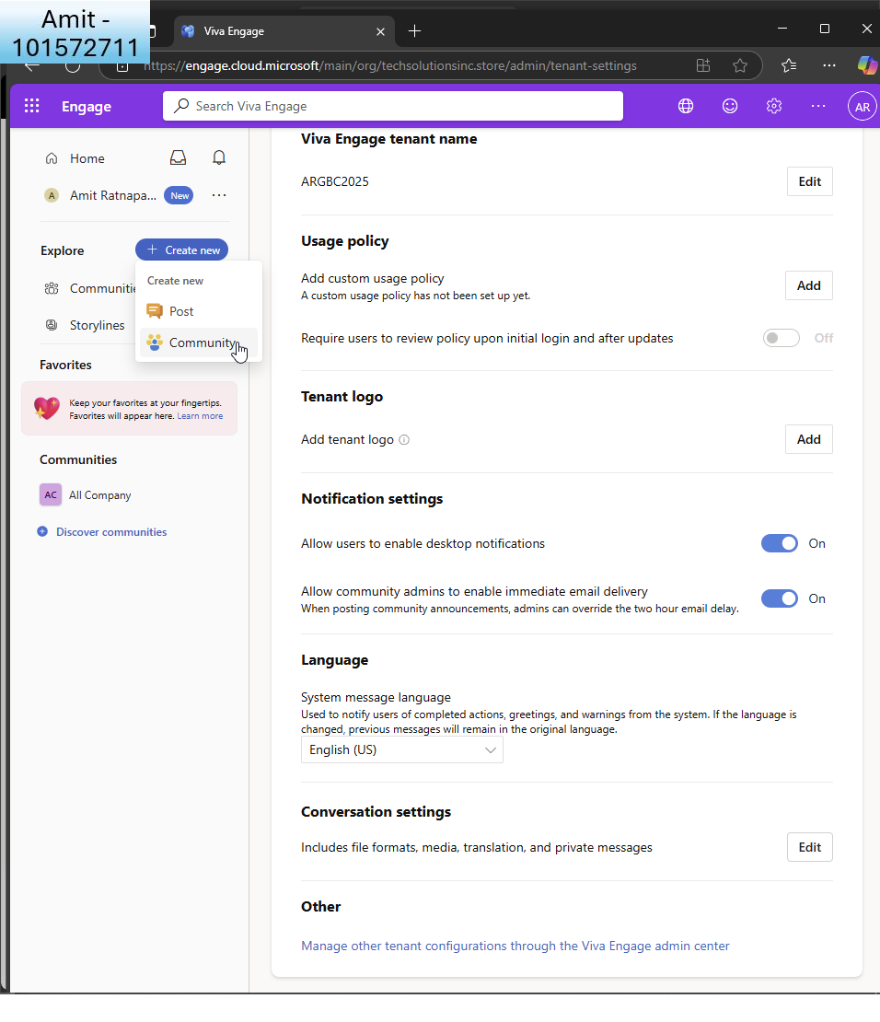  
      
    I go back to the main menu and ’create new community’  
      
    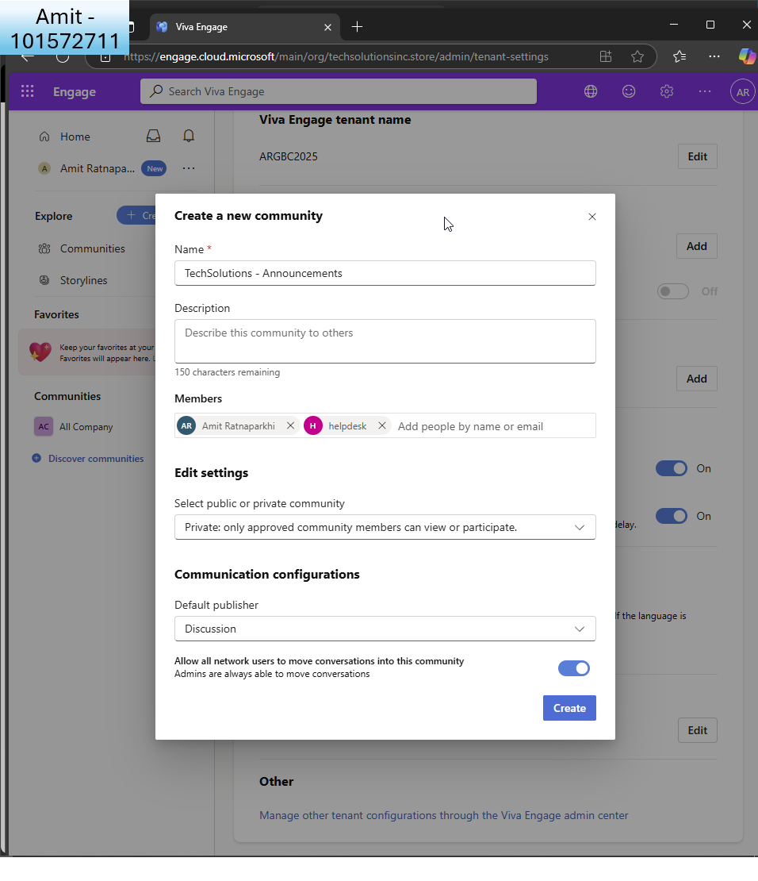  
      
    I create a new community for announcements, make it private and add GA and helpdesk   
    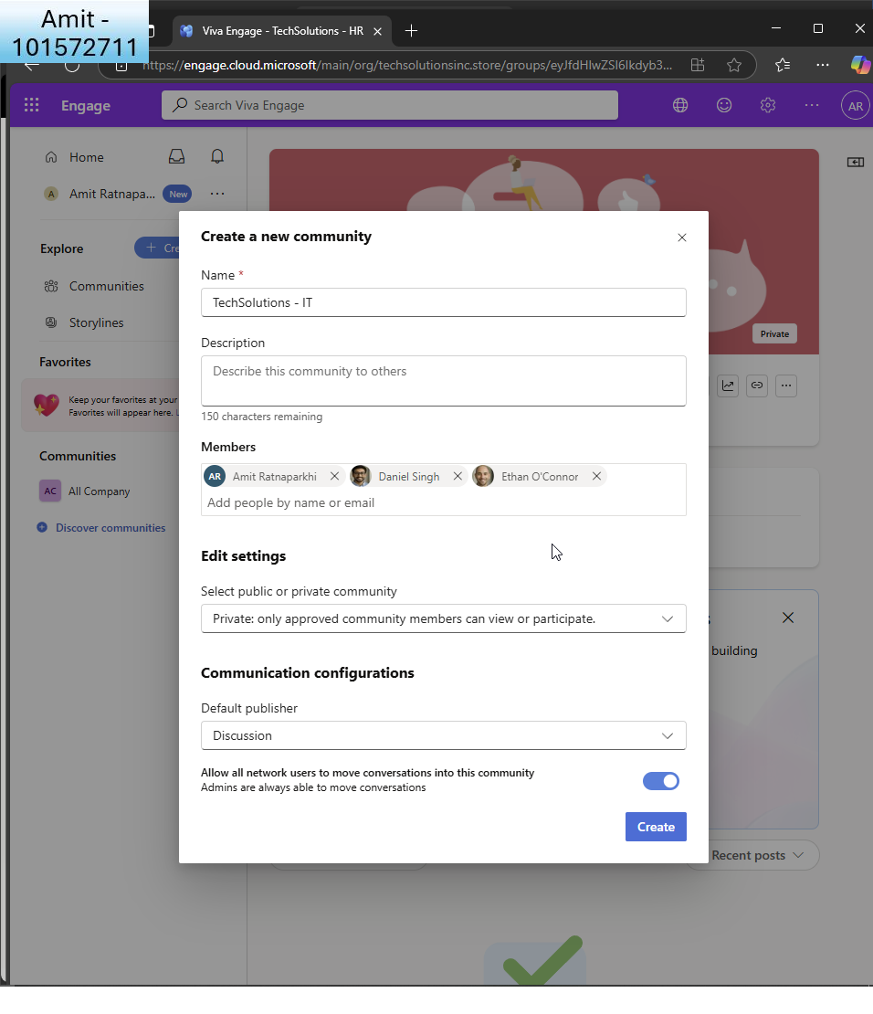  
      
    I do the same for IT department and add GA, and IT leads  
      
    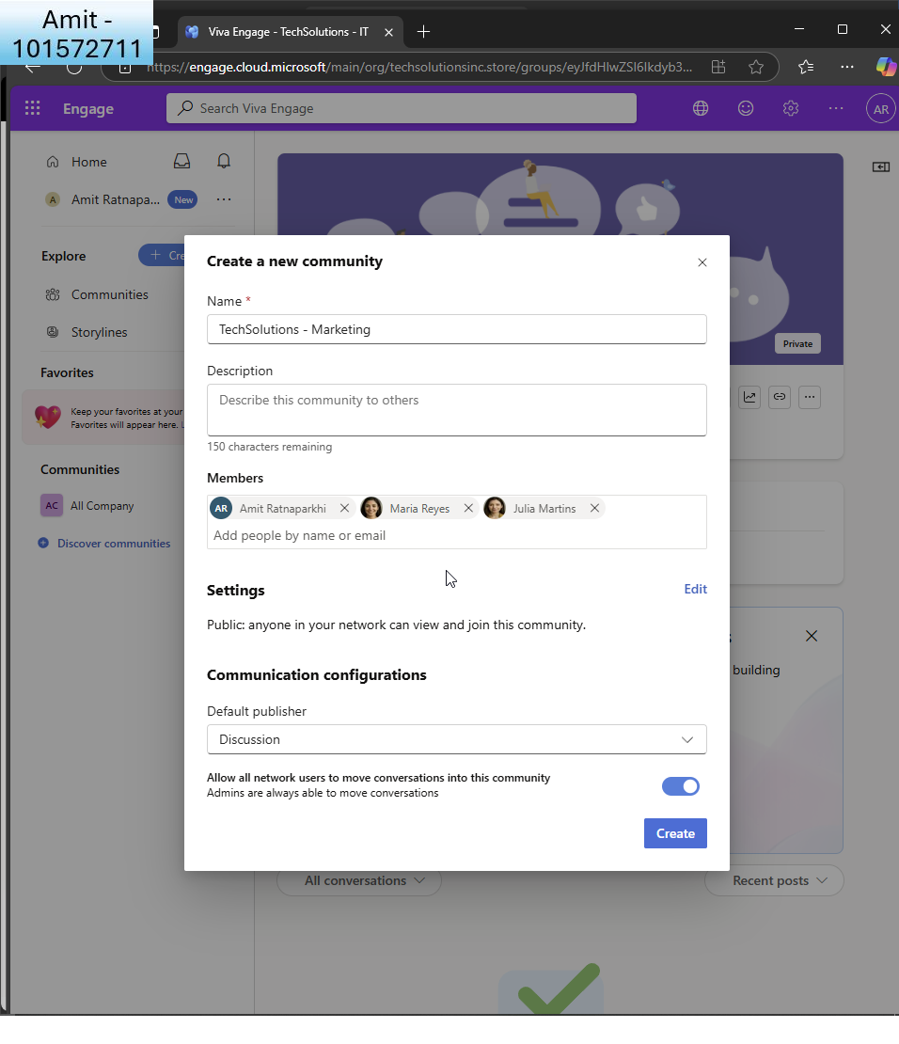  
      
    Once more I do the same for Marketing, add GA and marketing leads. I make this one public.
  + Ensure compliance with the company's social media policy.  
      
    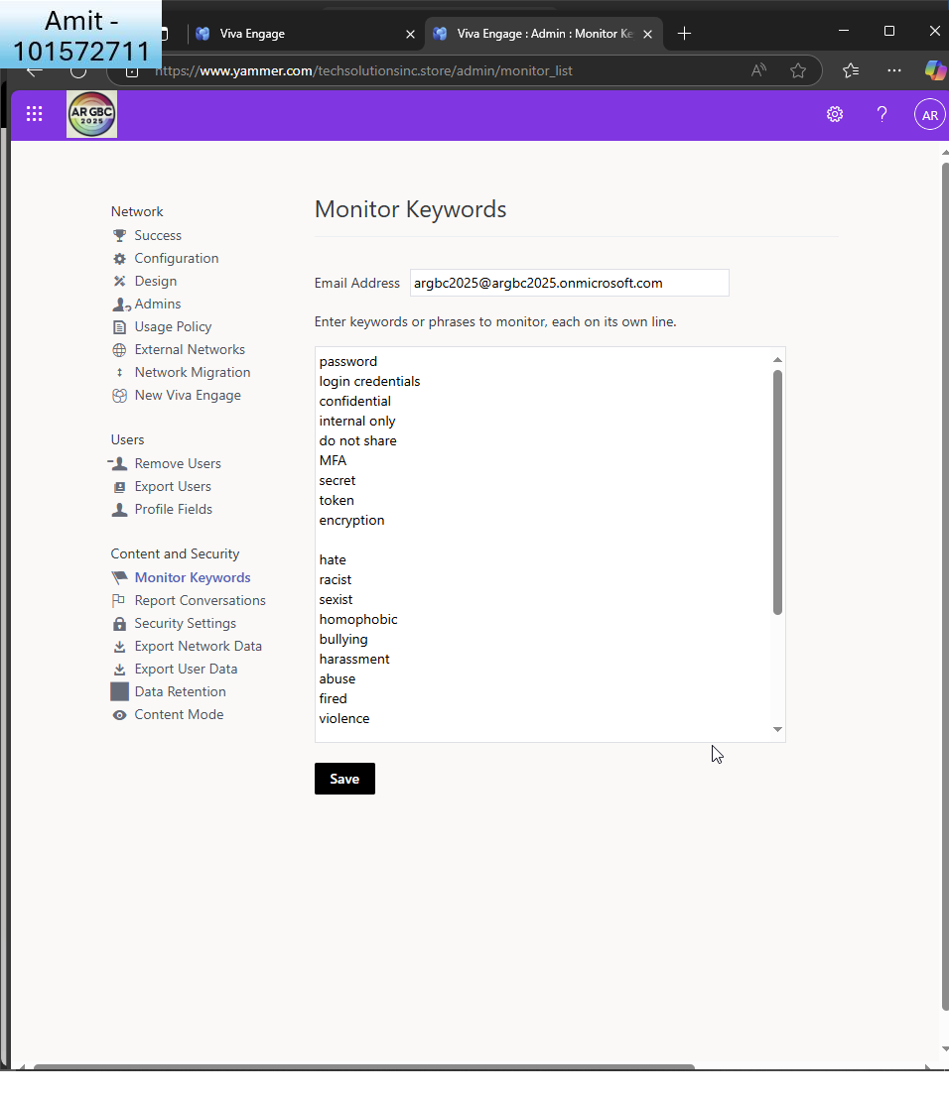  
      
    I go back to security settings for the tenant and click ’monitor keywords’ and add some keywords to monitor.  
    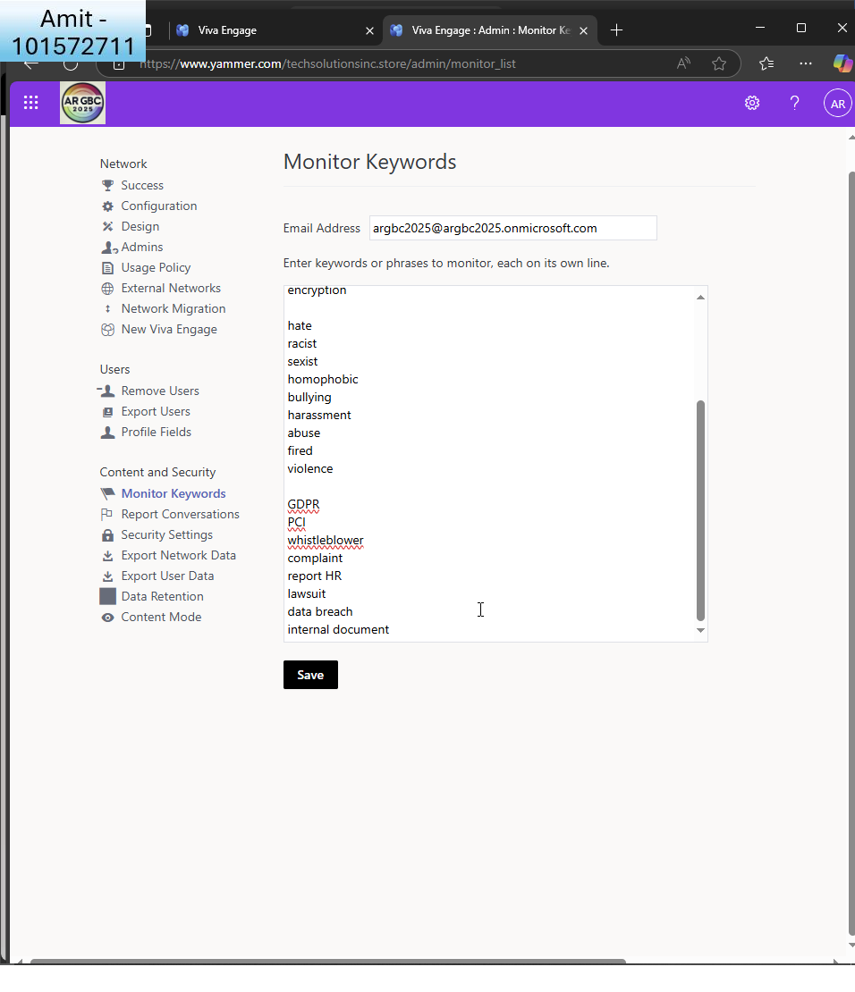

Here are some more.

Part B:  
  
Wow this task was so very eye-opening! it was like experiencing creating a real workplace start to finish. I started in SharePoint and created the IT, HR, and Marketing departmental sites in seperate of one another. Organising different document libraries and doing permissions gave a feel for the work that even the simplest aspect, like who sees what, entails. I like how MS365 organises this. Within the HR site, I enabled versioning and content approval, and it was really simple once I had located the settings, and it really made sense of how sensitive documents are managed in real organisations. I like how MS365 showcases this.

OneDrive work opened my eyes to compliance and retention at a different level altogether but I got so confused that onedrive is managed by sharepoint now! I disabled external sharing, then set policies to keep files for five years and auto-delete outdated files in a year's time. Learning how to create retention labels and deploy them through Microsoft Purview was so confusing at first (so many menus and policies!) but once I had it, it was powerful. I realised how important these features are when you're trying to manage data responsibly at scale.

The best part was Viva Engage, honestly. So, I set up internal sites for announcements and team chats, and it actually did feel like building the social centre of a real company. I can see this how can be someone’s full time job! I blocked external communication and even set up content filtering by keyword to highlight the important/dangerous stuff. One shock was the retirement of Yammer and moving everything to Viva. In the beginning, I was looking for the old admin centre, but it's set up differently in a way. It was a bit confusing, but it did give me some indication of how the platform is building out. It would be super useful if MS365 had access to legacy systems too.

There were a couple of frustrating moments along the way. Some of the config areas were tucked away where I wasn't expecting to find them, and plenty of back-and-forthing amongst the admin centres SharePoint, Viva, Purview, the primary M365 admins, Teams. It's a lot to keep track of. Opening, closing Windows, tabs and some admin centres opened in an entirely new window and required log in details again!  
  
Language wasn't being applied consistently either. "policy", "label", and "retention" had different meanings in different areas. And while I liked the new Viva UI, it took way too long to discover the correct settings (specifically, to block external messaging). But it did teach me a lot. Task 3 boosted my confidence in using Microsoft 365 to create safe, organised areas in which one can really work and collaborate. Much to keep track of, but also fascinating to see it all come together but I still have a lot to learn.

**Task 4: Monitoring and Reporting**

1. **Configure Audit Logs**:
   * Enable and configure audit logging in the Microsoft 365 compliance center.  
       
     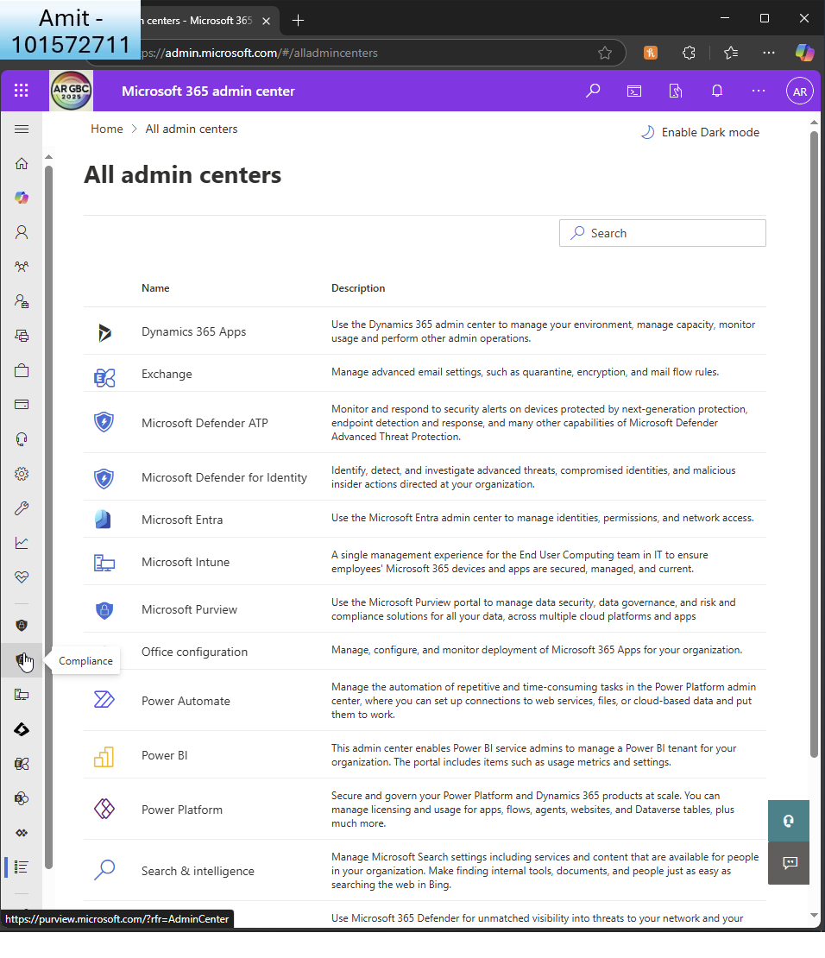  
       
     I go to the compliance centre  
       
       
     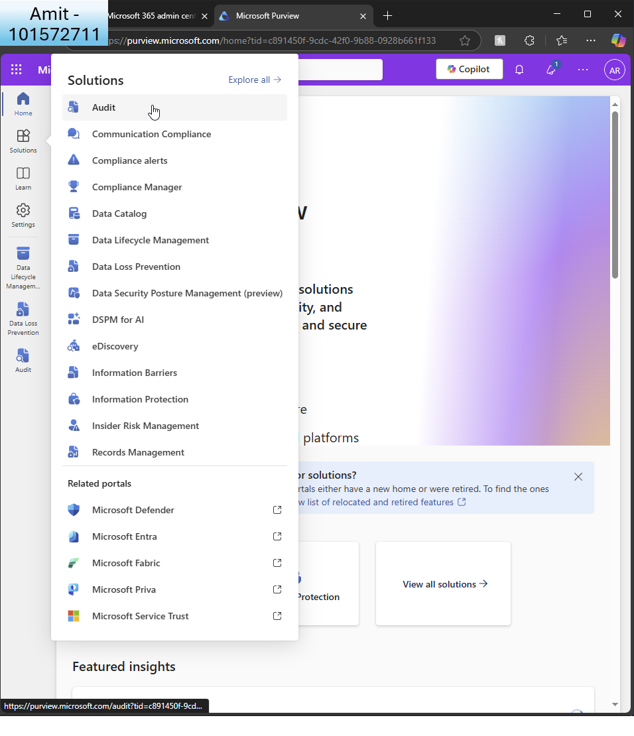

Under ‘solutions’ I choose ‘audit’  
  
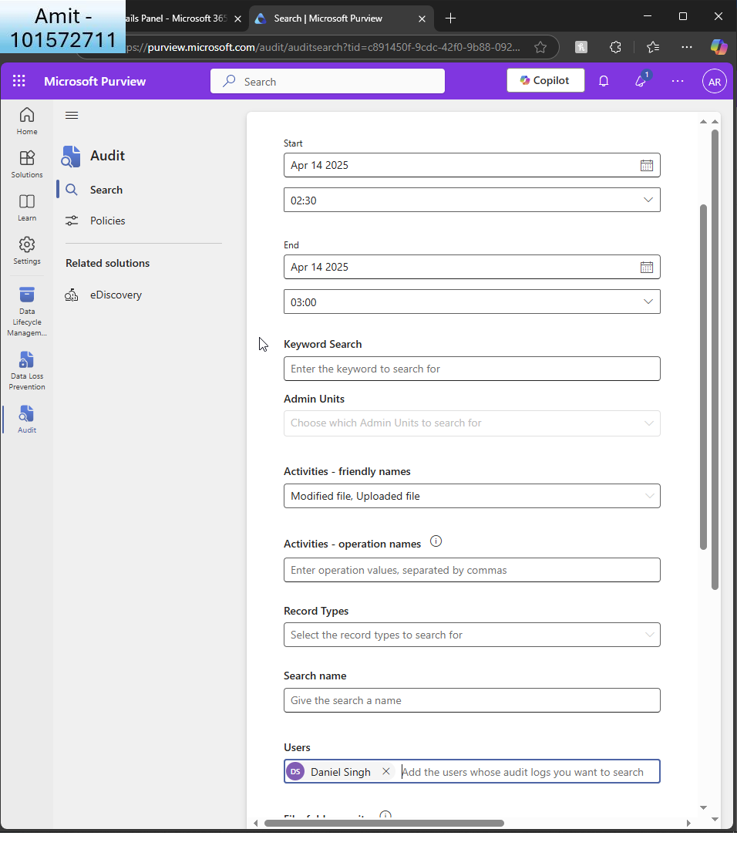I can see auditing is already enabled (from a previous task).

- Create a custom audit log search to track user activities related to at least one activity in SharePoint such as updating the site content

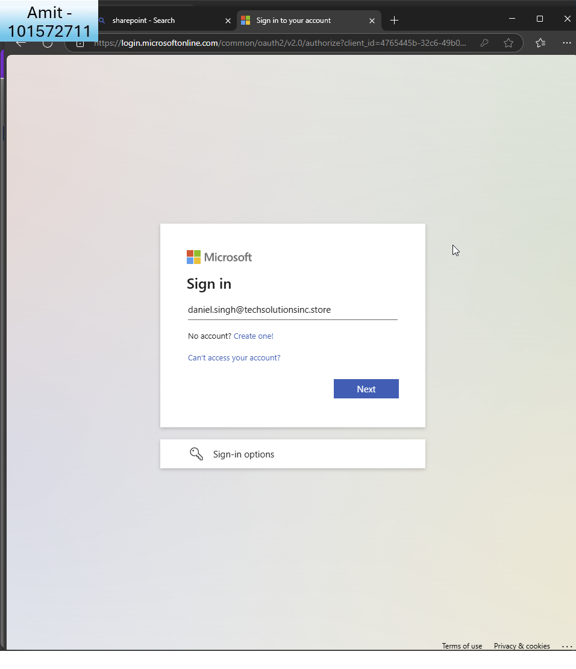  
I wish to run a search for user ’Daniel’ to see if he uploaded and modified a file to IT sharepoint site. I log in as him to replicate the actions.  
  
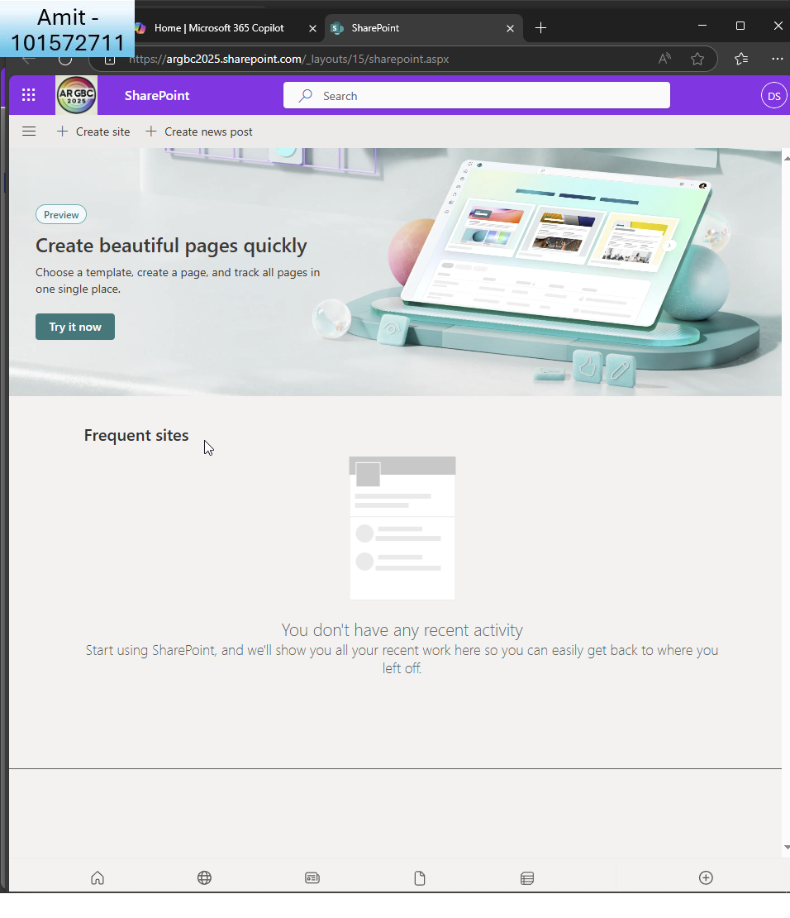  
First I must create a site within IT sharepoint  
  
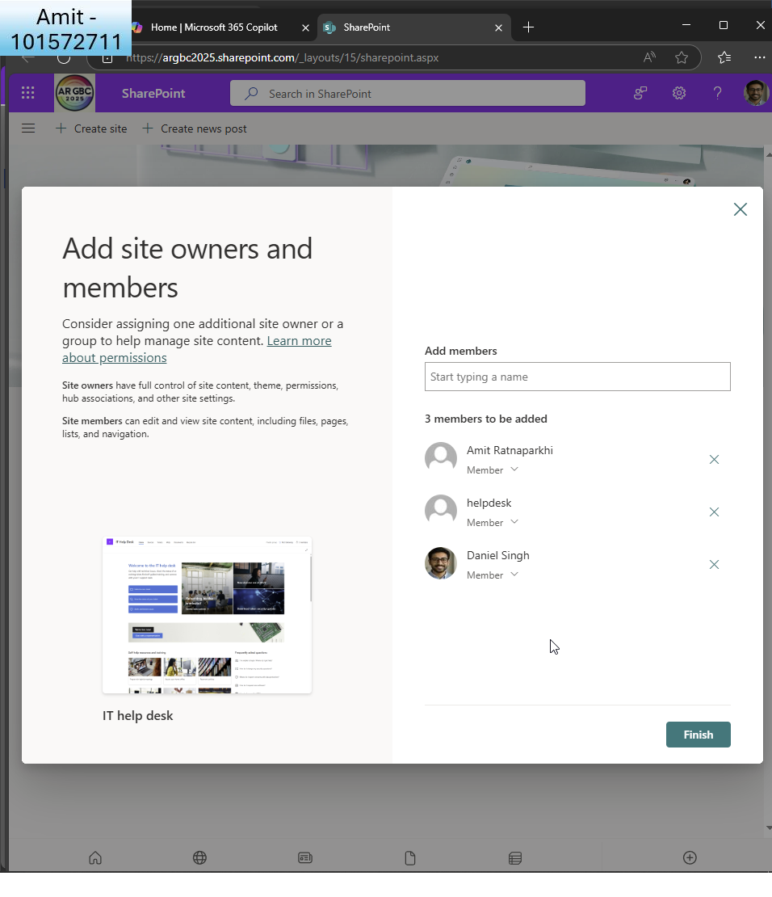I add ’Daniel’ with GA and helpdesk as members  
  
  
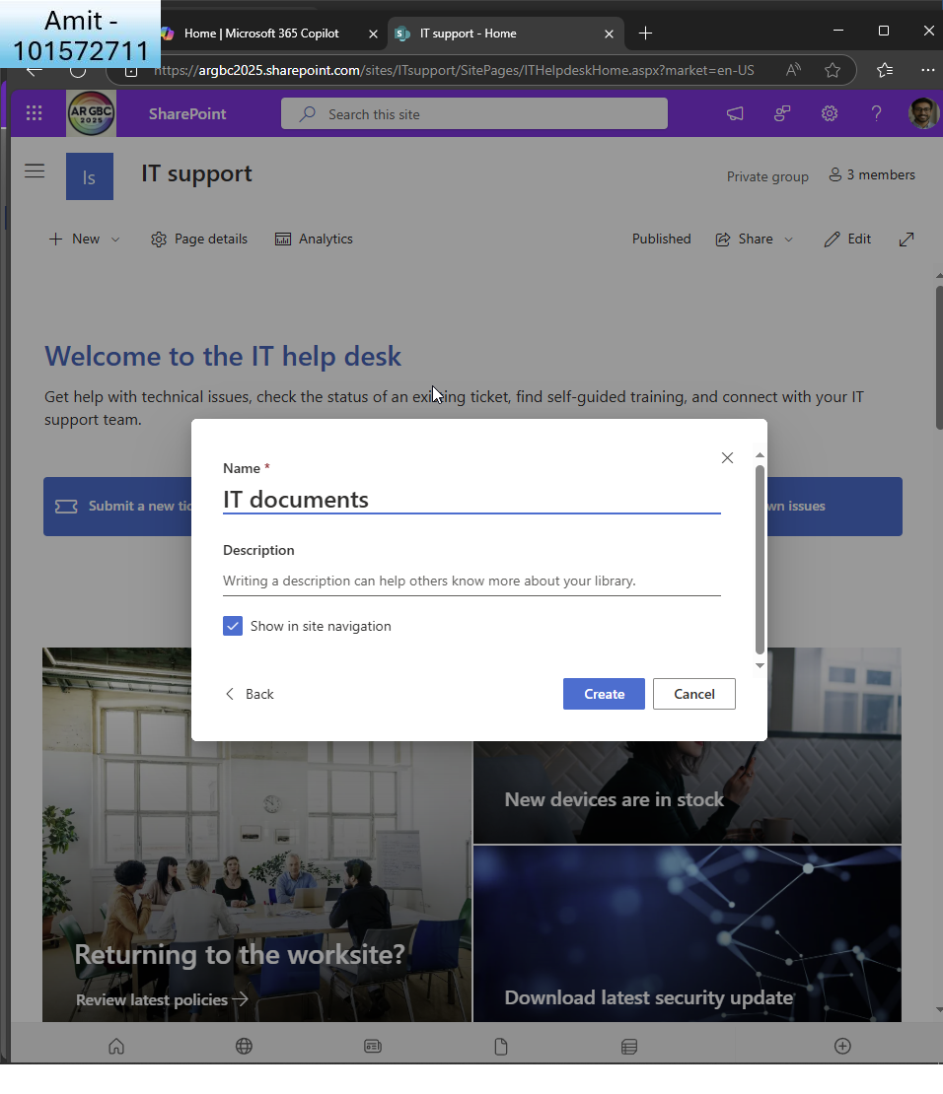  
I create an ’IT documents’ page  
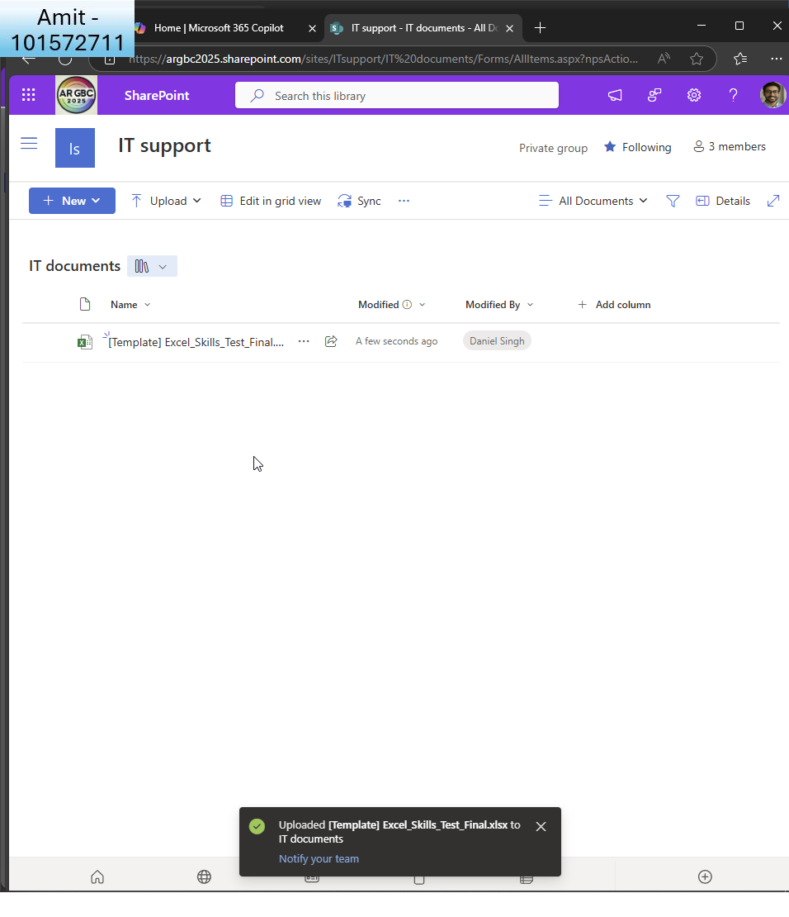I log in as Daniel once more and upload an excel file  
  
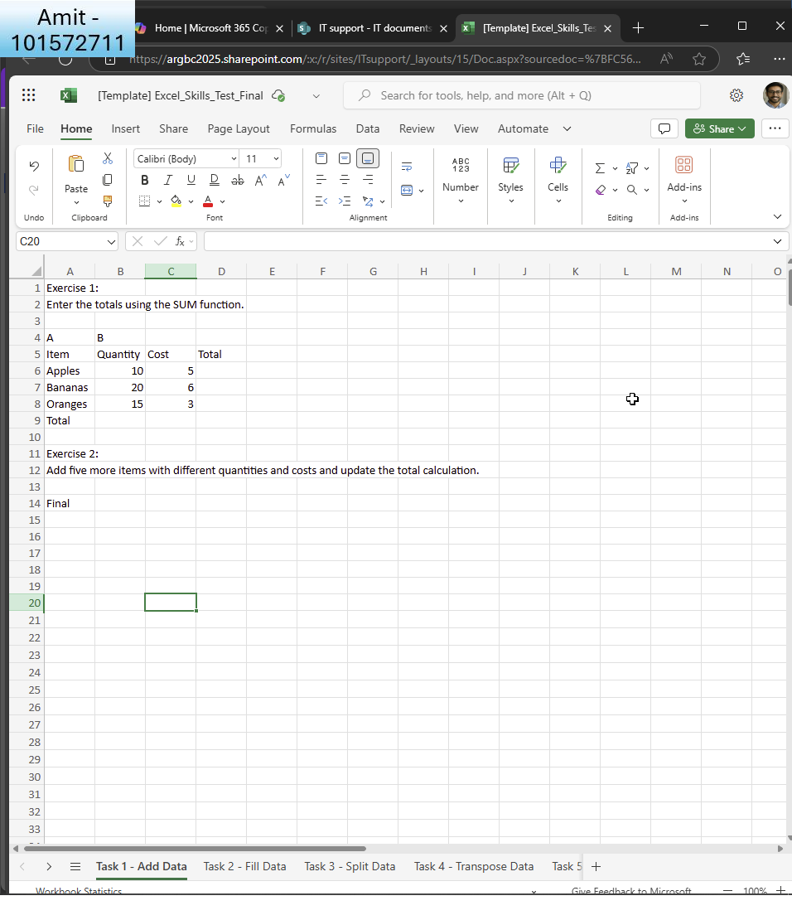I modify the file  
  
  
I now wait 30 minutes and run a search to see any modified/uploaded files by Daniel today  
  
  
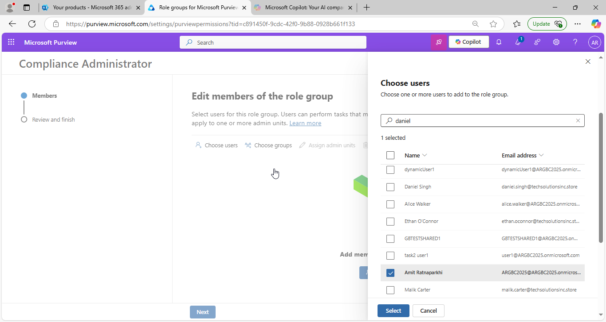I realise I need to assign the role of ’compliance administrator’ to the GA before I can run audits

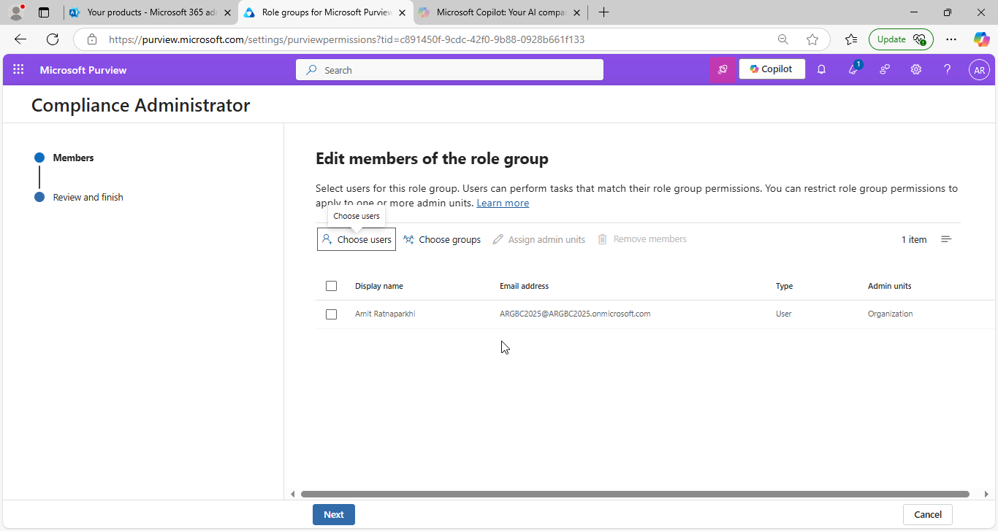I assign the role to GA  
  
  
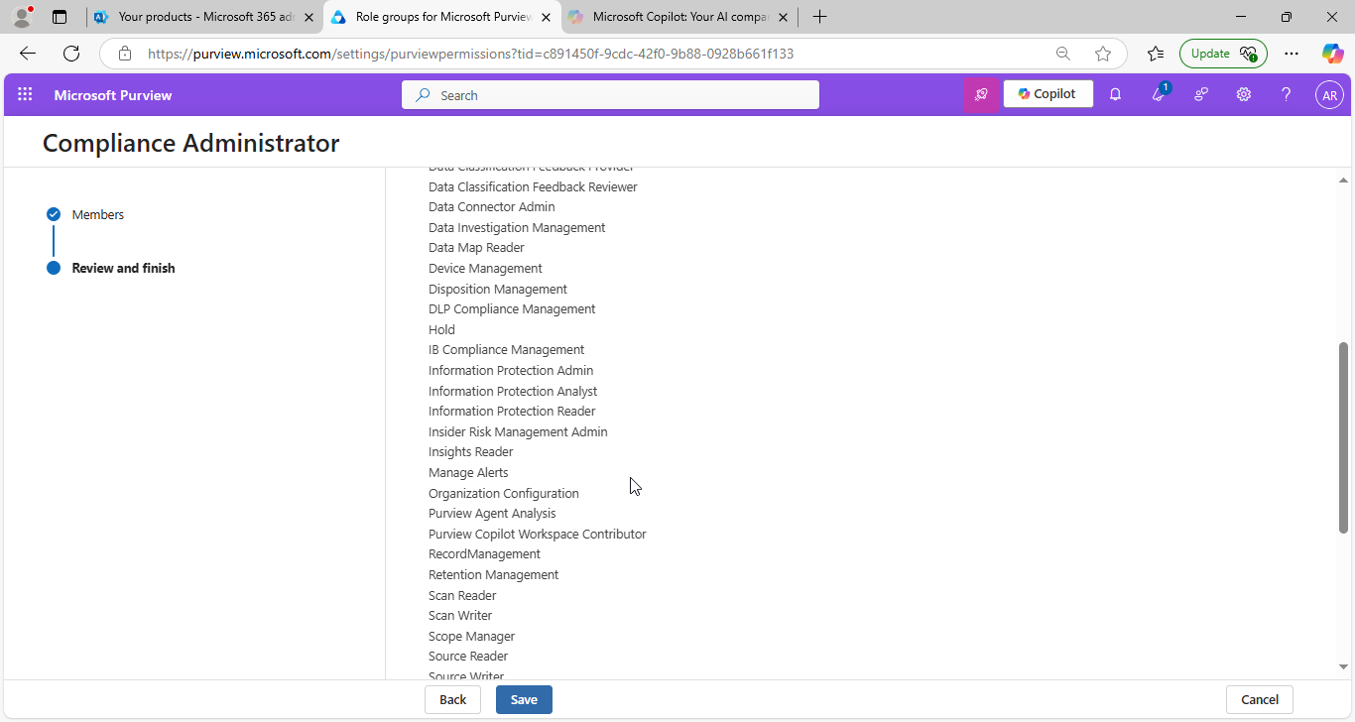  
I click ’save’  
  
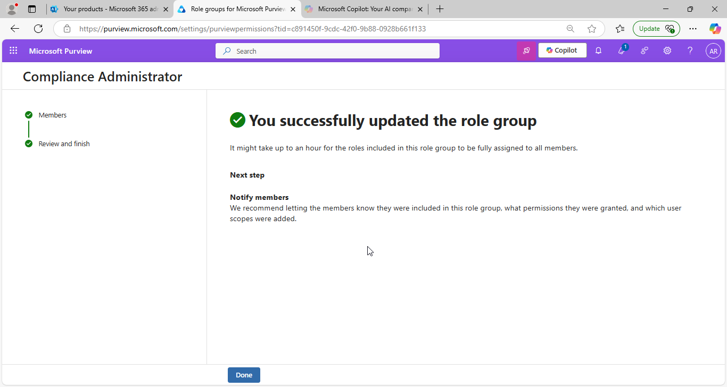  
I see the confirmation  
  
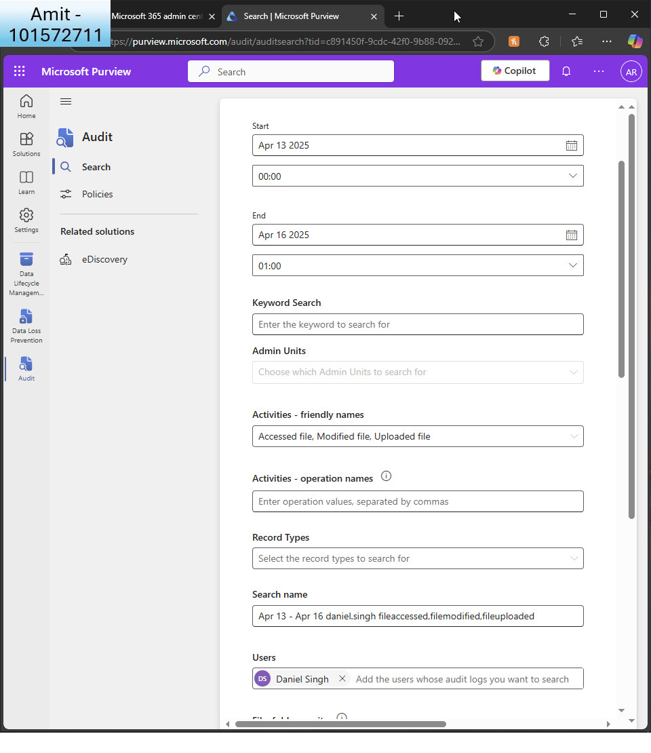

And I create a search for any file that Daniel has accessed, uploaded or modified in the past 3 days

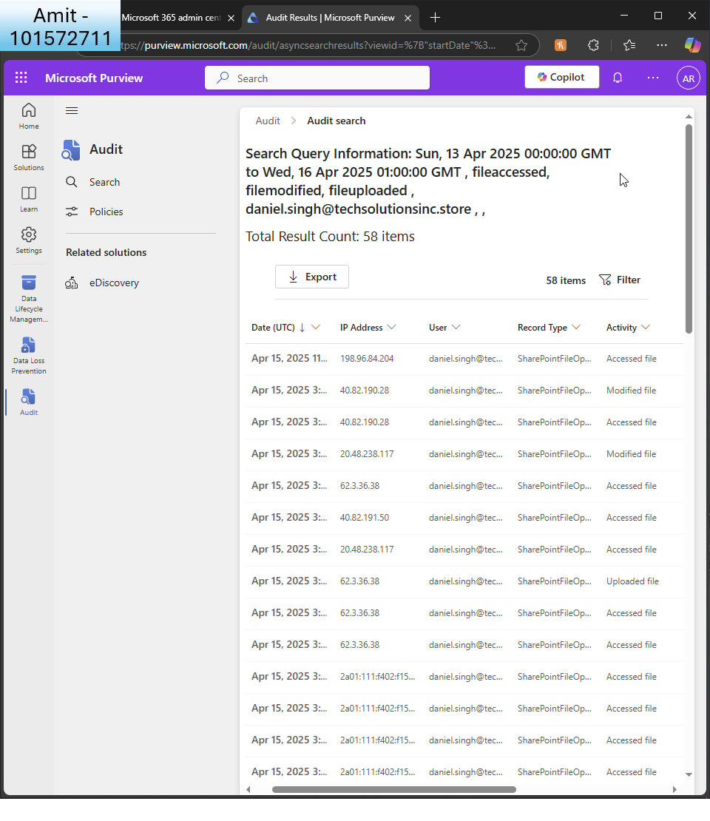  
  
I receive the results  
  
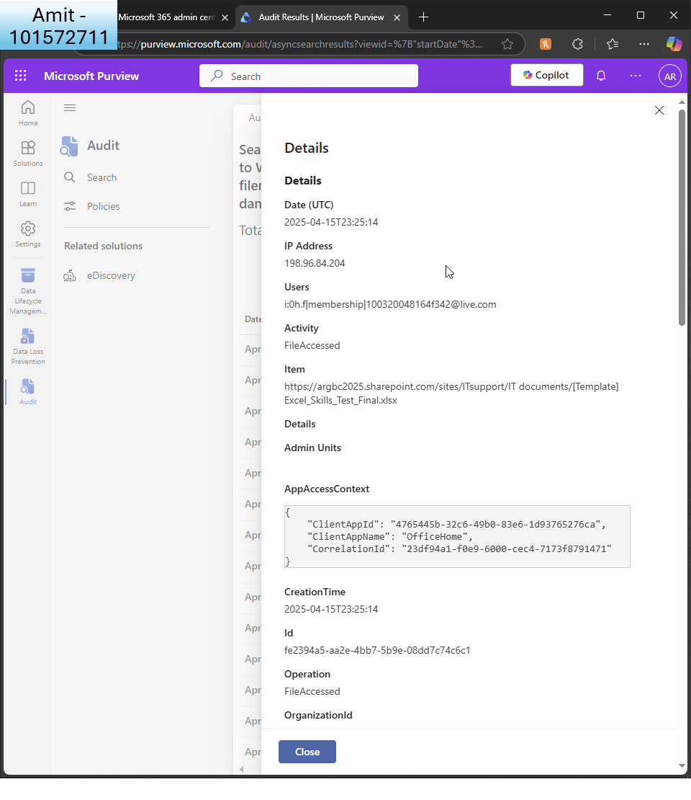  
  
I click on the latest, for example  
  
  
  
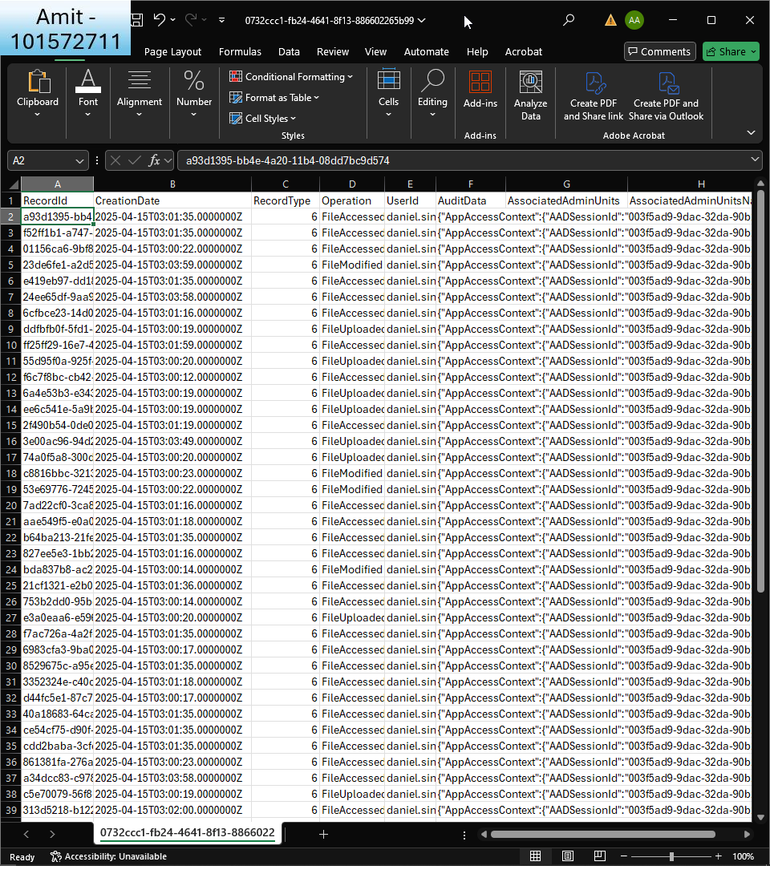  
  
I export the logs as CSV and open in Excel to examine further

1. **Set Up Alerts**:
   * Configure alert policies to notify administrators of suspicious activities, such as multiple failed login attempts or mass deletion of files.  
       
     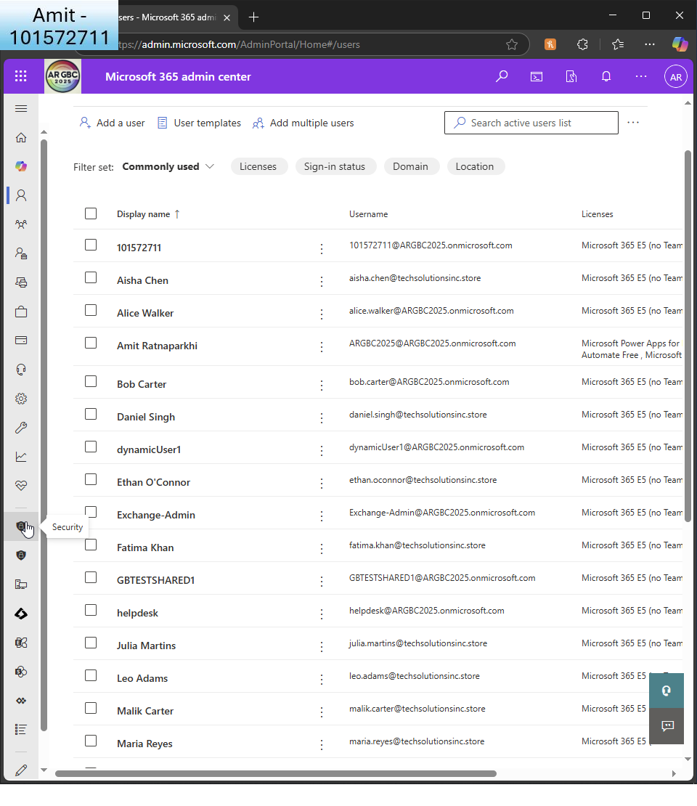  
       
     I go to Defender   
       
       
       
       
       
     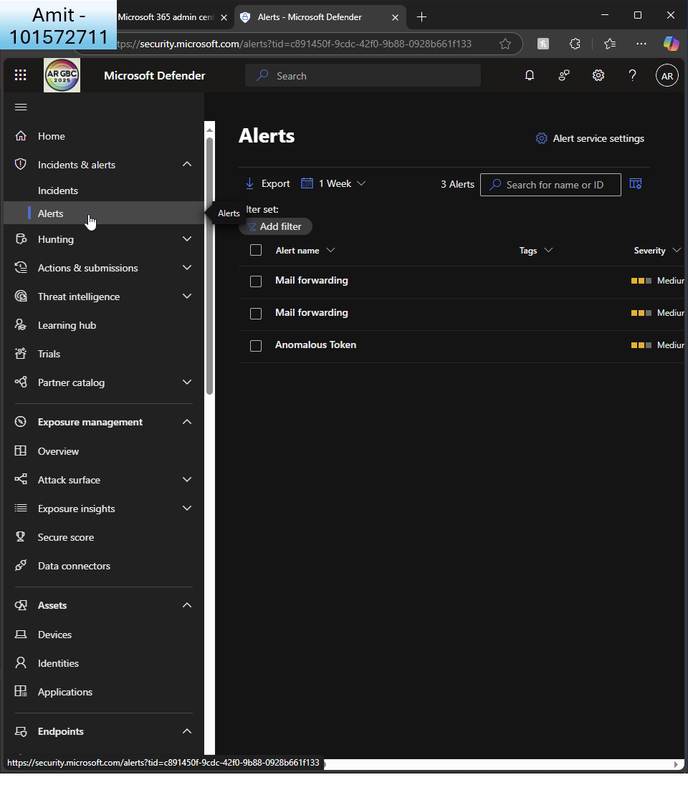  
       
     I create a policy for an alert  
       
     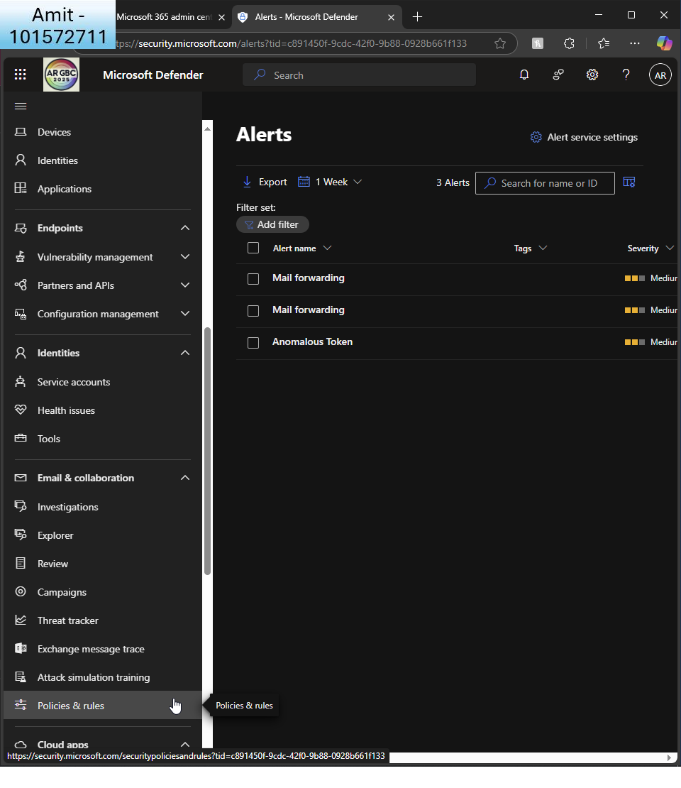  
       
     I go to ’policies & rules’  
       
     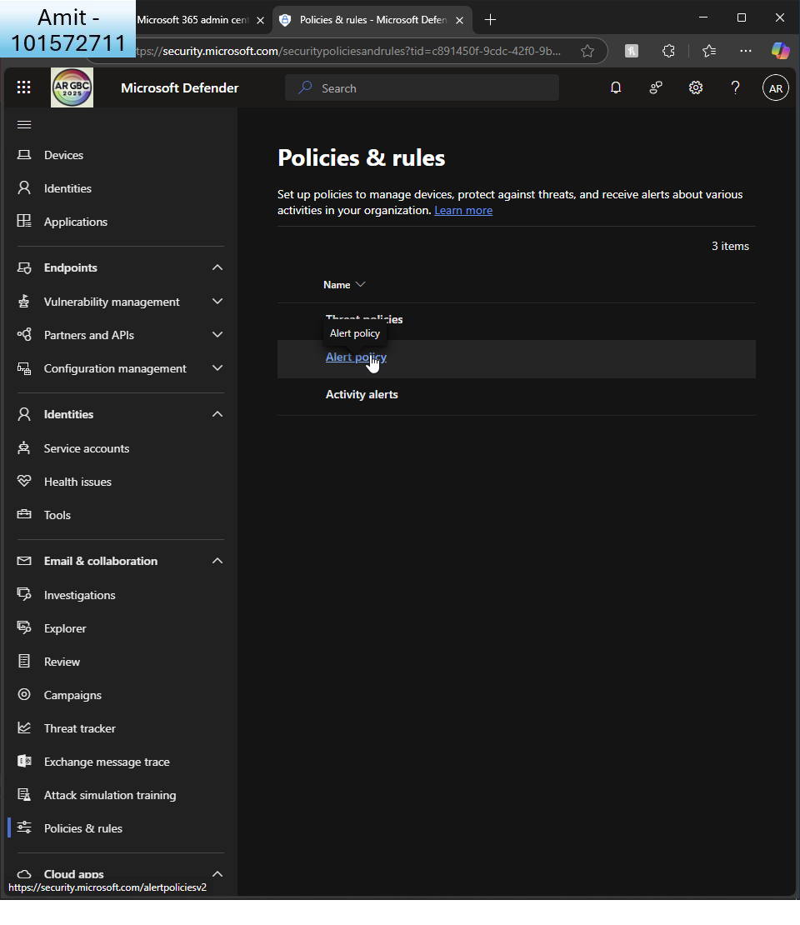  
       
     I click ’alert policy’  
       
     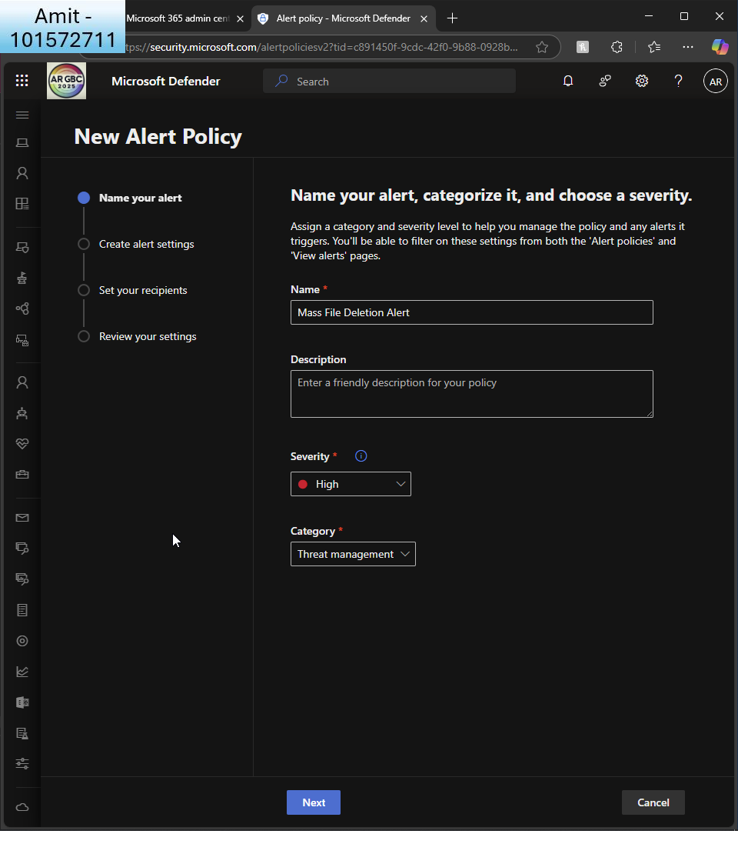  
       
     I name the policy and give it a high severity and categorise it under ’threat management’  
       
     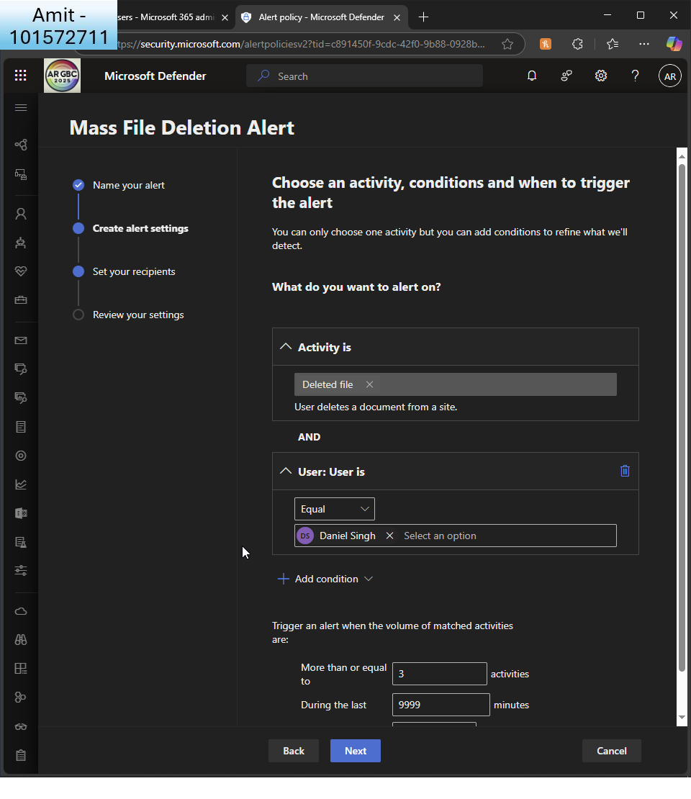  
       
     I choose to create a policy alert if files are deleted by user ’Daniel Singh’   
       
     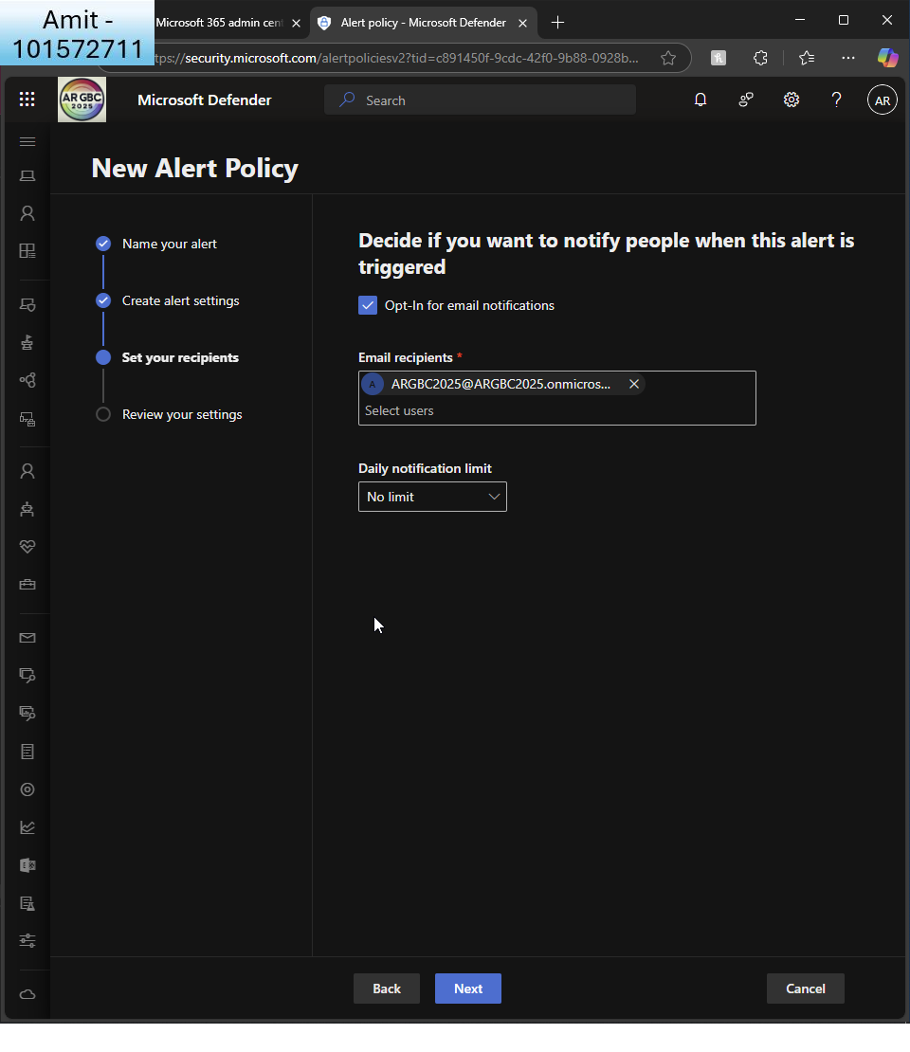  
       
     I set GA as a recipient of notification  
       
     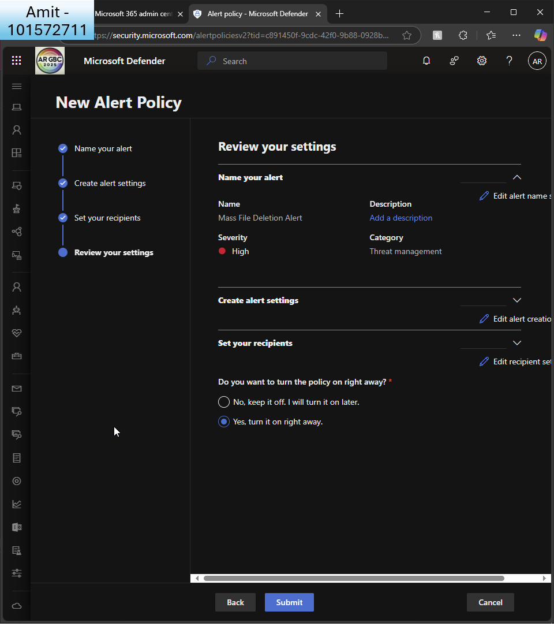  
       
     I review settings and turn it on straight away  
       
     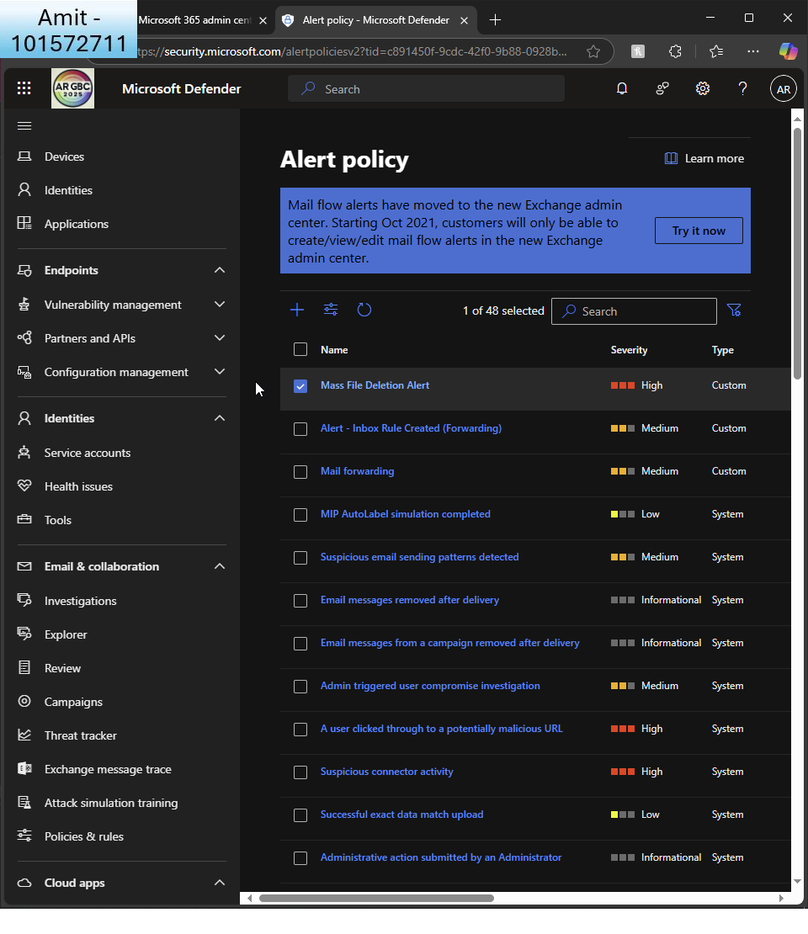  
       
     I can see my new alert policy  
       
     I realise that the policy was not created in the correct place. It was created under ’email and collaborations’ and I now realise it must be created under ’MS defender for cloud apps’. I choose to create an alert for ’mass download by a single user’.  
       
       
       
       
     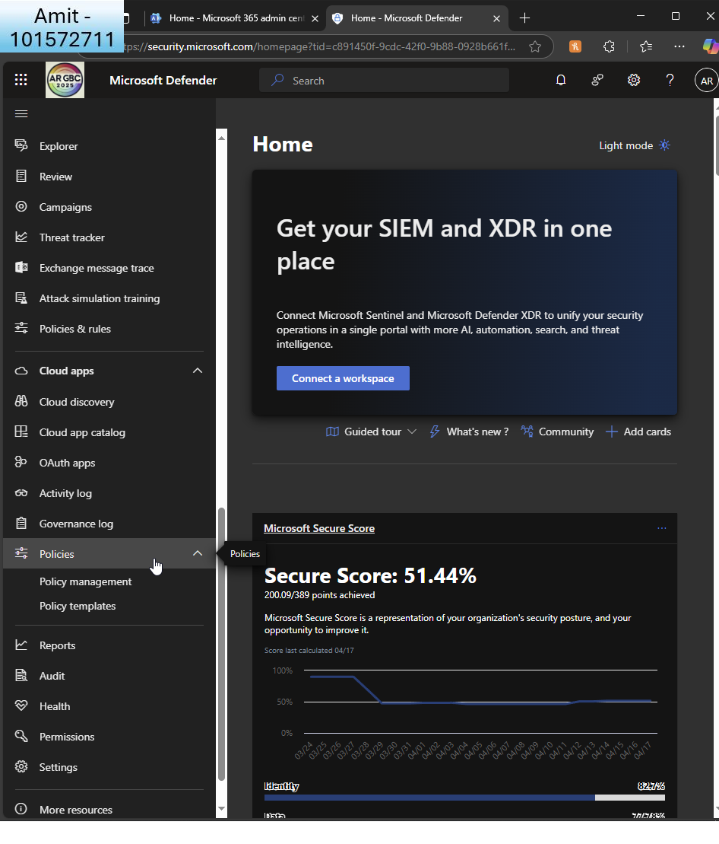  
       
     In Defender, I go to ’cloud apps - policies’  
       
       
       
     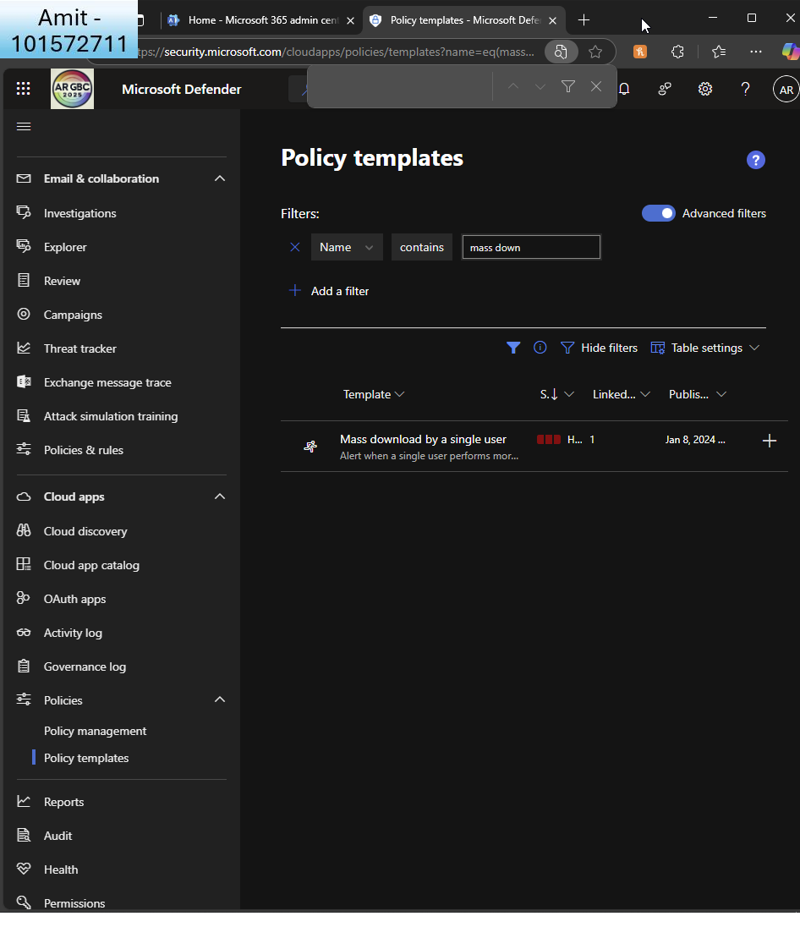  
       
     I search for a policy template named ’mass download by a single user’  
       
     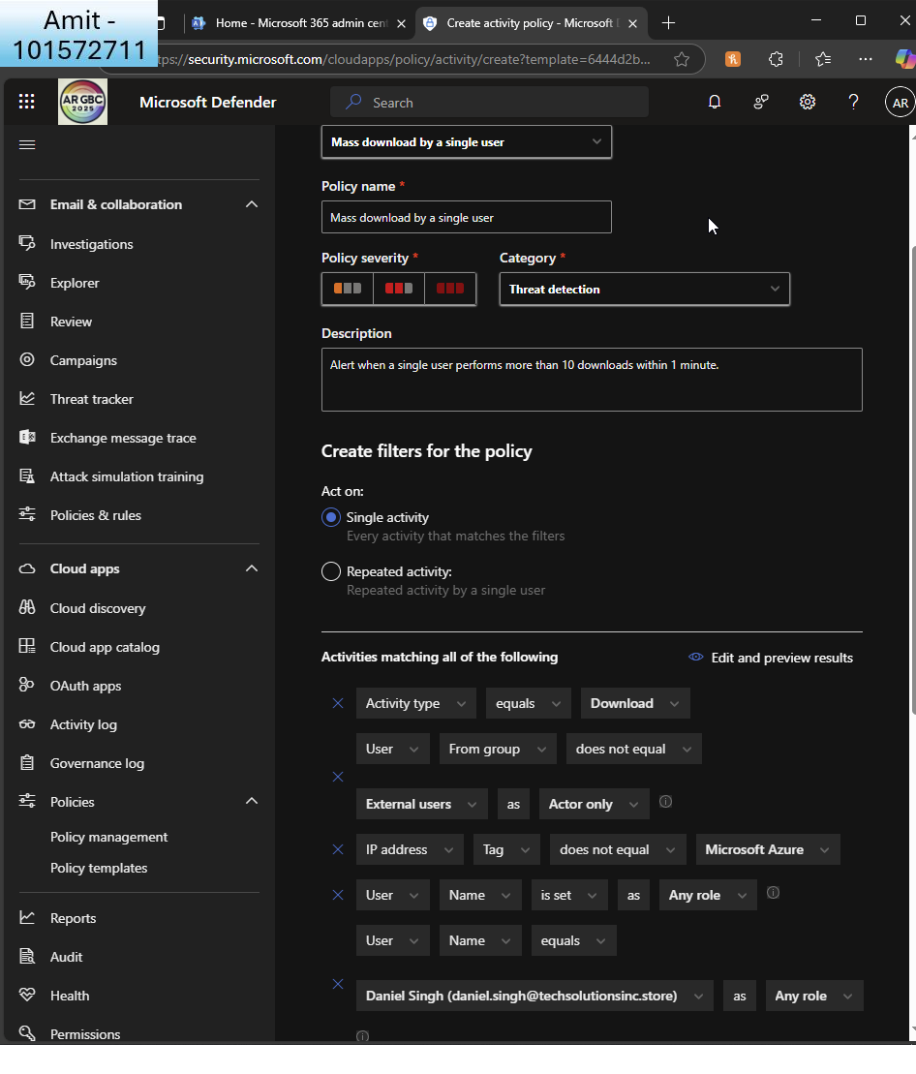  
       
     I edit the policy to target user ’Daniel’  
       
     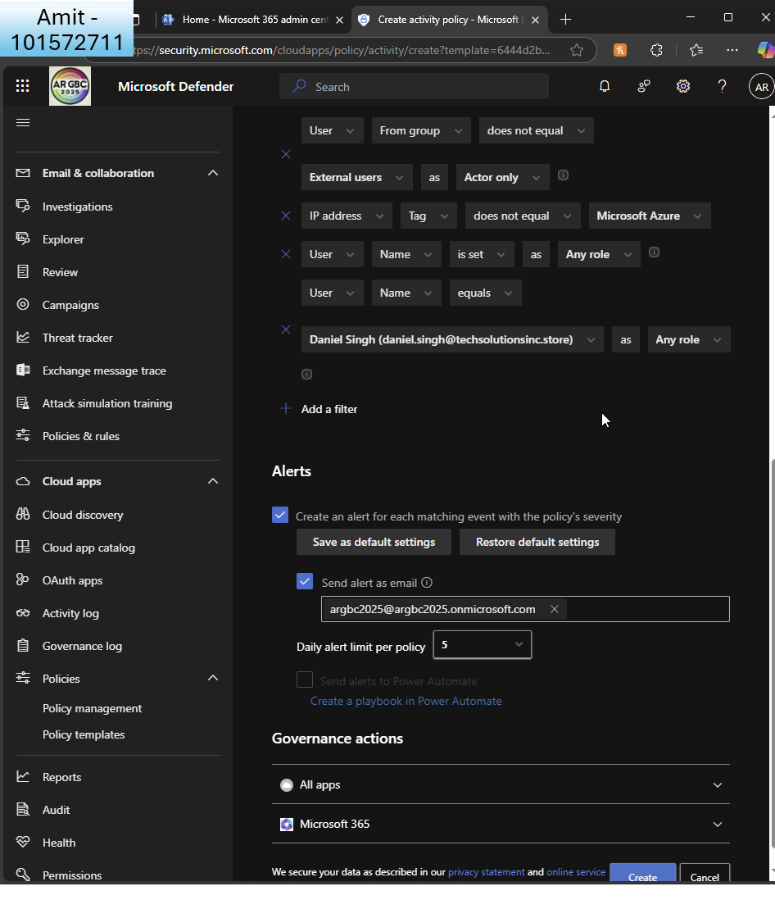  
       
     I make sure GA gets sent the alert  
       
     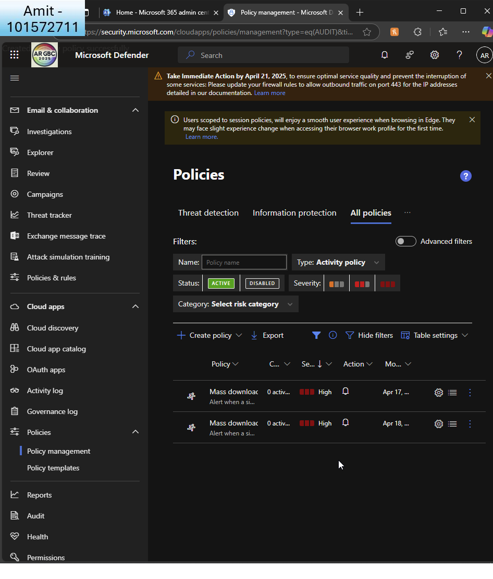  
       
     I can see my new policy listed  
       
     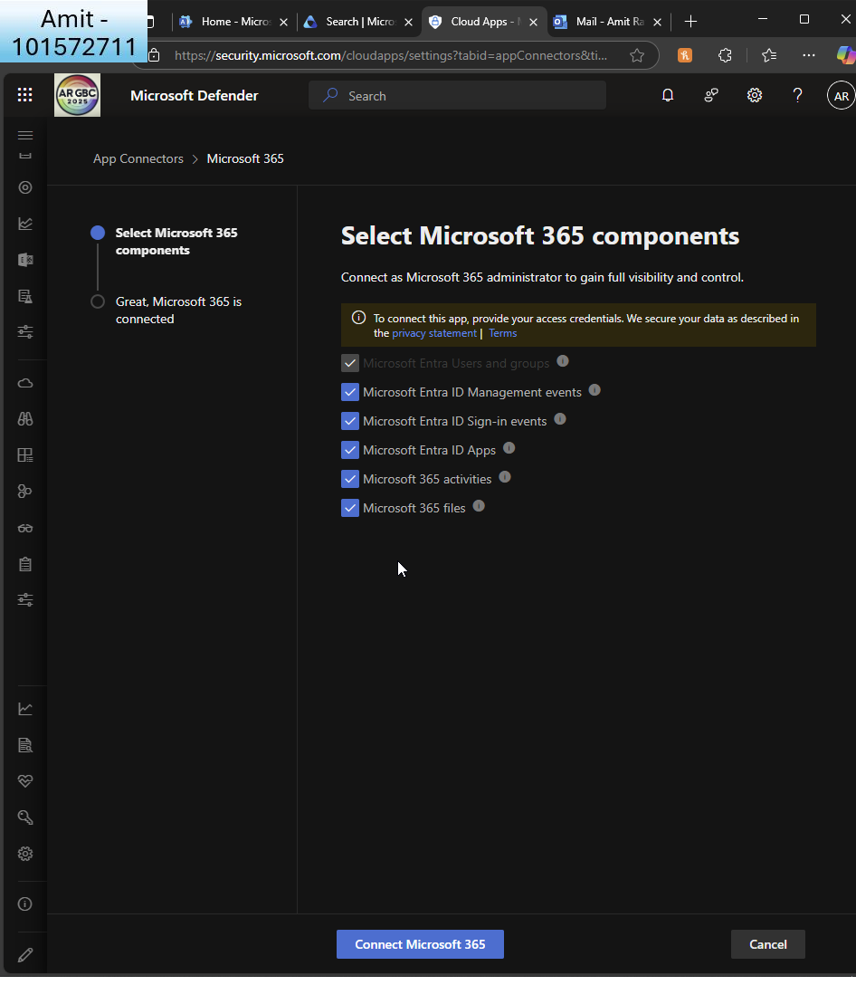  
       
     The alert was not showing in ’activity logs’ so I ensured that the app connector was active for MS365 components  
       
       
     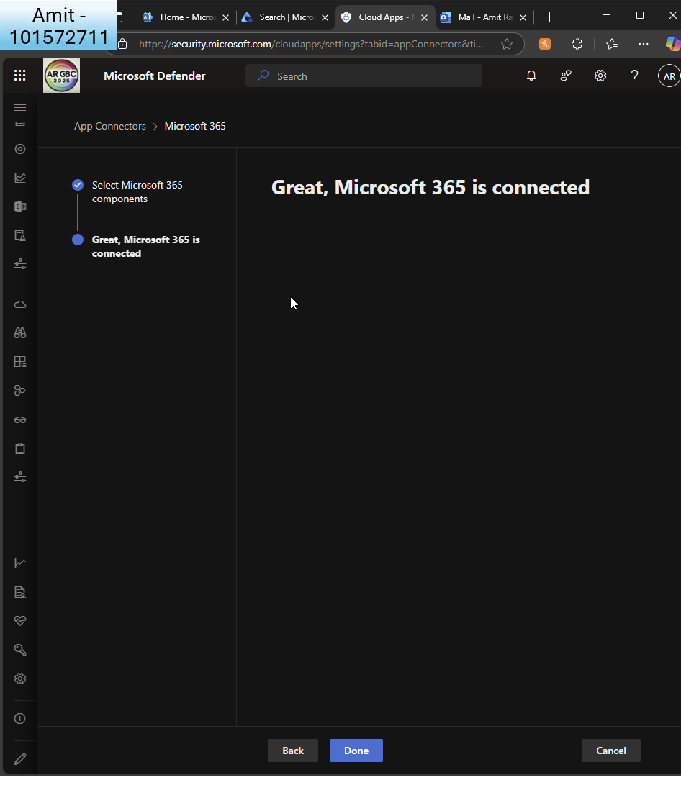  
       
     I see MS365 is now connected  
       
       
     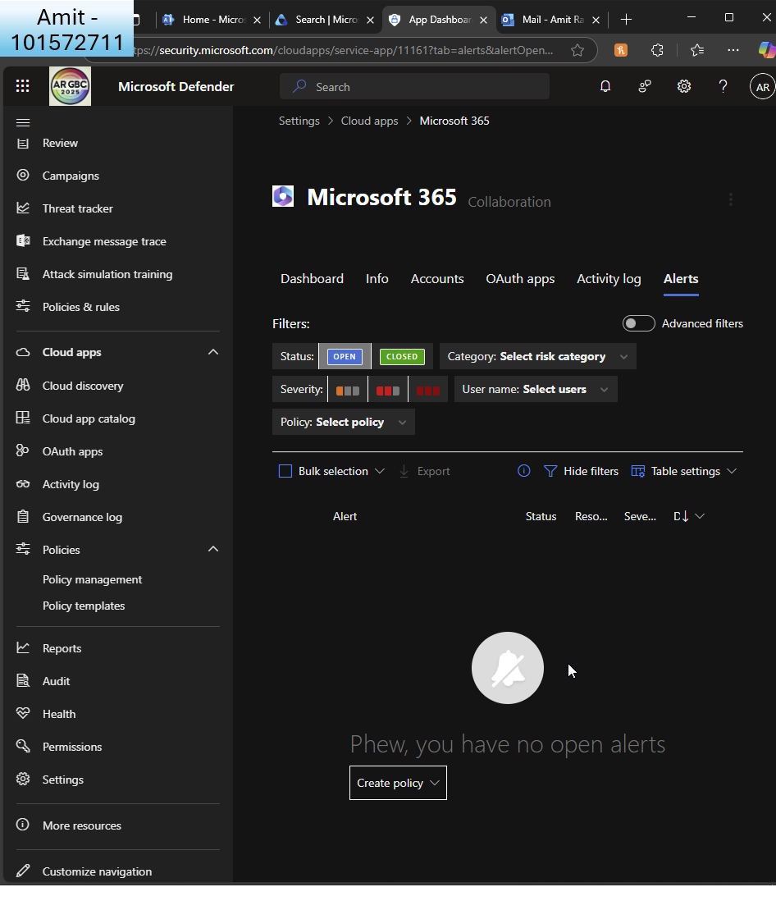  
     I create the policy directly in the app connector page to trigger an alert  
       
     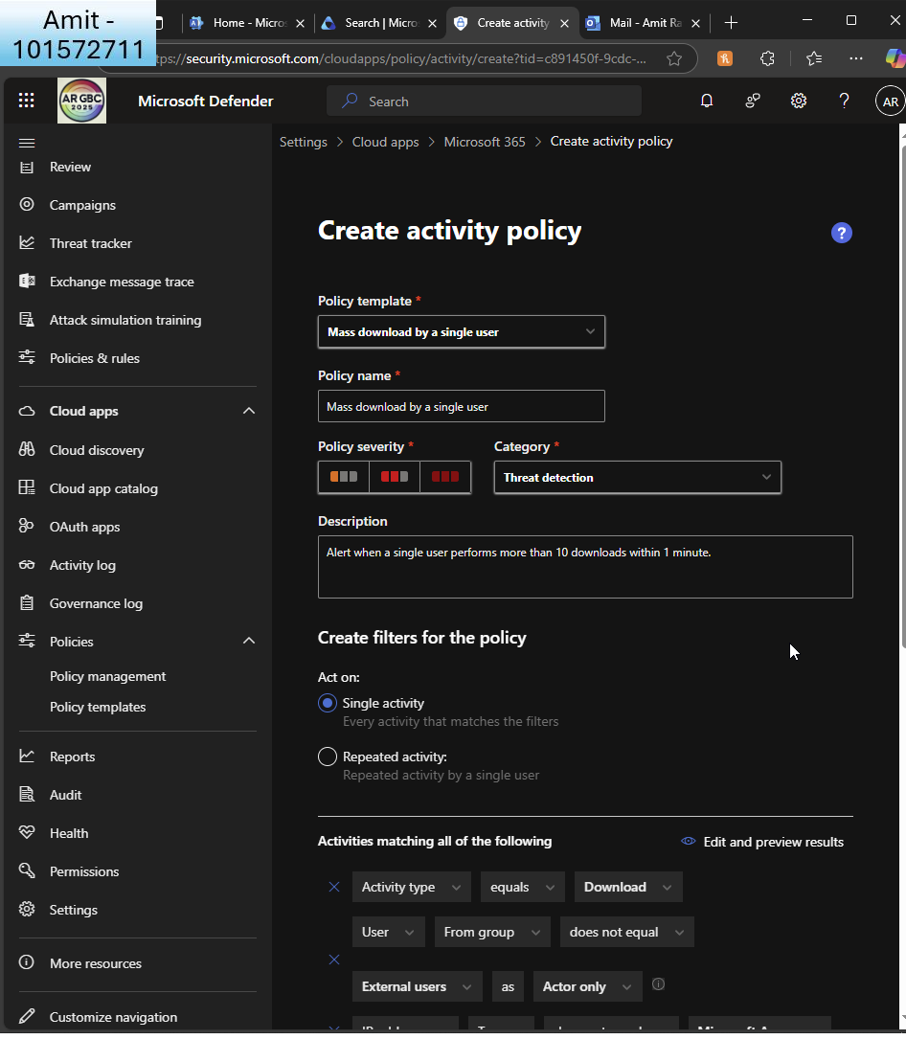  
       
     I match the previous policy of ’mass download by single user’  
       
     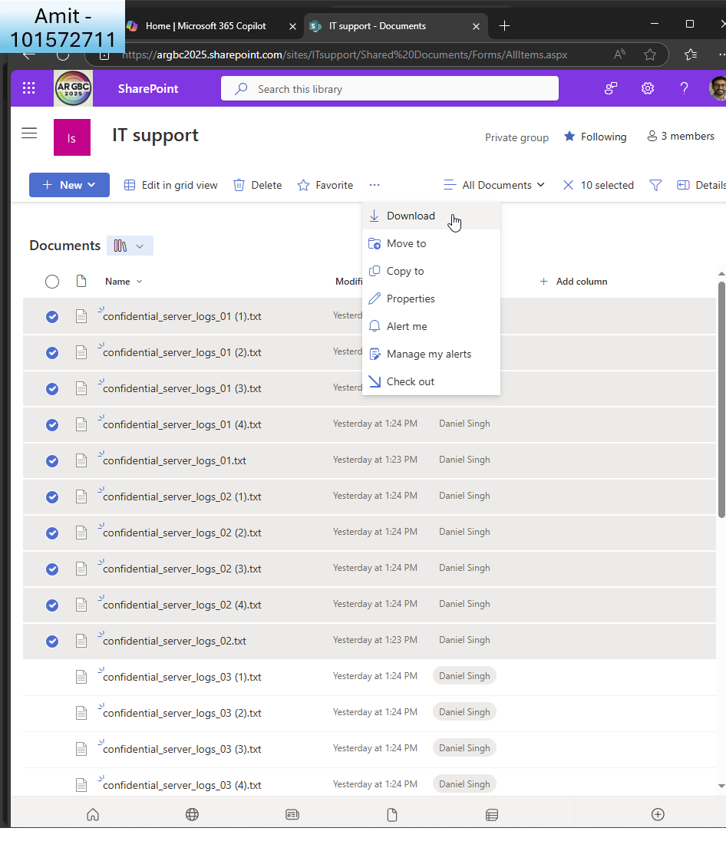  
       
     I log in as Daniel and mass download files  
       
     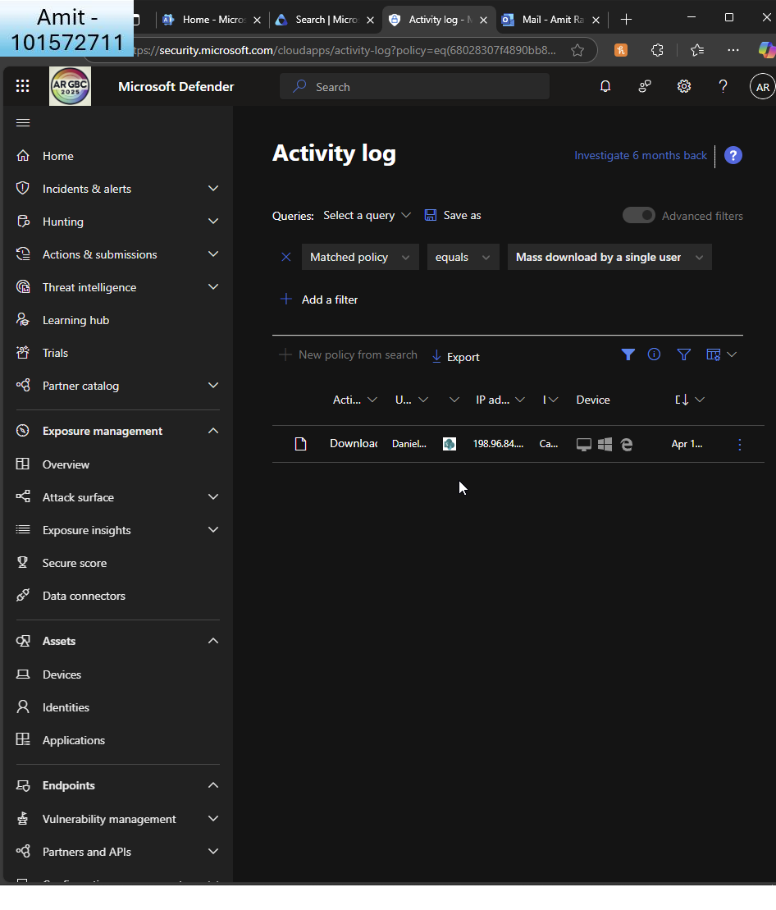  
       
     I can see in the cloud apps activity log, there is a record of the download  
     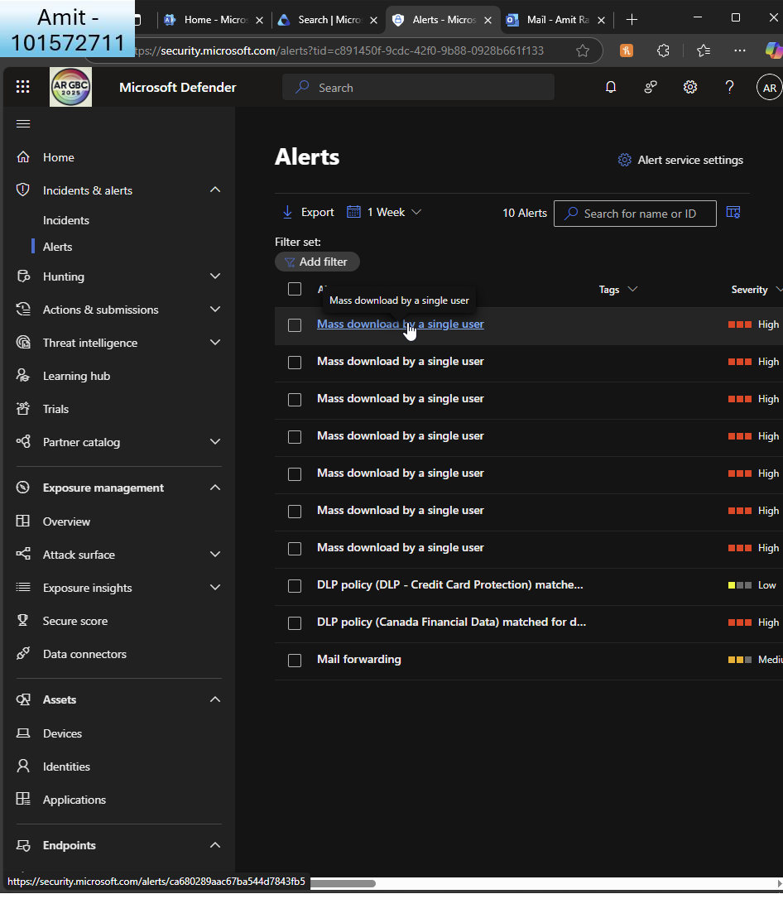  
       
     I wait a few minutes and can now see the alert in Defender  
       
     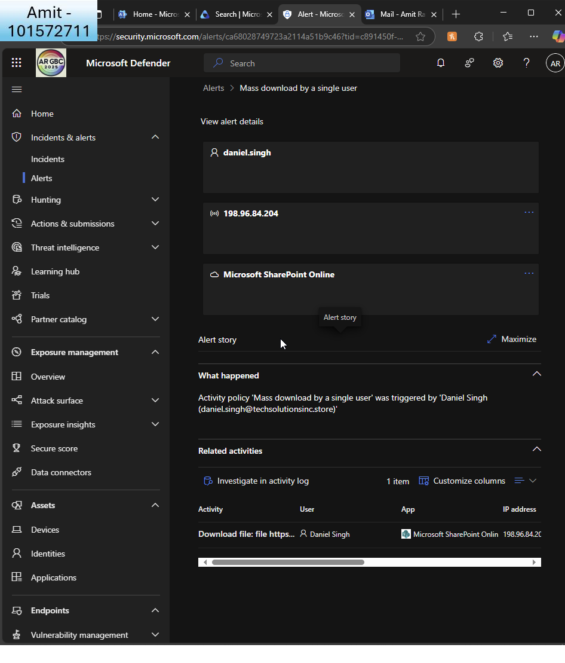  
     If I click on one, it shows the alert was caused by Daniel downloading mass files  
       
       
     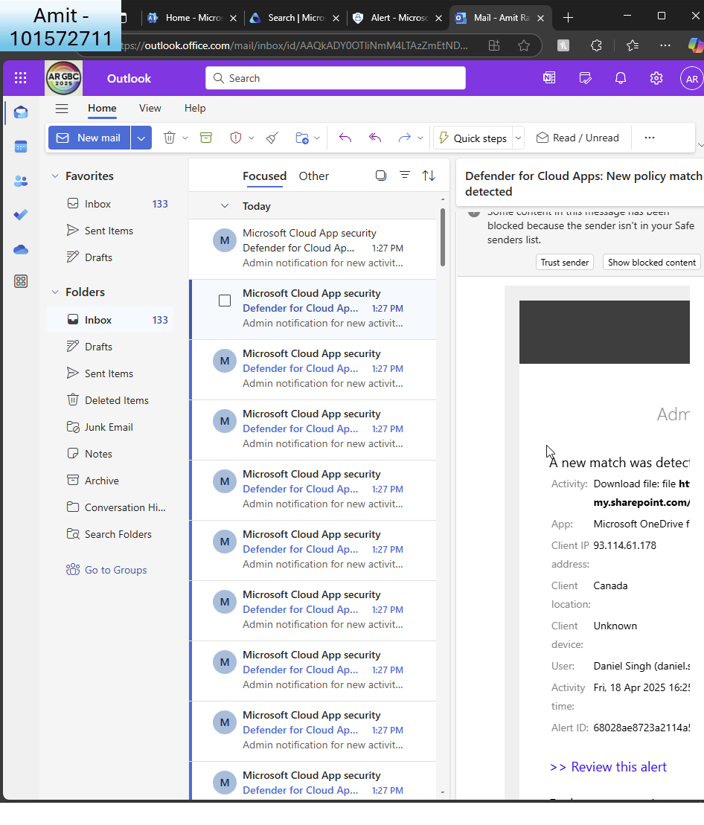  
       
     I also receive the alert as a notification to GA

* + Set up notifications for data loss prevention (DLP) policy breaches. (You can navigate to Insider risk management)   
      
    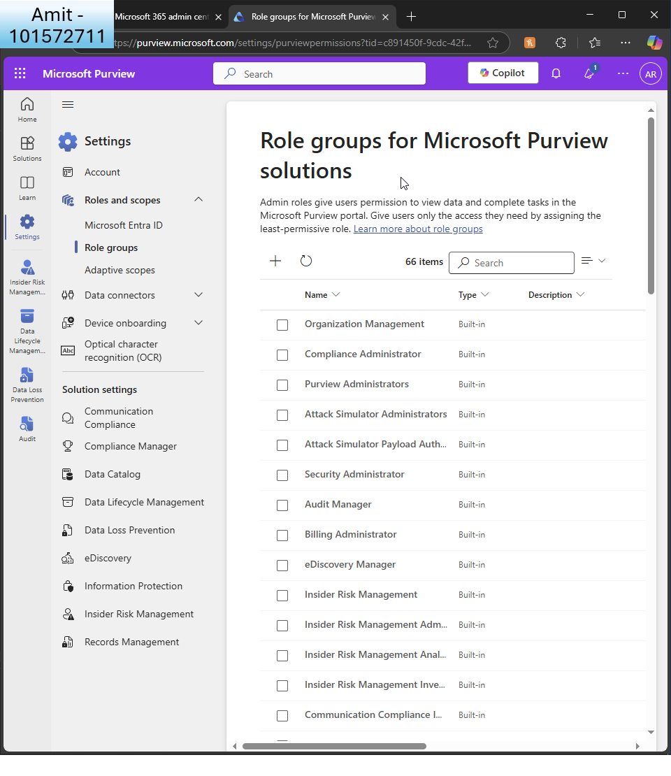  
      
    I see insider risk management role is not assigned by default to GA  
    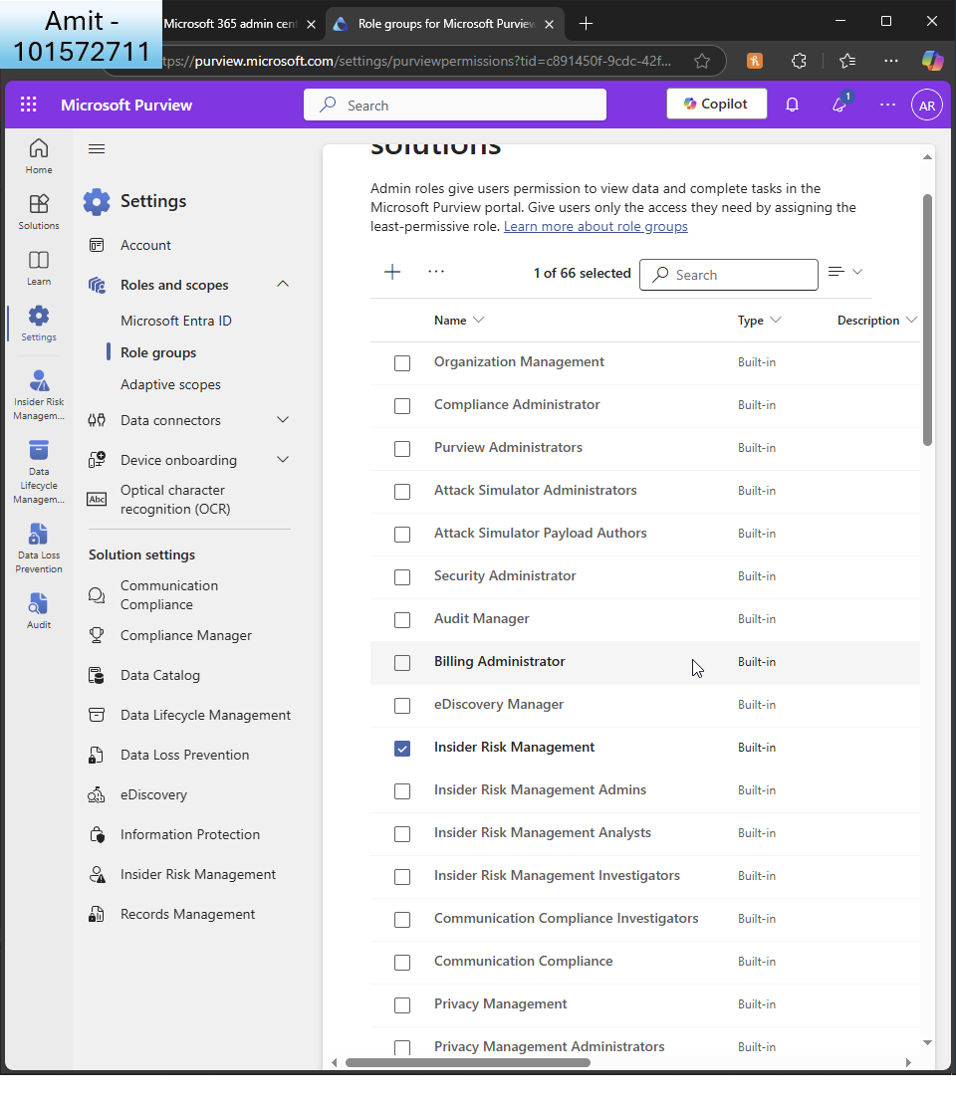  
      
    I click it  
      
    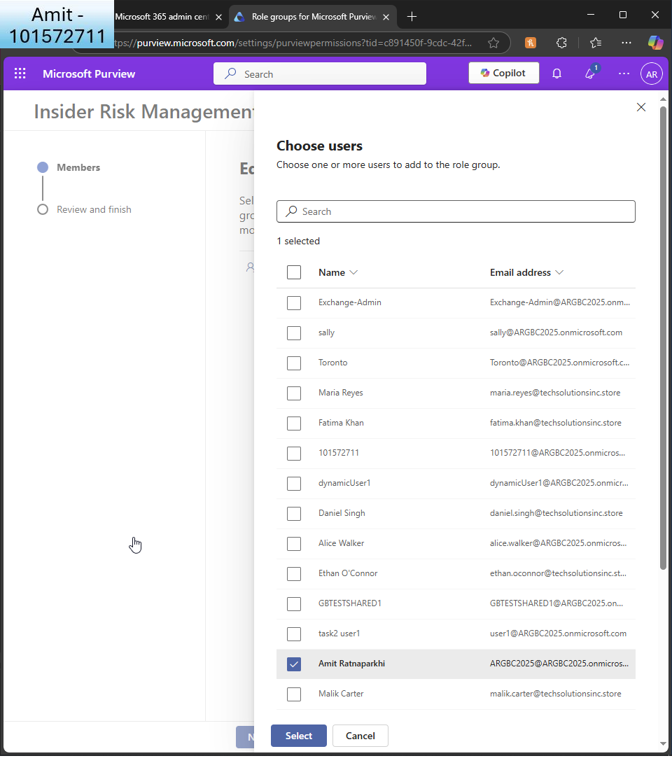  
      
    I choose GA as the user  
      
    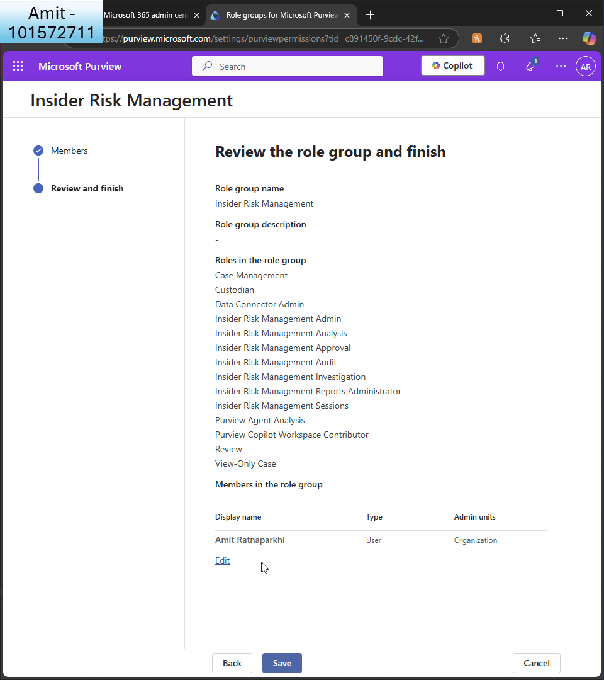  
      
    I review and finish  
      
    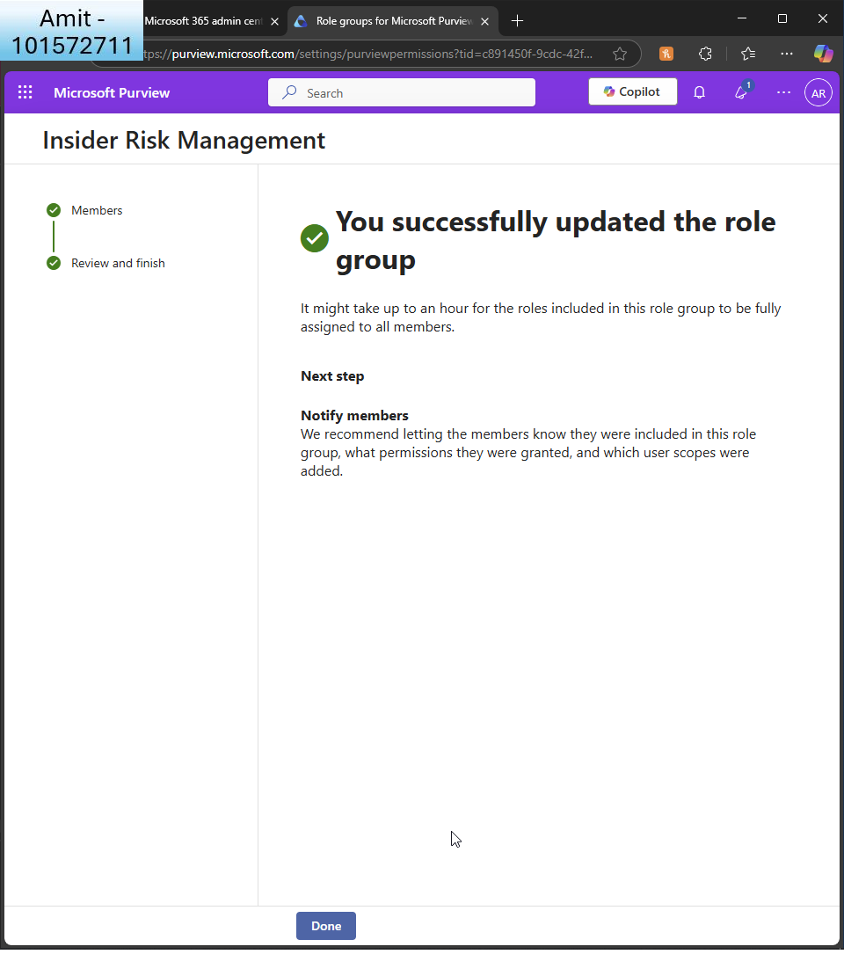  
      
    I see the confirmation  
      
    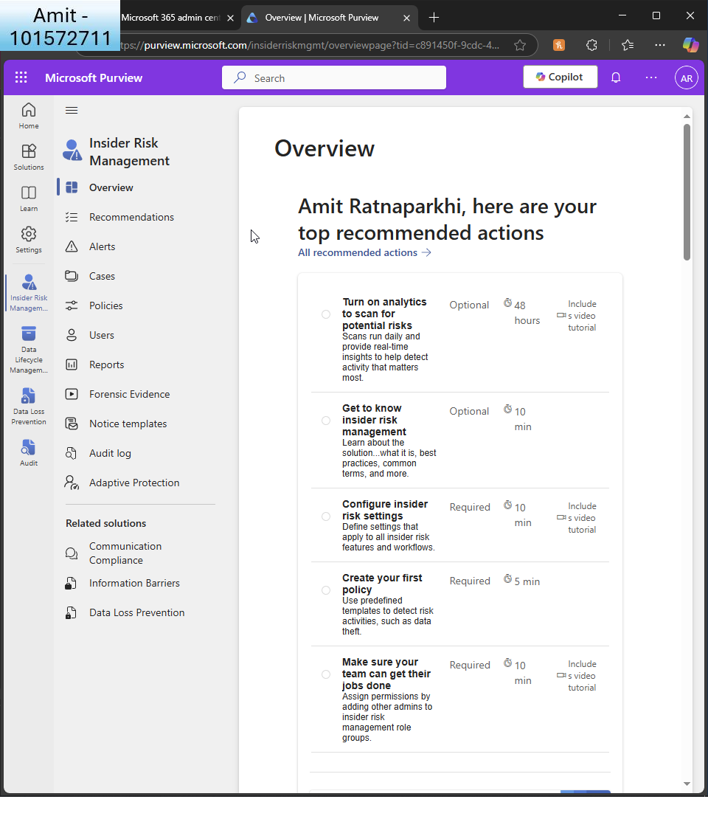  
      
    I see the IRM console and enable ’analytics to scan for potential risks’  
      
    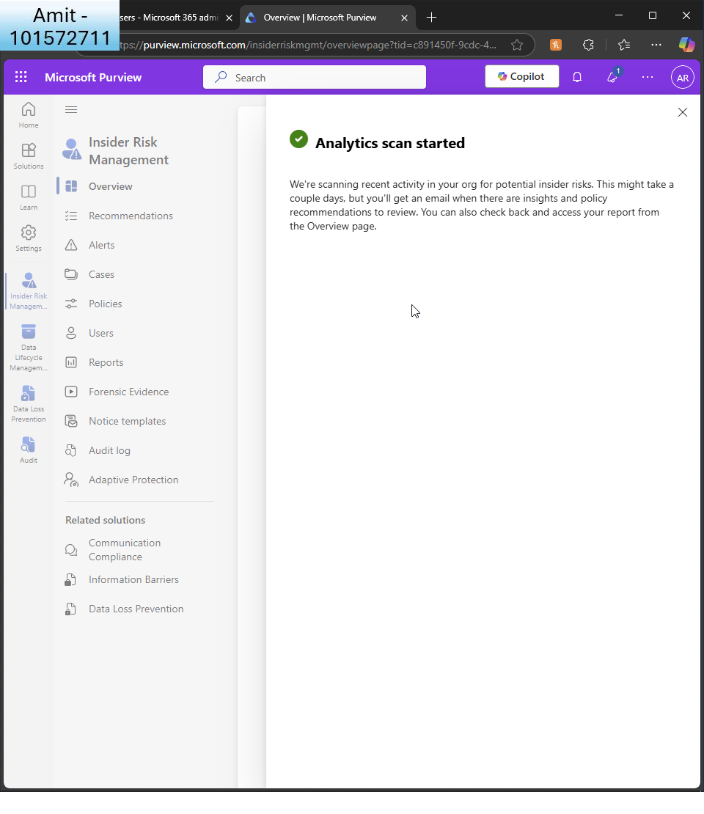  
      
    I can see it will take up to 48 hours to scan  
      
    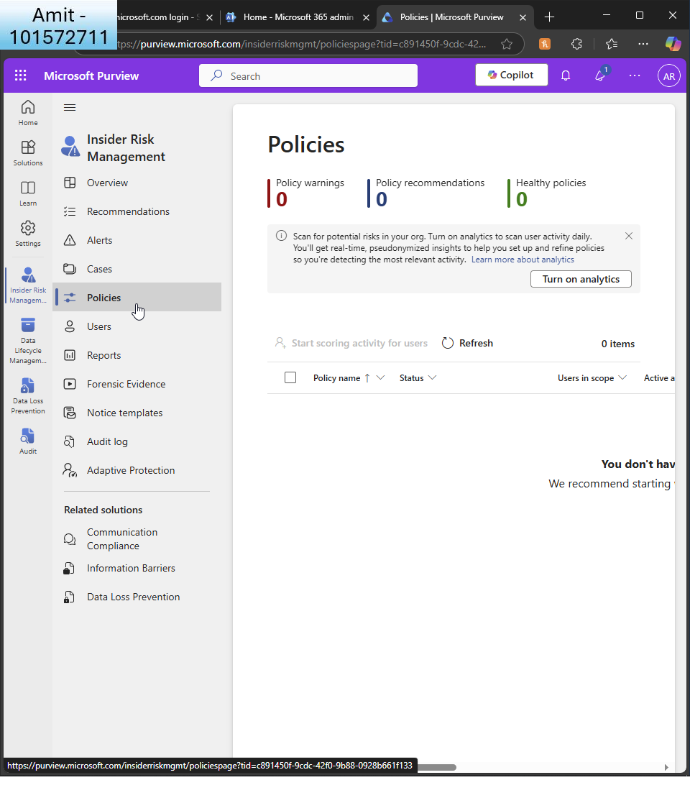  
      
    I create my policy  
      
    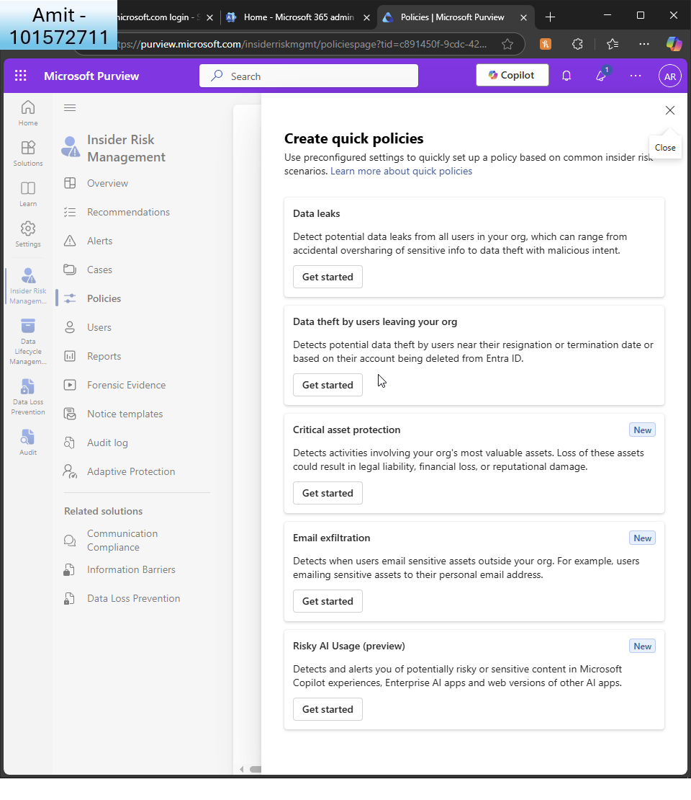  
      
    I create a quick policy  
      
      
    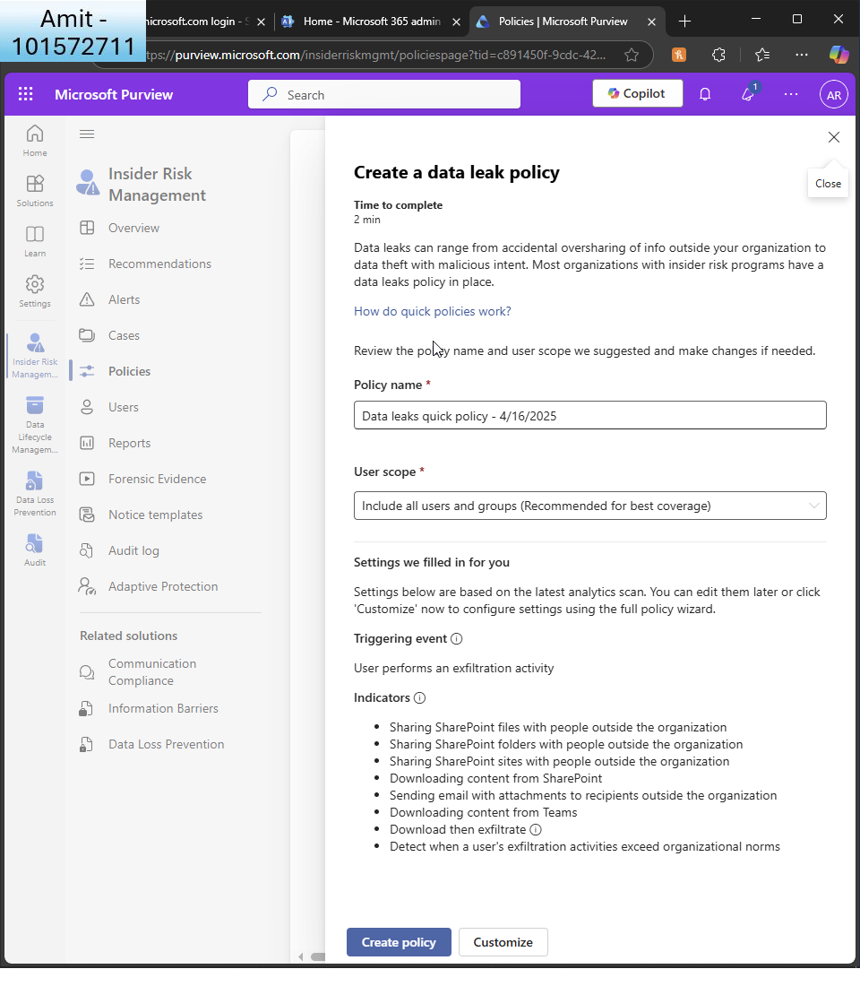  
      
    I create a ’data leak’ policy  
      
    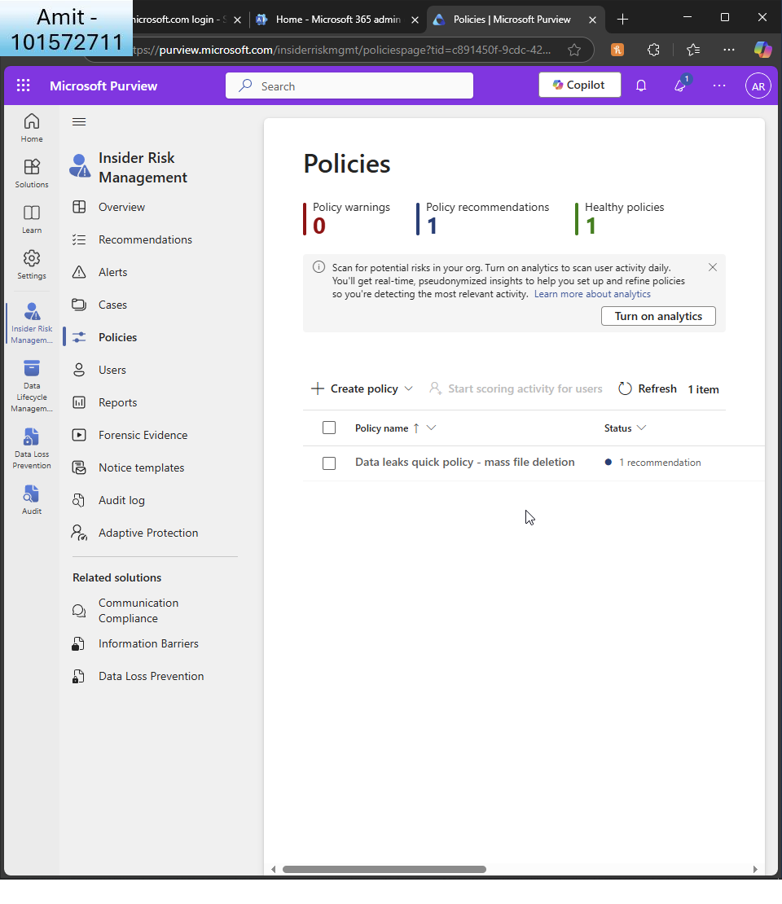  
      
    I see the new policy  
      
    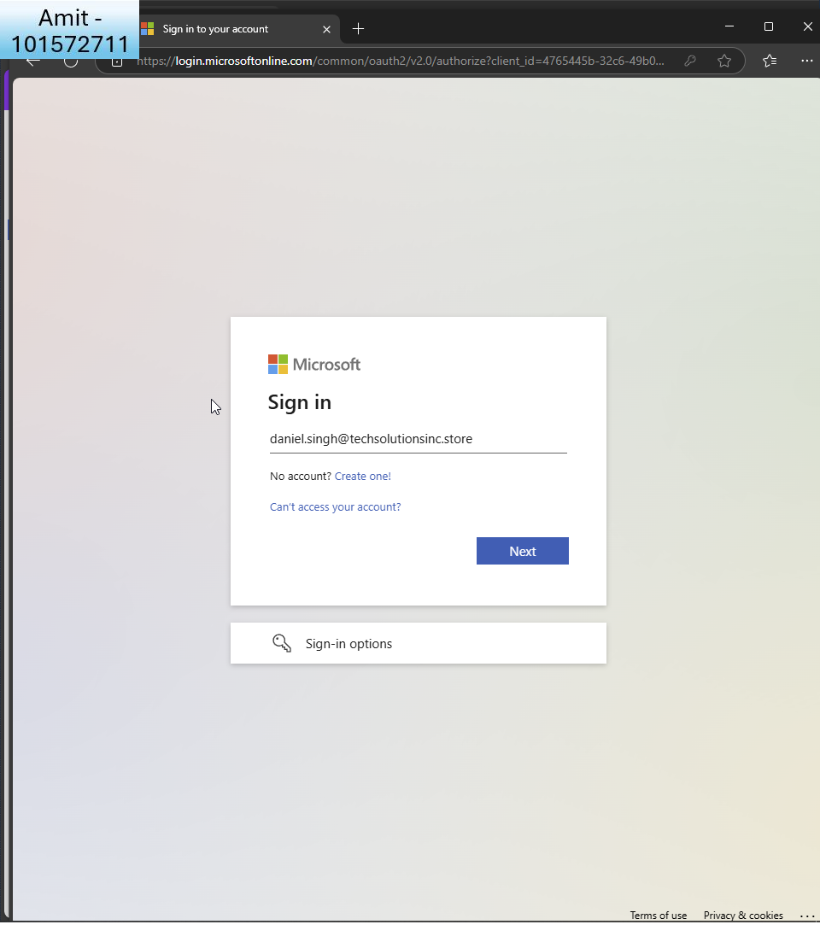  
    To simulate I sign in as Daniel  
      
    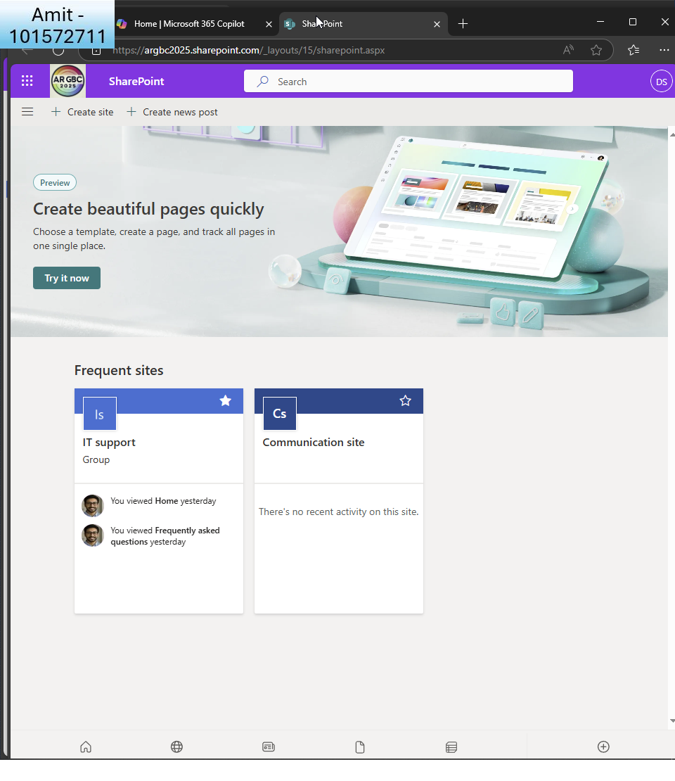  
      
    I go to IT support page to upload many documents  
      
    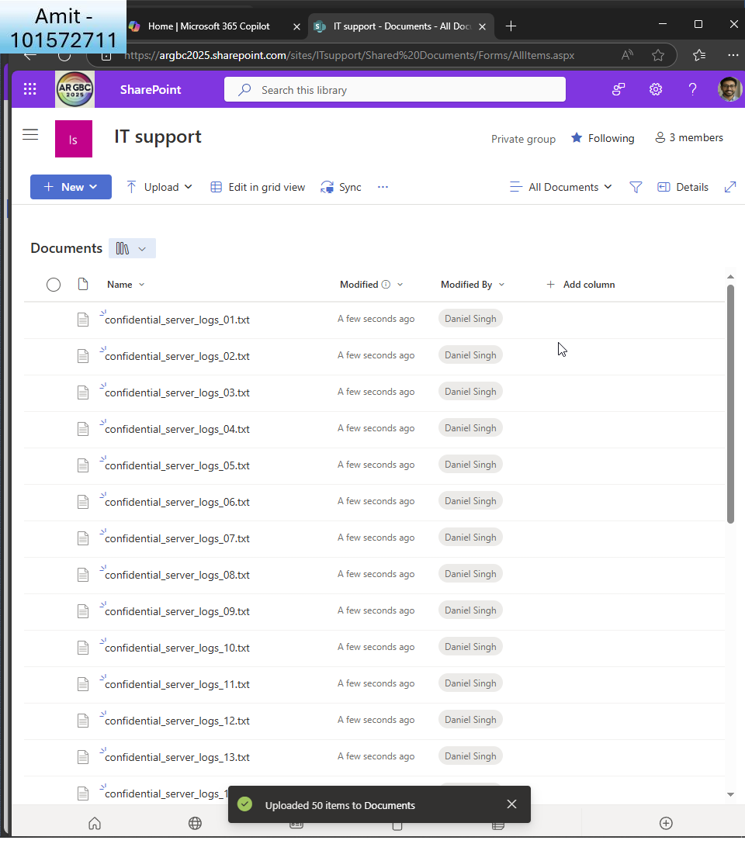  
    Here are the files  
      
    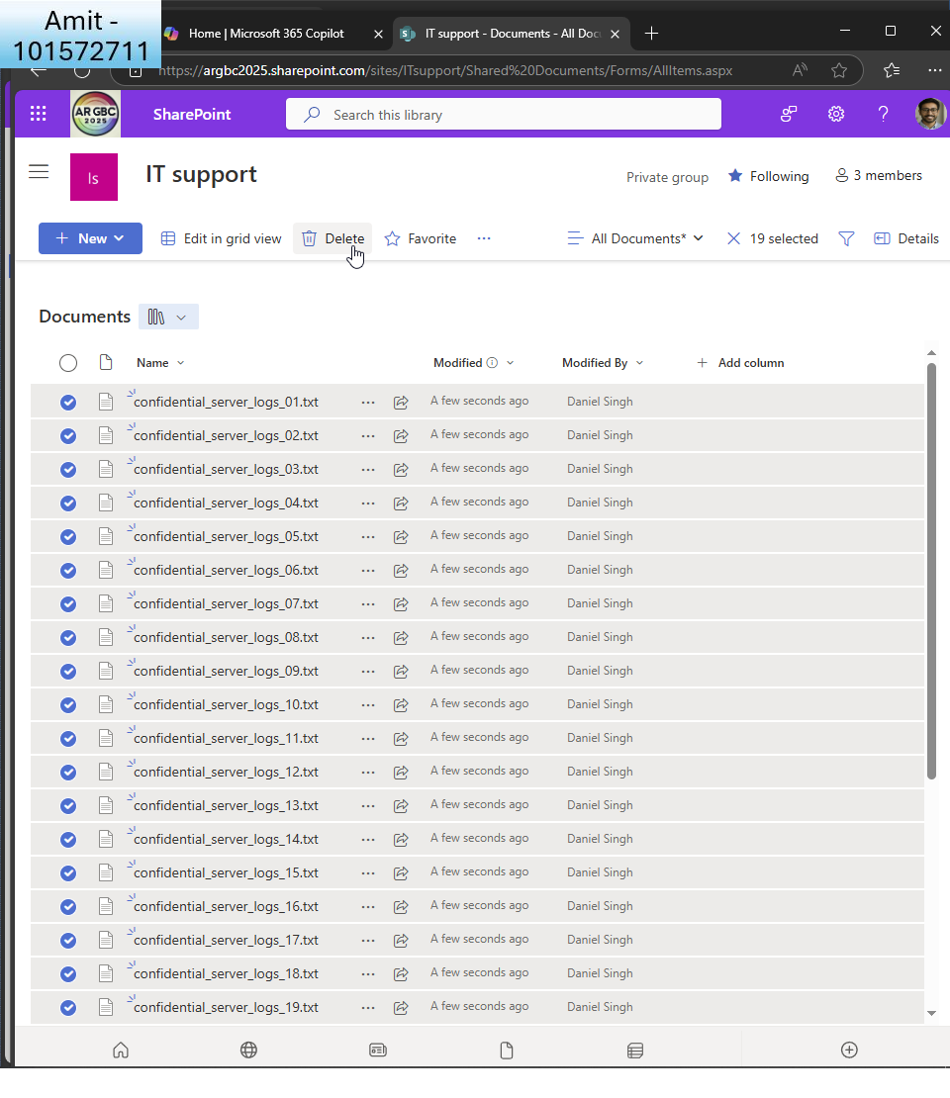  
    I delete multiple files  
      
    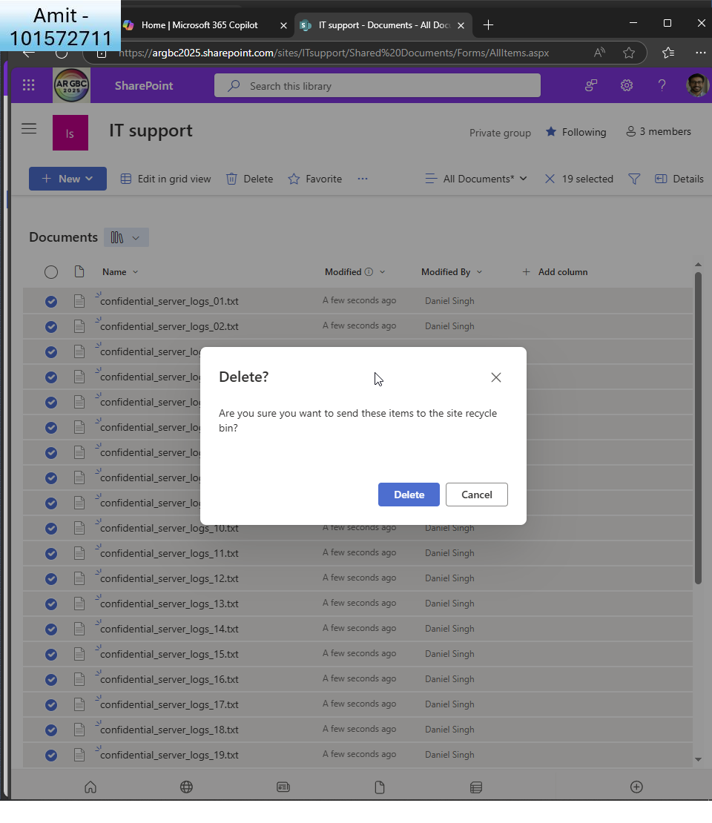  
      
    I see the confirmation and now wait up to 48 hours for the scan to show as an alert.

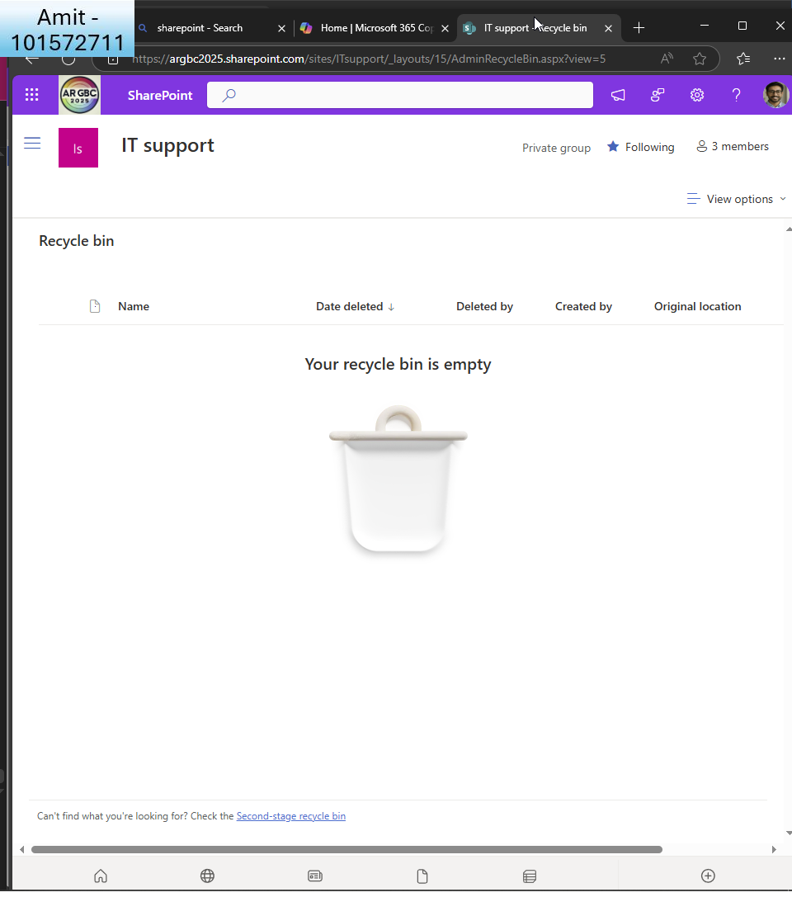  
for good measure I also delete from recycle bin and now wait an hour for the alert to trigger  
  
I realise that there is an issue with this DLP policy as I couldn’t get to alert so I will start again with a brand new DLP policy:  
  
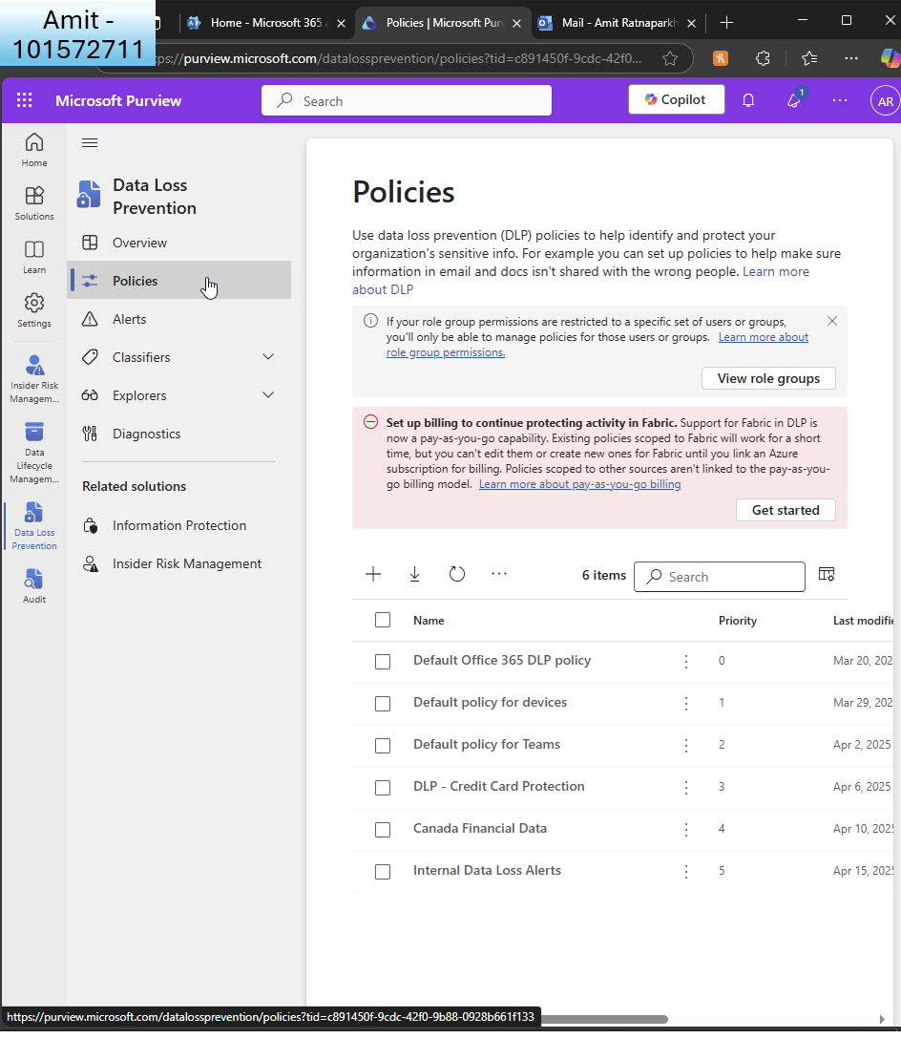  
I create a new DLP policy  
  
  
  
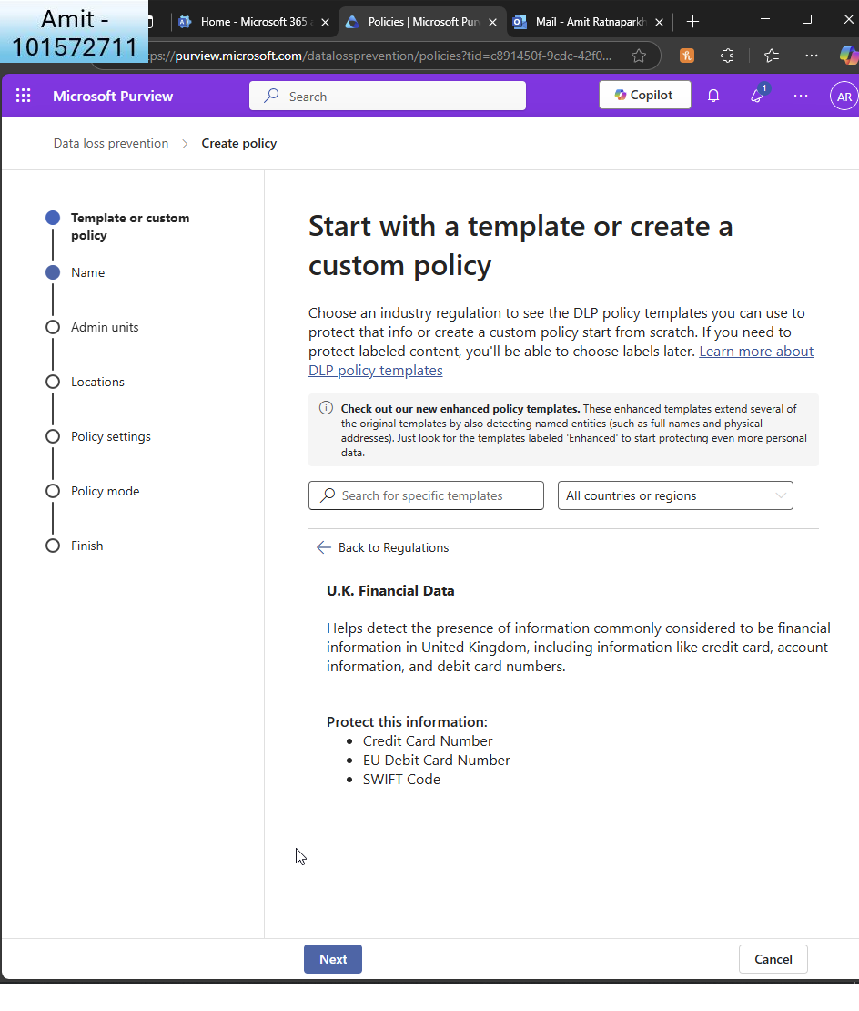  
I choose UK financial date and choose a template

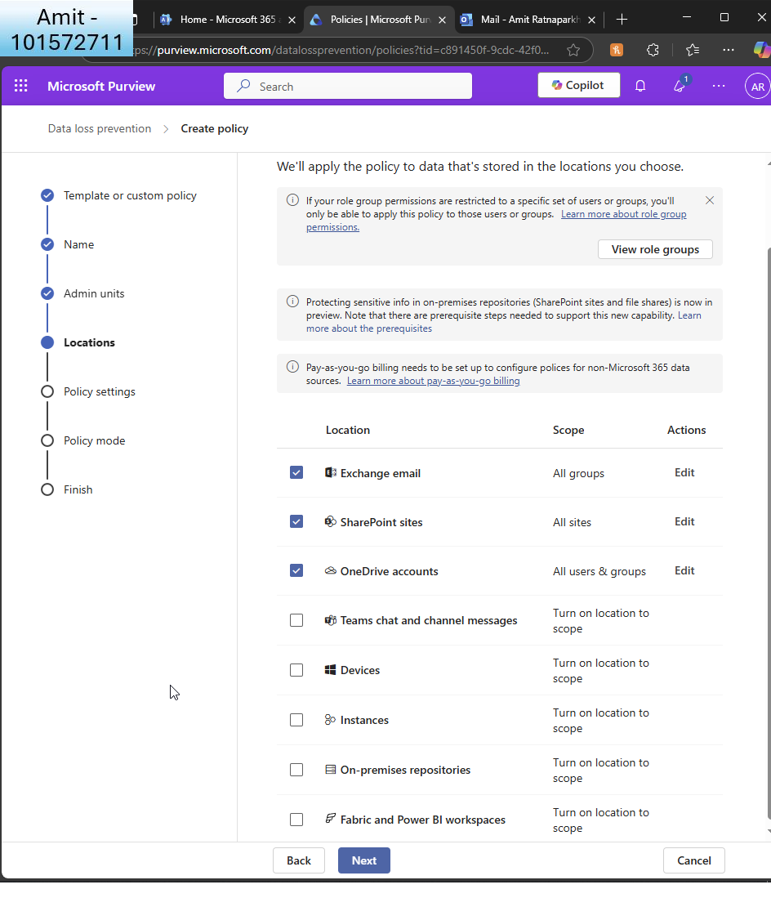  
I ensure locations are correct  
  
  
  
  
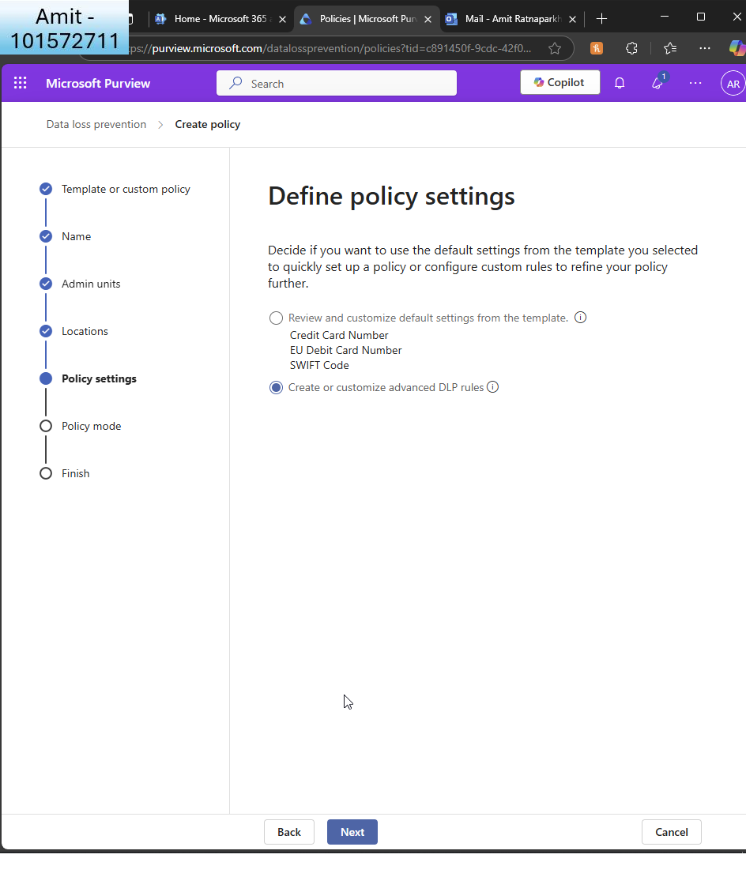  
I define the policy settings and customise  
  
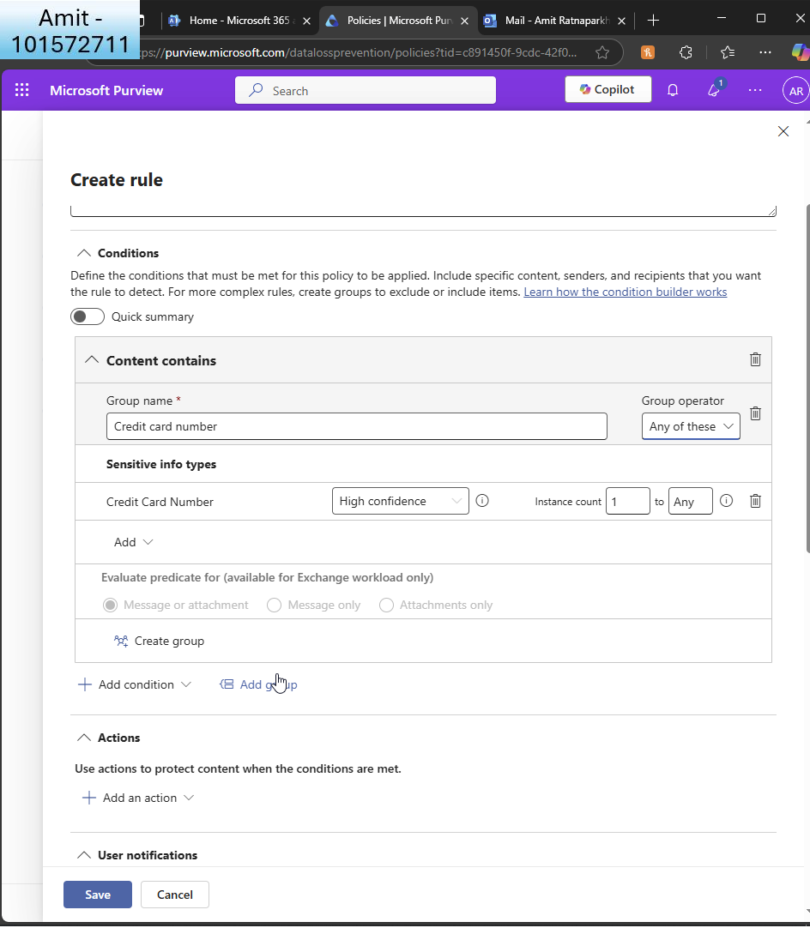I create the rule for credit card numbers  
  
  
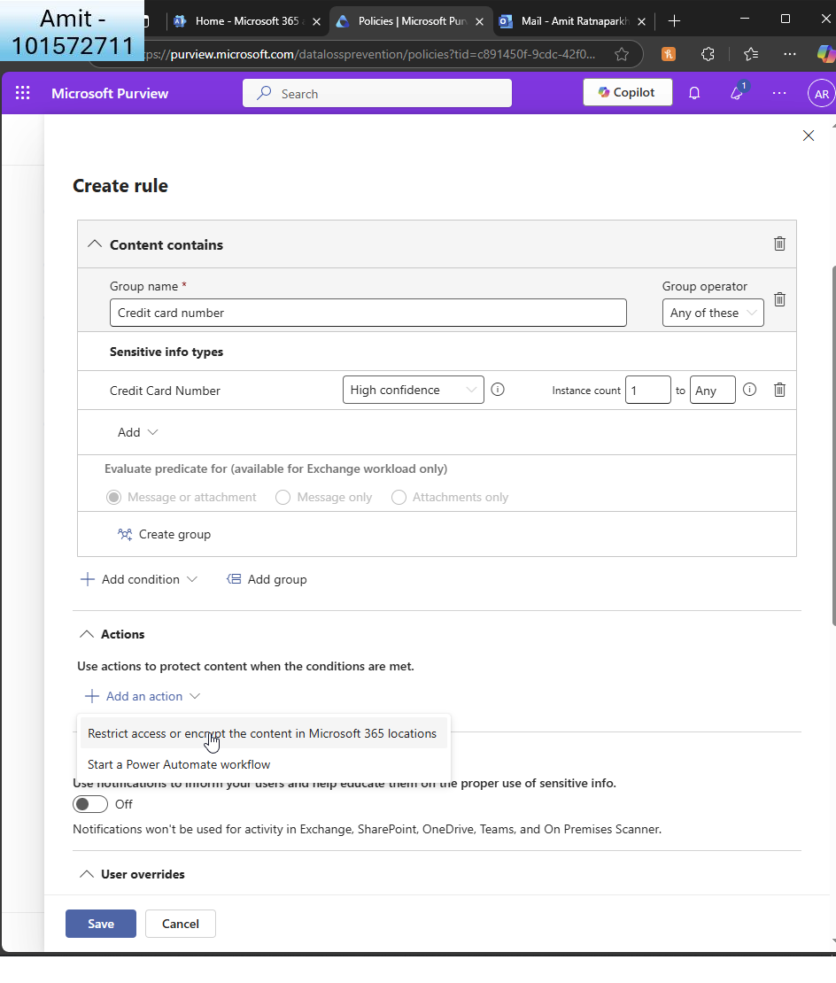I restrict access for the user  
  
  
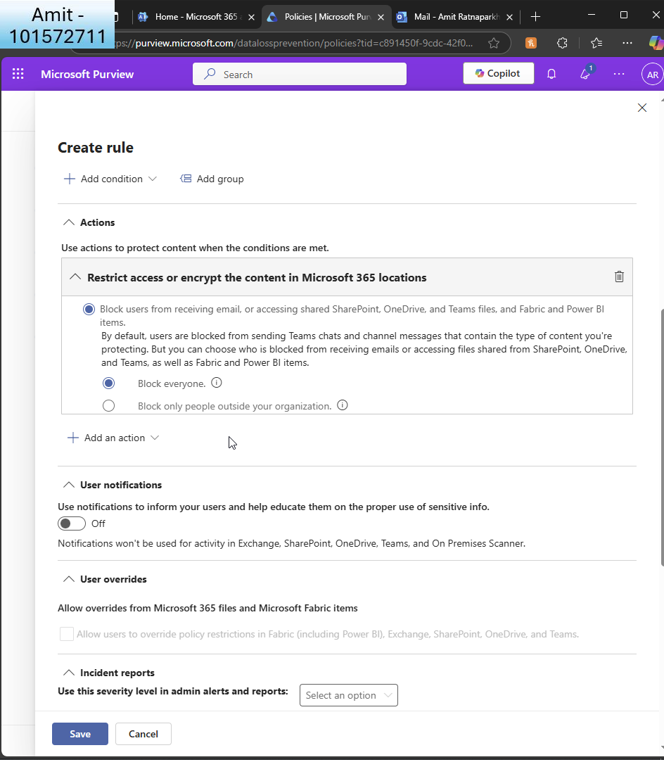I choose ’block everyone’  
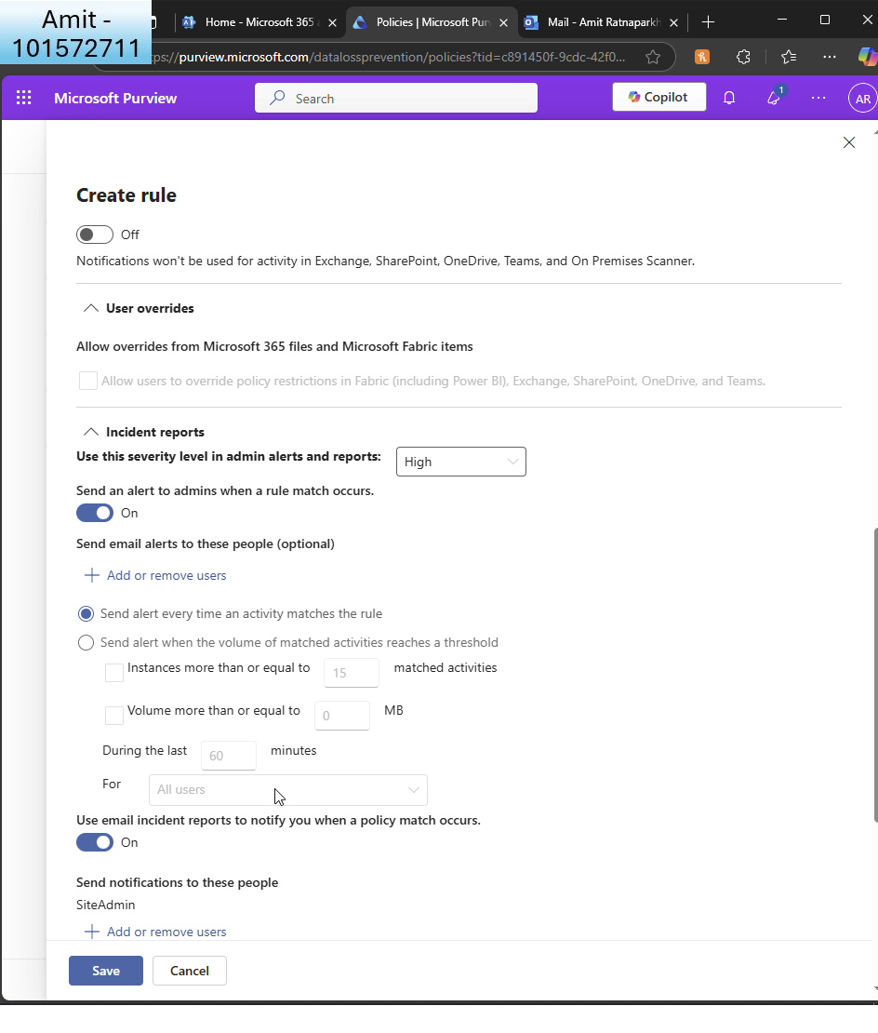  
I choose to send alerts to admins  
  
  
  
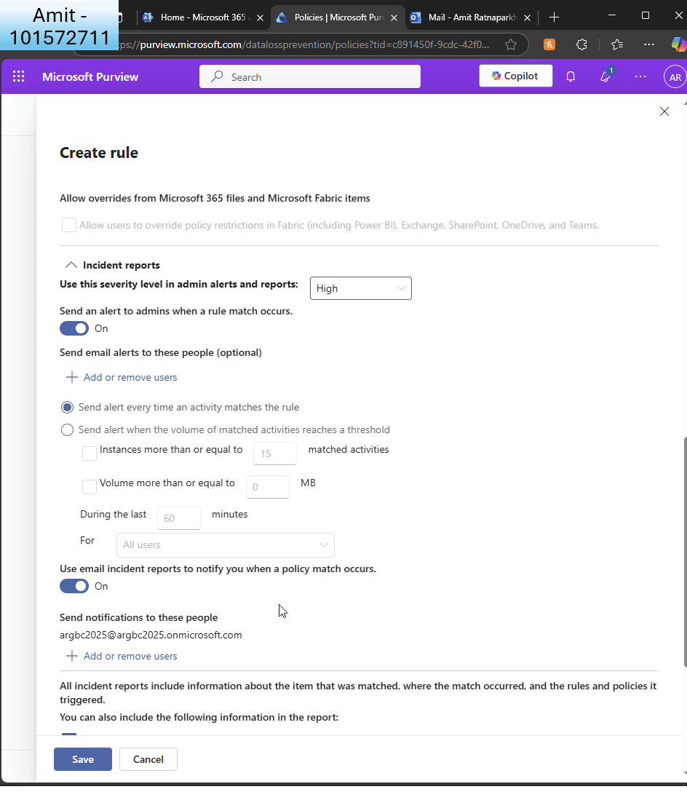I make sure action is taken with rule match occurs

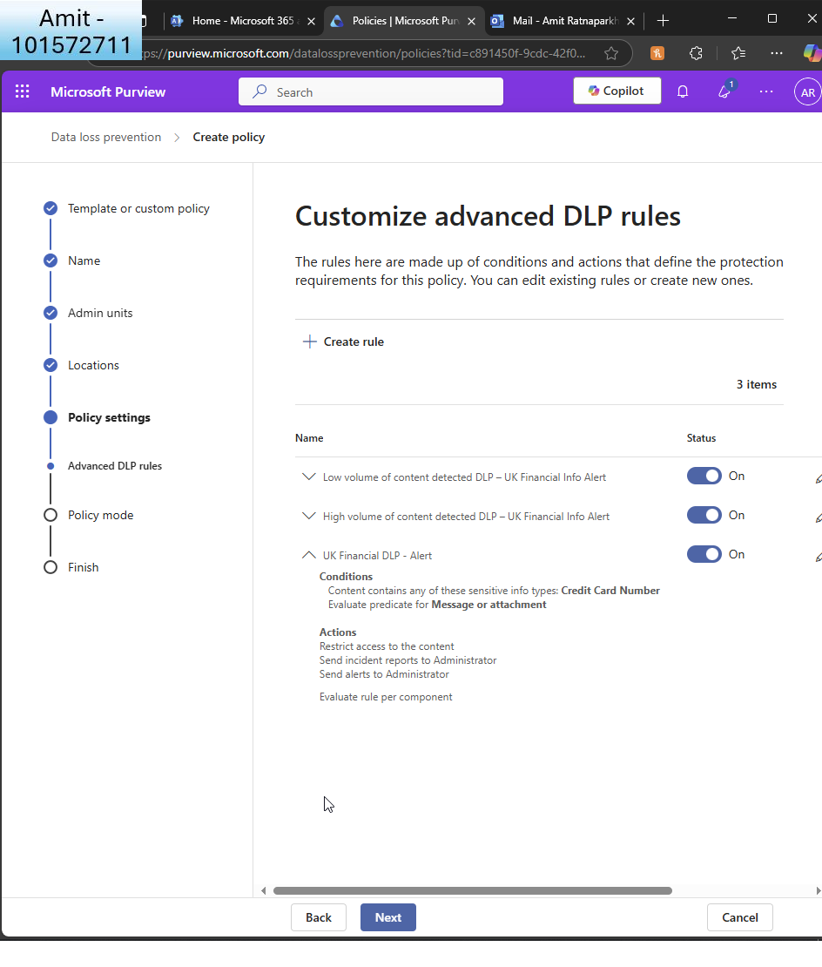  
I review the customised options  
  
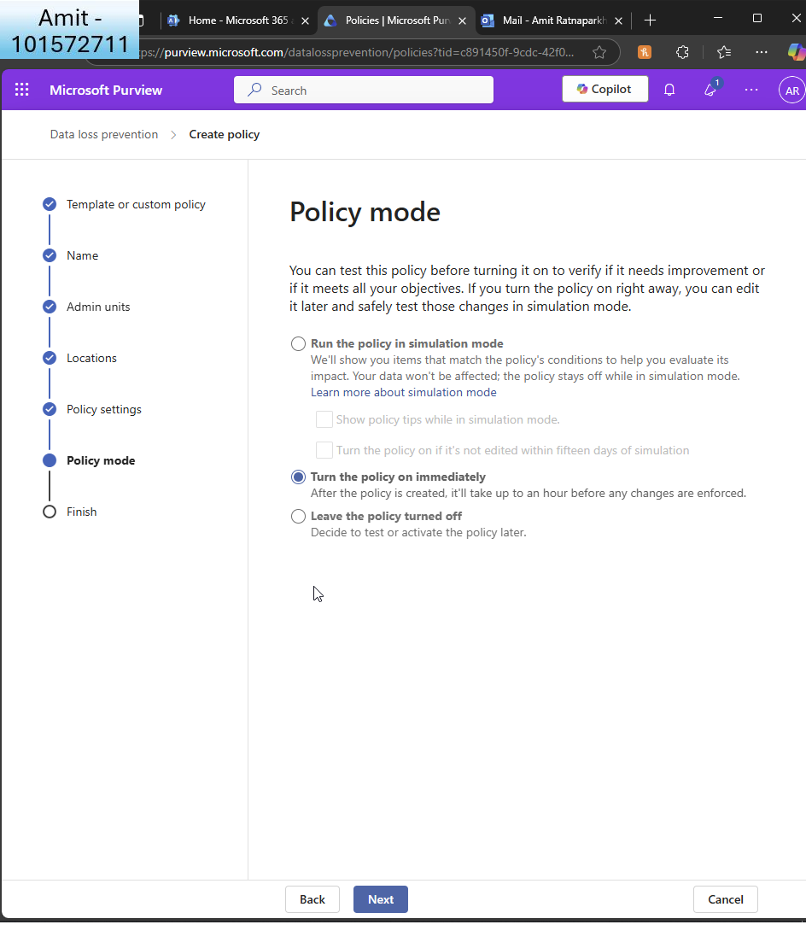  
I turn the policy on  
  
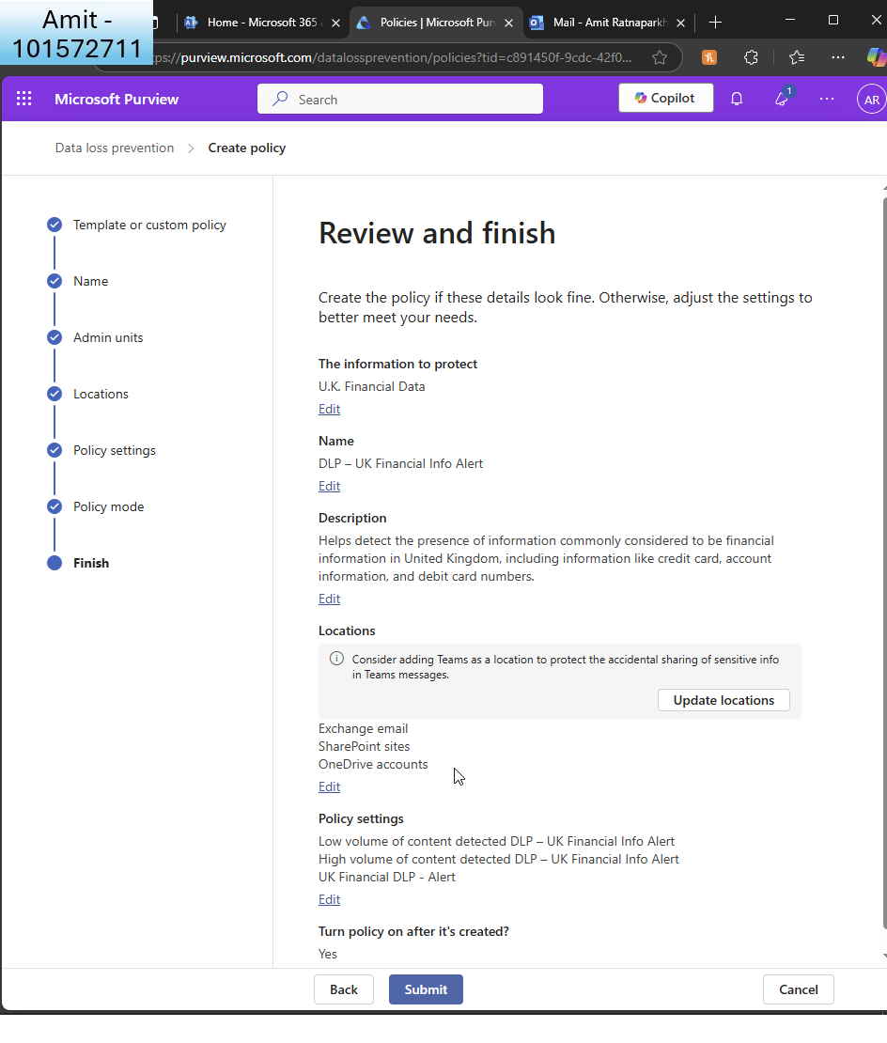I review and finish  
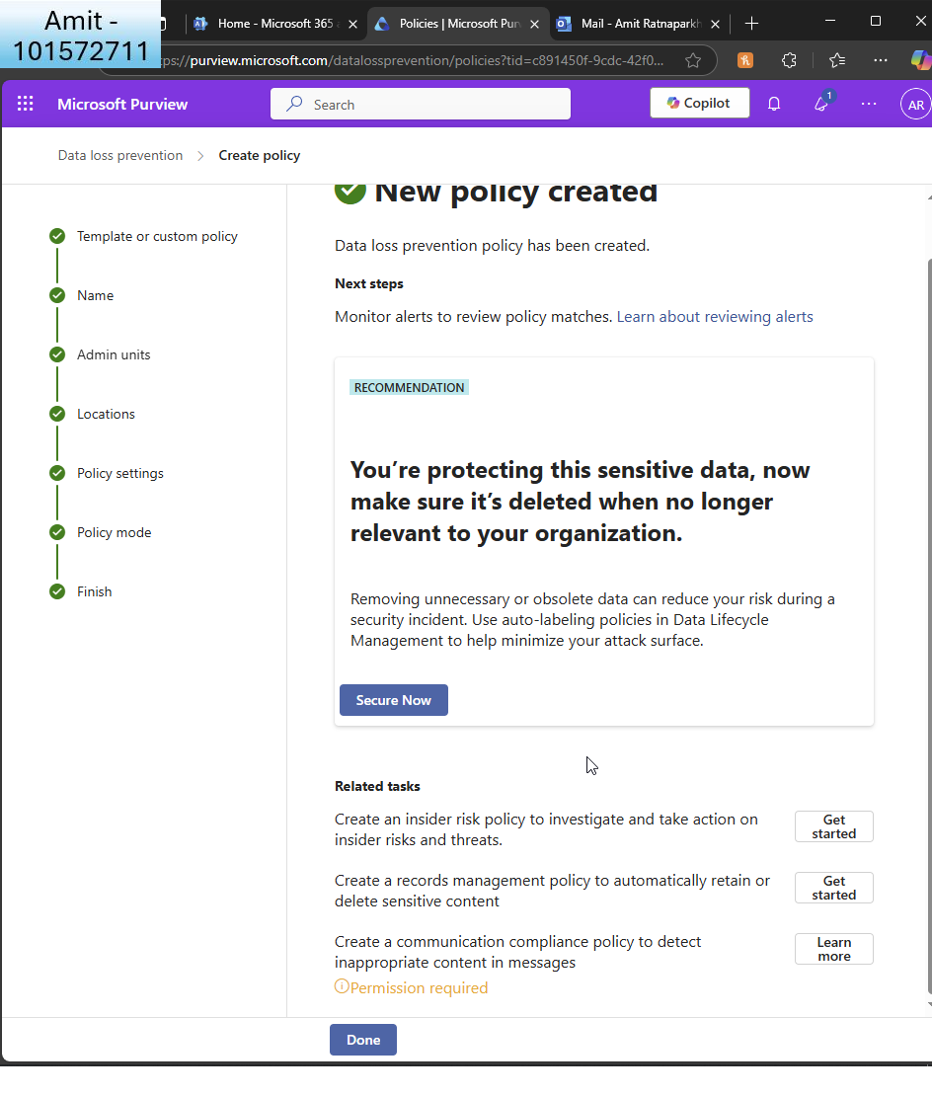  
  
From here I directly go to creating an insider risk policy  
  
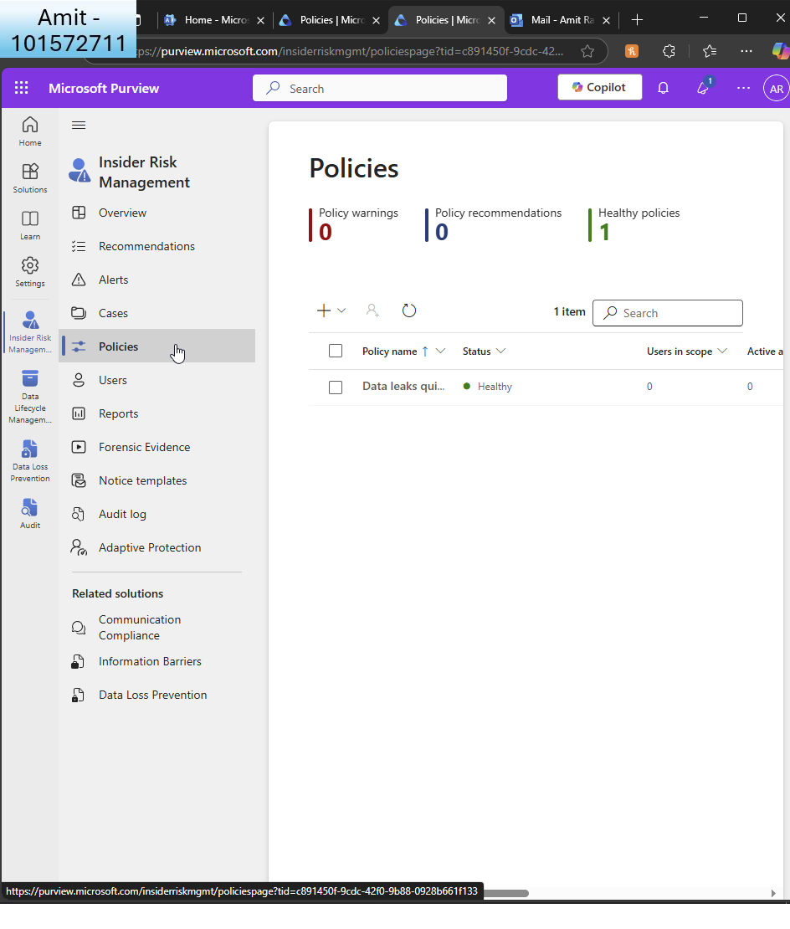I go to ’policies’  
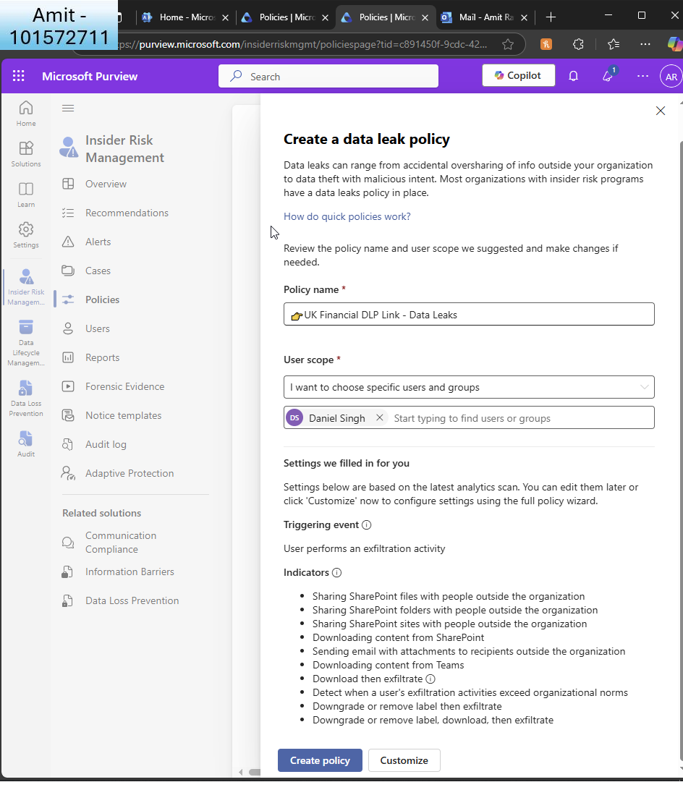  
I create a data leak policy (quick) create  
  
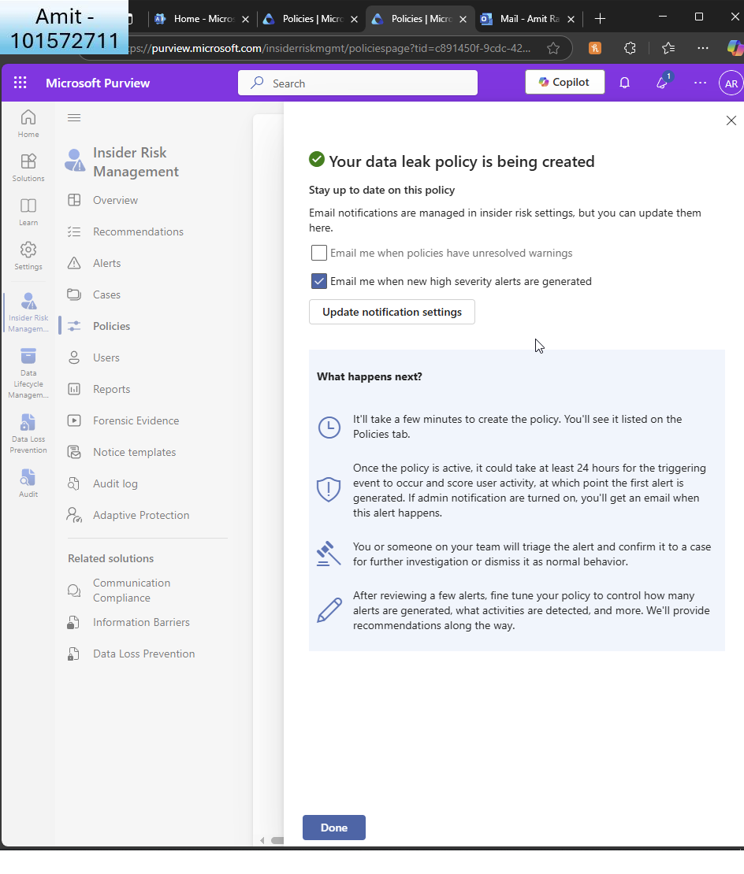  
I see the confirmation  
  
  
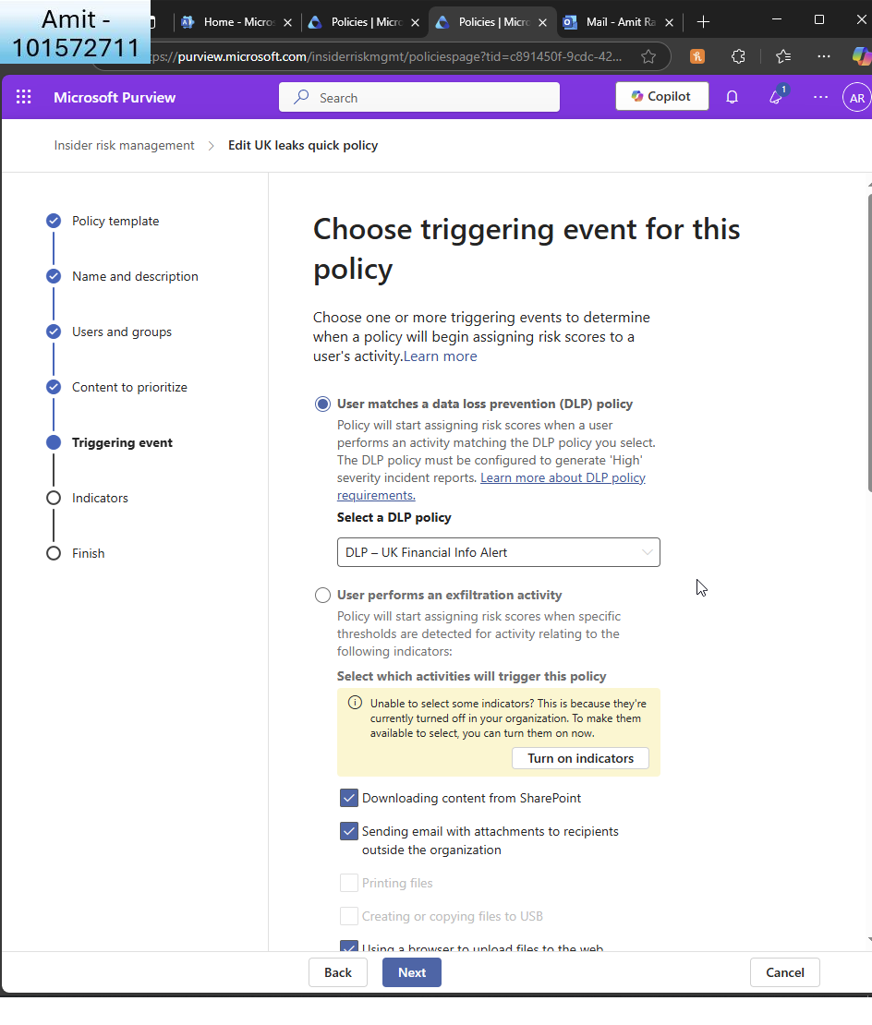  
IRM said I need to choose a triggering event so I choose to run it when matched to my credit card DLP policy  
  
  
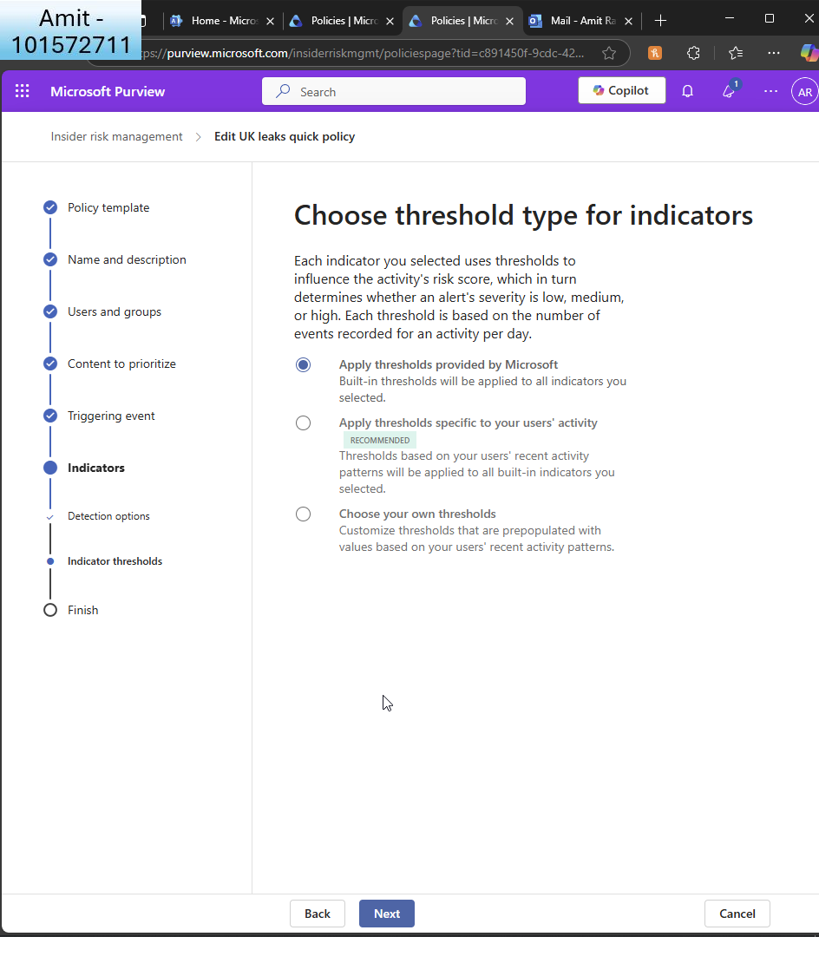I choose default thresholds by MS

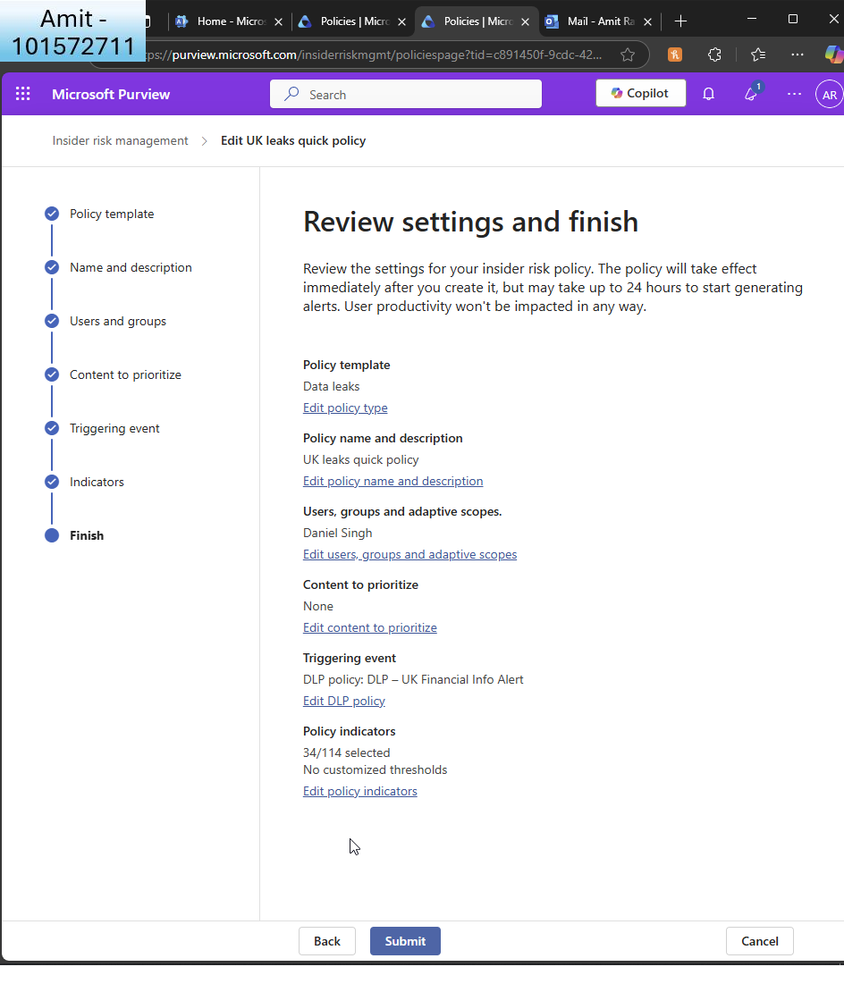I review and finish  
  
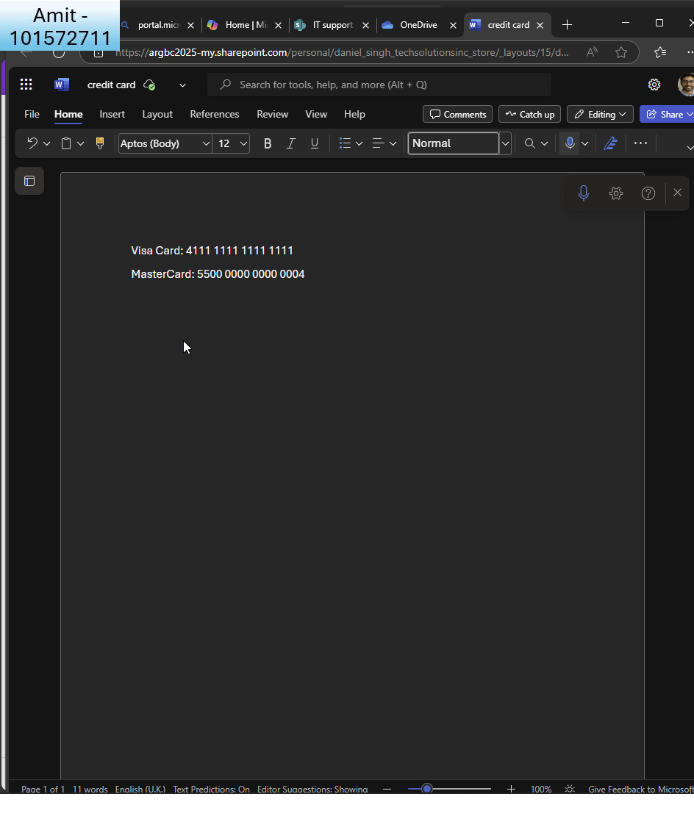I create a ’dummy’ credit card file as user ’Daniel’  
  
  
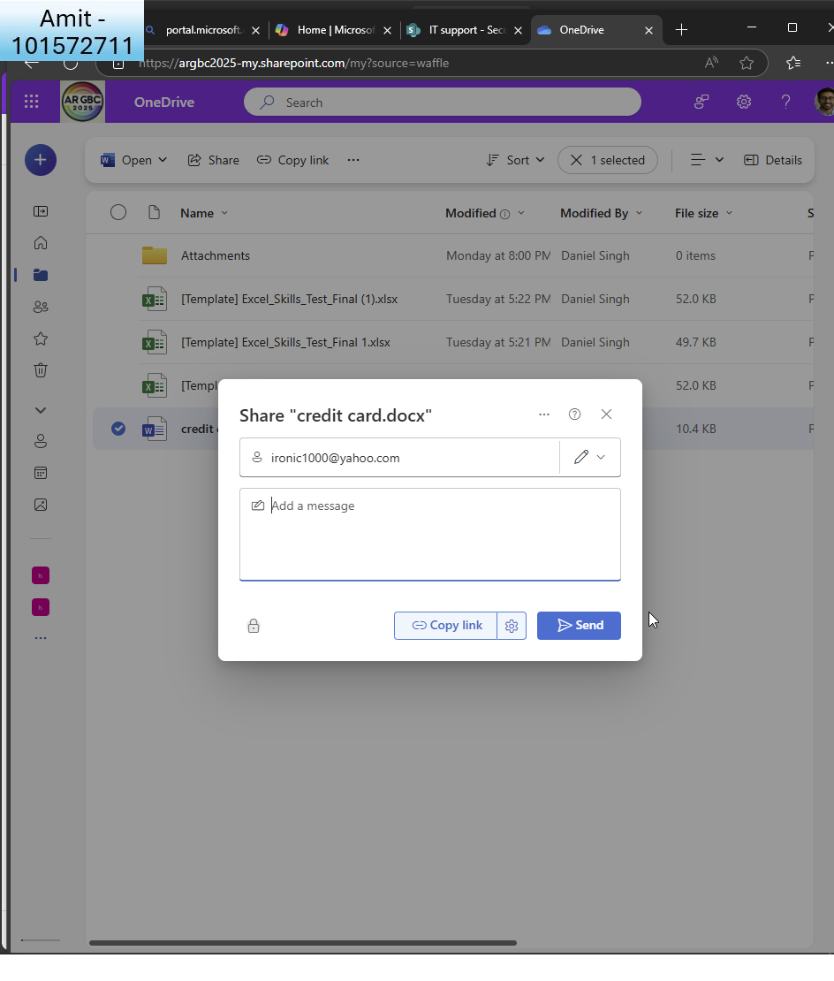  
  
I share it externally  
  
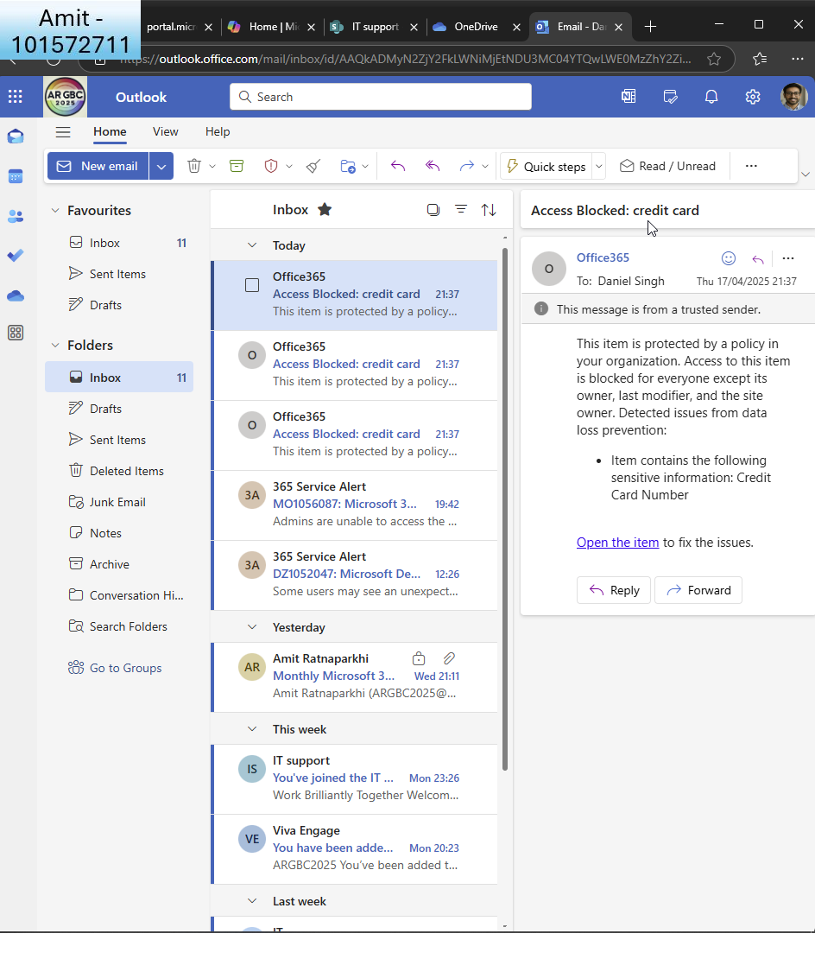  
  
I receive a notification as Daniel  
  
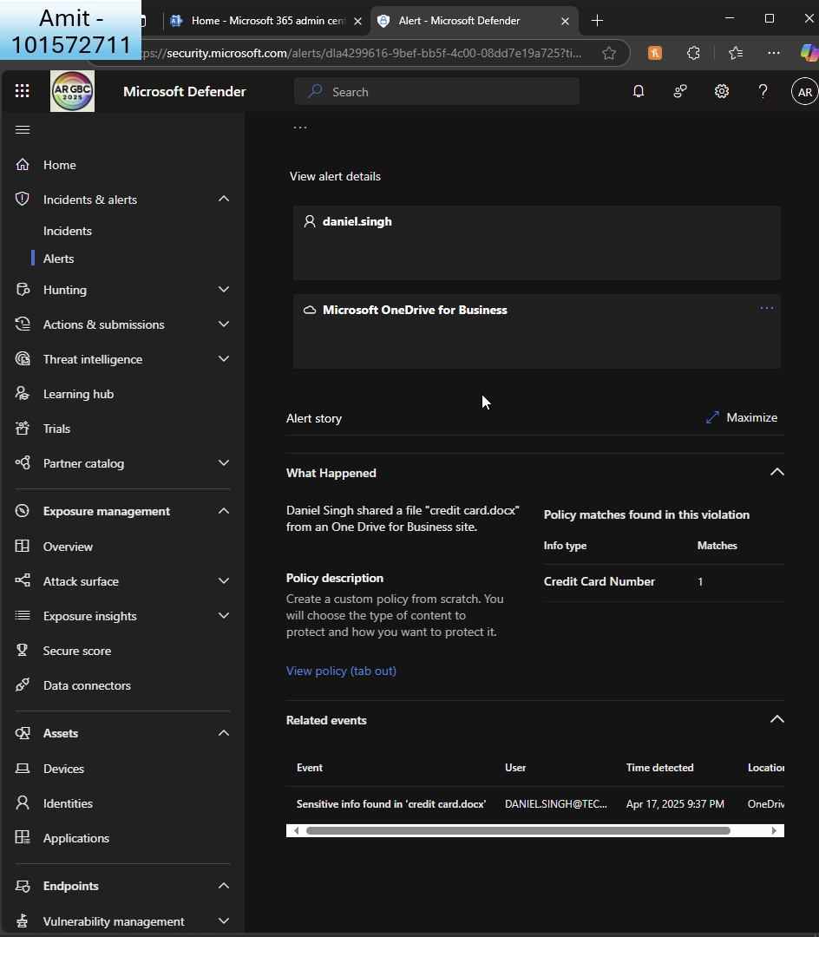  
  
And I can see the alert in Defender

1. **Generate Usage Reports**:
   * Use the Microsoft 365 admin center to generate reports on user activity, email usage, and SharePoint site usage.  
       
     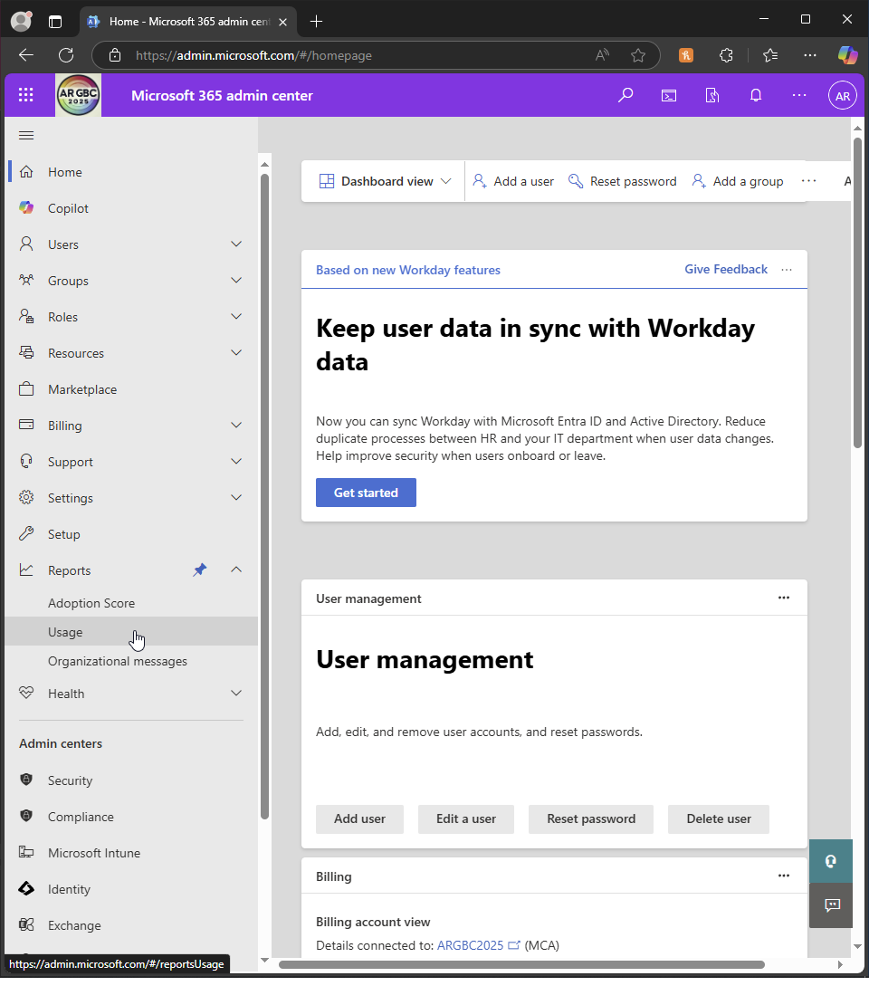  
       
     In admin centre, I go to ’reports - usage’  
     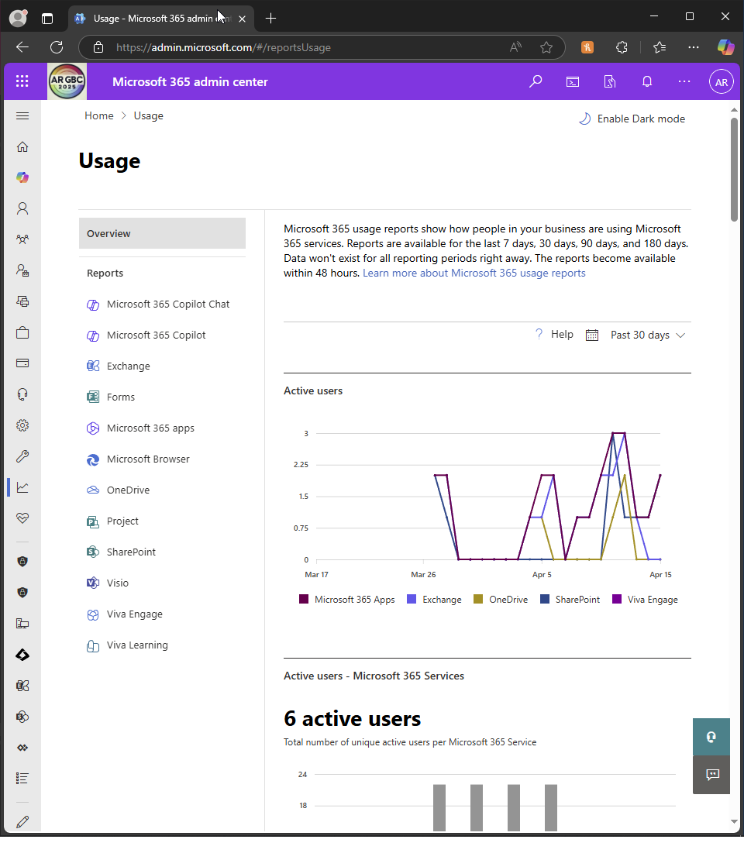  
       
     I can see reports such as active users  
       
       
     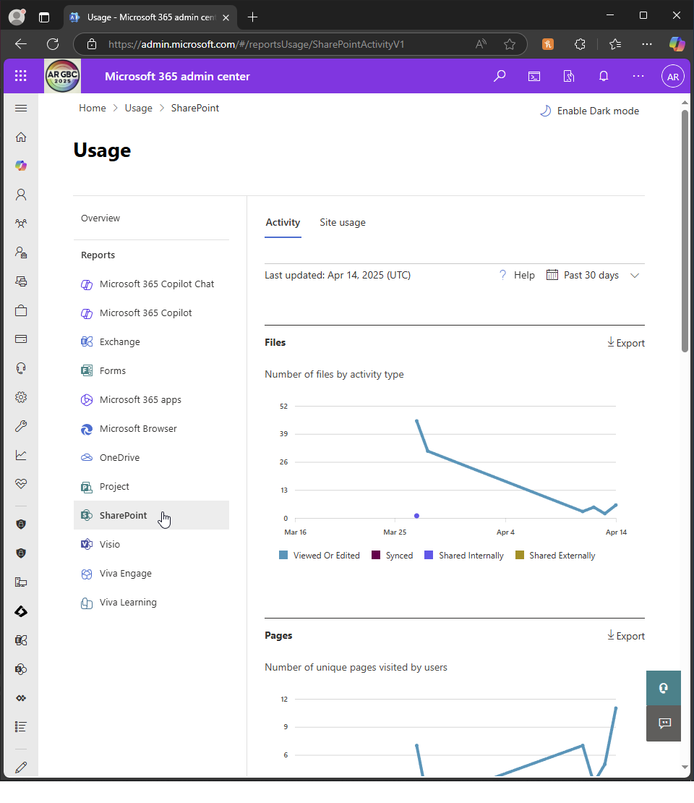  
       
     Sharepoint activity i.e. files  
     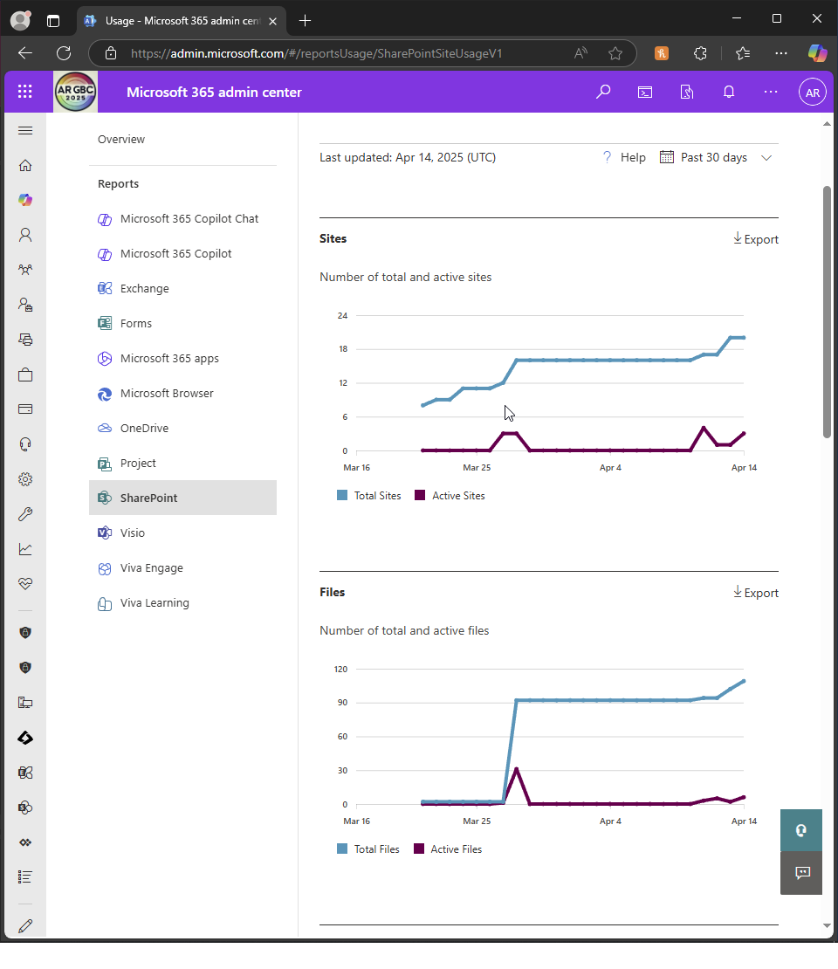  
       
     Sharepoint active sites  
       
     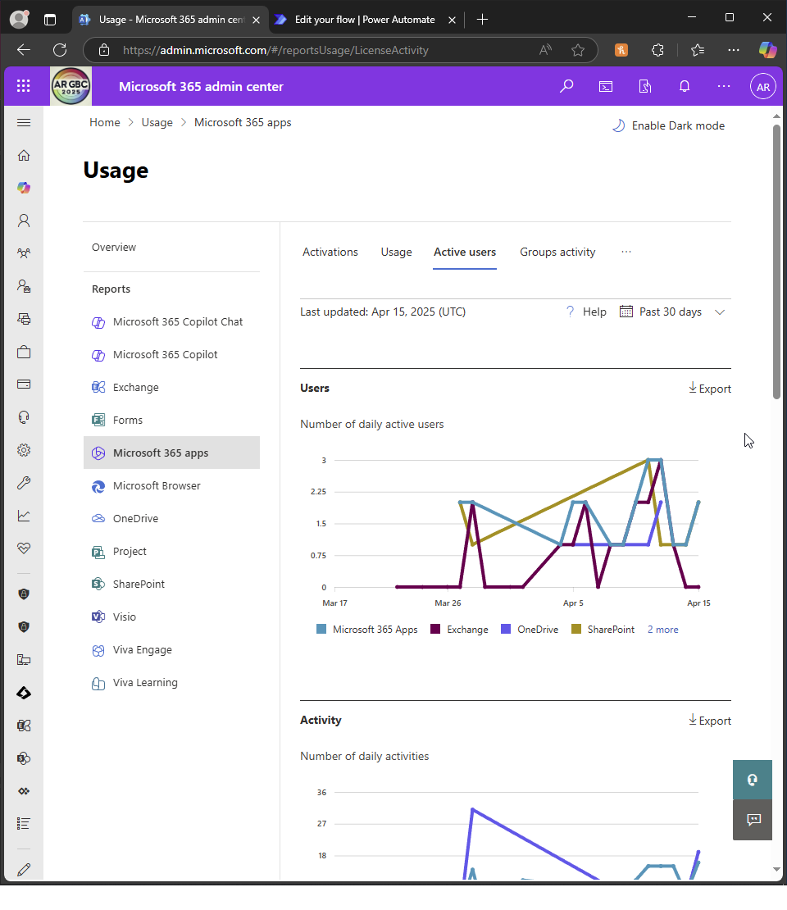  
       
     Active users  
       
       
     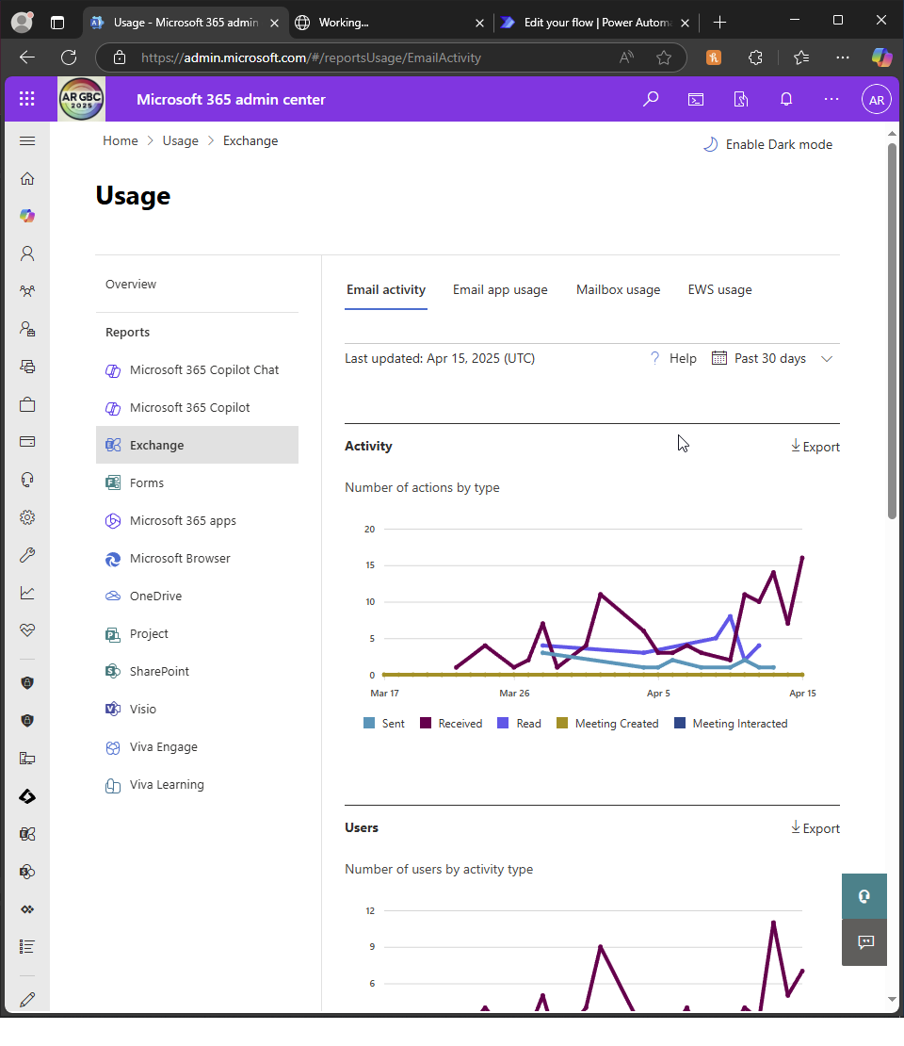  
       
     Email activity  
       
     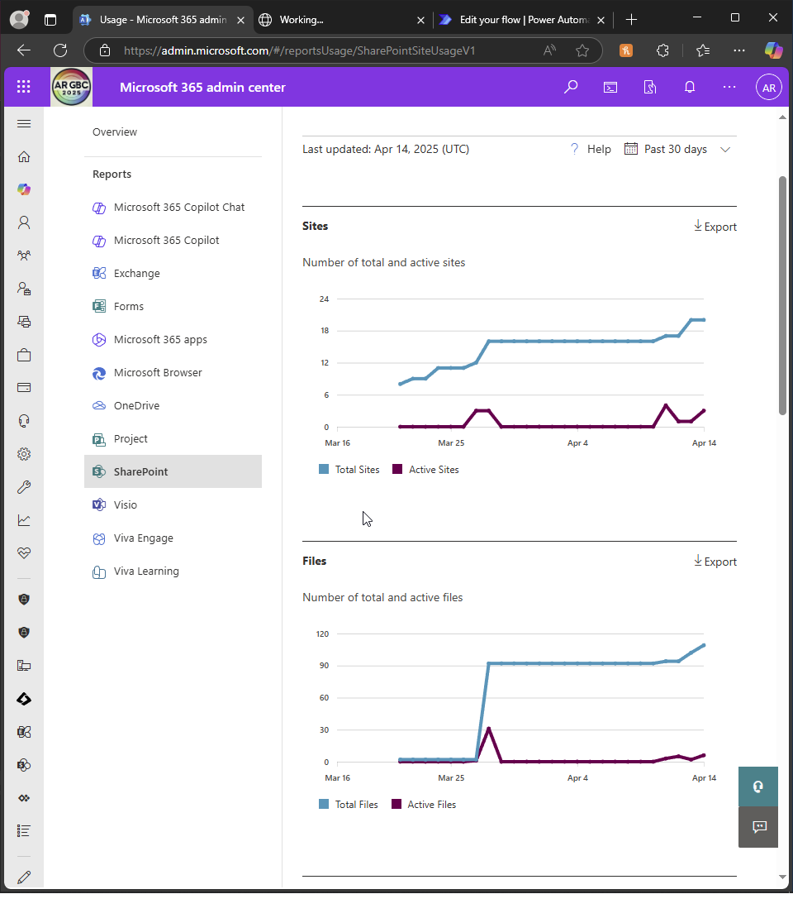  
     Sharepoint sites and files. Click export to export all of them as CSV files  
     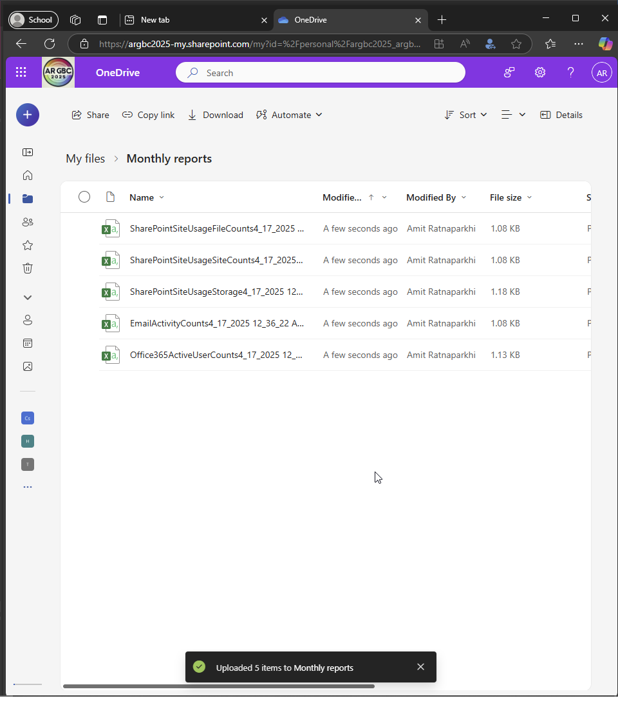  
       
     I upload them to onedrive ’monthly reports’ folder
   * Schedule monthly reports to be sent to IT administrators and department heads.( Optional, you can use Power Automate)   
       
     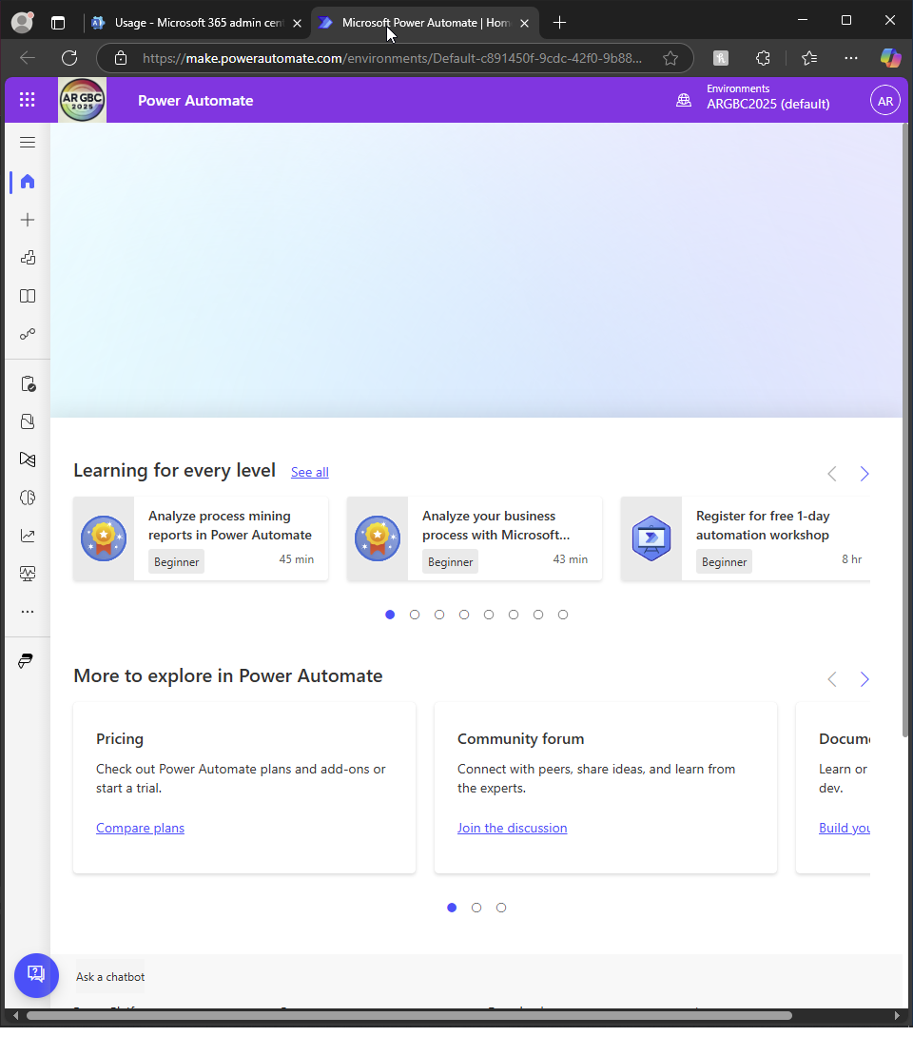  
       
     I choose to use Power Automate so I open it up  
     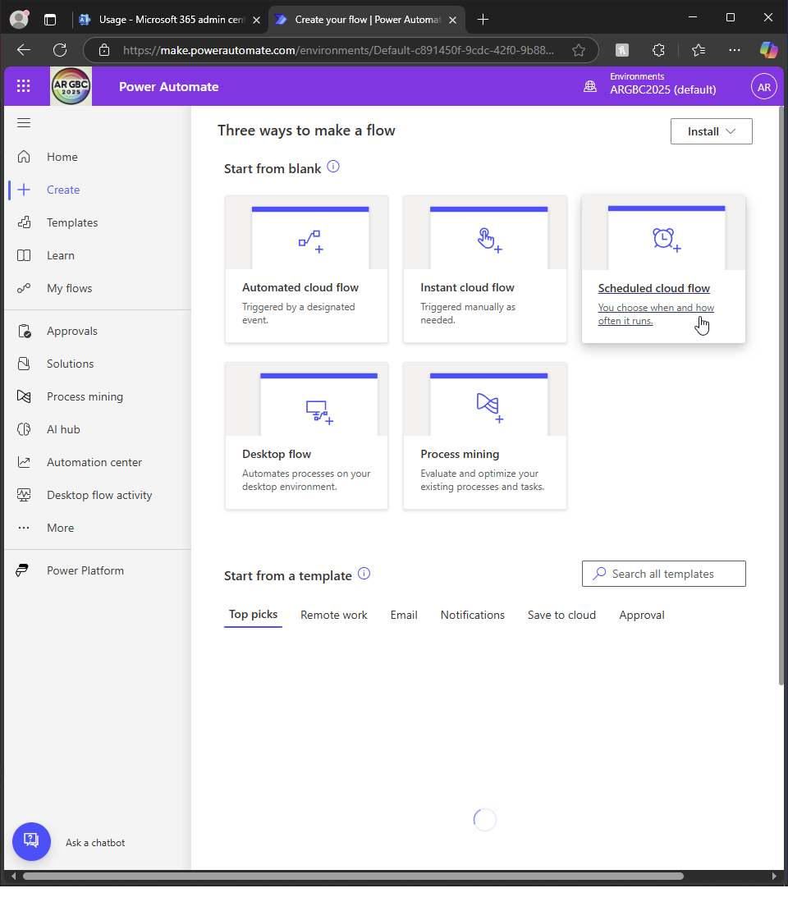  
       
     I click ’create’  
       
     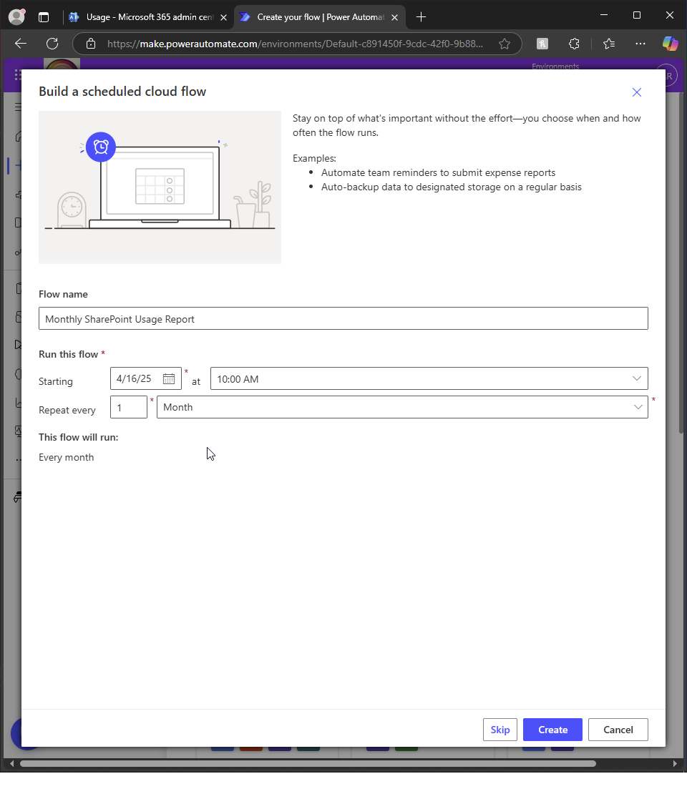  
       
     I name my flow and make it monthly  
       
       
     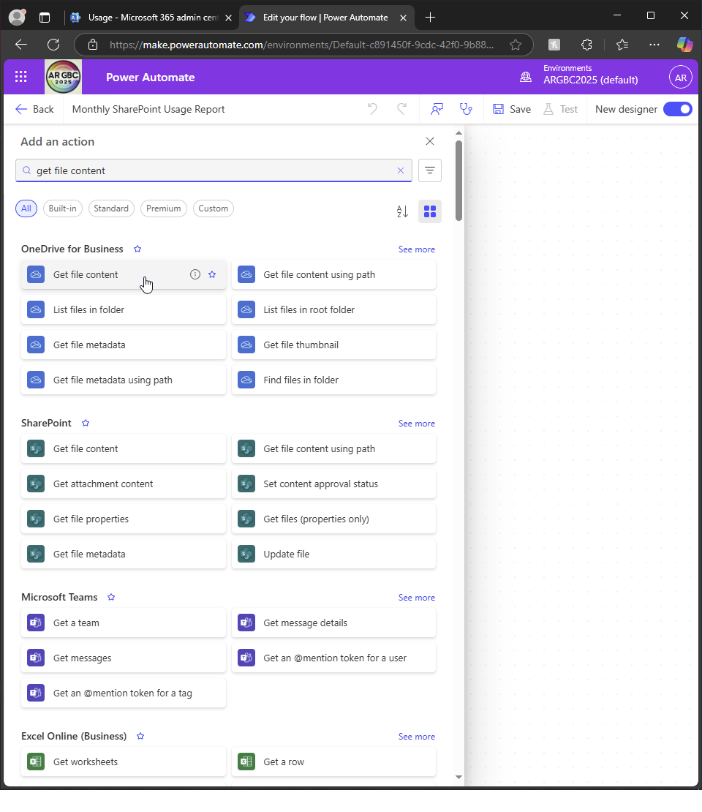  
       
     I choose to get file content from onedrive (the place I stored the CSVs)  
       
     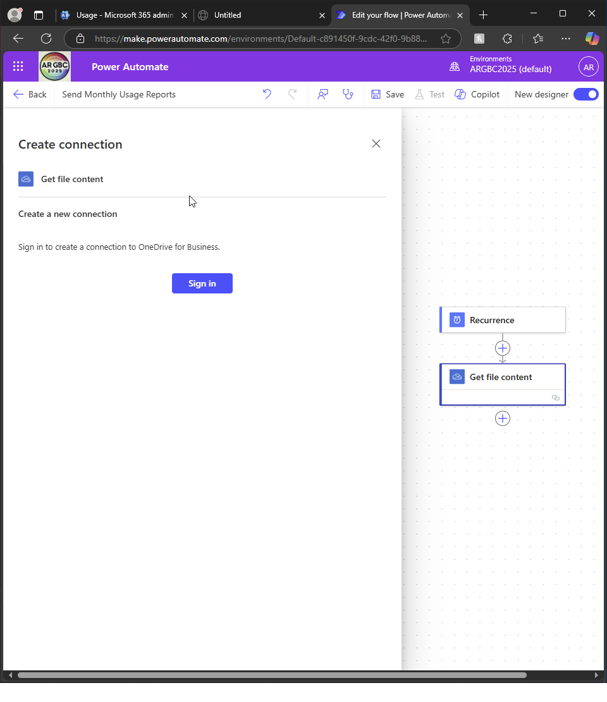  
       
     I create the connection with ondrive  
       
     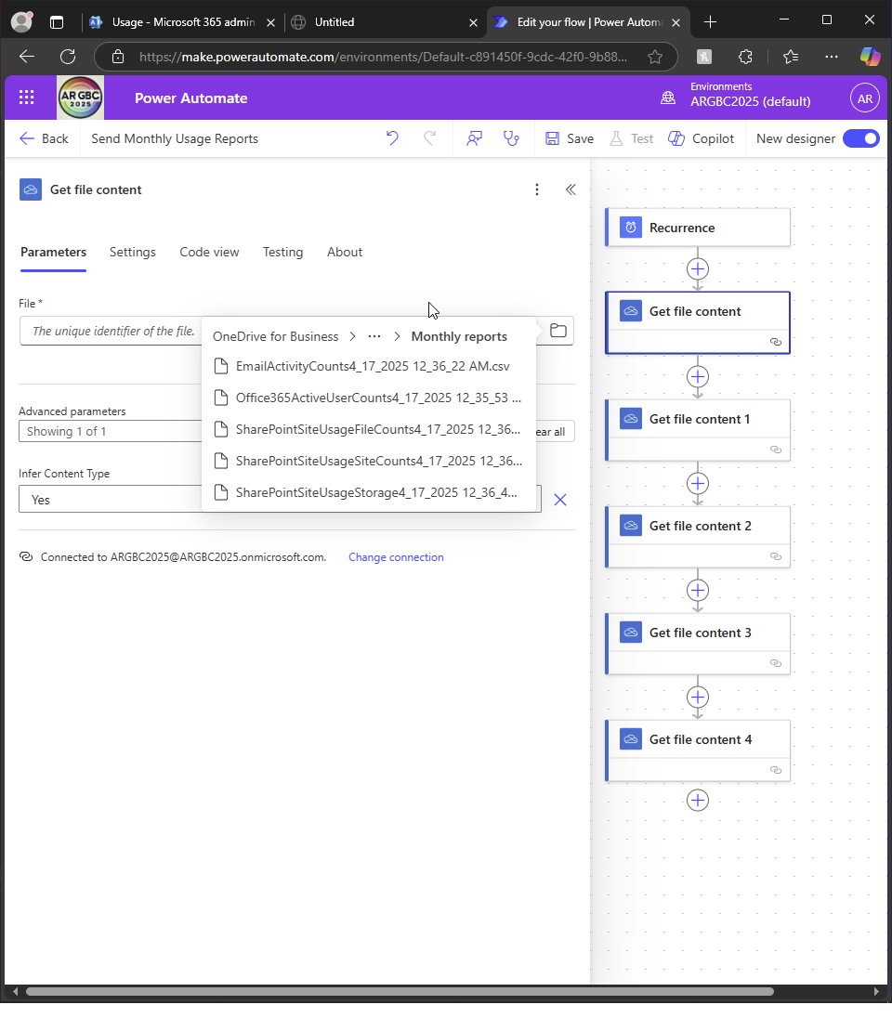  
       
     I repeat the process of getting file content so it gets content from all 5 CSV files  
       
     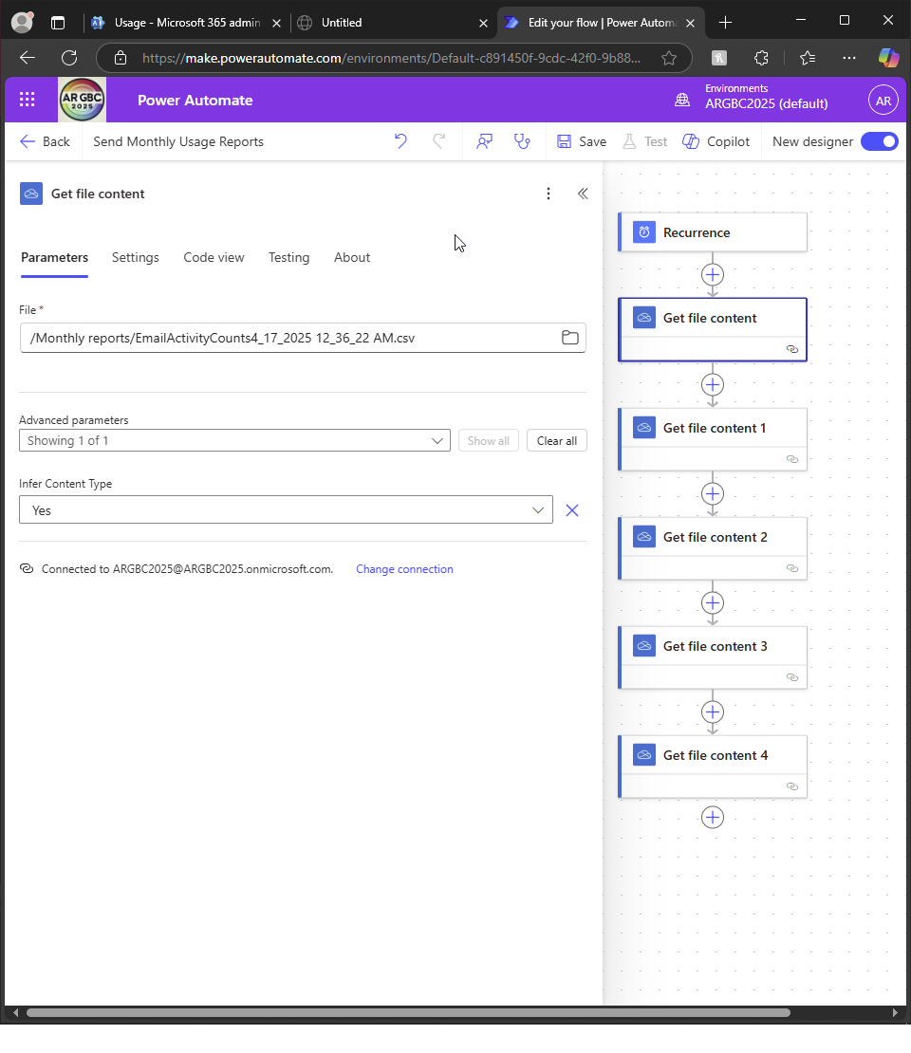  
       
     I specify the file  
       
     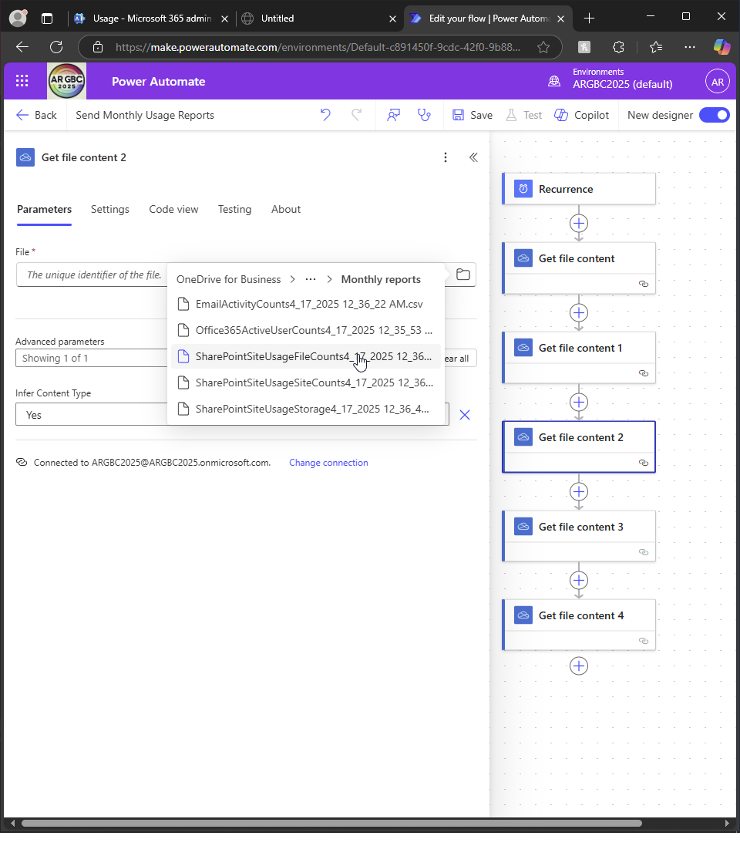  
       
     And repeat for each file content flow box  
       
     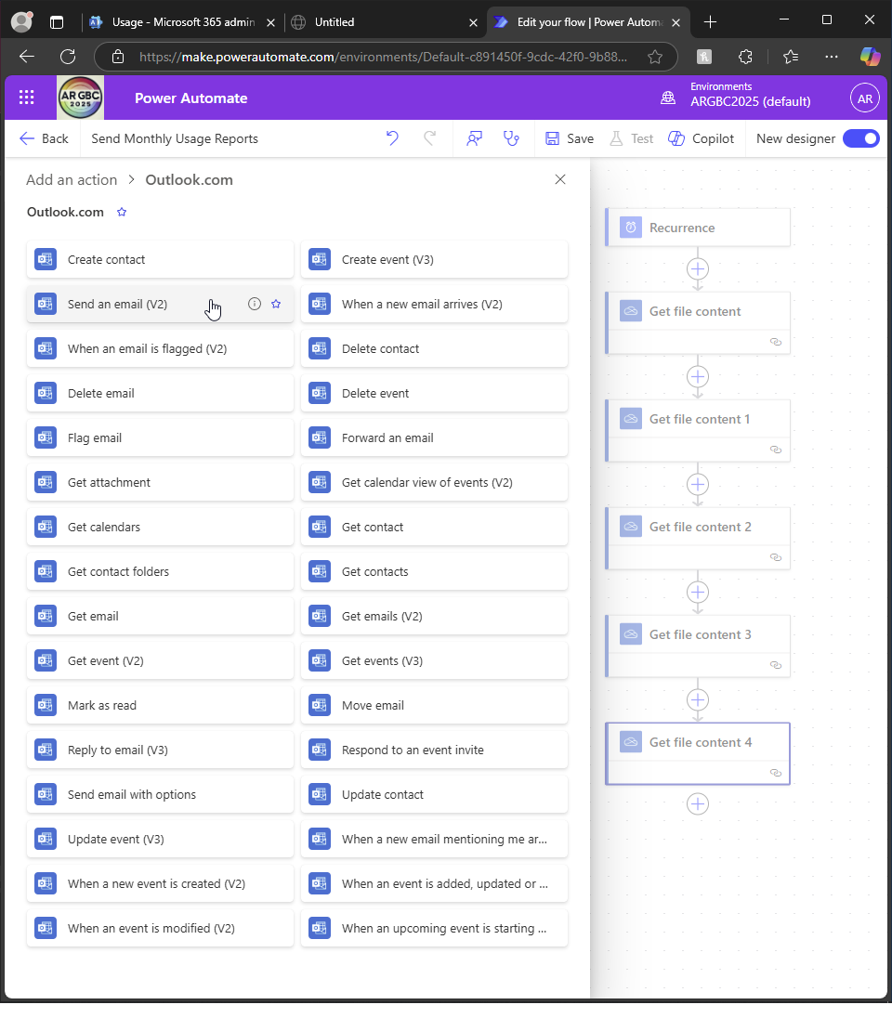  
     I add an action after ’get file content 4’ flow box to send an email  
       
     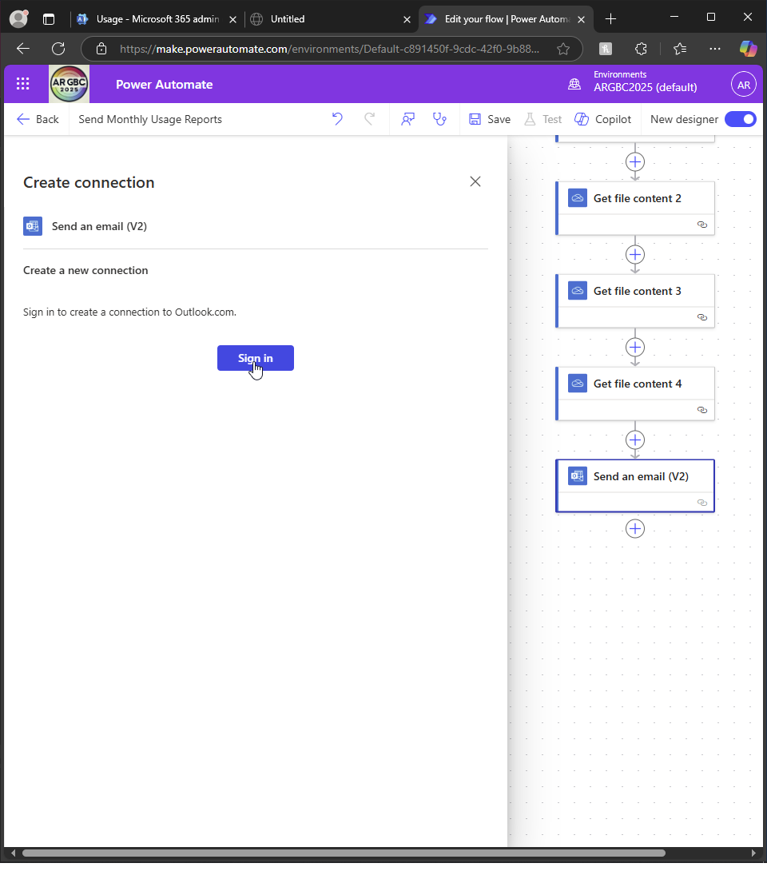  
       
     I create the connection to Outlook  
       
     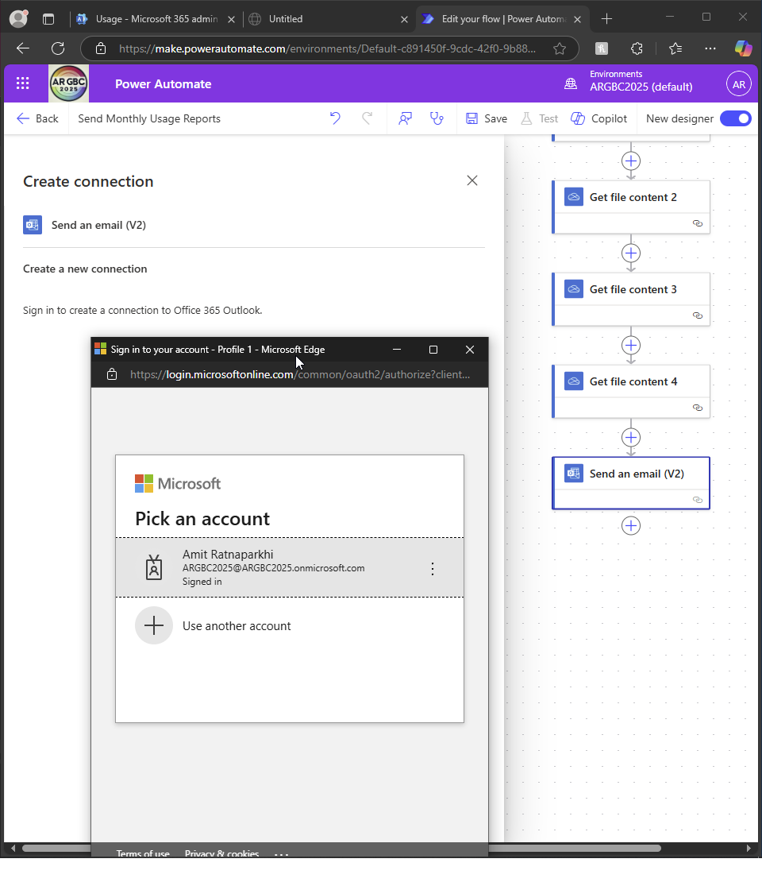  
       
     I sign in as GA  
       
     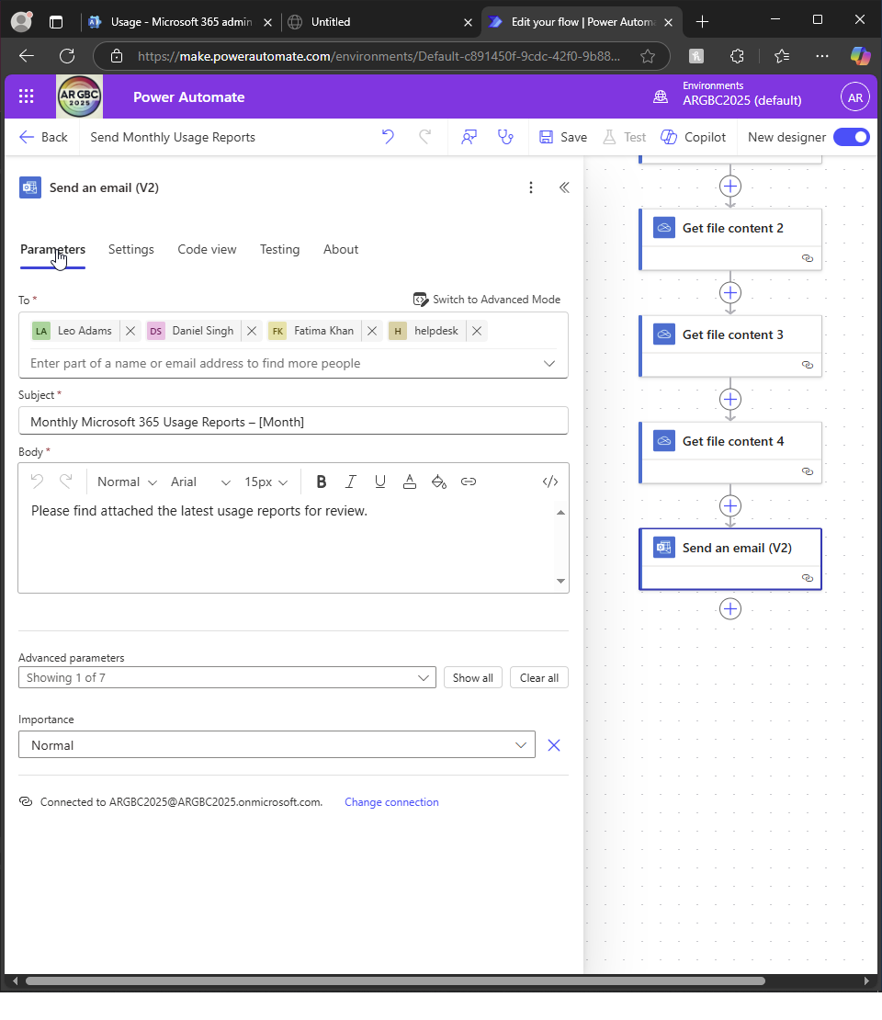  
       
     I choose to send the mail to IT departments and department heads  
       
     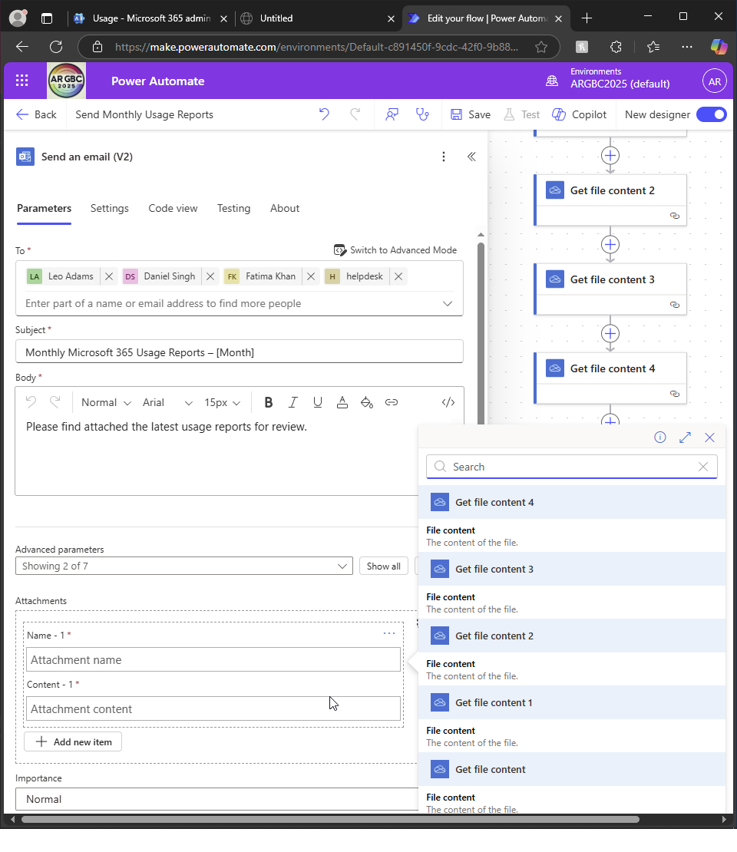  
     I dynamically attach each file contents  
       
       
     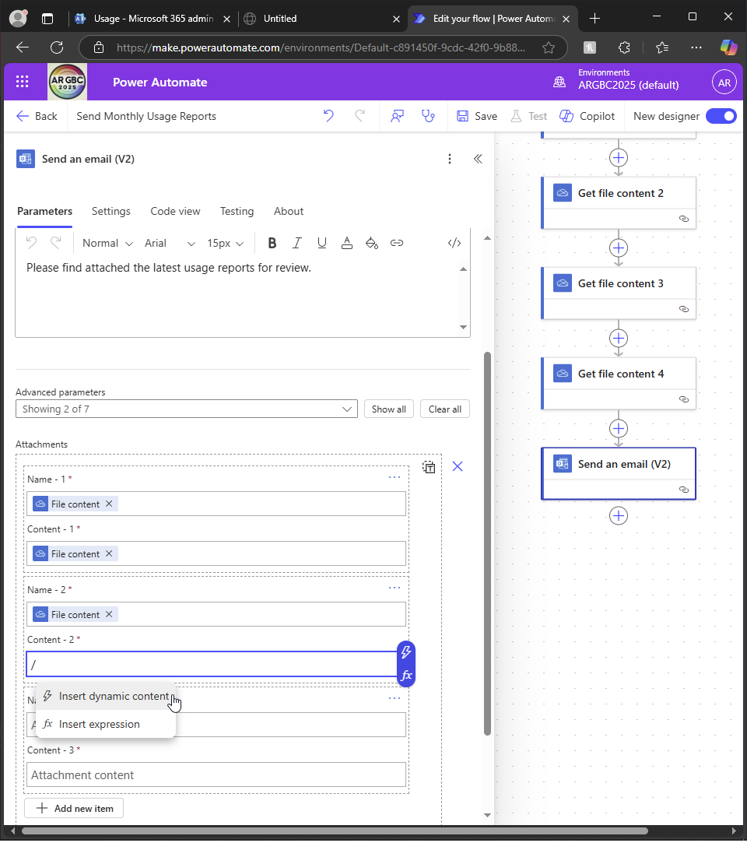  
       
     5 times, for each CSV  
       
     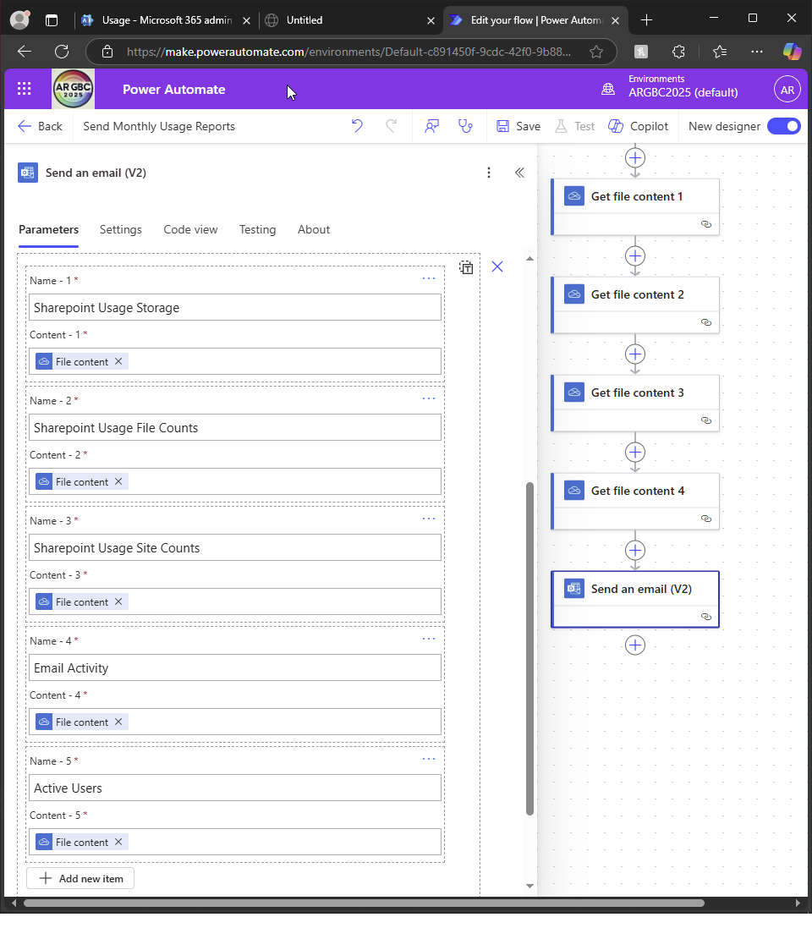  
     I give meaningful names to each file  
       
     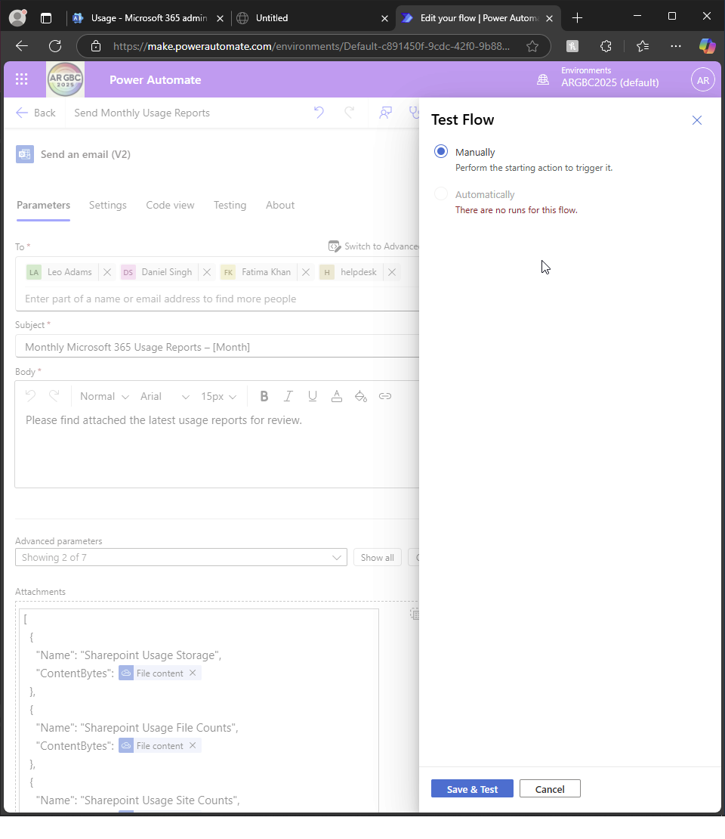  
     I save it and test flow  
       
     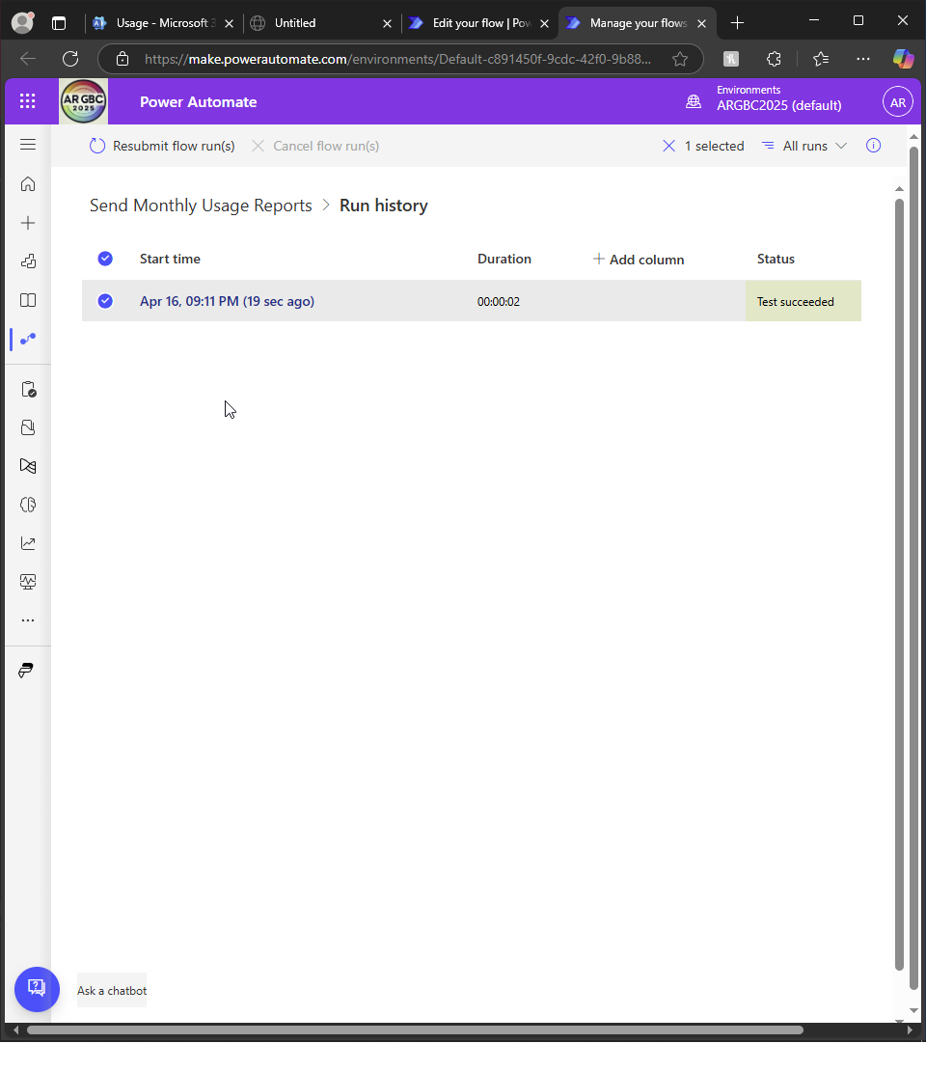  
       
     I confirm the test succeeded

1. **Implement and Monitor Service Health**:
   * Set up service health alerts to notify administrators of any issues with Microsoft 365 services.  
       
     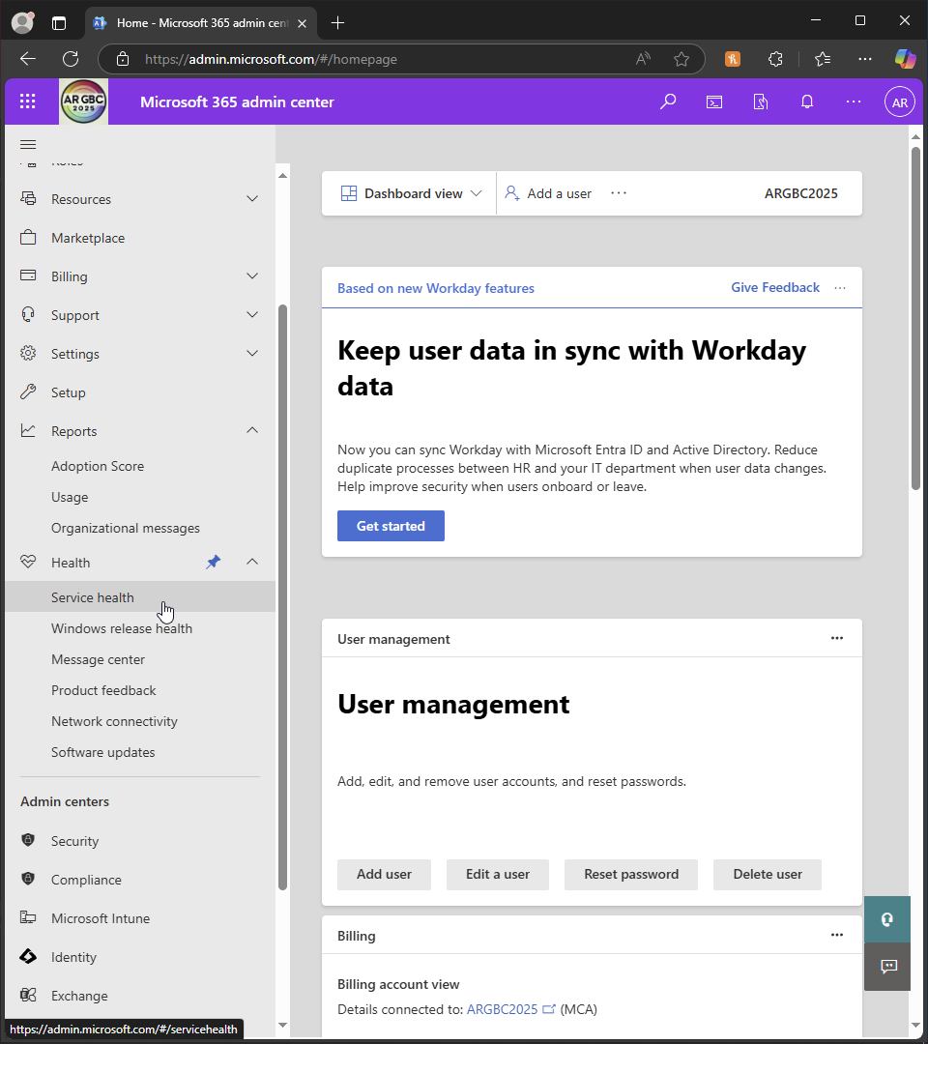  
     I go to admin centre - health - service health  
       
       
     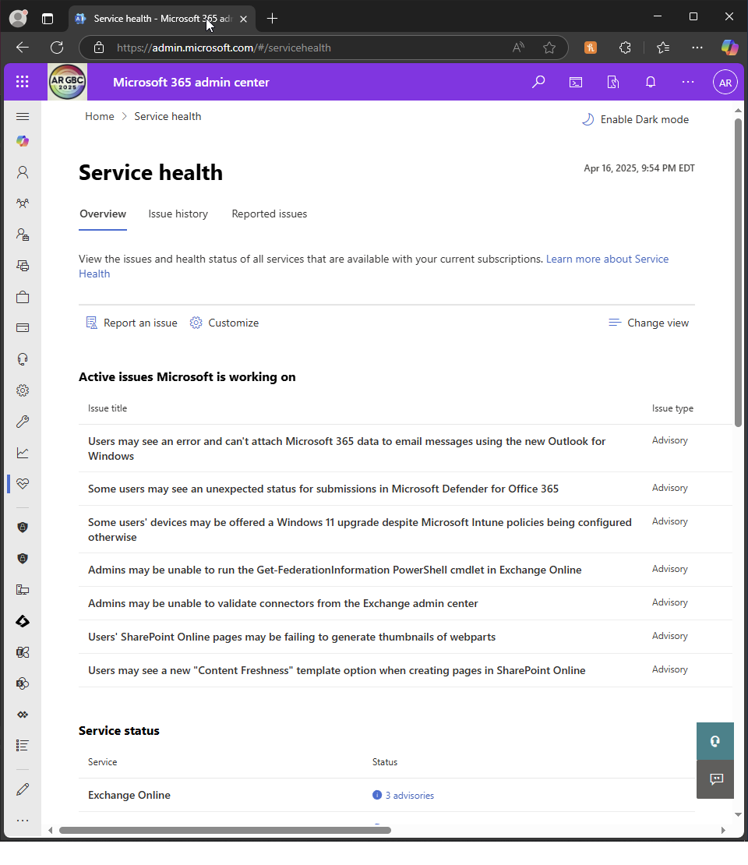  
       
     I check the dashboard  
       
     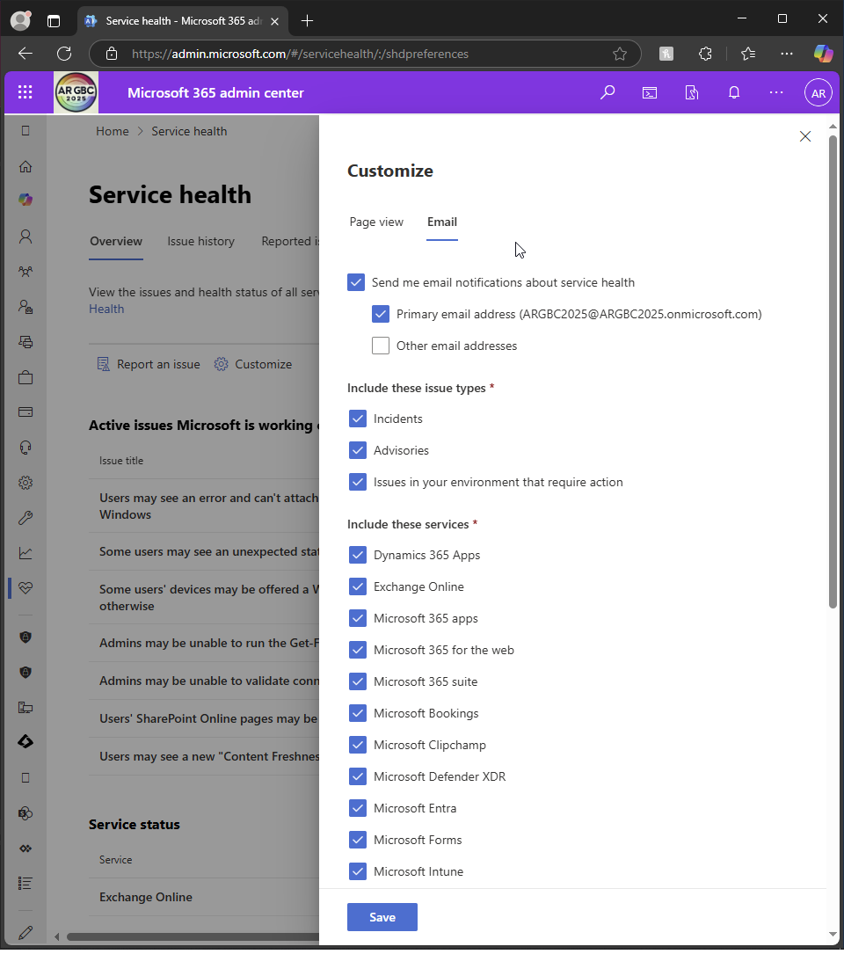  
       
     I click ’customise - email’ and ensure all services are ticked  
       
       
     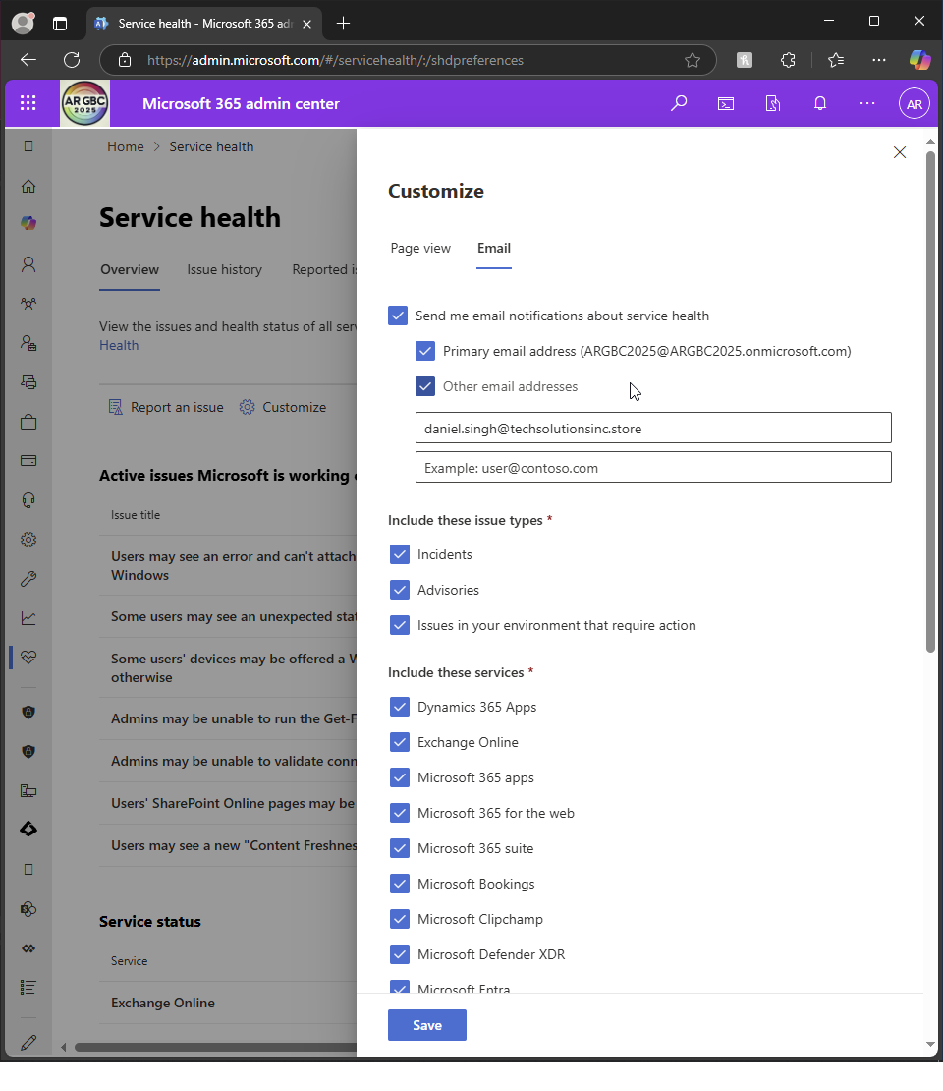  
       
     I ensure GA and IT head are recipients of the email
   * Monitor the Service Health dashboard regularly to ensure all services are running smoothly.  
       
     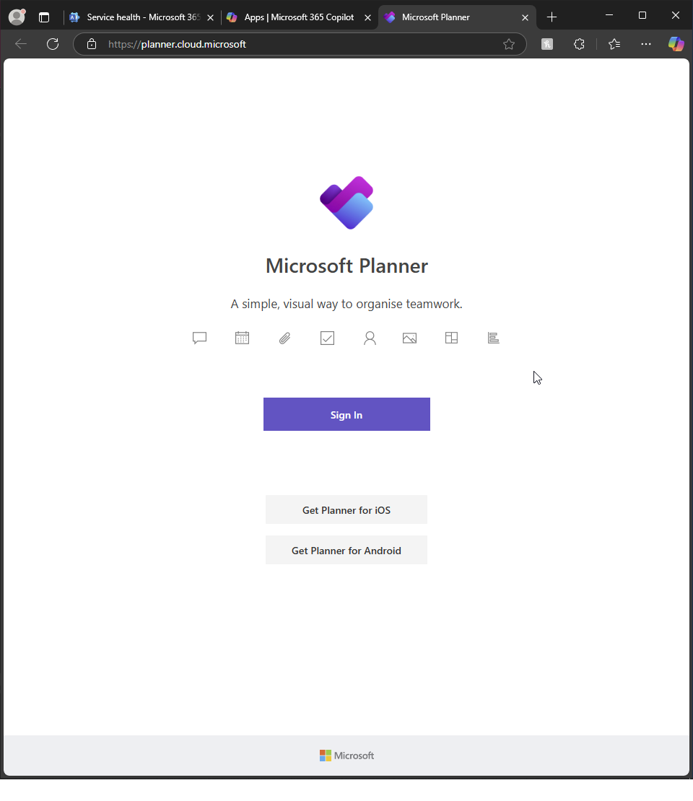  
       
     I open MS Planner  
       
       
       
     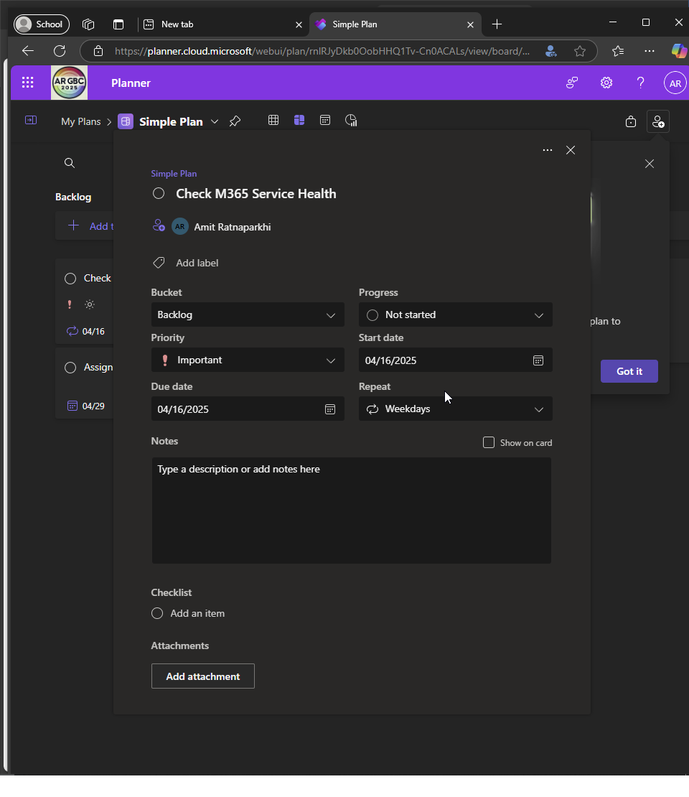  
       
     I create a reoccurring task to remind me to check MS service health

Part B:  
  
Wow! My task 4 felt like actually working as a real-life Microsoft 365 administrator and, at times, felt relentless! My starting point was to enable audit logs (again, because they had already been enabled from a previous task, but still had to exercise to do so for the task). I customised the audit log search to watch for SharePoint activity by Daniel Singh (IT admin), the account that had been configured to make file edits and deletes. The activity didn’t display at first, so confusing! until I enabled the role of MS compliance administrator to myself. Strange to think that you need to add it to GA, you would think GA has access to everything! When the entries did display, it became fascinating to see how much insight Microsoft 365 offers into each action, each document, each click.

Creating alert policies to monitor for suspect activity was easy enough until I went to do so through DLP. That was red-herring! I had interpreted the assignment literally in attempting to catch mass deletions through a DLP rule — to be met with a brick wall of system errors (chatGPT was very wrong and I told her off!) Further probe, and I found that DLP does not accommodate such behavioural triggers such as volumes of deletion. Wasted time attempting to make it work, then changed tact and effectively did create the alert properly in the correct place in Microsoft Defender. To send out the notifications of the DLP policy breaches, used Insider Risk Management as allowed under the assignment. Even as Global Admin, however, I couldn't access without manually adding myself to the Insider Risk role group — something that can be explained by Microsoft. I can only assume that Purview is an entirely seperate module to MS365. Once in, sharing of data had to be activated, wait for analytics to be in action, and simulate a further mass deletion using 50 dummy files uploaded by Daniel. Re-ran the activity after the realisation that anything would ever be triggered unless Insider Risk Analytics had been manually switched to be in effect.  
  
I realised at this point that I was confusing DLP with Defender alerts. I did some research and noticed that they don’t have to be connected and the assignment was simply asking to trigger an alert for suspicious activity. So I went back to the drawing board! I started off with the idea that Defender and DLP alert settings are hand-in-hand. I could set up a DLP policy, which would natively send notifications out to Defender or Insider Risk. I spent hours trying to get them to talk with one another, with nothing seeming to happen.

I initially set up a custom alert for mass file removal, activating all of the indicators and modifying each of the settings I could. When I deleted the files from both recycle bins, though, nothing registered. Findings revealed that the Microsoft 365 connector wasn't even sending activity logs, even though it had previously appeared to be connected. I had to perform troubleshooting for that as well.

In the long run, I opted for a change of strategy. I switched the policy to single user mass download because it had a pre-configured template and was much easier to set up and as if my magic , it worked! It's been a learning curve, though, I can see that the greater the real-world exposure, the more second nature the setup of such policies will be, and the less intimidating.

I then built a few email, SharePoint, and user activity utilisation reports from the admin centre and exported them to OneDrive. A scheduled flow in Power Automate sent the reports to IT as well as department heads each month. Even here, there was a struggle! First using the incorrect Outlook connector and encountering authentication problems before discovering that you need to use the Office 365 connector. The final task was setting up a recurring alert as well as a reminder to glance at the dashboard from time to time. Which was easy (horray!) but even here, the “Preferences > Email” preference in previous versions is now anachronistic, and the alert setting is now under the “Customise” button. MS365 changes every minute! Overall, this task summarised everything that I’d thus far learned, but with the very real hiccups along the way.

If I were to improve Microsoft 365, first and foremost, its admin UI consistency would be the first to be gone. There's still so much in their own little pockets (Defender, Purview, Admin Center, Viva) that occasionally even the same feature is called something different based on what you're in. Giving Global Admins access to Insider Risk by default, or at least making it more obvious they're blocked, would be a no-brainer. The DLP interface really should inform you about what kinds of conditions they can work with, especially when users are trying to detect in-reality signals such as mass deletion.   
  
For all of that, this was by far, the most helpful and realistic exercise. It didn’t simply tell me to click things — it had me act as an administrator, diagnose as an administrator, and actually create things that you might plausibly do in a real organisation, rather than a student.

**Deliverables**:

* A detailed report documenting each step taken during the project, including screenshots and explanations.
* A summary of configurations and policies implemented, along with their rationale.
* A presentation to the class demonstrating the setup and explaining the choices made during the project.

**Assessment Criteria**:

* Completeness and accuracy of the tasks performed.
* Understanding and application of Microsoft 365 features and best practices.
* Quality of documentation and presentation.
* Ability to troubleshoot and resolve issues encountered during the project.

~~~~~~  
Paste your screenshots here